UNITED STATES
SECURITIES AND EXCHANGE COMMISSION
WASHINGTON, D.C. 20549

FORM 20-F

☐ REGISTRATION STATEMENT PURSUANT TO SECTION 12(b) OR (g) OF THE SECURITIES EXCHANGE ACT OF 1934

OR

☒ ANNUAL REPORT PURSUANT TO SECTION 13 OR 15(d) OF THE SECURITIES EXCHANGE ACT OF 1934

For the fiscal year ended March 31, 2026

OR

☐ TRANSITION REPORT PURSUANT TO SECTION 13 OR 15(d) OF THE SECURITIES EXCHANGE ACT OF 1934

OR

☐ SHELL COMPANY REPORT PURSUANT TO SECTION 13 OR 15(d) OF THE SECURITIES EXCHANGE ACT OF 1934

Date of event requiring this shell company report

For the transition period from ________ to ________

Commission file number: 001-42915

ALPS GROUP INC
(Exact name of Registrant as specified in its charter)

N/A
(Translation of Registrant’s name into English)

Cayman Islands
(Jurisdiction of incorporation or organization)

Unit E-18-01 & E-18-02, Level 18, Icon Tower (East)
No. 1, Jalan 1/68F, Jalan Tun Razak
50400 Kuala Lumpur
Wilayah Persekutuan, Malaysia
(Address of principal executive offices)

Dr. Tham Seng Kong
Telephone: +603-2163 1113
Unit E-18-01 & E-18-02, Level 18, Icon Tower (East)
No. 1, Jalan 1/68F, Jalan Tun Razak
50400 Kuala Lumpur
Wilayah Persekutuan, Malaysia
(Name, Telephone, E-mail and/or Facsimile number and Address of Company Contact Person)

Securities registered or to be registered pursuant to Section 12(b) of the Act.

Title of each class |  | Trading Symbol(s) |  | Name of each exchange on which registered
Ordinary shares, par value $0.0001 per share |  | ALPS |  | The Nasdaq Stock Market LLC
Warrants to purchase ordinary shares |  | ALPWF |  | None.

Securities registered or to be registered pursuant to Section 12(g) of the Act.

None
(Title of Class)

Securities for which there is a reporting obligation pursuant to Section 15(d) of the Act.

None
(Title of Class)

Indicate the number of outstanding shares of each of the issuer’s classes of capital or common stock as of the close of the period covered by the annual report.

As of March 31, 2026, the issuer had 166,400,314 Ordinary Shares, par value $0.0001 per share, issued and outstanding.

Indicate by check mark if the registrant is a well-known seasoned issuer, as defined in Rule 405 of the Securities Act.

Yes ☐ No ☒

If this report is an annual or transition report, indicate by check mark if the registrant is not required to file reports pursuant to Section 13 or 15(d) of the Securities Exchange Act of 1934.

Yes ☐ No ☒

Note - Checking the box above will not relieve any registrant required to file reports pursuant to Section 13 or 15(d) of the Securities Exchange Act of 1934 from their obligations under those Sections.

Indicate by check mark whether the registrant (1) has filed all reports required to be filed by Section 13 or 15(d) of the Securities Exchange Act of 1934 during the preceding 12 months (or for such shorter period that the registrant was required to file such reports), and (2) has been subject to such filing requirements for the past 90 days.

Yes ☒ No ☐

Indicate by check mark whether the registrant has submitted electronically every Interactive Data File required to be submitted pursuant to Rule 405 of Regulation S-T (§232.405 of this chapter) during the preceding 12 months (or for such shorter period that the registrant was required to submit such files).

Yes ☒ No ☐

Indicate by check mark whether the registrant is a large accelerated filer, an accelerated filer, a non-accelerated filer, or an emerging growth company. See definition of “large accelerated filer,” “accelerated filer,” and “emerging growth company” in Rule 12b-2 of the Exchange Act.

Large accelerated filer | ☐ | Accelerated filer | ☐
Non-accelerated filer | ☒ | Emerging growth company | ☒

If an emerging growth company that prepares its financial statements in accordance with U.S. GAAP, indicate by check mark if the registrant has elected not to use the extended transition period for complying with any new or revised financial accounting standards provided pursuant to Section 13(a) of the Exchange Act. ☐

* | The term “new or revised financial accounting standard” refers to any update issued by the Financial Accounting Standards Board to its Accounting Standards Codification after April 5, 2012.

Indicate by check mark whether the registrant has filed a report on and attestation to its management’s assessment of the effectiveness of its internal control over financial reporting under Section 404(b) of the Sarbanes-Oxley Act (15 U.S.C. 7262(b)) by the registered public accounting firm that prepared or issued its audit report. ☐

If securities are registered pursuant to Section 12(b) of the Act, indicate by check mark whether the financial statements of the registrant included in the filing reflect the correction of an error to previously issued financial statements. ☐

Indicate by check mark whether any of those error corrections are restatements that required a recovery analysis of incentive-based compensation received by any of the registrant’s executive officers during the relevant recovery period pursuant to §240.10D-1(b). ☐

Indicate by check mark which basis of accounting the registrant has used to prepare the financial statements included in this filing:

U.S. GAAP ☐ | International Financial Reporting Standards as issued by the  International Accounting Standards Board ☒ | Other ☐

* | If “Other” has been checked in response to the previous question, indicate by check mark which financial statement item the registrant has elected to follow. Item 17 ☐ Item 18 ☐

If this is an annual report, indicate by check mark whether the registrant is a shell company (as defined in Rule 12b-2 of the Exchange Act). Yes ☐ No ☒

TABLE OF CONTENTS

INTRODUCTION |  | ii
PART I |  | 2
ITEM 1. | IDENTITY OF DIRECTORS, SENIOR MANAGEMENT AND ADVISERS | 2
ITEM 2. | OFFER STATISTICS AND EXPECTED TIMETABLE | 2
ITEM 3. | KEY INFORMATION | 2
ITEM 4. | INFORMATION ON THE COMPANY | 39
ITEM 4A. | UNRESOLVED STAFF COMMENTS | 98
ITEM 5. | OPERATING AND FINANCIAL REVIEW AND PROSPECTS | 98
ITEM 6. | DIRECTORS, SENIOR MANAGEMENT AND EMPLOYEES | 111
ITEM 7. | MAJOR SHAREHOLDERS AND RELATED PARTY TRANSACTIONS | 117
ITEM 8. | FINANCIAL INFORMATION | 123
ITEM 9. | THE OFFER AND LISTING | 123
ITEM 10. | ADDITIONAL INFORMATION | 124
ITEM 11. | QUANTITATIVE AND QUALITATIVE DISCLOSURES ABOUT MARKET RISK | 137
ITEM 12. | DESCRIPTION OF SECURITIES OTHER THAN EQUITY SECURITIES | 138
PART II |  | 139
ITEM 13. | DEFAULTS, DIVIDEND ARREARAGES AND DELINQUENCIES | 139
ITEM 14. | MATERIAL MODIFICATIONS TO THE RIGHTS OF SECURITY HOLDERS AND USE OF PROCEEDS | 139
ITEM 15. | CONTROLS AND PROCEDURES | 139
ITEM 16. | [RESERVED] | 140
ITEM 16A. | AUDIT COMMITTEE FINANCIAL EXPERT | 140
ITEM 16B. | CODE OF ETHICS | 140
ITEM 16C. | PRINCIPAL ACCOUNTANT FEES AND SERVICES | 140
ITEM 16D. | EXEMPTIONS FROM THE LISTING STANDARDS FOR AUDIT COMMITTEES | 140
ITEM 16E. | PURCHASES OF EQUITY SECURITIES BY THE ISSUER AND AFFILIATED PURCHASERS | 140
ITEM 16F. | CHANGE IN REGISTRANT’S CERTIFYING ACCOUNTANT | 141
ITEM 16G. | CORPORATE GOVERNANCE | 141
ITEM 16H. | MINE SAFETY DISCLOSURE | 141
ITEM 16I. | DISCLOSURE REGARDING FOREIGN JURISDICTIONS THAT PREVENT INSPECTIONS | 141
ITEM 16J. | INSIDER TRADING POLICIES | 141
ITEM 16K. | Cybersecurity | 141
PART III |  | 142
ITEM 17. | FINANCIAL STATEMENTS | 142
ITEM 18. | FINANCIAL STATEMENTS | 142
ITEM 19. | EXHIBITS | 143

i

INTRODUCTION

Except as otherwise indicated or required by context, references in this annual report to “we,” “us,” “our,” “our company,” “Alps,” “Alps Group,” “the Company” and “PubCo” are refer to Alps Group Inc and its subsidiaries and consolidated affiliated entity(ies).

Our consolidated financial statements are presented in U.S. dollars. All references in this annual report to “$,” “U.S. $”, “U.S. dollars”, “USD” and “dollars” mean U.S. dollars, unless otherwise noted.

We completed a Business Combination with Globalink on October 28, 2025. Pursuant to the terms of the Merger Agreement, the Business Combination between Globalink and Alps was effected in two steps: (i) Globalink merged with and into the Company, with into the Company remaining as the surviving publicly traded entity (the “Redomestication Merger”); and (ii) Merger Sub merged with and into Alps Holdco, resulting in Alps Holdco remaining as the surviving entity and a wholly-owned subsidiary of into the Company (the “Acquisition Merger”). The Company’s Ordinary Shares began trading on the Nasdaq Stock Market LLC (“Nasdaq”) under the symbol “ALPS” on October 31, 2025. Our Warrants are listed on the OTCID under the symbol “ALPWF.”

This annual report on Form 20-F includes our audited consolidated financial statements for the fiscal years ended March 31, 2026, March 31, 2025, and March 31, 2024.

In this annual report on Form 20-F, unless the context otherwise requires, references to:

 | ● | “Alps Malaysia” means Alps Global Holding Berhad, a Malaysian company and a subsidiary of Alps Holdco;
 | ● | “Alps Holdco” means Alps Life Sciences Inc, a Cayman Islands exempted company;
 | ● | “APC” means Annual Practising Certificate. A certificate issued by the MMC for practitioner to legally practice medicine and has to be renewed every year.
 | ● | “Amended and Restated Registration Rights Agreement” means the Amended and Restated Registration Rights Agreement entered at the Closing by the Company, certain stockholders of Globalink and certain shareholders of Alps Holdco;

ii

 | ● | “Business Combination” means the Redomestication Merger and the Acquisition Merger as contemplated by the Merger Agreement;
 | ● | “cGCP” means current good clinical practice, an international ethical and scientific quality standard for designing, conducting, recording, and reporting clinical trials that involve the participation of human subjects;
 | ● | “cGMP” means current good manufacturing practice, a system for ensuring that products are consistently produced and controlled according to quality standards;
 | ● | “Chardan” means Chardan Capital Markets, LLC, the representative of the underwriters for the IPO of Globalink;
 | ● | “Closing” means the consummation of the Business Combination;
 | ● | “Closing Date” means October 28, 2025, the date on which the Business Combination was consummated;
 | ● | “Code” means the Internal Revenue Code of 1986, as amended;
 | ● | “Combined Company” or the “Company”, “Alps Group” or “Alps” means Alps Group Inc and its consolidated subsidiaries and consolidated affiliated entity(ies) after the Business Combination;
 | ● | “Companies Act” means the Companies Act (Revised) of the Cayman Islands;
 | ● | “common stock” or “Globalink common stock” means the Globalink common stock;
 | ● | “Continental” means Continental Stock Transfer & Trust Company, Globalink’s transfer agent, warrant agent, rights agent and trustee;
 | ● | “COVID-19” means the worldwide novel coronavirus disease pandemic;
 | ● | “CTIL” means the Clinical Trial Import License in Malaysia;

 | ● | “CTX” means the Clinical Trial Exemption in Malaysia;
 | ● | “Effective Time” means the time at which the Business Combination became effective;

iii

 | ● | “Exchange Act” means the Securities Exchange Act of 1934, as amended;
 | ● | “FDA” means the U.S. Food and Drug Administration;
 | ● | “Globalink” means Globalink Investment Inc., a Delaware corporation or the reference to the current corporation as a special purpose acquisition corporation prior to the Business Combination;

 | ● | “IPO” means the initial public offering of Globalink consummated on December 9, 2021;
 | ● | “IRS” means the United States Internal Revenue Service;
 | ● | “ISO” means the International Organization of Standardization;
 | ● | “Law” means any domestic or foreign, federal, state, municipality or local law, statute, ordinance, code, rule, or regulation;
 | ● | “LCP” means Letter of Credentialing and Privileging Medical Practice;
 | ● | “MAB” means Medicine Advertisements Board;
 | ● | “Merger Agreement” means the Merger Agreement by and among Globalink, Alps Holdco, the Sponsor, PubCo, Merger Sub and Dr. Tham Seng Kong, dated January 30, 2024, as amended and restated on May 20, 2024 and was further amended on March 6, 2025, April 18, 2025 and September 27, 2025;
 | ● | “Merger Consideration Shares” means 160,000,000 PubCo ordinary shares, subject to the withholding of the Escrow Shares deposited in the Escrow Account, and after the Closing are subject to reduction for the indemnification obligations of the Indemnifying Parties set forth in the Merger Agreement;
 | ● | “Merger Sub” means Alps Biosciences Merger Sub, a Cayman Islands exempted company and a wholly-owned subsidiary of PubCo;
 | ● | “MMC” means Malaysian Medical Council;
 | ● | “MOH” means Ministry of Health, Malaysia;
 | ● | “MS” means Malaysian Standard;
 | ● | “NPRA” means National Pharmaceutical Regulatory Agency, Malaysia;
 | ● | “PGM” means Public Gold Marketing Sdn. Bhd., a Malaysian private limited company, an investor who purchased 570,000 private units in the private placement simultaneously with the consummation of the IPO. PGM is an affiliate of the Sponsor as its 95% equity holder has a familial relationship with the control person of the Sponsor;
 | ● | “PIPE Investment” means the private placement contemplated by the Subscription Agreements entered into by and between PubCo, Globalink, Alps Holdco, and certain investors for an aggregate of $3,107,731 for 310,788 PubCo ordinary shares, to be consummated simultaneously with the closing of the Business Combination;
 | ● | “PIPE Subscription Agreements” means the subscription agreements with investors (the “PIPE Investors”) for the subscription of PubCo ordinary shares;
 | ● | “POC” means proof-of-concept;
 | ● | “Private Units” mean the 570,000 Globalink units issued to Public Gold Marketing Sdn. Bhd., a Malaysian private limited company, in a private placement;

iv

 | ● | “Private Warrants” means warrants of Globalink included in the Private Units, each entitling the holder thereof to purchase one-half (1/2) share of Globalink common stock at a purchase price of $11.50 per whole share;
 | ● | “PubCo” means Alps Group Inc (formerly known as “Alps Global Holding Pubco”), a Cayman Islands exempted company;
 | ● | “ordinary shares”, “shares” or “Ordinary Shares” means the ordinary shares of the Company of par value US$0.0001 each;
 | ● | “Warrants” means warrants of the Company each entitling the holder thereof to purchase one-half (1/2) of one (1) ordinary share at a purchase price of $11.50 per whole share;
 | ● | “public units” means the units of Globalink sold in the IPO, whether they were purchased in the IPO or thereafter in the open market, each consisting of one share of common stock, $0.001 par value, one right to receive one-tenth (1/10) of a share of common stock upon the consummation of an initial business combination and one redeemable warrant entitling the holder thereof to purchase one-half (1/2) of a share of common stock at a price of $11.50 per whole share;
 | ● | “public warrants” means warrants of Globalink included in the public units, each entitling the holder thereof to purchase one-half (1/2) share of Globalink common stock at a purchase price of $11.50 per whole share;
 | ● | “R&D” means research and development;
 | ● | “rights” or “Globalink rights” means the rights of Globalink included in the units, each entitling its holder to receive one-tenth (1/10) of a share of Globalink common stock upon the consummation of the Business Combination;
 | ● | “RM” or “Ringgit Malaysia” means the lawful currency of Malaysia;
 | ● | “SEC” means the U.S. Securities and Exchange Commission;
 | ● | “Securities Act” means the Securities Act of 1933, as amended;
 | ● | “Sponsor” or “Parent Representative” means GL Sponsor LLC, a Delaware limited liability company;
 | ● | “Trust Account” means Globalink’s trust account maintained by Continental;
 | ● | “units” or “Globalink units” means public units and private units, collectively;
 | ● | “U.S. Dollars,” “US Dollars,” “$,” or “US$” means the legal currency of the United States;
 | ● | “U.S. GAAP” or “GAAP” means accounting principles generally accepted in the United States;
 | ● | “ZAR” means the legal currency of the Republic of South Africa.

v

FORWARD-LOOKING STATEMENTS

This annual report on Form 20-F (including information incorporated by reference herein, the “Report”) contains forward-looking statements that reflect our current expectations and views of future events. The forward-looking statements are contained principally in “Item 3. Key Information—D. Risk Factors,” “Item 4. Information on the Company—B. Business Overview,” and “Item 5. Operating and Financial Review and Prospects.” These forward-looking statements are made under the “safe-harbor” provisions of the U.S. Private Securities Litigation Reform Act of 1995. Known and unknown risks, uncertainties and other factors, including those listed under “Item 3. Key Information—D. Risk Factors,” may cause our actual results, performance, or achievements to be materially different from those expressed or implied by the forward-looking statements.

The words “may,” “might,” “will,” “could,” “would,” “should,” “expect,” “intend,” “plan,” “goal,” “objective,” “anticipate,” “believe,” “estimate,” “predict,” “potential,” “continue” and “ongoing,” or the negative of these terms, similar expressions or other comparable terminology intended to identify statements about the future. We have based these forward-looking statements largely on our current expectations and projections about future events that we believe may affect our financial condition, results of operations, business strategy, and financial needs. These forward-looking statements include statements relating to:

 | ● | our goals and growth strategies

 | ● | our future business development, financial condition and results of operation;

 | ● | our expectations regarding demand for and market acceptance of our services;

 | ● | our expectations regarding our relationships with our investors and borrowers;

 | ● | competition in our industry;

 | ● | relevant government policies, laws and regulations relating to our industry;

 | ● | continued market acceptance of our services and products;

 | ● | protection of our intellectual property rights;

 | ● | changes in the laws that affect our operations;

 | ● | fluctuations in operating results;

 | ● | inflation and fluctuations in foreign currency exchange rates;

 | ● | dependence on our senior management and key employees;

 | ● | our ability to continue to develop new technologies and/or upgrade our existing technologies;

 | ● | our ability to obtain and maintain all necessary government certifications, approvals, and/or licenses to conduct our business;

 | ● | the cost of complying with current and future governmental regulations and the impact of any changes in the regulations on our operations;

 | ● | capabilities of our business operations;

 | ● | changes in general economic, business and industry conditions; and

 | ● | other risks and uncertainties indicated in this annual report, including those set forth in “Item 3. Key Information—D. Risk Factors.”

These forward-looking statements are based on information available as of the date of this Report, and current expectations, forecasts and assumptions, and involve a number of judgments, risks and uncertainties. Accordingly, forward-looking statements should not be relied upon as representing our views as of any subsequent date, and we do not undertake any obligation to update forward-looking statements to reflect events or circumstances after the date they were made, whether as a result of new information, future events or otherwise, except as may be required under applicable securities laws.

You should not place undue reliance on these forward-looking statements. New risk factors and uncertainties emerge from time to time and it is not possible for our management to predict all risk factors and uncertainties, nor can we assess the impact of all factors on our business or the extent to which any factor, or combination of factors, may cause actual results to differ materially from those contained in any forward-looking statements. As a result of a number of known and unknown risks and uncertainties, our actual results or performance may be materially different from those expressed or implied by these forward-looking statements.

This Report also contains statistical data and estimates that we obtained from industry publications and reports generated by third-party providers of market intelligence. These industry publications and reports generally indicate that the information contained therein was obtained from sources believed to be reliable, but do not guarantee the accuracy and completeness of such information.

1

Part I

ITEM 1. IDENTITY OF DIRECTORS, SENIOR MANAGEMENT AND ADVISERS

Not applicable.

ITEM 2. OFFER STATISTICS AND EXPECTED TIMETABLE

Not applicable.

ITEM 3. KEY INFORMATION

A. | [Reserved]

B. | Capitalization and Indebtedness

Not applicable.

C. | Reasons for the Offer and Use of Proceeds

Not applicable.

D. | Risk Factors

Our business faces significant risks and uncertainties. You should carefully consider all of the information contained in this Annual Report, together with the other documents we file with or furnish to the SEC, including the risk factors described below, before deciding whether to invest in, or continue to hold, our securities. If any of the following risks, or other risks and uncertainties that are currently unknown to us or that we currently deem immaterial, materialize, our business, reputation, financial condition, results of operations, cash flows and the market price of our securities could be materially and adversely affected. The risk factors described below should not be regarded as a complete or exhaustive discussion of all the risks that we may face.

The risk factors set forth below relate to the business and operations of Alps Group Inc, its wholly owned subsidiary Alps Holdco, Alps Malaysia and their respective subsidiaries and consolidated affiliated entities (collectively, the “Company,” “Alps,” “we”, “us” and “our”). Where applicable, specific references to a company will refer to such company only.

2

Risks Related to Alps’ Business and Industry

Alps Group Inc is a recently formed public holding company with limited operating history, which may make it difficult to evaluate our business and prospects.

Alps Group Inc recently completed the Business Combination and operates as a holding company through Alps Life Sciences Inc., which in turn operates through Alps Global Holding Berhad and its subsidiaries. As a newly public company, Alps Group Inc. has limited operating history as a consolidated group, and investors have limited historical information upon which to evaluate our business, operations and prospects.

As a biotechnology entity, our product pipeline remains in the preclinical stage. Our activities have primarily focused on strategic planning, fundraising, intellectual property development, identifying new therapeutic targets, and advancing product candidates through various stages of research and development. Alps’ pipeline includes biologics and biopharmaceuticals, none of which have obtained regulatory approval, and none of our product candidates has commenced clinical trials.

As a result, Alps’ ability to successfully undertake and complete pivotal clinical trials, secure regulatory approvals, scale up manufacturing, or engage in effective sales and marketing for product commercialization remains unproven. Despite Alps’ significant investments in research, development, and operations, forecasting our future with any degree of certainty is more challenging than it would be as compared to a company with a more extensive operational history or closer proximity to commercialization.

In addition, we expect to face challenges associated with operating as an early-stage biotechnology company and a newly public company, including managing growth, prioritizing research and development initiatives, securing additional financing, complying with increased regulatory and reporting obligations, and executing our business strategy. Alps is also likely to face unexpected expenses and obstacles that could adversely impact its business. Failure to effectively mitigate these risks could adversely impact our business.

Alps will need to obtain substantial additional funding to complete the development of its product candidates.

We expect to continue to incur significant expenses in connection with our ongoing activities, particularly as we advance the research and development of our product candidates and technology platforms, including MyImmune, MyCelEst, and patient-derived organoid-based personalized cancer test development. The development of biotechnology products is capital-intensive and involves significant uncertainties, including the costs associated with research and development activities, regulatory requirements, manufacturing capabilities and potential commercialization efforts.

Following the successful completion of the Business Combination, Alps intends to use its available resources to support the development of its product candidates and technology platforms, as well as for other research and development activities, working capital, and general corporate purposes. In addition, as a newly listed public company, Alps expects to incur increased costs associated with legal, accounting, regulatory compliance, corporate governance and other obligations applicable to public companies.

3

As Alps continues to advance its research and development programs, it may require substantial additional funding through public or private equity offerings, debt financing, strategic collaborations, licensing arrangements or other sources. However, obtaining additional financing may result in dilution to our stockholders or impose burdensome debt covenants and repayment obligations. Our future capital requirements and the timing and amount of our operating expenditures will depend largely on:

 | ● | the timing and progress of preclinical and clinical development of our current and potential future product candidates;
 | ● | the number and scope of preclinical and clinical programs we decide to pursue;
 | ● | our ability to maintain our current licenses and collaborations, conduct our research and development programs and establish new strategic partnerships and collaborations;
 | ● | the progress of the development efforts of our existing strategic partners and third parties with whom we may in the future enter into collaboration and research and development agreements;
 | ● | the costs and timing of preparing, filing and prosecuting patent applications, maintaining and enforcing our intellectual property rights and defending any intellectual property-related claims, including any claims by third parties that we are infringing upon their intellectual property rights;
 | ● | our ability to establish and maintain strategic collaborations, licensing or other arrangements and the financial position, terms of any such agreements, including the timing and amount of any future milestone, royalty or other payments due under any such agreement;
 | ● | the cost and timing of regulatory approvals; and
 | ● | our efforts to enhance operational systems and to hire and retain personnel, including personnel to support development of our product candidates, the operation of our manufacturing facility, and to satisfy our obligations as a public company.

The availability of additional funding on terms favorable to us is not guaranteed. Should we fail to secure the necessary capital in adequate amounts or under acceptable terms, we might be compelled to reduce our workforce significantly, delay, downscale, or cease the development or commercialization of our product candidates, or explore less desirable collaborations for our product candidates. Such scenarios could severely impact our business prospects, financial health, operational results, and lead to a decline in the market price of Alps’ securities.

Our liquidity position is exposed to risks arising from our near-term debt obligations, and failure to meet these obligations may materially harm our business.

We have $10,199,391 of total liabilities as at March 31, 2026, and we may incur additional indebtedness in the future for various reasons, including research and development programs, fluctuations in operating results, capital expenditures, potential acquisitions and other strategic initiatives.

Any indebtedness incurred by Alps could result in increased financial obligations and may adversely affect its financial flexibility. Such indebtedness may:

 | ● | make it difficult for us to satisfy our obligations, including interest payments;
 | ● | require us to dedicate cash flows to debt service, reducing funds available for research and development, capital expenditures, working capital or other strategic transactions;
 | ● | limit our flexibility to plan for and respond to changes in our business;
 | ● | negatively impact our credit rating and increase borrowing costs;
 | ● | place us at a competitive disadvantage relative to less-leveraged competitors;
 | ● | increase our vulnerability to adverse economic and industry conditions, including interest rate changes; and
 | ● | make it difficult to refinance existing debt or obtain new financing on commercially reasonable terms.

4

In addition, if Alps is unable to generate sufficient cash flows or obtain additional financing to satisfy its obligations, Alps may be required to delay, reduce or discontinue certain research and development activities or modify its business strategy. Any inability to manage its liquidity position or meet its financing obligations could materially and adversely affect Alps’ business, financial condition and results of operations.

Alps has identified a material weakness in its internal control over financial reporting and may identify additional material weaknesses in the future that may cause it to fail to meet its reporting obligations or result in material misstatements in its financial statements. If Alps fails to remediate its material weakness, Alps may not be able to report its financial results accurately or to prevent fraud.

Internal control over financial reporting is a process designed to provide reasonable assurance regarding the reliability of financial reporting and the preparation of financial statements in accordance with IFRS. A material weakness is defined as a deficiency, or a combination of deficiencies, in internal control over financial reporting, such that there is a reasonable possibility that a material misstatement of a company’s annual or interim financial statements will not be prevented or detected on a timely basis by the company’s internal controls.

Prior to the completion of the Business Combination, Alps Malaysia and its subsidiaries operated as a private group and had limited accounting and financial reporting personnel and resources compared with those typically available to a public company. As a private company, Alps Malaysia was not required to establish and evaluate its internal control over financial reporting in accordance with the standards applicable to public companies under Section 404 of the Sarbanes-Oxley Act of 2002 (the “Sarbanes-Oxley Act”). Following the completion of the Business Combination, Alps Group Inc. became subject to the reporting requirements applicable to public companies under the Exchange Act, the Sarbanes-Oxley Act and the rules and regulations of the SEC.

In connection with our evaluation of internal control over financial reporting, we identified a material weakness primarily relating to (i) a lack of sufficient accounting and supervisory personnel with the appropriate level of technical accounting experience and training, (ii) limited supervision over external advisors providing technical accounting services, and (iii) inconsistent application of accounting processes and procedures by our accounting personnel. As a result, we may not always prevent or detect misstatements in our financial statements on a timely basis.

We have taken, and continue to take, measures to remediate the identified material weakness, including enhancing our accounting and financial reporting processes, strengthening documentation and control procedures, improving segregation of duties, enhancing personnel training relating to IFRS, SEC reporting requirements and internal controls, and appointing a Chief Financial Officer (“CFO”) to strengthen our finance leadership and support our obligations as a public company. However, the remediation process remains ongoing, and we cannot assure you that these measures will fully address the identified material weakness within the expected timeframe or that additional deficiencies will not be identified in the future.

If we fail to establish and maintain effective internal control over financial reporting, we may be unable to accurately report our financial results, prevent or detect material misstatements or fraud, or comply with our reporting obligations as a public company. In addition, our independent registered public accounting firm may disagree with management’s assessment of the effectiveness of our internal controls or identify additional deficiencies. Any failure to maintain effective internal controls could result in material misstatements in our financial statements, delays in financial reporting, regulatory scrutiny, loss of investor confidence, limitations on our ability to access capital markets and a decline in the market price of Alps’ securities.

We may not meet publicly announced product development objectives.

We sometimes estimate for planning purposes the timing of the accomplishment of various scientific, clinical, regulatory and other product development objectives. These milestones may include our expectations regarding the commencement or completion of scientific trials or clinical trials, the submission of regulatory filings or the achievement of commercialization objectives. From time to time, we may publicly announce the expected timing of some of these milestones, such as the completion of an ongoing clinical trial, the initiation of other clinical programs, receipt of marketing approval or a commercial launch of a product. The achievement of many of these milestones is outside of our control. All of these milestones are based on a variety of assumptions, which may cause the timing of achievement of the milestones to vary considerably from our estimates. If we fail to achieve announced milestones in the timeframes we expect, or at all, it may have a material adverse effect on our business, financial condition and results of operations and the price of our securities may be adversely affected.

5

Risks Related to Development of Our Product Candidates

The selection and prioritization of our product candidates for development are subject to change based on various factors. Abandoning a product candidate’s development or changing our development priorities could leave us without a viable replacement, impacting our business prospects.

Alps may determine to abandon the development of one or more of Alps’ product candidates, or we may change the prioritization of the development of certain product candidates, or Alps may select or acquire and prioritize the development of new product candidates. Alps’ choice and prioritization of product candidates for development will be influenced by a variety of factors, including but not limited to:

 | ● | Alps may have limited capital to finance its development programs and projected costs may affect its ability to enter into licensing or collaborative arrangements with other biotechnology or biopharma companies or universities with their own laboratory facilities and research staffs to conduct research and development of one or more product candidates;
 | ● | competitors may develop alternatives that render Alps’ potential product candidates obsolete or less attractive;
 | ● | potential product candidates that Alps develop may nevertheless be covered by third parties’ patents or other exclusive rights;
 | ● | potential product candidates may not be effective in treating their targeted diseases;
 | ● | potential product candidates may, on further study, be shown to have harmful side effects, toxicities or other characteristics that indicate that they are unlikely to be products that will receive marketing approval and achieve market acceptance;
 | ● | Alps’ analysis of market demand and market prices for the products we plan to develop could lead us to conclude that market conditions are not favorable for receiving an adequate return on Alps’ investment in product development and commercialization;
 | ● | a potential product candidate may not be capable of being produced in commercial quantities at an acceptable cost, or at all; or
 | ● | the regulatory pathway for a potential product candidate is too complex and difficult to successfully navigate programs.

Alps faces challenges in developing its manufacturing capabilities and currently relies may rely on third-party manufacturers, exposing it to various risks including lack of accessibility, quality control, quantity limitations, manufacturing delays, contractual breaches or terminations.

The manufacturing of biotechnology product candidates is complex, requiring significant expertise and capital, including the development of advanced manufacturing facilities, which we currently lack. Unless Alps we can finance and develop its own our manufacturing facilities, we will need to depend on third-party manufacturers, with no guarantee of favorable terms or availability. Whether Alps manufactures products or rely relies on third parties, it faces risks including manufacturing delays, inability to meet quality and quantity requirements, regulatory compliance challenges, and potential contract breaches or terminations. Regardless of whether Alps manufactures or relies on third parties to manufacture products for Alps, Alps we will face all risks related to the manufacture of therapeutic products for use in medicine including the following risks:

 | ● | Alps or any third-party manufacturers might be unable to timely formulate and manufacture Alps’ products or produce the quantity and quality required to meet Alps’ clinical and commercial needs, if any;
 | ● | Alps or any third-party manufacturers may not be able to execute Alps’ manufacturing procedures appropriately;

6

 | ● | Any third-party manufacturers Alps engage may not perform as agreed or may not remain in the contract manufacturing business for the time required to supply Alps’ clinical trials or to successfully produce, store and distribute Alps’ products on a commercial scale;
 | ● | Alps or any third-party manufacturers will be subject to ongoing periodic unannounced inspection by the NPRA or other regulatory body, and corresponding state agencies to ensure strict compliance with cGMP and other government regulations and corresponding foreign standards. Alps will not have control over third-party manufacturers’ compliance with applicable regulations and standards;
 | ● | Alps may not own, or may have to share, the intellectual property rights to any improvements made by Alps’ third-party manufacturers in the manufacturing process for Alps’ product candidates;
 | ● | Third-party manufacturers could breach or terminate their agreements with Alps; and/or
 | ● | Alps or third-party manufacturers may experience manufacturing difficulties due to resource constraints or as a result of labor disputes or unstable political environments.

In addition, Alps in the future may rely on third parties to perform release testing on Alps’ product candidates prior to delivery to patients. If these tests are not appropriately conducted and test data are not reliable, patients could be put at risk of serious harm which could result in product liability suits.

If Alps or any third-party manufacturers that Alps may engage were to encounter any of these difficulties, Alps’ ability to provide Alps’ product candidates to patients in clinical trials or to the medical marketplace would be jeopardized. Any delay or interruption in the supply of clinical trial supplies could delay the completion of clinical trials, increase the costs associated with maintaining clinical trial programs and, depending upon the period of delay, could require Alps to either commence new clinical trials at additional expense or terminate clinical trials completely.

The regulatory authorities also may, at any time following approval of a product for sale, audit Alps’ manufacturing facilities or those of Alps’ third-party contractors. If any such inspection or audit identifies a failure to comply with applicable regulations or if a violation of Alps’ product specifications or applicable regulations occurs independent of such an inspection or audit, Alps or the relevant regulatory authority may require remedial measures that may be costly and/or time-consuming for Alps or a third party to implement and that may include the temporary or permanent suspension of a clinical study or commercial sales or the temporary or permanent closure of a facility. Any such remedial measures imposed upon Alps or third parties with whom we contract could materially harm Alps’ business.

Additionally, if supply from one approved manufacturer is interrupted, there could be a significant disruption in commercial supply. The regulatory agencies may also require additional studies if a new manufacturer is relied upon for commercial production. Switching manufacturers may involve substantial costs and is likely to result in a delay in Alps’ desired clinical and commercial timelines.

Alps may not be able to manufacture product that meets release criteria due to sterility, identity or potency issues. Alps may not have access or be able to make the reagents necessary to manufacture the cells and Alps may not have access to adequate supply channels to transport and distribute the products. There are also risks that the cells may be destroyed by interruption in their cryopreservation by means of natural disasters such as earthquakes, power outages, or other unexpected events, or the cells may be determined to be unacceptable as a source of human cellular therapies for reasons Alps cannot envision. Alps cannot assure you that any stability or other issues relating to the manufacture of any of Alps’ product candidates or products will not occur in the future. If any of Alps’ master cell banks are lost or destroyed, including due to systems failure, Alps’ planned clinical trials would be severely delayed, and Alps would incur significant costs associated with obtaining new supply of cell banks. Accordingly, failures or difficulties faced at any level of Alps’ supply chain could adversely affect Alps’ business and delay or impede the development and commercialization of any of Alps’ product candidates or products and could have an adverse effect on Alps’ business, prospects, financial condition and results of operations.

7

There are a limited number of manufacturers that operate under cGMP regulations and that might be capable of manufacturing cell-based products for Alps. Accordingly, Alps’ cell-based products may have to compete with other cell-based products to access these manufacturing facilities. Future therapies that Alps may develop may compete with other product candidates and products for access to manufacturing facilities. Any performance failure on the part of Alps’ existing or future manufacturers could delay clinical development or marketing approval.

Each of these risks could delay Alps’ clinical trials, any regulatory approval of Alps’ product candidates, or the commercialization of Alps’ product candidates, and could result in higher costs or deprive Alps of potential product revenue.

Our current product candidates are in preclinical development and have never been tested in humans. One or all of our current product candidates may fail in clinical development or suffer delays that materially and adversely affect their commercial viability.

To date, none of our candidates has proceeded to clinical trials or been tested in humans. Our future profitability hinges on our ability to obtain regulatory approvals and successfully commercialize our product candidates, either independently or with partners.

Achieving commercial distribution for our product candidates requires extensive preclinical studies and clinical trials to prove their safety, purity, and efficacy in humans. Although we have observed positive outcomes observed in preclinical animal models for treatment of heart failure using iPSC-derived cardiomyocytes, these findings may not necessarily translate to similar success in future human clinical trials. There’s a risk that our product candidates may not exhibit the desired safety and efficacy in later stages of clinical development, even if they show promise in early trials. It is uncertain whether NPRA will authorize us to conduct clinical trials. Moreover, the completion and outcomes of our preclinical studies are unpredictable, and it is uncertain whether the NPRA or other regulatory bodies will approve our clinical programs, protocols, or support the further development of our preclinical programs for human testing.

Further, some or all of Alps’ product candidates under development may require the genetic modification of the pluripotent master cell banks. There is no certainty that a genetic modification will provide a long-term solution to transplant rejection, or that the modified cells will not cause unanticipated health risks to the patient that could delay or even halt the development of the products.

The preclinical development stage exposes us to inherent risks of failure associated with novel therapeutic approaches, targets, and action mechanisms. While we plan to initiate clinical trials for our leading candidates, there’s no assurance of progressing to clinical development for any candidate or of demonstrating clinical benefits in patient testing. Considering the costs, uncertainties, delays, and challenges typical for preclinical stage biotechnology company like us, our prospects should be evaluated accordingly.

We may not be able to access the financial resources to continue development of, or to enter into any collaborations for, any of our current or potential future product candidates. This may be exacerbated if we experience any issues that delay or prevent regulatory approval of, or our ability to commercialize, a product candidate, such as:

 | ● | negative or inconclusive results from our preclinical studies or clinical trials or the clinical trials of others for product candidates similar to ours, leading to a decision or requirement to conduct additional preclinical studies or clinical trials or abandon any or all of our programs;
 | ● | adverse events experienced by participants in our clinical trials or by individuals using therapeutics similar to our product candidates;
 | ● | delays in submitting CTIL, CTX or comparable foreign applications, or delays or failures to obtain the necessary approvals from regulatory authorities to commence a clinical trial, or a suspension or termination of a clinical trial once commenced;

8

 | ● | conditions imposed by the NPRA or other regulatory authorities regarding the scope or design of our clinical trials;
 | ● | delays in enrolling research subjects in clinical trials;
 | ● | high drop-out rates of research subjects;
 | ● | inadequate supply or quality of product candidate components or materials or other supplies necessary for the conduct of our clinical trials;
 | ● | greater-than-anticipated clinical trial costs;
 | ● | poor potency or effectiveness of our product candidates during clinical trials;
 | ● | unfavorable NPRA or other regulatory authority inspection and review of a clinical trial or manufacturing site;
 | ● | delays as a result of the pandemic or other force majeure events or other associated events;
 | ● | failure of our third-party contractors or investigators to comply with regulatory requirements or otherwise meet their contractual obligations in a timely manner, or at all; or
 | ● | delays and changes in regulatory requirements, policies and guidelines.

Clinical trials are expensive, time-consuming and difficult to design and implement. There can be no assurance that our product candidates will be able to successfully complete clinical trials. The failure of our product candidates to complete clinical trials may have a material adverse effect on our business, financial condition, results of operations and prospects.

Human clinical trials are expensive and difficult to design and implement, in part because they are subject to rigorous regulatory requirements. Because our current and potential future product candidates are based on new technologies and discovery approaches, we expect that they will require extensive research and development and have substantial manufacturing and processing costs. In addition, the NPRA or other regulatory authorities may require us to perform additional testing before commencing clinical trials and may be hesitant to allow us to enroll patients impacted with our targeted disease indications in our future clinical trials. If we are unable to enroll patients impacted by our targeted disease indications in our future clinical trials, we would be delayed in obtaining potential POC data in humans, which could extend our development timelines. In addition, costs to treat patients and to treat potential side effects that may result from our product candidates may be significant. Accordingly, our clinical trial costs are likely to be high and there is no assurance that our product candidates will successfully complete clinical trials. A failure to complete clinical trials could have a material adverse effect on our business, financial condition, results of operations and prospects.

If we encounter difficulties enrolling patients in clinical trials, our clinical development activities could be delayed or otherwise adversely affected.

The timely completion of clinical trials in accordance with their protocols depends, among other things, on our ability to enroll a sufficient number of patients who remain in the study until its conclusion. We may encounter delays in enrolling, or be unable to enroll, a sufficient number of patients to complete any of clinical trials of our product candidates, and even once enrolled we may be unable to retain a sufficient number of patients to complete the trials. The enrollment of patients depends on many factors, including:

 | ● | the patient eligibility criteria defined in the protocol;
 | ● | the size of the patient population required for analysis of the trial’s primary endpoints;

9

 | ● | the proximity of patients to study sites;
 | ● | the design of the trial;
 | ● | our ability to recruit clinical trial investigators with the appropriate competencies and experience;
 | ● | clinicians’ and patients’ perceptions as to the potential advantages of the product candidate being studied in relation to other available therapies, including any new products that may be approved for the indications Alps is investigating;
 | ● | our ability to obtain and maintain patient consents; and
 | ● | the risk that patients enrolled in clinical trials will drop out of the trials before completion.

In addition, clinical trials of our product candidates may compete with other clinical trials for product candidates of other companies that are in the same therapeutic areas as our product candidates, and this competition will reduce the number and types of patients available to us, because some patients who might have opted to enroll in trials of our product candidates may instead opt to enroll in a trial being conducted by one of our competitors. Since the number of qualified clinical investigators is limited, we expect that clinical trials or our product candidates may be conducted at the same clinical trial sites that some of our competitors use, which will reduce the number of patients who are available for our clinical trials in such clinical trial site.

Delays or failures in planned patient enrollment or retention may result in increased costs, program delays or both, which could have a harmful effect on our ability to develop our product candidates or could render further development impossible.

Compassionate use of stem cells therapies and/or other medical treatments and procedures provided by Alps may subject us to medical malpractices, result in injuries that lead to costly liability suits, and/or subject us to penalties if we fail to comply with regulatory requirements or experience unanticipated problems with any products and/or product candidates.

We have facilitated compassionate use of stem cells therapies in Malaysia, in accordance with the applicable laws and regulations established by the Malaysian regulatory authorities.

In Malaysia, the Control of Drugs and Cosmetics Regulations 1984, under the Sale of Drugs Act 1952, allows hospitals or physicians to apply for an exemption from license registration for importing or manufacturing products solely for treating patients with life-threatening conditions, as per Regulation 15(6). This regulatory pathway enables the compassionate use or named patient program, extending to patients already part of an approved clinical trial. The application criteria for such programs are stringent, necessitating the treatment to be for patients facing serious or immediate life-threatening conditions, with no alternative therapies available, among other considerations. While Alps strives to ensure its applications for compassionate use align with the requirements established by the Malaysian authorities, there remains a risk that regulatory perspectives may diverge from Alps’ interpretations. If Alps’ determination does not align with regulatory perspective and Alps becomes required to make compassionate use applications, Alps’ results of operations and project development timeline may be adversely affected.

The investigational nature of Alps’ products under compassionate use implies that their safety and efficacy profiles are not fully established, typically warranting their use within clinical trial settings. Post-trial access to investigational products is facilitated through the compassionate use program in Malaysia, which is strictly limited to participants of approved clinical trials involving CTIL and CTX, on a named patient basis. Our physicians are responsible for off-label compassionate use of our product candidates which requires comprehensive patient consent prior to treatment initiation.

10

Given these conditions, there is an inherent risk of future legal liabilities or damages stemming from the off-label compassionate use of our product candidates. Should adverse outcomes arise from such use, or if regulatory authorities interpret our compliance with compassionate use provisions differently, we may face lawsuits that could significantly impact our operations and financial standing. The legal and regulatory landscape for compassionate use is complex and subject to change, and our engagement in these programs, despite rigorous adherence to existing guidelines, may expose us to unforeseen liabilities. Our assumptions regarding the use of investigational products are based on the current interpretation of applicable regulations. However, if Alps fails to comply with the evolving legal and regulatory framework governing cell and gene therapy products, the Company may face regulatory scrutiny, investigations, fines, or other penalties, which could adversely affect our business, revenue projections, operations, and financial condition.

In addition, Alps’ provision of medical treatments and procedures entails inherent risks associated with medical malpractice, despite rigorous adherence to industry standards and best practices. There is a risk that patients may experience adverse outcomes, complications, or dissatisfaction with the provided medical care, leading to potential claims of medical malpractice. Such claims could arise from allegations of negligence, errors in diagnosis or treatment, failure to obtain informed consent, or breaches of duty of care. While Alps endeavors to maintain high standards of medical care and employs qualified healthcare professionals, there remains the possibility of human error, unforeseen complications, or adverse reactions to treatments. Moreover, factors beyond Alps’ control, such as patient-specific conditions, medical histories, or external environmental factors, may contribute to adverse outcomes or perceived medical malpractice.

Alps maintains medical malpractice insurance coverage to mitigate the financial risks associated with potential medical malpractice claims. However, there can be no guarantee that such insurance coverage will be adequate to fully indemnify Alps against all potential liabilities arising from medical malpractice claims. Such claim whether meritorious or not, could result in significant legal expenses, damage to reputation, and financial liabilities for Alps. Furthermore, adverse publicity stemming from medical malpractice claims may impact patient confidence, referral patterns, and overall business operations.

The commercial success of any of Alps’ current or future product candidates will depend upon the degree of market acceptance by physicians, patients, third-party payors, and others in the medical community.

Even with approvals from the NPRA and comparable foreign regulatory authorities such as the FDA, the commercial success of Alps’ products will depend in part on the health care providers, patients, insurers, and third-party payors accepting Alps’ product candidates as medically useful, cost-effective, and safe. Any product that Alps bring to the market may not gain market acceptance by physicians, patients, insurers, third-party payors and other health care providers. The clinical development, commercialization, and marketing of our product candidates are at an early-stage, substantially research-oriented, and financially speculative. It is important to recognize that developing and bringing cell therapies to market is a challenging endeavor, with only a few companies achieving success thus far. Cell therapies, in general, carry inherent risks, including potential side effects, immune system responses, limited therapeutic efficacy, and high costs, which may hinder their regulatory approval or commercial adoption. Alps’ success hinges on several factors, including the establishment of a robust global market for cell therapies and its ability to carve out a competitive position within this evolving landscape with its product candidates.

Even if Alps, a collaborator, or a licensee of Alps’ technology successfully develop and obtain regulatory approval for Alps’ product candidates, the market may not understand or accept them. Alps’ product candidates represent novel treatments and are expected to compete with a number of more conventional products and therapies manufactured and marketed by others, including major pharmaceutical and biotechnology companies. The degree of market acceptance of any of Alps’ products will depend on a number of factors, including without limitation:

 | ● | the efficacy of the product as demonstrated in clinical studies and potential advantages over competing treatments;
 | ● | the prevalence and severity of the disease and any side effects;
 | ● | the clinical indications for which approval is granted, including any limitations or warnings contained in a product’s approved labeling;
 | ● | the convenience and ease of administration;
 | ● | the cost of treatment, particular if compared to existing treatments;

11

 | ● | the willingness of the patients and physicians to accept and use these therapies and the perception of efficacy and safety of Alps’ approved products by such parties;
 | ● | the marketing, sales and distribution support for the products;
 | ● | the publicity and ethical, social and legal concerns regarding the use of embryonic stem cells for Alps’ products or competing products and treatments;
 | ● | government regulations restricting or prohibiting Alps’ research or manufacturing processes for stem cells due to ethical, social and legal concerns regarding their use in medical research and treatment; and
 | ● | the pricing and availability of third-party insurance coverage and reimbursement.

Even if a product displays a favorable efficacy and safety profile upon approval, market acceptance of the product will initially remain uncertain. Efforts to educate the medical community and third-party payors on the benefits of the products may require significant investment and resources and may never be successful. If Alps’ products fail to achieve an adequate level of acceptance by physicians, patients, third-party payors, and other health care providers, Alps will not be able to generate sufficient revenue to become or remain profitable.

If the use or misuse of Alps’ product candidates harm patients or is perceived to harm patients even when such harm is unrelated to Alps’ product candidates, Alps’ regulatory approvals could be revoked or could otherwise be negatively impacted, and Alps could be subject to costly and damaging product liability claims.

The use or misuse of any product candidates in future clinical trials and the sale of any products for which Alps obtain marketing approval exposes Alps to the risk of product liability claims. Product liability claims might be brought against Alps by consumers, healthcare providers, pharmaceutical companies, or others selling or otherwise coming into contact with Alps’ products. There is a risk that Alps’ product candidates may induce adverse events. If Alps cannot successfully defend against product liability claims, Alps could incur substantial liability and costs. In addition, regardless of merit or eventual outcome, product liability claims may result in:

 | ● | impairment of Alps’ business reputation;
 | ● | initiation of investigations by regulators;
 | ● | withdrawal of clinical trial participants;
 | ● | costs due to related litigation;
 | ● | distraction of management’s attention from Alps’ primary business;
 | ● | substantial monetary awards to patients or other claimants;
 | ● | the inability to commercialize Alps’ product candidates;
 | ● | product recalls, withdrawals or labeling, and marketing or promotional restrictions;
 | ● | loss of revenue; and
 | ● | decreased demand for Alps’ product candidates, if approved for commercial sale.

Alps may not be able to maintain insurance coverage at a reasonable cost or in sufficient amounts to protect Alps against losses due to liability. If and when Alps commence clinical trials or obtain regulatory and marketing approval for any product candidates, Alps intends to increase Alps’ insurance coverage to include clinical use or the sale of commercial products, as applicable; however, Alps may be unable to obtain product liability insurance on commercially reasonable terms or in adequate amounts. On occasion, large judgments have been awarded in lawsuits based on drugs or medical treatments that had unanticipated adverse effects. A successful product liability claim or series of claims brought against Alps could cause Alps’ stock price to decline and, if judgments exceed Alps’ insurance coverage or if the insurer refuses to cover and insure the claim, such factors could adversely affect Alps’ results of operations and business.

12

Alps’ business entails a significant risk of product liability, and its inability to obtain sufficient insurance coverage could have a material effect on its business, financial conditions, results of operations and prospects.

Alps does not currently have insurance coverage for all potential risks inherent in the business operations of its subsidiaries.

As Alps conducts preclinical studies and future clinical trials for its product candidates, it exposes itself to inherent risks associated with product development, testing, manufacturing, and marketing. Despite any future efforts to secure additional product liability insurance, there is no guarantee it will fully reimburse Alps for potential expenses or losses incurred from liability claims. If Alps obtains marketing approval for any of its product candidates, such claims could trigger regulatory investigations into the safety and effectiveness of the products, manufacturing processes, and facilities, or the marketing programs. This could potentially result in product recalls or more serious enforcement actions, limitations on approved indications, or even the suspension or withdrawal of approvals. A successful product liability claim or series of claims against Alps could cause a decline in its share price. If judgments exceed Alps’ insurance coverage, it could adversely affect its results of operations and business, including preventing or limiting the commercialization of any product candidates it develops.

Moreover, insurance coverage is becoming increasingly expensive, and in the future, Alps or any future collaborators may struggle to maintain adequate coverage at a reasonable cost or in sufficient amounts to protect against liability losses.

Any cell-based products that receive regulatory approval may be difficult and expensive to manufacture on a commercial scale.

Producing cell-based therapeutic products derived from pluripotent stem cells and mesenchymal cells for commercial use presents substantial challenges, as these cells have traditionally been generated only on a small scale. This scale is not sufficient for the mass commercialization required for widespread market penetration. Should Alps succeed in advancing cell-derived therapeutic products to the market, significant advancements in manufacturing facilities, processes, and technologies will be essential for commercial-level production. Given the complex nature of pluripotent stem cell and mesenchymal cell products, manufacturing them on a commercial scale is anticipated to be more costly compared to most existing drugs. This increased manufacturing cost necessitates setting higher prices for these products to cover costs and generate profit. However, if the pricing makes these products prohibitively expensive, healthcare institutions and professionals might hesitate to adopt them, potentially impacting the volume of sales needed for Alps to recover development costs and achieve profitability.

The manufacturing operations of some of our potential product candidates including but not limited to cosmetics products infused with exosomes are themselves dependent upon third-party suppliers, making us potentially vulnerable to supply shortages and price fluctuations, which could harm our business.

We are currently at the stage where we are able to derive exosomes from human Umbilical Cord Mesenchymal Stem Cells (hUMSCs) with our in-house facilities at MYCELEST. We are in the process of exploring the development of exosome infused products and have not developed or manufactured exosome infused products. At this time, we are not capable of manufacturing the finished cosmetics products such as facial masks and face serum infused with exosomes in-house. Accordingly, we expect to rely on third party manufacturers to produce any exosome infused products that we develop in the future. Such future reliance on third party manufacturers or suppliers could potentially expose us to risks that could harm our business, including:

 | ● | interruption of supply resulting from modifications to or discontinuation of our products;
 | ● | delays in product shipments resulting from uncorrected defects, reliability issues, or variation in a component;
 | ● | a lack of long-term supply agreements;

13

 | ● | inability to obtain adequate supply in a timely manner, or to obtain adequate supply on commercially reasonable terms;
 | ● | difficulty and cost associated with locating and qualifying alternative suppliers in a timely manner;
 | ● | production delays related to the evaluation and testing from alternative suppliers, and corresponding regulatory qualifications; and
 | ● | damage to our brand reputation.

Any interruption in the supply, or our inability to obtain substitute from alternate sources at acceptable prices in a timely manner, could harm our ability to perform procedures, fulfil customer orders and satisfy market demand until new sources of supply are identified and qualified. As of the date of this annual report, we have not entered into any contracts with third parties for the manufacture of finished cosmetic products.

Alps’ inability to distinguish the product candidates from other similar treatment or solutions may restrict market acceptance of its products and market share.

While our line of product candidates represents a relatively new entry into the Southeast Asia market, it may not possess striking novelty against its predecessors. Alps’ future success will depend on our ability to increase demand for its products by demonstrating to a broad spectrum of healthcare providers the potential performance advantages and cost-effectiveness of our products, and our inability to do so could have a material adverse effect on the business, financial condition, and results of operations. As a result, we generally are required to invest a significant amount of time and resources to educate healthcare administrators and other purchasers about the benefits of a product in comparison to competing products and technologies before completing a sale, if any.

Several factors could hinder healthcare professionals’ adoption of our product candidates, including doubts about product efficacy, costs and reliability. Healthcare administrators considering our technology must allocate time to grasp the innovation, gauge physician receptiveness, evaluate the financial implications for their practice, and become adept at introducing and utilizing our products. Without a pressing competitive need, administrators may not prioritize learning about our products’ potential advantages. Acceptance and adoption by healthcare professionals may be contingent on additional clinical evidence supporting our products’ safety and effectiveness or endorsements from respected figures within the healthcare community. Moreover, economic pressures, such as downturns, shifts in healthcare reimbursement policies, or market-specific competitive challenges, might deter healthcare organizations from investing in significant capital equipment or new technologies.

Risks Related to Our Intellectual Property

Alps relies on patents and intellectual property rights licensed from third parties to engage in research, development and commercialization activities. If we fail to maintain these licenses on terms favorable or otherwise acceptable to Alps, Alps’ ability to engage in research, development and commercialization activities may be materially impacted, resulting in a materially adverse effect on our business, financial condition and operational results.

Alps, its affiliate and/or subsidiaries holds licenses granting them rights to third-party intellectual property that is necessary or useful to its business. In particular, Alps has obtained licenses from certain individuals for intellectual property concerning stem cell and/or exosome processing technologies. Alps may enter into additional licenses to third-party intellectual property in the future.

Alps’ licenses to such intellectual property rights may not provide exclusive or unrestricted rights in all fields of use and in all territories in which Alps may wish to develop or commercialize its products in the future and may restrict its rights to offer certain products in certain markets, including through non-compete provisions, or impose other obligations on Alps in exchange for its rights to the licensed intellectual property. In addition, Alps may not have full control over the maintenance, protection, enforcement or use of the intellectual property rights in-licensed from licensors, and therefore Alps may be reliant on the licensors to conduct such activities.

14

These in-licensed patents are critical to our research, development, and commercialization activities. Our success will depend in part on the ability of our licensors to obtain, maintain, and enforce patent protection for the licensed intellectual property. While these arrangements enable access to essential technology and intellectual property, they also pose several risks that could adversely affect our business, financial condition, and operational results, as follows:

 | ● | Our dependence on licensed intellectual property creates a risk of uncertainty regarding the continued availability of these rights. Licenses may be subject to termination under certain conditions, renegotiation, or may not be renewable on favorable terms, or at all. The loss of a critical license could result in the discontinuation of key research projects or the inability to continue manufacturing or selling certain products, which would negatively impact our business operations and financial performance.
 | ● | Licensed intellectual property rights often come with financial obligations, including upfront payments, milestone payments, royalties on sales, and maintenance fees. These financial commitments can be substantial and may adversely affect our profitability. Additionally, disputes over royalty calculations or other financial terms can lead to litigation or arbitration, further imposing financial and operational burdens on our company.
 | ● | Licenses typically contain restrictions on our ability to sublicense or otherwise transfer our rights to third parties. These restrictions can limit our flexibility in developing and commercializing our technology and products, potentially restricting our ability to enter into partnerships or collaborations that could be beneficial to our business.
 | ● | We may also be unaware of existing patents that may be infringed upon by their respective patent owners. Our rights to use licensed intellectual property may be challenged by third parties, including challenges to the validity, enforceability, or scope of the underlying patents. Such challenges could jeopardize our ability to continue utilizing essential technologies or force us into costly litigation to defend our rights to use the licensed intellectual property.
 | ● | Our licensors may not successfully prosecute the patent applications we have licensed. Our business may be adversely affected if licensors fail to adequately maintain or enforce the intellectual property rights we have licensed. Our ability to develop and commercialize our products depends on the licensors’ diligence in prosecuting patent applications, maintaining issued patents, and defending intellectual property against infringement or invalidity claims. Their failure to do so could materially and adversely affect our business and prospects.

Alps relies on in-licensed patents registered in China for research and development activities even though Alps operates its business from Malaysia. As such, there is a risk that these in-licensed patents will not constitute adequate protection and affect our ability to successfully develop and commercialize our products.

Alps relies on in-licensed patents from China to support its research, development, and commercialization activities. However, these patents provide protection solely within China and may not offer adequate protection in other region(s) where Alps operates. Currently, Alps operates and conducts all of its research and development activities in Malaysia. It also works with strategic research partners that are based in Malaysia and also expects to develop products for commercialization in Malaysia and other territories outside of China. As these in-licensed patents do not extend protection beyond China, Alps faces the possibility that competitors could develop similar or derivative products, potentially leading to market saturation and increased competition, impacting its ability to commercialize its own products successfully. In addition, there will always be a risk that competitors or other third parties could challenge the validity or enforceability of any patent issued or licensed or sublicensed to Alps, Alps’ ability to defend its intellectual property rights could be compromised. This may lead to delays or difficulties in bringing products to market, or even the inability to commercialize products entirely, particularly in regions where patent protection is absent or weak. Such challenges could significantly impact Alps’ long-term growth and ability to compete effectively in global markets.

15

If Alps, its subsidiaries, or associate companies fail to meet their obligations under license agreements, they risk losing the rights to critical technologies upon which the business depends.

Alps relies on license agreements with third parties, including research institutions, academic collaborators and other technology providers, for certain intellectual property rights and technologies that are important to its research and development activities. These agreements may impose various obligations on Alps, including payment obligations, development milestones, diligence requirements, confidentiality obligations, intellectual property protection obligations and other contractual commitments. If Alps, its subsidiary, or associate company fails to comply with their obligations under these license agreements, the relevant licensors may have the right to terminate the license or otherwise restrict Alps’ rights to use the licensed technologies. The loss of any such rights could prevent Alps from continuing to develop certain product candidates or technology platforms, require Alps to negotiate new or replacement licenses on less favorable terms, or result in delays, increased costs or the discontinuation of certain research and development activities.

In some cases, patent prosecution of our licensed technology is controlled solely by the licensor. If our licensors fail to obtain and maintain patent or other protection for the proprietary intellectual property we license from them, we could lose our rights to the intellectual property and our competitors could market competing products using the intellectual property.

In addition, the agreements under which Alps, its affiliate and/or subsidiaries currently licenses or otherwise obtains rights to intellectual property from third parties are complex, and certain provisions in such agreements may be susceptible to multiple interpretations, which may lead to disputes between Alps and its licensor, including:

 | ● | the scope of rights granted under the license agreement;
 | ● | the extent to which Alps’ product infringe on intellectual property of the licensor that is not subject to the license agreement;
 | ● | the right to sublicense patent and other rights under Alps’ collaborative development relationships;
 | ● | Alps’ diligence and other obligations under the license agreement; and
 | ● | the ownership of inventions and know-how resulting from the joint invention of intellectual property by Alps and its licensors and/or collaborators.

The resolution of any contract disagreement that may arise could narrow what Alps believes to be the scope of its rights to the relevant intellectual property, or increase what Alps believes to be its financial or other obligations under the relevant agreement, either of which could have a material adverse effect on its business, financial condition, results of operations, and prospects. If Alps is required to engage in litigation to enforce or defend its rights under its license agreements, even if it is successful, such litigation could require significant financial resources, divert the attention of management and harm Alps’ business. Moreover, if disputes over intellectual property that Alps has licensed or otherwise obtained rights to prevent or impair Alps’ ability to maintain its current arrangements on commercially acceptable terms, or at all, Alps may be unable to successfully commercialize the affected product, which could have a material adverse effect on Alps’ business, financial condition, results of operations, and prospects.

Alps relies on intellectual property that is jointly developed with third parties which exposes Alps to risks associated with the failure of joint owners to maintain, protect, and enforce such intellectual property and divergent interests arising during the course of joint ownership.

Alps engages in collaborations and partnerships with other entities, including universities. Through these collaborations, we may jointly develop intellectual property that is crucial to our product development and commercialization efforts. While these partnerships can be instrumental in advancing our research and development capabilities, they also introduce significant risks associated with the joint ownership of intellectual property, including:

 | ● | Joint ownership of intellectual property rights can lead to complexities in the management and decision-making processes regarding the exploitation, protection, and enforcement of these rights. Divergent interests among co-owners may result in delays or failure to effectively prosecute patent applications, maintain issued patents, or defend against challenges to our intellectual property rights.

16

 | ● | Agreements involving joint ownership often require detailed provisions on the allocation of revenues derived from the commercialization of jointly owned intellectual property. Disputes over revenue sharing or the allocation of expenses associated with the maintenance and protection of intellectual property may arise, potentially leading to litigation or arbitration that could be costly and time-consuming.
 | ● | Joint ownership arrangements typically include provisions that restrict our ability to unilaterally license or transfer our interest in jointly owned intellectual property. Such restrictions could limit our flexibility in responding to market opportunities or challenges, potentially affecting our competitive position and financial prospects.
 | ● | Our reliance on co-owners for the maintenance, protection, and enforcement of jointly owned intellectual property rights may expose us to risks associated with their solvency, willingness, and ability to fulfill these responsibilities. If a collaborator fails to perform its obligations, experiences financial difficulties, changes its strategic priorities or otherwise ceases to support the collaboration, Alps may experience delays, increased development costs or difficulties in advancing its research and development programs.

There is no certainty that Alps’ future patent applications will result in the successful registration of patents.

Alps may file additional new patent applications in the future seeking patent protection for new technology or products that Alps develops itself or jointly with others. However, there is no assurance that any of Alps’ licensed patent applications, or any patent applications that Alps may file in the future in the Malaysia or abroad, will result in the successful registration of such patents.

Navigating the patent application and maintenance process demands considerable investment and time, characterized by:

 | ● | The preparation and filing of patent applications, and the maintenance of patents that are issued, may require substantial time and money.
 | ● | A patent interference proceeding may be instituted with the Intellectual Property Corporation of Malaysia (“MyIPO”) when more than one person files a patent application covering the same technology, or if someone wishes to challenge the validity of an issued patent. At the completion of the interference proceeding, MyIPO will determine which competing applicant is entitled to the patent, or whether an issued patent is valid. Patent interference proceedings are complex, highly contested legal proceedings, and MyIPO’s decision is subject to appeal. This means that if an interference proceeding arises with respect to any of Alps’ patent applications, Alps may experience significant expenses and delay in obtaining a patent, and if the outcome of the proceeding is unfavorable to Alps, the patent could be issued to a competitor rather than to Alps.
 | ● | A derivation proceeding may be instituted by MyIPO or an inventor alleging that a patent or application was derived from the work of another inventor.
 | ● | Oppositions to the issuance of patents may be filed under United States Patent and Trademark Office (USPTO), European patent law and the patent laws of certain other countries. As with MyIPO interference proceedings, these foreign proceedings can be very expensive to contest and can result in significant delays in obtaining a patent or can result in a denial of a patent application.

These hurdles underscore the unpredictable and costly nature of securing patent protection, essential for safeguarding Alps’ proprietary technologies and innovations.

Alps’ patents may not adequately protect its technologies or products from competition.

 | ● | Alps may struggle to secure additional patents beyond those already owned or have licensed or sublicensed, and any patents obtained might not offer comprehensive protection against competitors or third parties developing, using or commercializing similar technologies or products.

17

 | ● | There will always be a risk that Alps’ competitors might be able to challenge the validity or enforceability of any patent issued or licensed or sublicensed to Alps. Any successful challenge could result in the loss of patent protection or limit Alps’ ability to prevent others from using its technologies or product candidates.
 | ● | In addition to interference proceedings, regulatory bodies like MyIPO can reexaminations of issued patents at the request of a third party. Alps’ patents may be subject to inter partes review (replacing the reexamination proceeding), a proceeding in which a third party can challenge the validity of one of Alps’ patents to have the patent invalidated. This means that patents owned or licensed by Alps may be subject to reexamination and may be lost if the outcome of the reexamination is unfavorable to Alps.
 | ● | Alps relies, and may continue to rely, on licenses and collaboration arrangements with third parties to access certain technologies and intellectual property rights. Any disputes regarding the scope, ownership, validity, enforceability or use of such licensed intellectual property, or any failure by Alps to comply with its obligations under applicable license agreements, could impair Alps’ ability to utilize such technologies and may adversely affect its research and development activities.
 | ● | The filing, prosecution, maintenance and enforcement of patents and other intellectual property rights require significant financial and operational resources. Alps may not have sufficient resources to adequately protect all of its intellectual property rights, and any failure to obtain, maintain or enforce such rights could allow competitors to develop or commercialize competing technologies or products, which could materially and adversely affect Alps’ business, financial condition and results of operations.

We may be unable to secure trademark protection for the “ALPS” mark in Malaysia, which could adversely affect our brand, competitive position, and business in that market.

Alps Malaysia filed a trademark application for the “ALPS” mark in Malaysia. The application has been provisionally rejected by the relevant intellectual property authority. We are currently in the process of responding to the provisional rejection; however, there can be no assurance that our response will be successful or that the trademark application will ultimately b approved.

If we are unable to obtain registration of the “ALPS” mark in Malaysia, we may not be able to prevent third parties from using the same or confusingly similar marks in that jurisdiction, which could result in consumer confusion, dilution of our brand identity, and erosion of our competitive position. In addition, the absence of registered trademark protection could expose us to claims by third parties asserting superior rights in the mark, potentially requiring us to rebrand our products or services in Malaysia, cease certain commercial activities, or defend costly and time-consuming legal proceedings. Any such outcome could result in significant expenditures, diversion of management attention, and harm to our reputation and business relationships in the region.

The outcome of the process is inherently uncertain and is subject to factors beyond our control, including the interpretation of applicable Malaysian trademark law and the discretion of the relevant adjudicating authority. Even if we are ultimately successful, the process may result in significant delays in obtaining registration, during which time our rights in the mark remain unprotected. We cannot predict the timing or outcome of these proceedings, and an adverse determination could have a material adverse effect on our ability to market and protect our brand in Malaysia and, consequently, on our business, results of operations, and financial condition in that market.

Alps may face challenges in enforcing its intellectual property rights throughout the world, which could adversely affect its business.

The cost of filing, prosecuting, and defending patents globally for Alps’ technology and product candidates would be excessively high. Patentability requirements vary across countries, especially in developing regions. Competitors may exploit our technology in areas where we lack patent coverage to develop rival products. Subsequently, they could potentially export these products to markets where we hold patents but have weaker enforcement mechanisms than Malaysia. This situation poses a risk of direct competition in regions where we cannot adequately protect our intellectual property rights.

Additionally, unexpected changes in foreign intellectual property laws may undermine our protection efforts. Legal systems in certain countries provide less robust intellectual property protection than Malaysia, presenting significant challenges in defending our rights there. Countries such as India and China, along with other developing nations, have legal frameworks less conducive to strong patent enforcement. This disparity in legal environments could hamper our ability to address infringement or prevent the unauthorized use of our intellectual assets.

Moreover, there are numerous countries possess compulsory licensing regulations, which may require patent holders to provide licenses to third parties, further complicating our control over our inventions outside Malaysia. In addition, certain countries impose restrictions on the enforceability of patents against government entities or contractors, potentially limiting available remedies for patent owners. In such jurisdictions, patent owners may have restricted remedies, potentially reducing the value of their patents significantly. If Alps or any of its licensors are compelled to grant licenses to third parties for patents relevant to its operations, its competitive stance in the respective jurisdiction could be compromised, adversely affecting our business prospects.

Proceedings to enforce our patent rights in foreign jurisdictions, whether or not successful, could result in substantial costs and divert our efforts and resources from other aspects of Alps’ business. Furthermore, while Alps intend to protect our intellectual property rights in major markets, we cannot ensure that Alps will be able to initiate or maintain similar efforts in all jurisdictions in which Alps may wish to market products or license Alps’ patented technologies. Accordingly, Alps’ efforts to protect Alps’ intellectual property rights in such countries may be inadequate.

18

Alps may be subject to patent infringement claims that could be costly to defend, which may limit Alps’ ability to use disputed technologies, and which could prevent Alps from pursuing research and development or commercialization of some of Alps’ technologies or products, require Alps to pay licensing fees to have freedom to operate and/or result in monetary damages or other liability for Alps.

Alps’ operational success is critically dependent on our ability to avoid infringing on the patents and proprietary rights of others. If the technology that Alps uses infringes a patent held by others, Alps could be sued for monetary damages by the patent holder or its licensee, or Alps could be prevented from continuing research, development, and commercialization of technologies and products that rely on that technology, unless Alps is able to obtain a license to use the patent. The cost and availability of a license to a patent cannot be predicted, and the likelihood of obtaining a license at an acceptable cost would be low if the patent holder or any of its licensees is using the patent to develop or market a technology or product with which Alps’ technologies or products would compete. If Alps could not obtain a necessary license, Alps would need to develop or obtain rights to alternative technologies, which could prove costly and could cause delays in developing Alps’ technologies or products, or Alps could be forced to discontinue the development or marketing of any technologies and products that were developed using the technology covered by the patent.

Risk Related to Government Regulation

Alps’ operations are subject to various laws and regulations in Malaysia.

Alps’ business is based in Malaysia and is regulated by various laws and regulations in Malaysia such as regulations on business licenses, business centers, the quality and the licensing of medical facilities, equipment and services, practice of medical practitioners, manufacturing facilities, procurement and usage of drugs, intellectual property rights, employment, personal data and privacy. Accordingly, our business centers are subject to periodic licensing renewal requirements and inspections by various government agencies and departments at the federal, state and municipal level. In addition, any changes in laws and regulations could require us to obtain additional licenses, permits, approvals or certificates, impose additional conditions or requirements for the renewal of the licenses of the business centers, or result in the invalidation of our currently owned licenses.

Based on Alps’ experience, some of the laws and regulations of the place where Alps operates its business are subject to amendments, uncertainty in interpretation and administrative actions from time to time. Therefore, Alps faces a risk that, for the implementation of its business plans and the introduction of any new services or products, Alps may not be able to obtain all the necessary registrations, certificates and/or licenses. Any failure to comply with the above laws and regulations may give rise to fines, administrative penalties and/or prosecution against Alps, which may adversely affect its reputation, financial condition or results of operation.

Developments in the social, political, regulatory and economic environment in Malaysia may have a material adverse impact on us.

A significant portion of Alps’ operations, research and development activities, personnel and business relationships are located in Malaysia. Accordingly, Alps’ business, prospects, financial condition and results of operations may be affected by social, political, regulatory and economic developments in Malaysia.

The Malaysian economy and business environment may be affected by various factors, including changes in government policies, laws and regulations, political instability, economic downturns, inflation, foreign exchange fluctuations, changes in taxation, labour market conditions, trade policies and other governmental or regulatory actions. Any adverse developments in Malaysia could increase Alps’ operating costs, affect its ability to conduct research and development activities, limit access to financing, disrupt business operations or otherwise adversely affect its growth prospects.

In addition, changes in regulations applicable to the biotechnology, healthcare and life sciences sectors, including those relating to research activities, clinical development, intellectual property, data protection, product approvals, manufacturing and commercialization, may result in increased compliance costs, delays or restrictions on Alps’ operations.

Although Alps monitors developments in Malaysia and seeks to comply with applicable laws and regulations, Alps cannot predict the impact of future changes in the social, political, regulatory or economic environment. Any significant adverse developments in Malaysia could materially and adversely affect Alps’ business, financial condition and results of operations.

19

Alps faces the risk that changes in the policies of the Malaysian government could have a significant impact upon the business we may be able to conduct in Malaysia and the profitability of such business.

The policies enacted by the Malaysian government have substantial effects on the country’s economic landscape. Our operations and financial performance are heavily influenced by the legal, regulatory, and policy environment in Malaysia, which governs various aspects of our business, including research and development activities, product approval, manufacturing, marketing, and sales. This regulatory framework is subject to change, particularly with shifts in political climate, economic priorities, or public health considerations. Any future alterations in Malaysian laws, regulations, or government policies, or their interpretation, could have adverse effects on our business, financial condition, and operational results. Such changes may result in increased compliance costs and necessitate modifications to our operations, products, or quality control and manufacturing processes. Adapting to these regulatory shifts may impose a financial burden that could impact our profitability.

There is also uncertainty regarding the continuity of current government policies, especially in the event of changes in leadership, social or political disruptions, or other circumstances affecting Malaysia’s political, economic, and social environment. We cannot guarantee that the government will maintain its current policies or that such policies will remain unchanged in the future.

Fluctuations in exchange rates could affect Alps’ business and the value of its securities.

We are exposed to fluctuations in foreign exchange rates, particularly changes in the value of the Malaysian Ringgit (“RM”) against other currencies. A significant portion of Alps’ operations, expenses and financial activities are conducted in RM, while certain transactions may involve other currencies. Suppliers and vendors that operate in USD comprise approximately 2%, 1% and 16% of our expenses for financial year ended March 31, 2024, March 31, 2025 and March 31, 2026, respectively. To the extent the USD increases in value relative to the RM, our margins may be affected. Foreign exchange rates may also impact trade between countries as fluctuations in currencies may impact the value of goods as between two trading countries. We do not take actions to hedge against foreign exchange and transaction risks and are therefore exposed to the swing in the value of the RM. Consequently, short-term or long-term exchange rate movements or controls may affect on our business, financial condition, results of operations and liquidity.

Alps is subject to laws and regulations governing corruption.

Alps is obligated to adhere to various international laws and regulations aimed at combating corruption, including the Malaysian Anti-Corruption Commission Act 2009, Anti-Money Laundering, Anti-Terrorism Financing and Proceeds of Unlawful Activities Act 2001.

Anti-bribery laws prohibit Alps, Alps’ employees, and some of Alps’ agents or representatives from offering or providing any personal benefit to covered government officials to influence their performance of their duties or induce them to serve interests other than the missions of the public organizations in which they serve. Certain commercial bribery rules also prohibit offering or providing any personal benefit to employees and representatives of commercial companies to influence their performance of their duties or induce them to serve interests other than their employers.

These anti-bribery regulations strictly prohibit Alps and its representatives from offering or delivering any undue advantage to government officials or commercial entity employees to improperly influence their official duties. This compliance is notably burdensome in regions where corruption is rampant and further complicated within the healthcare sector. Improper payments related to clinical trials, pharmaceutical procurement, or other activities have triggered significant enforcement actions and penalties under anti-bribery laws, especially in the United States and China.

Identifying and preventing violations of these laws is challenging. Despite preventative measures, it’s not always possible to curtail all illicit activities or manage the risks they pose. As a result, Alps could face government investigations, legal actions, or lawsuits due to non-compliance, leading to significant financial penalties and reputational harm.

20

In the medical field, corrupt practices such as kickbacks or bribes from pharmaceutical manufacturers or distributors to healthcare providers can lead to severe legal and financial repercussions. If Alps personnel or partners engage in illicit activities, Alps could face substantial fines across the jurisdictions it operates in, significantly impacting its financial health and operational outcomes. Recent trends show hospitals denying access to pharmaceutical sales representatives to avoid corruption perceptions, which could hinder Alps’ marketing efforts if this attitude becomes prevalent among potential clients.

As Alps contemplates international expansion, enhancing our compliance frameworks becomes imperative to mitigate the risks associated with the Foreign Corrupt Practices Act (FCPA) and similar anti-corruption statutes worldwide. Our comprehensive compliance programs must address a wide array of regulations, including meticulous record-keeping as a publicly traded entity, and ensure thorough training for all company personnel. The development and enforcement of these anti-corruption measures are costly and complex, particularly when dependent on third-party adherence. Violations of the FCPA and other anti-corruption laws can lead to severe penalties, including substantial fines, exclusion from government contracts, criminal charges against individuals, and potential suspension from U.S. securities exchanges. Even in the absence of penalties, the investigative and legal defense costs, along with the negative impact on our reputation, could significantly detract from our profitability and our ability to develop or market our product candidates. Furthermore, if our competitors are not subjected to the same stringent anti-corruption laws, they may adopt practices that afford them a competitive advantage in securing business deals with foreign healthcare institutions, positioning them unfavorably against us in the international market.

The regulatory approval processes of the NPRA and comparable foreign authorities such as FDA are lengthy, time consuming and inherently unpredictable, and if Alps is ultimately unable to obtain regulatory approval for Alps’ product candidates, Alps’ business will be substantially harmed.

The path to obtaining regulatory approvals from the NPRA and similar international bodies like the FDA is extensive, arduous, and fraught with uncertainty. This process, typically spanning several years post-initiation of clinical trials, hinges on multiple factors, including the regulatory authorities’ broad discretion. Moreover, policies, regulatory frameworks, and the specifics of clinical data required for approval are subject to change throughout a product candidate’s clinical journey and may differ across jurisdictions.

To date, Alps has not secured regulatory approval for any product candidate, and there is no assurance that any future product candidates Alps may develop will receive such approval. Both Alps and any potential collaborators are barred from marketing any of Alps’ product candidates in Malaysia without NPRA’s approval for biosimilar, gene, and cell therapy applications.

Securing commercialization approval in Malaysia or internationally necessitates demonstrating, through substantial evidence from controlled clinical trials, the safety and efficacy of a product candidate to the satisfaction of the NPRA and other equivalent foreign regulatory bodies such as FDA. Interpretations of nonclinical and clinical data can vary, and even promising data may not suffice for approval. Alps may face additional study requirements from the NPRA either before or after approval, potentially delaying the approval process by years or demanding resources beyond our current capacity.

Any therapeutic products that Alps and Alps’ subsidiaries may develop cannot be sold until the NPRA and corresponding foreign regulatory authorities approve the products for medical use. The need to obtain regulatory approval to market a new product means that:

 | ● | Expensive and time-consuming clinical trials of new products will need to be conducted. The full cost of conducting and completing clinical trials necessary to obtain NPRA and equivalent foreign regulatory approval of a new product cannot be presently determined but could exceed Alps’ financial resources or could discourage any future licensees or collaborators from pursuing NPRA approval of Alps’ product candidates.
 | ● | Clinical trials and the regulatory approval process for a pharmaceutical or cell-based product can take several years to complete. As a result, Alps will face expenses and delays inherent in seeking NPRA and foreign regulatory approval of new products, even if the results of clinical trials are favorable.

21

 | ● | Data obtained from preclinical and clinical studies is susceptible to varying interpretations and regulatory changes that could delay, limit, or prevent regulatory agency approvals.
 | ● | Because the therapeutic products Alps plan to develop with pluripotent stem cell technology involve the application of new technologies and approaches to medicine, NPRA or foreign regulatory agencies may subject those products to additional or more stringent review than drugs or biologicals derived from other technologies.
 | ● | A product that is approved may be subject to restrictions on use.
 | ● | The NPRA can recall or withdraw approval of a product, if it deems necessary.
 | ● | Alps may face similar regulatory issues in foreign countries.

Approval of Alps’ product candidates may be delayed or refused for many reasons, including the following:

 | ● | The NPRA or comparable foreign regulatory authorities may disagree with the design or implementation of the applicable clinical trial.
 | ● | A clinical trial might not demonstrate to the satisfaction of the NPRA or comparable foreign regulatory authorities that Alps’ product candidates are safe and effective for any of their proposed indications.
 | ● | The results of clinical trials may not meet the level of statistical significance required by the NPRA or comparable foreign regulatory authorities for approval.
 | ● | A clinical trial fail to demonstrate that Alps’ product candidates’ clinical and other benefits outweigh their safety risks.
 | ● | The NPRA or comparable foreign regulatory authorities may disagree with Alps’ interpretation of data from preclinical programs or clinical trials.
 | ● | The facilities of the any third-party manufacturers with which Alps may contract may not be adequate to support approval of Alps’ product candidates (for example, regulatory approval of cell and tissue-based products require high standards of quality control).
 | ● | The approval policies or regulations of the NPRA or comparable foreign regulatory authorities may significantly change in a manner rendering Alps’ clinical data insufficient for approval.
 | ● | Of the large number of potential products in development, only a small percentage successfully complete the NPRA or foreign regulatory approval processes and are commercialized. The lengthy approval process as well as the unpredictability of future clinical trial results may result in Alps’ failing to obtain regulatory approval to market Alps’ product candidates, which would significantly harm Alps’ business, results of operations and prospects.
 | ● | Ethical, social and legal concerns about research regarding stem cells, could result in regulations restricting or prohibiting the processes Alps may use. Government agencies, parliamentary committees and foreign governments have expressed interest in further regulating biotechnology. More restrictive regulations or claims that Alps’ products are unsafe or pose a hazard could prevent Alps from commercializing any products. New government requirements may be established that could delay or prevent regulatory approval of Alps’ product candidates under development. It is impossible to predict whether legislative changes will be enacted, regulations, policies or guidance changed, or interpretations by agencies or courts changed, or what the impact of such changes, if any, may be.
 | ● | Regulatory requirements governing gene and cell therapy products have changed frequently and may continue to change in the future.

22

Additionally, ethical, social, and legal debates surrounding stem cell research could lead to restrictive regulations or outright bans on essential processes. Legislative changes, policy shifts, or new regulatory requirements could further complicate the approval landscape for gene and cell therapy products, emphasizing the volatile regulatory environment surrounding biotechnology.

The FDA and other comparable foreign regulatory authorities may not accept data from trials or studies conducted in Malaysia or other locations outside of their jurisdiction.

Alps intends to supply its product candidates to numerous clinics and medical centers outside of Malaysia. Such foreign clinics and medical centers may intend to use Alps’ product candidates, to conduct clinical studies for the potential treatment of a wide variety of indications, and Alps may choose to conduct international clinical trials or studies in the future. The primary purpose of these clinical studies is for the open-label treatment of the respective indication; accordingly, there is no randomized control group for patients treated in these foreign clinical studies.

The acceptance of study data by the NPRA, or other comparable foreign regulatory authority from clinical trials or studies approved by NPRA or jurisdictions outside of their respective jurisdictions may be subject to certain conditions. In cases where data from foreign clinical trials or studies are intended to serve as the basis for regulatory approval in the United States, the FDA will generally not approve the application on the basis of foreign data alone unless (1) the data are applicable to the United States population and United States medical practice; (2) the trials are performed by clinical investigators of recognized competence and pursuant to cGCP requirements; and (3) the FDA is able to validate the data through an on-site inspection or other appropriate means. The FDA may accept the use of some foreign data to support a marketing approval if the clinical trial meets certain requirements. Additionally, the FDA’s clinical trial requirements, including the adequacy of the subject population studied and statistical powering, must be met. Furthermore, such foreign trials or studies would be subject to the applicable local laws of the foreign jurisdictions where the trials or studies are conducted, including from our ongoing and planned pre-clinical studies. There can be no assurance that the FDA or any applicable foreign regulatory authority will accept data from trials or studies conducted outside of its respective jurisdiction. If the FDA, or any applicable foreign regulatory authority does not accept such data, it may result in the need for additional studies, which would be costly and time-consuming and delay aspects of our business plan, and which may result in our product candidates not receiving approval for commercialization in the applicable jurisdiction.

If we fail to comply with the extensive legal and regulatory requirements affecting the health care industry, Alps could face increased costs, penalties and a loss of business.

Alps’ activities, and the activities of any collaborators, distributors and other third-party providers that Alps may engage in the future, will be subject to extensive government regulation and oversight both in Malaysia and in foreign jurisdictions where Alps operates. The NPRA and comparable agencies in other jurisdictions will directly regulate many of Alps’ most critical business activities, including the conduct of preclinical and clinical studies, product manufacturing, advertising and promotion, product distribution, adverse event reporting, and product risk management. Alps’ interactions in Malaysia or abroad with physicians and other health care providers that prescribe or purchase Alps’ products will also be subject to government regulation designed to prevent fraud and abuse in the sale and use of the products and place greater restrictions on the marketing practices of health care companies. Biotechnology companies such as ours are facing heightened scrutiny of their relationships with health care providers from anti-corruption enforcement officials. In addition, biotechnology companies such as ours may be the target of lawsuits and investigations alleging violations of government regulation, including claims asserting submission of incorrect pricing information, impermissible off-label promotion of pharmaceutical products, payments intended to influence the referral of health care business, submission of false claims for government reimbursement, antitrust violations, and violations related to environmental matters. Risks relating to compliance with laws and regulations may be heightened if Alps operates in jurisdictions outside of Malaysia.

Regulations governing the health care industry are subject to change, with possibly retroactive effect, including:

 | ● | new laws, regulations or judicial decisions, or new interpretations of existing laws, regulations or decisions, related to health care availability, pricing or marketing practices, compliance with wage and hour laws and other employment practices, method of delivery, payment for health care products and services, compliance with health information and data privacy and security laws and regulations, tracking and reporting payments and other transfers of value made to physicians and teaching hospitals, extensive anti-bribery and anti-corruption prohibitions, product serialization and labeling requirements and used product take-back requirements;

23

 | ● | changes in the NPRA and foreign regulatory approval processes that may delay or prevent the approval of new products and result in lost market opportunity;
 | ● | requirements that provide for increased transparency of clinical trial results and quality data, which could impact Alps’ ability to protect trade secrets and competitively-sensitive information contained in approval applications or could be misinterpreted leading to reputational damage, misperception, or legal action which could harm Alps’ business; and
 | ● | changes in NPRA and foreign regulations that may require additional safety monitoring, labeling changes, restrictions on product distribution or use, or other measures after the introduction of Alps’ products to market, which could increase Alps’ costs of doing business, adversely affect the future permitted uses of approved products, or otherwise adversely affect the market for Alps’ products.

Violations of governmental regulation may be punishable by criminal and civil sanctions against Alps, including fines and civil monetary penalties and exclusion from participation in government programs, as well as sanctions against executives overseeing Alps’ business. In addition to penalties for violation of laws and regulations, Alps cannot ensure that Alps’ compliance controls, policies and procedures will in every instance protect Alps from acts committed by Alps’ employees, collaborators, partners or third-party providers that would violate the laws or regulations of the jurisdictions in which Alps operate. Whether or not Alps has complied with the law, an investigation into alleged unlawful conduct could increase Alps’ expenses, damage Alps’ reputation, divert management time and attention, and adversely affect Alps’ business.

mRNA drug development has substantial clinical development and regulatory risks due to the novel and unprecedented nature of this new category of therapeutics.

As a potential new category of therapeutics, to Alps’ knowledge, no mRNA therapies have been approved to date by the NPRA. Successful discovery and development of mRNA-based (and other) therapies by either Alps or its collaborators is highly uncertain and depends on numerous factors, many of which are beyond Alps’ or their control. Alps’ product candidates that appear promising in the early phases of development may fail to advance, experience delays in the clinic or clinical holds, or fail to reach the market for many reasons, including:

 | ● | discovery efforts aimed at identifying potential immunotherapies may not be successful;
 | ● | nonclinical or preclinical study results may show product candidates to be less effective than desired or have harmful or problematic side effects;
 | ● | clinical trial results may show the product candidates to be less effective than expected, including a failure to meet one or more endpoints or have unacceptable side effects or toxicities;
 | ● | manufacturing failures or insufficient supply of GMP materials for clinical trials, or higher than expected cost could delay or set back clinical trials, or make Alps’ product candidates commercially unattractive;
 | ● | Alps’ improvements in the manufacturing processes may not be sufficient to satisfy the clinical or commercial demand of the product candidates or regulatory requirements for clinical trials; and
 | ● | changes that Alps makes to optimize its manufacturing, testing or formulating of GMP materials could impact the safety, tolerability and efficacy of its product candidates.

24

Risk Related to Our Healthcare, Wellness and Aesthetics Business

We are subject to customer complaints, claims and legal proceedings in the regular course of our operations from time to time, which could result in significant costs and materially and adversely affect our brand image, reputation and results of operations.

We rely heavily on our doctors and medical staff to make sound decisions regarding the treatment of our customers. However, we cannot guarantee that every employee at our treatment centers will consistently adhere to the appropriate professional standard of care. Any deviation from this standard by our medical staff, or any failure in managing our services and activities, may lead to unsatisfactory treatment outcomes, patient injuries, or in extreme cases, fatalities.

Given the subjective nature of the aesthetic medical industry, we are also vulnerable to various types of complaints related to our services. These may include dissatisfaction with customer service, disputes over charges, over-promising of treatment outcomes, dissatisfaction with post-treatment recovery periods, and general dissatisfaction with treatment results. Moreover, as the number of procedures we perform continues to increase with our growth, the absolute number of such complaints, allegations, and claims—regardless of merit—may also rise.

Failure to manage these complaints, allegations, and claims effectively could significantly damage our reputation, business, financial condition, and prospects. Even unfounded complaints or legal proceedings, if widely publicized, could tarnish our corporate image, divert management resources, and result in additional costs to address these matters. Furthermore, settlements or successful claims against us could entail substantial costs, damages, compensation, and reputational harm, ultimately impacting our business, financial performance, and operational outcomes.

If we are unable to recruit and retain an adequate number of managers, doctors, nurses, consultants and other support staff in our treatment centers, our service quality and business strategy may suffer.

Our performance hinges significantly on the expertise and dedication of highly skilled medical professionals. Securing and retaining top-tier talent across all areas of our treatment centers is crucial for our future success. However, the recruitment of qualified physicians in Malaysia is highly competitive due to their scarcity. Physicians typically consider several key factors when choosing medical institutions, including reputation, organizational culture, management efficiency, facility quality, patient volume, compensation, training opportunities, and location.

Competing with other aesthetic medical centers or clinics for qualified professionals may pose challenges for our company. If we fail to attract or retain seasoned and qualified physicians, it could adversely impact our business, financial stability, and operational outcomes.

Furthermore, recruiting and retaining qualified medical professionals have become increasingly costly in recent years, with no guarantee of success in the future. If we cannot attract a sufficient number of skilled professionals, our service quality and ability to execute our business strategy may suffer. Additionally, a shortage of qualified professionals may necessitate higher wage payments, leading to reduced profits and adversely affecting our operating results and financial performance.

Alps may fail to maintain the quality of the medical equipment, medical supplies, materials, skincare products, implants and consumables it uses. If these products do not meet the required standards, Alps could be exposed to liabilities and its business operations and reputation could suffer.

Despite implementing stringent measures for supplier selection, such as maintaining an updated list of qualified suppliers, Alps cannot guarantee the defect-free or substantial compliance of all medical equipment, supplies, materials, skincare products, implants, and consumables used in its operations. Defective or substandard products from Alps’ suppliers may expose Alps to liability claims, complaints, adverse publicity, penalties, license suspensions, or court-awarded compensations. In such cases, Alps may incur costs to replace products, impacting its profit margins and causing service delays for customers.

Alps’ suppliers are also governed by extensive laws and regulations, and any violations on their part may adversely affect its reputation or procurement processes. Applicable Malaysian laws mandate sourcing materials from licensed suppliers, and non-compliance could result in penalties or fines. Moreover, if Alps’ suppliers lose necessary qualifications without their knowledge, Alps may inadvertently breach regulatory requirements. This could lead to reputational damage, liabilities for defective goods, negative publicity, and adverse effects on its operational results.

25

Alps faces intense competition, and if it does not compete successfully against new or existing competitors, Alps may lose its market share and its profitability may be adversely affected.

Alps faces competition from private aesthetic hospitals, clinics, and public general hospitals’ aesthetic medical departments situated in the same geographical areas as our treatment centers. Additionally, the rapid expansion of the aesthetic medical industry in Malaysia may attract new domestic or international players, further intensifying competition. Some competitors, existing or potential, may possess competitive advantages such as greater financial resources or marketing capabilities, potentially replicating our business model. Alps’ competition for customers is primarily based on factors like location, pricing, service range, quality, and brand reputation. However, Alps cannot guarantee its ability to effectively compete against new or existing rivals. Failure to do so may impede its revenue and profitability growth and lead to a decline in market share.

If Alps is unable to adapt to changing aesthetic medical trends and its customers’ changing needs, we will not be able to compete effectively, which may materially and adversely affect its business, financial condition and results of operations.

In the aesthetic medical industry, it is essential to closely monitor market trends and customer needs, potentially leading to the introduction of new products, technologies, devices, solutions, service categories, and treatment procedures, as well as improvements to existing services. Alps participates in conferences organized by its suppliers in order to keep abreast of the latest aesthetic medical solutions, standards, and technologies. Investments in development and acquisitions may be necessary to stay abreast of new technologies, implement innovative solutions, or phase out outdated ones. Failure to identify, develop, and introduce new products, solutions, service categories, features, enhancements, and technologies in a timely and cost-effective manner could lead to a decline in demand for its services, hindering its ability to compete effectively and attract customers, thereby potentially impacting its business and financial performance negatively.

To successfully expand in markets outside of Malaysia, Alps must address many issues with which it has limited experience.

International expansion is subject to a number of risks, including:

 | ● | difficulties in staffing and managing our international operations;
 | ● | increased competition as a result of more procedures receiving regulatory approval or otherwise freedom to market in international markets;
 | ● | reduced or varied protection for intellectual property rights in some countries;
 | ● | foreign tax laws;
 | ● | fluctuations in currency exchange rates;
 | ● | foreign certification and regulatory clearance or approval requirements;
 | ● | difficulties in developing effective marketing campaigns in unfamiliar foreign countries;
 | ● | political, social, and economic instability abroad, terrorist attacks, and security concerns in general;
 | ● | potentially adverse tax consequences, including the complexities of foreign value-added tax systems, tax inefficiencies related to our corporate structure, and restrictions on the repatriation of earnings;
 | ● | the burdens of complying with a wide variety of foreign laws and different legal standards; and
 | ● | increased financial accounting and reporting burdens and complexities.

If one or more of these risks were realized, it could require Alps to dedicate significant financial and management resources and its revenue may decline.

26

Alps may determine to expand its business if it is able to raise sufficient capital to do so, and Alps may experience difficulties in managing this growth, which could disrupt Alps’ operations.

As of March 31, 2026, Alps had 89 employees. Many of the biotechnology companies that Alps competes against for qualified personnel and consultants have greater financial and other resources, different risk profiles and a longer history in the industry than Alps do and are better positioned to attract and retain personnel and consultants. If Alps is unable to continue to attract and retain high-quality personnel and consultants, the rate and success at which Alps can discover and develop product candidates and operate Alps’ business will be limited.

Future growth would impose significant additional responsibilities on Alps’ management, including the need to identify, recruit, maintain, motivate and integrate additional employees, scientists, researches, doctors and consultants. Also, Alps’ management may need to divert a disproportionate amount of its attention away from Alps’ day-to-day activities and devote a substantial amount of time to managing these growth activities. Alps may face challenges in effectively managing the expansion of its operations, potentially leading to infrastructure weaknesses, operational errors, missed business opportunities, employee attrition, and decreased productivity among remaining staff. The growth of administrative resources could necessitate substantial capital investments and may divert financial resources from other projects, such as product candidate development. If Alps’ management fails to effectively handle its growth, expenses may exceed projections, hindering revenue generation and growth potential, and impeding the execution of its business strategy. Alps’ future financial performance and its ability to successfully commercialize product candidates and compete in the market will, in part, hinge on its capacity to manage future growth effectively.

Alps’ future success depends on its ability to retain key personnel and to attract, retain and motivate qualified personnel.

Alps’ industry has experienced a high rate of turnover of management personnel in recent years. Alps is highly dependent on our executive officers, senior management and key personnel. Despite having employment contracts with these executives, nothing stops them from ending their association with Alps at any time.

If Alps loses one or more of its executive officers, senior management or key employees, replacing executive officers and key employees may be difficult, and may take an extended period of time because of the limited number of individuals in Alps’ industry with the breadth of skills and experience required to develop, gain regulatory approval of and commercialize product candidates successfully. Competition to hire from this limited pool is intense, and Alps may be unable to hire, train, retain or motivate these additional key personnel on acceptable terms given the competition among numerous pharmaceutical and biotechnology companies for similar personnel. Alps also will experience competition for the hiring of scientific and clinical personnel from universities and research institutions. In addition, Alps will rely on consultants and advisors, including scientific and clinical advisors, to assist us in formulating its research and development and commercialization strategy. Alps’ consultants and advisors may be engaged by entities other than Alps and may have commitments under consulting or advisory contracts with other entities that may limit their availability to Alps

Alps may not be able to make acquisitions or investments, or successfully integrate them into Alps’ business.

In line with Alps’ research and expansion strategies, Alps actively engages in a variety of potential strategic transactions, such as investments, alliances, partnerships, joint ventures, and acquisitions. These endeavors target businesses, biological assets, research institutions, and other assets that are either complementary to its operations or are anticipated to foster business growth. Notably, Alps has sought and continue to explore strategic research collaborations with institutions across jurisdictions to advance its product candidates. On June 18, 2026, MyGenome Sdn Bhd, a wholly owned subsidiary of Alps, entered into Research Consultancy and Collaboration Agreement with Dr. Wai Mun Kong of AxioCell Biotech Sdn Bhd regarding a collaboration to develop patient-derived organoid (“PDO”) technology, a three-dimensional tumor model derived from patient tissue, for use in preclinical drug testing and the development of personalized cancer therapies in Malaysia. This collaboration is at an early stage, and there can be no assurance that the collaboration will successfully achieve its intended objectives, that the PDO technology will be successfully developed or validated, or that such technology will result in commercially viable products, therapies or diagnostic applications. The development of PDO technology involves scientific, technical, regulatory and commercial uncertainties, and the failure to overcome any of these challenges could adversely affect Alps’ ability to realize the anticipated benefits of this collaboration.

27

These types of transactions involve numerous risks, including, among others:

 | ● | intense competition for suitable targets and partners, which could increase prices and adversely affect Alps’ ability to consummate deals on favorable or acceptable terms;
 | ● | complex technologies, terms and arrangements, which may be difficult to implement and manage;
 | ● | failures or delays in closing transactions;
 | ● | difficulties integrating brand identity, technologies, operations, existing contracts, and personnel;
 | ● | failure to realize the anticipated return on investment, benefits or synergies;
 | ● | failure to identify the problems, liabilities, or other shortcomings or challenges of an acquired company, partner or technology, including but not limited to issues related to intellectual property, cybersecurity risks, regulatory compliance practices, litigation, security interests over assets, contractual issues, revenue recognition or other accounting practices, or employee or user issues;
 | ● | regulatory changes that require adjustments to Alps’ business or shareholding or rights in relation to subsidiaries or joint ventures; and
 | ● | adverse reactions to acquisitions by investors and other stakeholders.

Navigating these risks is crucial for maintaining our strategic direction and safeguarding Alps’ intellectual property and business interests.

Alps’ business and operations could suffer in the event of system failures.

Despite the implementation of security measures, our internal computer systems and those of our contractors and consultants are vulnerable to damage from computer viruses, unauthorized access, natural disasters including earthquakes and tsunamis, terrorism, war, and telecommunication and electrical failures. A loss of or damage to our data, a disruption in access to our data, or inappropriate disclosure of confidential or proprietary information, could disrupt Alps’ operations, delay or otherwise adversely affect the development of Alps’ product candidates, significantly increase Alps’ costs, or result in delays in any future regulatory filings we may make.

In addition, our product candidates, which encompass mRNA profiling, Whole Genome Sequencing (WGS), as well as those manufactured using cells stored in a cryopreserved master cell bank, are crucial components of Alps’ operations. While Alps believes it has adequate backup measures in place to address potential data loss in the event of a catastrophic incident, there remains a risk that its third-party suppliers and manufacturers could experience loss or damage to multiple cell banks and other critical data, severely impacting our manufacturing capabilities and the data generated.

We cannot guarantee the absence of stability or other manufacturing issues with any of our product candidates or products in the future. Any delay or interruption in the supply of clinical trial materials could impede the completion of planned trials, escalate associated costs, and potentially necessitate the initiation of new trials at additional expense or even termination. Adverse developments affecting the clinical or commercial manufacturing of our product candidates or products may lead to shipment delays, inventory shortages, lot failures, product withdrawals, or recalls, disrupting the supply chain and the data generated. Consequently, challenges encountered at any level of our supply chain could negatively impact our business, delaying or obstructing the development and commercialization of our product candidates or products, thereby affecting our business, prospects, financial condition, and operational results.

28

Security breaches and other disruptions could compromise our information and expose us to liability, and could cause our business and reputation to suffer.

In the normal course of operations, Alps collects and stores sensitive data, which includes protected health information, personally identifiable information, financial details, intellectual property, and proprietary business information owned or controlled by the company, its customers, payers, and other involved parties. Alps manages its applications and data by utilizing a combination of on-site systems and cloud-based data centers.

The secure processing, maintenance, and transmission of this information are vital to our operations and business strategy. Despite the security measures in place, our information technology and infrastructure may be susceptible to cyberattacks or breaches caused by employee-related costs. Alps will also incur fees and costs related to integration and systems consolidation. The elimination of duplicative costs may not offset incremental transaction-related and other integration costs in the near-term errors, malfeasance, or other disruptions. Any such breach could compromise our networks, resulting in unauthorized access, public disclosure, loss, or theft of information. Such occurrences could lead to legal claims, liability under privacy protection laws, and disruptions to Alps’ operations, potentially tarnishing its reputation. Even without a direct interruption to its operations, fines, penalties, or financial liabilities resulting from a security breach could undermine confidence in our services, adversely impacting its business and competitive standing.

Any unauthorized access, loss, or dissemination of information could also trigger legal proceedings and liabilities under Malaysian laws and regulations governing personal data protection and cybersecurity, as well as those specifically addressing patient and medical data.

Unfavorable media coverage could harm Alps’ business, financial condition, results of operations and prospects.

Adverse publicity about aspects such as our business practices, customer support, product standards, privacy and security measures, compliance with regulations, financial or operational performance, accounting decisions, or leadership could damage Alps’ reputation. This negative attention could also negatively affect Alps’ credibility, business health, operational outcomes, and future prospects and the engagement and loyalty of Alps’ network of patients, scientific collaborators, and research partners relying on Alps’ assets. Moreover, adverse media attention could attract regulatory scrutiny, potentially leading to actions or the introduction of new laws or regulations affecting our operations. The risks associated with unfavorable publicity are amplified by the extensive use of social media and the rising occurrence of misleading or unfounded news, especially on social media and online platforms.

Any failure in Alps’ efforts to train health practitioners could result in the misuse of its products, reduce the market acceptance of its products and have a material adverse effect on the business, financial condition, and results of operations.

The proficiency of health practitioners in utilizing Alps’ products requires a significant learning curve. It is critical to the success of Alps’ sales efforts to adequately train a sufficient number of practitioners. Following completion of training, Alps relies on health practitioners and administrators to advocate the benefits of its products in the broader marketplace. Convincing practitioners to dedicate the time and energy necessary for adequate training and implementation is challenging, and Alps cannot provide assurance that it will be successful in these efforts. If practitioners are not properly trained, they may misuse or ineffectively use Alps’ products, leading to potential negative outcomes for patients, as well as negative publicity, regulatory actions, or lawsuits against Alps, all of which could adversely impact its reputation.

If future data proves to be inconsistent with Alps’ clinical results or if competitors’ products present more favorable results, Alps’ revenues could decline and Alps’ business, financial condition, and results of operations could be materially and adversely affected.

If future research contradicts Alps’ clinical outcomes or if competitors’ products demonstrate superior benefits, it could significantly impact Alps’ business, financial condition, and operational results. This may arise from new studies that diverge from our previous findings or from research favoring competitors’ products in terms of efficacy or reliability. Additionally, healthcare professionals may postpone purchasing Alps’ products until further long-term clinical evidence and endorsements by key professionals confirm the effectiveness of its products for clinical use. Such developments could lead to a decline in Alps’ revenues and have a material adverse effect on its overall performance.

29

In the future, if Alps’ customers cannot obtain third-party reimbursement for their use of Alps’ products, they could be less inclined to purchase Alps’ products.

Our products will generally purchase by medical professionals who have various billing practices and patient mixes. Such practices range from primarily private pay to those who rely heavily on third-party payers, such as private insurance or government programs. At present, our products are not generally claimable pursuant to any insurance policies. However, in the future, in the event our products and treatments are covered by insurance policies, we anticipate third-party payers to review and frequent challenge the prices charged for our medical products and/or services. Payers may deny coverage and reimbursement on various grounds, including if they determine that the procedure was not medically necessary. Accordingly, both coverage and reimbursement can be expected to vary significantly from payer to payer. For the portion of physicians who rely heavily on third-party reimbursement, the inability to obtain reimbursement for services using Alps’ products could deter them from purchasing or using Alps’ products. Alps cannot predict the effect that future health care reforms or changes in financing for health plans could have on Alps’ business. Any such changes could have an adverse effect on the ability of a physician or medical institution to generate a profit using Alps’ current or future products. In addition, such changes could act as disincentives for capital investments by medical professionals.

Risks Related to Alps Group Inc Operating as a Public Company

Alps management team has limited experience managing a public company.

While the members of Alps management team have experience operating and managing the business, they have limited or no experience managing a publicly-traded company, interacting with public company investors, and complying with the increasingly complex laws, rules and regulations that govern public companies. There are significant obligations it will now be subject to relating to reporting, procedures and internal controls, and the Alps management team may not successfully or efficiently manage its transition to being a public company. These new obligations and scrutiny will require significant attention from management and could divert their attention away from the day-to-day management of Alps’ business, which could adversely affect its business, financial condition and operating results.

If Alps fails to implement and maintain an effective system of internal controls, Alps may be unable to accurately report its results of operations, meets its reporting obligations or prevent fraud, and investor confidence and the market price of Alps’ Ordinary Shares may be materially and adversely affected.

Alps is subject to the Sarbanes-Oxley Act of 2002. Section 404 of the Sarbanes-Oxley Act, or Section 404, requires that Alps include a report from management on the effectiveness of Alps’ internal control over financial reporting in Alps’ annual report on Form 20-F beginning with Alps’ annual report in Alps’ second annual report on Form 20-F after becoming a public company. In addition, once Alps ceases to be an “emerging growth company” as defined in the JOBS Act, Alps may be required to have its independent registered public accounting firm attest to and report on the effectiveness of Alps’ internal control over financial reporting. Moreover, even if Alps’ management concludes that Alps’ internal control over financial reporting is effective, Alps’ independent registered public accounting firm, after conducting its own independent testing, may issue an adverse opinion on the effectiveness of internal control over financial reporting if it is not satisfied with Alps’ internal controls or the level at which Alps’ controls are documented, designed, operated or reviewed, or if it interprets the relevant requirements differently from Alps. In addition, Alps’ reporting obligations will place a significant strain on Alps’ management, operational and financial resources and systems for the foreseeable future. Alps may be unable to timely complete its evaluation testing and any required remediation.

30

During the course of documenting and testing Alps’ internal control procedures, in the event that Alps identifies weaknesses and deficiencies in Alps’ internal control over financial reporting, and fails to maintain the adequacy of its internal control over financial reporting, as these standards are modified, supplemented, or amended from time to time, Alps may not be able to conclude on an ongoing basis that it has effective internal control over financial reporting in accordance with Section 404. Generally speaking, if Alps fails to achieve and maintain an effective internal control environment, it could result in material misstatements in Alps’ financial statements and could also impair Alps’ ability to comply with applicable financial reporting requirements and related regulatory filings on a timely basis. As a result, Alps’ businesses, financial condition, results of operations and prospects, as well as the trading price of the ordinary shares, may be materially and adversely affected. Additionally, ineffective internal control over financial reporting could expose Alps to increased risk of fraud or misuse of corporate assets and subject Alps to potential delisting, regulatory investigations and civil or criminal sanctions. Alps may also be required to restate its financial statements from prior periods. Alps will incur increased costs as a result of being a public company.

Alps is a public company and expects to incur significant legal, accounting, and other expenses. For example, as a result of becoming a public company, Alps has increased the number of independent directors and adopt policies regarding internal controls and disclosure controls and procedures. Operating as a public company will make it more difficult and more expensive for it to obtain director and officer liability insurance, and Alps may be required to accept reduced policy limits and coverage or incur substantially higher costs to obtain the same or similar coverage. In addition, Alps will incur additional costs associated with its public company reporting requirements. It may also be more difficult for Alps to find qualified persons to serve on its board of directors or as executive officers.

After Alps is no longer an “emerging growth company,” Alps may incur significant expenses and devote substantial management effort toward ensuring compliance with the requirements of Section 404 and the other rules and regulations of the SEC.

If Alps ceases to qualify as a foreign private issuer, it would be required to comply fully with the reporting requirements of the Exchange Act applicable to U.S. domestic issuers, and it would incur significant additional legal, accounting, and other expenses that it would not incur as a foreign private issuer.

As a foreign private issuer, Alps will be exempt from the rules under the Exchange Act prescribing the furnishing and content of proxy statements, and its officers, directors, and principal shareholders will be exempt from the reporting and short-swing profit recovery provisions contained in Section 16 of the Exchange Act. In addition, it will not be required under the Exchange Act to file periodic reports and financial statements with the SEC as frequently or as promptly as United States domestic issuers, and it will not be required to disclose in its periodic reports all of the information that United States domestic issuers are required to disclose. If it ceases to qualify as a foreign private issuer in the future, it would incur significant additional expenses that could have a material adverse effect on its results of operations.

Because Alps is a foreign private issuer and is exempt from certain Nasdaq corporate governance standards applicable to U.S. issuers, you will have less protection than you would have if it were a domestic issuer.

Alps’ status as a foreign private issuer exempts it from compliance with certain Nasdaq corporate governance requirements if it instead complies with the statutory requirements applicable to a Cayman Islands exempted company. The statutory requirements of Alps’ home country of Cayman Islands do not strictly require a majority of its board to consist of independent directors. Thus, although a director must act in the best interests of Alps, it is possible that fewer board members will be exercising independent judgment and the level of board oversight of the management the company may decrease as a result. In addition, the Nasdaq Listing Rules also require U.S. domestic issuers to have an independent compensation committee with a minimum of two members, a nominating committee, and an independent audit committee with a minimum of three members. Alps, as a foreign private issuer, with the exception of needing an independent audit committee composed of at least three members, is not subject to these requirements. Although not required and as may be changed from time to time, we have a majority-independent board of directors, an audit committee, a compensation committee, and a nominating committee. Subject to the foregoing, we may choose to rely on the exemptions listed above. As a result, you may not be provided with the benefits of certain corporate governance requirements of NASDAQ applicable to U.S. domestic public companies. The composition of each committee, as well as the continued service of independent directors, may change from time to time due to resignations, reappointments, or other circumstances outside of Alps’ control.

The Nasdaq Listing Rules may also require shareholder approval for certain corporate matters that Alps’ home country’s rules do not. Following Cayman Islands governance practices, as opposed to complying with the requirements applicable to a U.S. company listed on Nasdaq, may provide less protection to you than would otherwise be the case.

31

Although as a foreign private issuer, Alps is exempt from certain corporate governance standards applicable to US domestic issuers, if Alps cannot continue to satisfy the listing requirements and other rules of Nasdaq, Alps’ securities may be delisted, which could negatively affect the price of its securities and your ability to sell them.

Alps’ securities are listed on Nasdaq following the Business Combination. Alps cannot assure you that its securities will continue to be listed on Nasdaq.

In addition, in order to maintain its listing on Nasdaq, Alps is required to comply with certain rules of Nasdaq, including those regarding minimum shareholders’ equity, minimum share price, minimum market value of publicly held shares, and various additional requirements. Even if Alps initially meets the listing requirements and other applicable rules of Nasdaq, Alps may not be able to continue to satisfy these requirements and applicable rules.

On May 15, 2026, Alps received a letter from the Listing Qualifications Department of The Nasdaq Stock Market LLC notifying Alps that based on the closing bid price of the ordinary shares for the last 30 consecutive business days, Alps is currently not in compliance with the continued listing requirement of Nasdaq under Nasdaq Listing Rules 5450(a)(1), which requires the Company to maintain a minimum bid price of $1.00 per share. Nasdaq has provided Alps with a compliance period of 180 calendar days, or until November 11, 2026, in which to regain compliance with Nasdaq continued listing requirement. Alps is currently evaluating options to regain compliance and intends to timely regain compliance with Nasdaq’s continued listing requirement. Although Alps will use all reasonable efforts to achieve compliance, there can be no assurance that Alps will be able to regain compliance with that rule or will otherwise be in compliance with other Nasdaq continued listing requirement.

If Alps is unable to satisfy Nasdaq criteria for maintaining its listing, its securities could be subject to delisting.

If Nasdaq subsequently delists its securities from trading, Alps could face significant consequences, including:

 | ● | a limited availability for market quotations for its securities;
 | ● | reduced liquidity with respect to its securities;
 | ● | a determination that its ordinary shares is a “penny stock,” which will require brokers trading in Alps Ordinary Shares to adhere to more stringent rules and possibly result in a reduced level of trading activity in the secondary trading market for Alps Ordinary Shares;
 | ● | limited amount of news and analyst coverage; and
 | ● | a decreased ability to issue additional securities or obtain additional financing in the future.

You may face difficulties in protecting your interests, and your ability to protect your rights through U.S. courts may be limited, because Alps is incorporated under Cayman Islands law.

Alps Group Inc is an exempted company incorporated under the laws of the Cayman Islands. Alps’ corporate affairs are governed by the Amended and Restated Memorandum and Articles of Association, the Companies Act (As Revised) of the Cayman Islands and the common law of the Cayman Islands. The rights of shareholders to take action against Alps’ directors, actions by Alps’ minority shareholders and the fiduciary duties of Alps’ directors under Cayman Islands law are to a large extent governed by the common law of the Cayman Islands. The common law of the Cayman Islands is derived in part from comparatively limited judicial precedent in the Cayman Islands as well as from the common law of England, the decisions of whose courts are of persuasive authority, but are not binding, on a court in the Cayman Islands. The rights of Alps’ shareholders and the fiduciary duties of Alps’ directors under Cayman Islands law are not as clearly established as they would be under statutes or judicial precedent in some jurisdictions in the United States. In particular, the Cayman Islands have a less developed body of securities laws than the United States and provides significantly less protection to investors. In addition, some U.S. states, such as Delaware, have more fully developed and judicially interpreted bodies of corporate law than the Cayman Islands.

There is no statutory recognition in the Cayman Islands of judgments obtained in the United States, although a judgment obtained in the United States will be recognized and enforced in the courts of the Cayman Islands at common law, without any re-examination of the merits of the underlying dispute, by an action commenced on the foreign judgment debt in the Grand Court of the Cayman Islands, provided such judgment (a) is given by a foreign court of competent jurisdiction; (b) imposes on the judgment debtor a liability to pay a liquidated sum for which the judgment has been given; (c) is final; (d) is not in respect of taxes, a fine or a penalty; and (e) was not obtained in a manner and is not of a kind the enforcement of which is contrary to natural justice or the public policy of the Cayman Islands. It may be difficult or impossible for you to bring an action against Alps or against these individuals in the Cayman Islands in the event that you believe that your rights have been infringed under the applicable securities laws or otherwise. Even if you are successful in bringing an action of this kind, the laws of the Cayman Islands may render you unable to enforce a judgment against Alps’ assets or the assets of Alps’ directors and officers.

32

Shareholders of Cayman Islands exempted companies like Alps have no general rights under Cayman Islands law to inspect corporate records or to obtain copies of lists of shareholders of these companies. Alps’ directors have discretion under Alps’ Amended and Restated Memorandum and Articles of Association to determine whether or not, and under what conditions, its corporate records may be inspected by its shareholders, but are not obliged to make them available to its shareholders. This may make it more difficult for you to obtain the information needed to establish any facts necessary for a shareholder motion or to solicit proxies from other shareholders in connection with a proxy contest.

As a result of all of the above, Alps’ public shareholders may have more difficulty in protecting their interests in the face of actions taken by Alps’ management, members of the board of directors or controlling shareholders than they would as public shareholders of a company incorporated in the United States.

Cayman Islands companies may not have standing to initiate a derivative action in a federal court of the United States. As a result, your ability to protect your interests if you are harmed in a manner that would otherwise enable you to sue in a United States federal court may be limited to direct shareholder lawsuits.

Alps is deemed to be an “emerging growth company” and, as a result of the reduced disclosure and governance requirements applicable to emerging growth companies, Alps Ordinary Shares may be less attractive to investors.

Alps is deemed to be an “emerging growth company” as defined in Section 2(a)(19) of the Securities Act, as modified by the JOBS Act, and it intends to take advantage of some of the exemptions from reporting requirements that are available to emerging growth companies, including not being required to comply with the auditor attestation requirements in the assessment of Alps’ internal control over financial reporting under Section 404(b) of the Sarbanes-Oxley Act.

Alps may take advantage of these reporting exemptions until it is no longer an emerging growth company. Alps will remain an emerging growth company until the earlier of (1) the last day of the fiscal year (a) following the fifth anniversary of the date of the first sale of common equity securities pursuant to an effective registration statement, (b) in which Alps has total annual gross revenue of at least $1.235 billion, or (c) in which Alps is deemed to be a large accelerated filer, which means the market value of Alps Ordinary Shares that is held by non-affiliates exceeds $700 million as of the end of its last fiscal year, and (2) the date on which Alps has issued more than $1.0 billion in non-convertible debt during the prior three-year period.

Alps cannot predict if investors will find its Ordinary Shares less attractive because it will rely on the accommodations and exemptions available to emerging growth companies. If some investors find Alps Ordinary Shares less attractive as a result, there may be a less active trading market for Alps Ordinary Shares and Alps’ share price may be more volatile.

Risks Related to Our Securities

We cannot be sure that an active trading market will develop for the Ordinary Shares.

We are a newly formed entity and prior to the Business Combination, we had not issued any securities in the U.S. markets nor had there been extensive information about us, our businesses, or our operations publicly available. The listing of the Ordinary Shares on Nasdaq does not ensure that a market for the Ordinary Shares will develop or the price at which the Ordinary Shares will trade. No assurance can be provided as to the demand for or trading price of the Ordinary Shares.

33

Even if we are successful in developing a public market, there may not be enough liquidity in such market to enable shareholders to sell their Ordinary Shares. If an active trading market for the Ordinary Shares does not develop, investors may not be able to re-sell their Ordinary Shares, rendering their shares illiquid and possibly resulting in a complete loss of their investment. We cannot predict the extent to which investor interest in our company will lead to the development of an active, liquid trading market. The trading price of and demand for the Ordinary Shares and the development and continued existence of a market and favorable price for the Ordinary Shares will depend on a number of conditions, including the development of a market following, including by analysts and other investment professionals, our businesses, operations, results and prospects, general market and economic conditions, governmental actions, regulatory considerations, legal proceedings and developments or other factors. These and other factors may impair the development of a liquid market and the ability of investors to sell shares at an attractive price. These factors also could cause the market price and demand for the Ordinary Shares to fluctuate substantially, which may limit or prevent investors from readily selling their shares and may otherwise negatively affect the price and liquidity of the Ordinary Shares. Many of these factors and conditions are beyond the control of us and shareholders.

Our share price may be volatile and could decline substantially.

The market price of our Ordinary Shares may be volatile, both because of actual and perceived changes in our financial results and prospects, and because of general volatility in the stock market. The factors that could cause fluctuations in our share price may include, among other factors discussed in this section, the following:

 | ● | actual or anticipated variations in the financial results and prospects of the company or other companies in the gaming industry;
 | ● | changes in economic and financial market conditions;
 | ● | changes in the market valuations of other companies in the gaming industry;

 | ● | announcements by us or our competitors of new services, expansions, investments, acquisitions, strategic partnerships or joint ventures;
 | ● | mergers or other business combinations involving us;
 | ● | additions and departures of key personnel and senior management;
 | ● | changes in accounting principles;
 | ● | the passage of legislation or other developments affecting us or our industry;
 | ● | the trading volume of the Ordinary Shares in the public market;
 | ● | the release of lockup, escrow or other transfer restrictions on our outstanding equity securities or sales of additional equity securities;
 | ● | potential litigation or regulatory investigations;
 | ● | changes in financial estimates by research analysts;
 | ● | natural disasters, terrorist acts, acts of war or periods of civil unrest; and
 | ● | the realization of some or all of the risks described in this section.

In addition, the stock markets have experienced significant price and trading volume fluctuations from time to time, and the market prices of equity securities of businesses in our and certain other industries may become extremely volatile and sometimes subject to sharp price and trading volume changes. These broad market fluctuations may materially and adversely affect the market price of the Ordinary Shares.

34

Exercise of Warrants could increase the number of shares eligible for future resale in the public market and result in dilution to our shareholders.

As of the date of this annual report, there are 12,070,000 Warrants outstanding. Each Warrant entitles its holder to purchase one-half of one Ordinary Share at an exercise price of $11.50 per whole share (subject to adjustment as described herein). To the extent Warrants, additional Ordinary Shares will be issued, which will result in dilution to our then existing shareholders and increase the number of shares eligible for resale in the public market. Sales of substantial numbers of such shares in the public market could depress the market price of our Ordinary Shares.

Our Warrants may never be in the money, and they may expire worthless.

The exercise price for our Warrants is $11.50 per whole share (subject to adjustment as described herein), which exceed the market price of our Ordinary Shares, which was $0.4025 per share based on the closing price of our Ordinary Shares on Nasdaq as of August 5, 2026. The likelihood that warrant holders will exercise the Warrants and any cash proceeds that we would receive are dependent upon the market price of our Ordinary Shares. If the market price for our Ordinary Shares is less than $11.50 per share, we believe warrant holders will be unlikely to exercise their securities.

We may issue additional Ordinary Shares or other equity or convertible debt securities without approval of the holders of the Ordinary Shares, which would dilute existing ownership interests and may depress the market price of our Ordinary Shares.

We may issue additional Ordinary Shares or other equity or convertible debt securities of equal or senior rank in the future without approval of the holders of the Ordinary Shares in certain circumstances. Our issuance of additional Ordinary Shares or other equity or convertible debt securities of equal or senior rank would have the following effects: (1) our existing shareholders’ proportionate ownership interest may decrease; (2) the amount of cash available per share, including for payment of dividends in the future, may decrease; (3) the relative voting power of each previously outstanding Ordinary Shares may be diminished; and (4) the market price of the Ordinary Shares may decline.

Volatility in our share price could subject us to securities class action litigation.

The market price of our Ordinary Shares may be volatile and, in the past, companies that have experienced volatility in the market price of their shares have been subject to securities class action litigation. We may be the target of securities class action litigation and investigations. Securities litigation against us could result in substantial costs and divert management’s attention from other business concerns, which could adversely affect our business, financial condition and results of operations.

The requirements of being a public company may strain our resources, divert our management’s attention and affect our ability to attract and retain qualified board members.

As a public company, we are subject to the reporting requirements of the Exchange Act, the Sarbanes-Oxley Act, the Dodd-Frank Act, listing requirements of Nasdaq and other applicable securities rules and regulations. As such, we have incurred and expect to continue to incur relevant legal, accounting and other expenses, and these expenses may increase even more if we no longer qualify as an “emerging growth company,” as defined in Section 2(a) of the Securities Act. The Exchange Act requires, among other things, that we file annual and current reports with respect to our business and results of operations. The Sarbanes-Oxley Act requires, among other things, that we maintain effective disclosure controls and procedures and internal control over financial reporting. We may need to hire more employees or engage outside consultants to comply with these requirements, which will increase our costs and expenses.

Changing laws, regulations and standards relating to corporate governance and public disclosure are creating uncertainty for public companies, increasing legal and financial compliance costs and making some activities more time-consuming. These laws, regulations and standards are subject to varying interpretations, in many cases due to their lack of specificity, and, as a result, their application in practice may evolve over time as new guidance is provided by regulatory and governing bodies. This could result in continuing uncertainty regarding compliance matters and higher costs necessitated by ongoing revisions to disclosure and governance practices. These laws and regulations may increase our legal and financial compliance costs and render our certain business activities more time-consuming and costly.

35

Members of our management team have limited experience managing a publicly traded company, interacting with public company investors and complying with the increasingly complex laws pertaining to public companies. Our management team may not successfully or efficiently manage the transition to being a public company subject to significant regulatory oversight and reporting obligations under the federal securities laws and regulations and the continuous scrutiny of securities analysts and investors. The need to establish the corporate infrastructure demanded of a public company may divert the management’s attention from implementing our growth strategy, which could prevent the improvement of our business, financial condition and results of operations. Furthermore, these rules and regulations may make it more difficult and more expensive for us to obtain director and officer liability insurance, and consequently we may be required to incur substantial costs to maintain the same or similar coverage. These additional obligations could have a material adverse effect on our business, financial condition, results of operations and prospects. These factors could also make it more difficult to attract and retain qualified members of our board of directors, particularly to serve on our audit committee, compensation committee and nominating committee, and qualified executive officers.

As a result of disclosure of information in the public filings required of a public company, our business and financial condition has and will become more visible, which we believe may result in threatened or actual litigation, including by competitors and other third parties. If such claims are successful, our business and results of operations could be adversely affected, and, even if the claims do not result in litigation or are resolved in our favor, these claims, and the time and resources necessary to resolve them, could cause an adverse effect on our business, financial condition, results of operations, prospects and reputation.

Recent market volatility could impact the share price and trading volume of our securities.

The trading market for our securities could be impacted by recent market volatility. Recent stock run-ups, divergences in valuation ratios relative to those seen during traditional markets, high short interest or short squeezes, and strong and atypical retail investor interest in the markets may impact the demand for the Ordinary Shares.

A possible “short squeeze” due to a sudden increase in demand of the Ordinary Shares that largely exceeds supply may lead to price volatility in the Ordinary Shares. Investors may purchase the Ordinary Shares to hedge existing exposure or to speculate on the price of the Ordinary Shares. Speculation on the price of the Ordinary Shares may involve both long and short exposures. To the extent aggregate short exposure exceeds the number of the Ordinary Shares available for purchase, investors with short exposure may have to pay a premium to repurchase the Ordinary Shares for delivery to lenders. Those repurchases may in turn, dramatically increase the price of the Ordinary Shares. This is often referred to as a “short squeeze.” A short squeeze could lead to volatile price movements in the Ordinary Shares that are not directly correlated to the operating performance.

Alps may grant incentive awards in the future, which may result in increased share-based compensation expenses

We may from time to time consider implementing additional employee incentive plans, including equity-based compensation plans, to attract, retain, and motivate employees, directors and consultants. These plans may include stock options, restricted share units, performance share units, or other share-based awards. The adoption of any new plans, or the grant of awards under existing or future plans, may result in the issuance of additional ordinary shares, which could dilute your ownership interest and adversely affect the market price of Alps Ordinary Shares.

Any significant increase in share-based compensation expense, or any perception that Alps may issue a substantial number of additional shares under such plans, could also negatively impact investor sentiment and the market price of Alps Ordinary Shares. We believe the granting of share-based compensation is of significant importance to our ability to attract and retain key personnel and employees, and as such, we will also grant share-based compensation and incur share-based compensation expenses in the future. As a result, expenses associated with share-based compensation may increase, which may have an adverse effect on us and our business and results of operations.

It is not expected that we will pay dividends in the foreseeable future.

It is expected that we will retain most, if not all, of our available funds and any future earnings to fund the development and growth of our business. As a result, it is not expected that we will pay any cash dividends in the foreseeable future.

36

Our board of directors has complete discretion as to whether to distribute dividends. Even if the board of directors decides to declare and pay dividends, the timing, amount and form of future dividends, if any, will depend on the future results of operations and cash flow, capital requirements and surplus, the amount of distributions, if any, received from our subsidiaries, our financial condition, contractual restrictions and other factors deemed relevant by the board of directors. There is no guarantee that our shares will appreciate in value or that the trading price of the shares will not decline.

If securities and industry analysts do not publish research or publish inaccurate or unfavorable research or cease publishing research about us, the price and trading volume of our securities could decline significantly.

The trading market for our Ordinary Shares and Warrants will depend in part on the research and reports that securities or industry analysts publish about us. Securities and industry analysts do not currently, and may never, publish research on us. If no securities or industry analysts commence coverage us, the trading price for the Ordinary Shares would likely be negatively impacted. In the event securities or industry analysts initiate coverage, if one or more of the analysts who cover us downgrade our securities or publish inaccurate or unfavorable research about our business, our share price would likely decline. If one or more of these analysts cease coverage or fail to publish reports on us, demand for the Ordinary Shares could decrease, which might cause our share price and trading volume to decline.

We are a foreign private issuer within the meaning of the rules under the Exchange Act, and as such we are exempt from certain provisions applicable to domestic public companies in the United States.

As a foreign private issuer, we are exempt from certain provisions of the securities rules and regulations in the United States that are applicable to U.S. domestic issuers, including: (1) the rules under the Exchange Act requiring the filing of quarterly reports on Form 10-Q or current reports on Form 8-K with the SEC; (2) the sections of the Exchange Act regulating the solicitation of proxies, consents, or authorizations in respect of a security registered under the Exchange Act; (3) the sections of the Exchange Act requiring insiders to file public reports of their share ownership and trading activities and liability for insiders who profit from trades made in a short period of time; and (4) the selective disclosure rules by issuers of material nonpublic information under Regulation FD.

We are required to file an annual report on Form 20-F within four months of the end of each fiscal year. In addition, we are also required to submit our 6-month interim unaudited financial statements on Form 6-K within six months from the end of the second quarter (September 30). Press releases relating to financial results and material events will also be furnished to the SEC on Form 6-K. However, the information we are required to file with or furnish to the SEC will be less extensive and less timely compared to that required to be filed with the SEC by U.S. domestic issuers. Accordingly, you may receive less or different information about us than you would receive about a U.S. domestic public company.

We could lose our status as a foreign private issuer under current SEC rules and regulations if more than 50% of our outstanding voting securities become directly or indirectly held of record by U.S. holders and any one of the following is true: (1) the majority of our directors or executive officers are U.S. citizens or residents; (2) more than 50% of our assets are located in the United States; or (3) our business is administered principally in the United States. If we lose our status as a foreign private issuer in the future, we will no longer be exempt from the rules described above and, among other things, will be required to file periodic reports and annual and quarterly financial statements as if we were a company incorporated in the United States. If this were to happen, we would likely incur substantial costs in fulfilling these additional regulatory requirements and members of our management would likely have to divert time and resources from other responsibilities to ensuring these additional regulatory requirements are fulfilled.

37

The IRS may not agree with the position that we should be treated as a foreign corporation for U.S. federal income tax purposes following the Business Combination, which could have a material adverse effect on our financial position and results from operations and on non-U.S. holders’ securities.

Although we are incorporated under the laws of the Cayman Islands, the IRS may assert that we should be treated as a U.S. corporation (and, therefore, a U.S. tax resident) for U.S. federal income tax purposes pursuant to Section 7874 of the Code. For U.S. federal income tax purposes, a corporation is generally considered a tax resident in the jurisdiction of its organization or incorporation. Because we are incorporated under the laws of the Cayman Islands, we would generally be classified as a foreign corporation (and, therefore, a non-U.S. tax resident) for U.S. federal income tax purposes. Section 7874 of the Code provides an exception pursuant to which a foreign incorporated entity may, in certain circumstances, be treated as a U.S. corporation for U.S. federal income tax purposes. These rules are complex and require analysis of all relevant facts and circumstances, and there is limited guidance and significant uncertainties as to their application. If it were determined that we should be taxed as a U.S. corporation for U.S. federal income tax purposes under Section 7874 of the Code, we would be subject to U.S. federal income tax on our taxable income like any other U.S. corporation and certain distributions made by us to non-U.S. holders’ securities would be subject to U.S. withholding tax at the rate of 30% or such lower rate as provided by an applicable treaty. Taxation as a U.S. corporation could also have a material adverse effect on our financial position and results from operations.

Our view is that we are not treated as a U.S. corporation for U.S. federal income tax purposes, based on our position that immediately after completion of the Business Combination, former shareholders of Globalink owned, by reason of owning (or being treated as owning) stock of Globalink, less than 80% of the voting power and value of our securities (the “Ownership Test”). Further, holders are cautioned that the application of Section 7874 of the Code to us is complex. Applicable Treasury Regulations under Section 7874 of the Code are subject to significant uncertainty, and there is limited guidance regarding their application. Moreover, the application of Section 7874 of the Code to the facts and circumstances of the Business Combination are uncertain. The Company has not sought any rulings from the IRS with respect to the statements made and the positions or conclusions described in this summary. The IRS may not agree with our position that we should be treated as a non-U.S. corporation for U.S. federal income tax purposes, and there can be no assurance that, if challenged, such treatment will be sustained by a court. The remainder of this annual report assumes that Alps will not be treated as a U.S. corporation for U.S. federal income tax purposes under Section 7874 of the Code.

We may be or become a passive foreign investment company (“PFIC”), which could result in adverse U.S. federal income tax consequences to U.S. Holders of our Ordinary Shares and Warrants.

In general, we will be treated as a PFIC for any taxable year in which either (1) at least 75% of our gross income (looking through certain 25% or more-owned subsidiaries) is passive income or (2) at least 50% of the average value of our assets (looking through certain 25% or more-owned subsidiaries) is attributable to assets that produce, or are held for the production of, passive income. Passive income generally includes, without limitation, dividends, interest, rents, royalties, and gains from the disposition of passive assets. If we are determined to be a PFIC for any taxable year (or portion thereof) that is included in the holding period of a U.S. Holder (as defined in the Section of this annual report captioned “Certain United States Federal Income Tax Considerations”) of our securities, the U.S. Holder may be subject to increased U.S. federal income tax liability and may be subject to additional reporting requirements.

If we are or become a PFIC, a U.S. holder of Ordinary Shares or Warrants may be subject to adverse U.S. federal income tax consequences, such as taxation at the highest marginal ordinary income tax rates on capital gains and on certain actual or deemed distributions, interest charges on certain taxes treated as deferred, and additional reporting requirements. Certain elections (including a qualified electing fund (“QEF”) or a mark-to-market election) may be available to U.S. Holders of Ordinary Shares (but, under current law, not our Warrants) to mitigate some of the adverse tax consequences resulting from PFIC treatment. There is no assurance that we will provide the information necessary for a U.S. Holder to make a QEF election with respect to the U.S. Holder’s Ordinary Shares.

The PFIC rules may affect U.S. Holders with respect to equity interests in subsidiaries and other entities which we may hold, directly or indirectly, that are PFICs (collectively, “Lower-Tier PFICs”). There can be no assurance that we do not own, or will not in the future acquire, an interest in a subsidiary or other entity that is or would be treated as a Lower-Tier PFIC. U.S. Holders should consult their tax advisors regarding the application of the PFIC rules to any of Alps’ subsidiaries.

The determination of whether we are a PFIC is a fact-intensive determination made on an annual basis applying principles and methodologies that in some circumstances are unclear and subject to varying interpretation. Our PFIC status for any taxable year will not be determinable until after the end of such taxable year. Accordingly, there can be no assurance with respect to our status as a PFIC for our current taxable year or any other taxable year. We urge U.S. Holders to consult their own tax advisors regarding the possible application of the PFIC rules in light of their individual circumstances.

38

Changes to, or changes in interpretations of, tax laws could have a material adverse effect on our business, financial condition and results of operations.

We are subject to income taxes and non-income taxes in the United States and other countries in which we transact or conduct business, and such laws and rates vary by jurisdiction. Tax laws and regulations, including at non-U.S. and U.S. federal and local jurisdictions, frequently change, especially in relation to the interpretation of existing tax laws for new and emerging industries, and we cannot always reasonably predict the impact from, or the ultimate cost of compliance with, current or future tax laws.

Any changes in the taxation of our business activities may increase our worldwide effective tax rate and harm our business, financial condition and results of operations. Our tax expense could also be impacted by the applicability of withholding taxes and the impact of changes in the evaluation of tax positions we have taken in prior tax periods. The amount of taxes we pay in these jurisdictions could increase substantially as a result of changes in the applicable tax principles, including increased tax rates, new tax laws or revised interpretations of existing tax laws and precedents, which could harm our liquidity and results of operations.

All statements contained herein concerning U.S. federal income or other tax consequences are based on existing law and interpretations thereof. The tax regimes to which we are subject or under which we operate, including income and non-income taxes, are unsettled and may be subject to significant change. While some of these changes could be beneficial, others could negatively affect our after-tax returns. Accordingly, no assurance can be given that the currently anticipated tax treatment will not be modified by legislative, judicial or administrative changes, possibly with retroactive effect. In addition, no assurance can be given that any tax authority or court will agree with any particular interpretation of the relevant laws.

We may be unable to maintain the listing of our securities in the future.

If we fail to meet the continued listing requirements and Nasdaq delists the Ordinary Shares, we could face significant material adverse consequences, including:

 | ● | a limited availability of market quotations for the Ordinary Shares;
 | ● | a limited amount of news and analyst coverage for us; and
 | ● | a decreased ability to issue additional securities or obtain additional financing in the future.

ITEM 4. INFORMATION ON THE COMPANY

A. | History and Development of the Company

The legal name of the Company is Alps Group Inc. The Company was incorporated as an exempted company under the laws of Cayman Islands on May 14, 2024, for the purpose of completing the Business Combination. After the Business Combination, the business of Alps Life Sciences Inc, Alps Global Holding Berhad and their respective subsidiaries and affiliates prior to the consummation of the Business Combination became the business of Alps Group Inc following the consummation of the Business Combination. The Company conducts its operations through Alps Global Holding Berhad and its subsidiaries, namely, Alps Biotech Sdn. Bhd., Alps Wellness Centre Sdn. Bhd., Alpscap Berhad, Celebre Pro Medic Sdn. Bhd., Celestialab Sdn. Bhd., Mont Life (M) Sdn. Bhd., MyGenome Sdn. Bhd., TMC Global Holdings Sdn. Bhd., and Alps Insurance PCC Inc.

39

The Company’s registered office is c/o Ogier Global (Cayman) Limited, 89 Nexus Way, Camana Bay, Grand Cayman, KY1-9009, Cayman Islands, and the Company’s principal executive office is Unit E-18-01 & E-18-02, Level 18, Icon Tower (East), No. 1, Jalan 1/68F, Jalan Tun Razak, 50400 Kuala Lumpur, Wilayah Persekutuan, Malaysia. The Company’s principal website address is https://alps-holdings.com. We do not incorporate the information contained on, or accessible through, the Company’s websites into this Report, and you should not consider it a part of this Report. The SEC maintains an Internet site that contains reports, proxy and information statements, and other information regarding issuers that file electronically with the SEC. The SEC’s website is www.sec.gov.

Share Subscription Agreement with Cilo Cybin Holdings Limited

On September 15, 2023, Alps Global Holding Berhad entered into a share subscription agreement with Dr. Tham Seng Kong, Cilo Cybin Holdings Limited (“Cilo Cybin”) and Gabriel Theron, pursuant to which Alps Global Holding Berhad and Dr. Tham each subscribed for 28,762,252 ordinary shares in Cilo Cybin, representing approximately 40.5% of its issued share capital at the time. Cilo Cybin was subsequently listed on the Alternative Exchange of the Johannesburg Stock Exchange on June 25, 2024 as a special purpose acquisition company focused on the biotechnology and pharmaceutical sectors. On September 29, 2025, Cilo Cybin completed its acquisition of Cilo Cybin Pharmaceutical Proprietary Limited, following which Alps Global Holding Berhad’s shareholding in Cilo Cybin was diluted from approximately 40.5% to approximately 9.98% as a result of the enlarged issued share capital.

Closing of the Business Combination

On October 28, 2025, we completed a Business Combination with Globalink, Pursuant to the terms of the Merger Agreement, the Business Combination between Globalink and Alps was effected in two steps: (i) Globalink merged with and into the Company, with into the Company remaining as the surviving publicly traded entity (the “Redomestication Merger”); and (ii) Merger Sub merged with and into Alps Holdco, resulting in Alps Holdco remaining as the surviving entity and a wholly-owned subsidiary of into the Company (the “Acquisition Merger”). The Company’s Ordinary Shares began trading on the Nasdaq Global Market under the symbol “ALPS” on October 31, 2025. Our Warrants are listed on the OTCID under the symbol “ALPWF.”

Appointment of Chief Financial Officer and Independent Director

On January 8, 2026, we announced that Cheing Lye-Ping (Penny) joined as Chief Financial Officer of the Company.

On April 17, 2026, we announced that Mr. Lee Hee Hang, a former Partner at Ernst & Young LLP, joined the Alps Board as Independent Director, and to serve as a member of the Audit Committee and the Compensation Committee.

Divestment of Interest in Vax Biotech Sdn. Bhd.

On March 30, 2026, we divested the 30% equity interest in Vax Biotech Sdn. Bhd. previously held by Alps Global Holding Berhad. Following the divestment, Vax Biotech Sdn. Bhd. ceased to be an affiliate of Alps. As a result of the divestment, Alps no longer participates in or has any involvement in the development of the cholera vaccine pipeline previously conducted through Vax Biotech Sdn. Bhd. Following the divestment, Alps has discontinued the related research and development activities associated with such cholera vaccine pipeline.

40

Corporate Structure

The chart below illustrates our corporate structures and identifies our subsidiaries as of the date of this annual report:

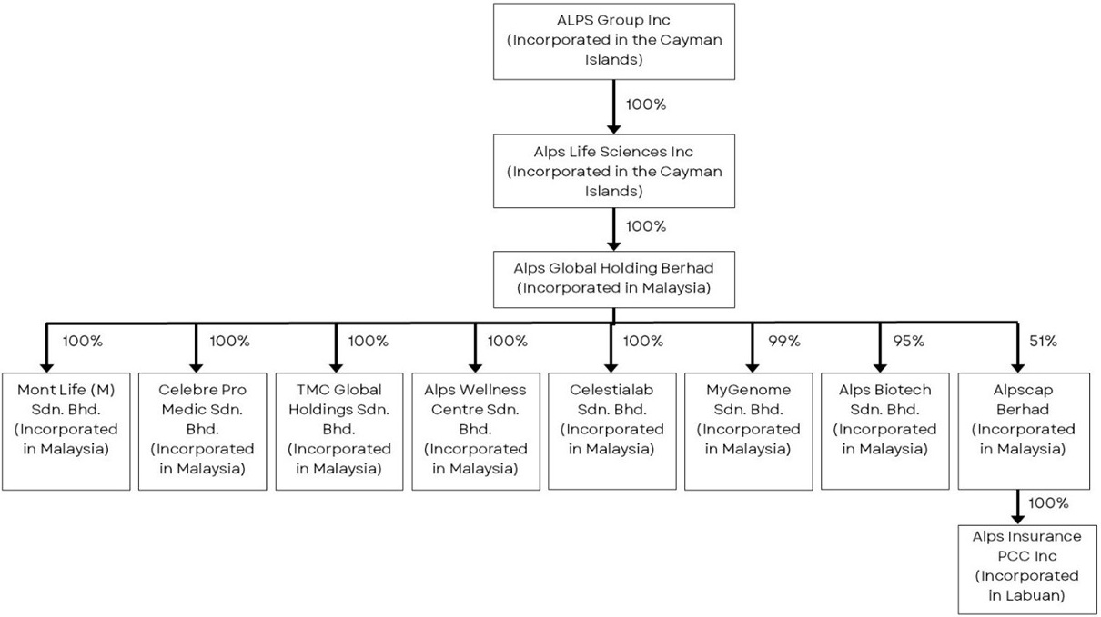
Details of our subsidiaries are summarized below:

Company Name |  | Principal Activities |  | Date of  Incorporation |  | Principal place  of business
Alps Life Sciences Inc |  | Investment holding |  | April 11, 2024 |  | Malaysia
Alps Global Holding Berhad |  | Business of research and development (including stem cell) in all kinds of biotechnology related business, invest and manage business such as health and beauty centre, medical centre as well as acting as an investment holding company |  | April 14, 2017 |  | Malaysia
Mont Life (M) Sdn. Bhd. |  | Skincare, aesthetic, health supplements, food and drinks supplements and household products |  | May 8, 2015 |  | Malaysia
Celebre Pro Medic Sdn. Bhd. |  | Business of beauty, health consultant and therapist |  | October 31, 2011 |  | Malaysia
TMC Global Holdings Sdn. Bhd. |  | Beauty and health care consultants |  | July 4, 2014 |  | Malaysia
Alps Wellness Centre Sdn. Bhd. |  | Business of health screening, beauty aesthetics, and to act as wellness centre |  | August 18, 2017 |  | Malaysia
Celestialab Sdn. Bhd. (“Celestialab”) |  | i) Acquire, hold investment and manage movable and immovable assets, landed properties. ii) Manufacture cellular products such as human stem cells and lymphocytes-products to develop, establish, maintain and aid in the development, establishment and maintenance of laboratories on medical science and biotechnology, research stations, containment facilities and programmes |  | November 27, 2017 |  | Malaysia

41

Company Name |  | Principal Activities |  | Date of  Incorporation |  | Principal place  of business
MyGenome Sdn. Bhd. (“MyGenome”) |  | Manufacture of medicaments, medical laboratories, research and development on biotechnology |  | November 27, 2018 |  | Malaysia
Alps Biotech Sdn. Bhd.(“Alps Biotech”) |  | Leasing of intellectual property and similar products, except copyrighted works, research and development on medical sciences, investment advisory services |  | May 9, 2019 |  | Malaysia
Alpscap Berhad |  | Activities of holding companies, accounting, bookkeeping and auditing activities, tax consultancy |  | April 11, 2018 |  | Malaysia
Alps Insurance PCC Inc. |  | Provision of unconventional healthcare financing solutions |  | December 24, 2020 |  | Malaysia

B. | Business Overview

Glossary

For purposes of this section, unless otherwise stated or unless the context otherwise requires, the following terms shall have the following meanings:

“CAGR” | means compound annual growth rate;
“CAR-T” | means chimeric antigen receptor T-cells;
“DNA” | means deoxyribonucleic acid;
“hiPSCs” | means human-induced pluripotent stem cells;
“KIRs” | means killer cell immunoglobulin-like receptors;
“iPSC” | means induced pluripotent stem cells;
“MHC” | means major histocompatibility complex;
“mRNA” | means messenger ribonucleic acid;
“NK” | means natural killer cells;
“WGS” | means whole genome sequencing; and
“GMP” | means good manufacturing practice.

Mission

Our mission is to foster a fair healthcare ecosystem. Alps has taken steps to cultivate an ecosystem of collaboration among clinicians, stakeholders, and researchers who share our vision. Together, we are dedicated to expanding the range of diagnostic and treatment options available while simultaneously reducing costs, ensuring that cutting-edge medicine is more accessible.

Overview

Our group consists of Alps Group Inc, Alps Life Sciences Inc, Alps Global Holding Berhad and our subsidiaries, namely, Alps Biotech Sdn. Bhd., Alps Wellness Centre Sdn. Bhd., Alpscap Berhad, Celebre Pro Medic Sdn. Bhd., Celestialab Sdn. Bhd., Mont Life (M) Sdn. Bhd., MyGenome Sdn. Bhd., TMC Global Holdings Sdn. Bhd., and Alps Insurance PCC Inc. We are focused on becoming a fully integrated platform for biotechnology research, medical and wellness company. Our principal activities are research and development in various biotechnology-related products and services, with a focus on the use of precision and preventive medicine, and that substantially all of our operations are conducted through Alps and our subsidiaries and affiliate.

42

Because all of our pipeline candidates are in the pre-clinical phase, we do not generate revenue from our research and development efforts. Rather, we provide aesthetic treatments, general healthcare and wellness services to generate revenue which is used to support and sustain our research and development activities. This revenue is crucial for covering ongoing operational expenses, funding clinical studies and developing innovative biotechnology solutions, including new product candidates and advancements in precision medicine. Alps believes that this approach ensures that Alps’ R&D activities are not only innovative but also aligned with practical market needs and trends.

Business Milestones

Alps aspires to establish a fully integrated platform encompassing biotechnology research, medical, and wellness services specializing in predictive, precision and preventive health management. We intend to advance personalized medicine through ongoing innovation.

Alps aims to become a leading healthcare destination, offering its expertise at fair and accessible prices. Our scope of biotechnology platform extends to creating a comprehensive “bench to bedside” ecosystem. This includes both upstream activities, such as sourcing raw materials and production, and to downstream operations that cover distribution, marketing and fill-and-finish processes.

Situated in the heart of Kuala Lumpur’s central business district, the core establishments of Alps include Alps Medical Centre operated by our subsidiary, TMC Global Holdings Sdn. Bhd. while Alps Wellness Centre is operated by Alps Wellness Sdn. Bhd., offering a range of medical, aesthetic, and wellness services. Additionally, MyGenome operates a molecular laboratory and has been granted with a BioNexus status by the Malaysian government through the Malaysian Investment Development Authority (MIDA). The BioNexus status affords MyGenome with incentives and benefits, among others, an income tax exemption of 70% on statutory income for a period of ten (10) years. MyGenome’s molecular laboratory accredited by the Malaysian Standard MS ISO 15189:2022, Medical laboratories – Requirements for quality and competence, and specializes in genetics sequencing including WGS, leveraging expertise in DNA and mRNA analysis. Celestialab, our subsidiary, focuses on the cultivation, research and development of cellular products. Both MyGenome and Celestialab contribute to our precision and preventive ethos aimed at enhancing individual health and well-being.

Furthermore, we collaborate with universities for research and development to develop product pipelines that align with our company’s mission. Alps’ initiatives of creating a bench-to-bed platform with the competitive advantage and positioning set in place, allows the adoption of high technology pipelines at a low or conservative burn rate.

Our Research and Development

Leveraging on our network comprising professional providers, suppliers, and supporting services, Alps aims to provide its clientele with access to DNA and mRNA sequencing, cellular therapy, as well as wellness and anti-aging products and services.

Alps possesses in-house laboratories capable of performing a range of genomic and cellular research, including WGS, Whole Exome Sequencing (WES), targeted sequencing, mRNA tests. Alps also operates a cGMP accredited cell manufacturing laboratory. WGS, known as the most comprehensive clinical-grade DNA test available, provides invaluable insights into an individual’s inherited genetic predispositions. By unraveling the entire genetic makeup, this sequencing offers a wealth of information that can shape personalized medicine and enhance treatment efficacy.

In the realm of diagnostics and therapeutics, mRNA gene expression profiling is rapidly becoming a game-changer by acting as molecular biomarkers. These biomarkers are crucial for the early, accurate prediction and diagnosis of diseases, heralding a more proactive stance in healthcare management. mRNA tests provide a window into gene expression changes as they occur, facilitating prompt medical interventions to preempt disease progression.

43

Alps is committed to integrate WGS and mRNA expression profiling into routine diagnostic practices and to forge new paths in personalized medicine. Looking ahead, we aim to further enhance our service offerings by integrating the production and cultivation of autologous stem cells directly within our facilities. Additionally, we intend to establish an international research and development hub, collaborating with renowned scientists and institutions to advance cellular therapy as therapeutic entities.

Our Pipeline

We are advancing a broad portfolio of pre-clinical product candidates derived from the following drug classes focused on the treatment of cancer, infectious and non-communicable diseases:

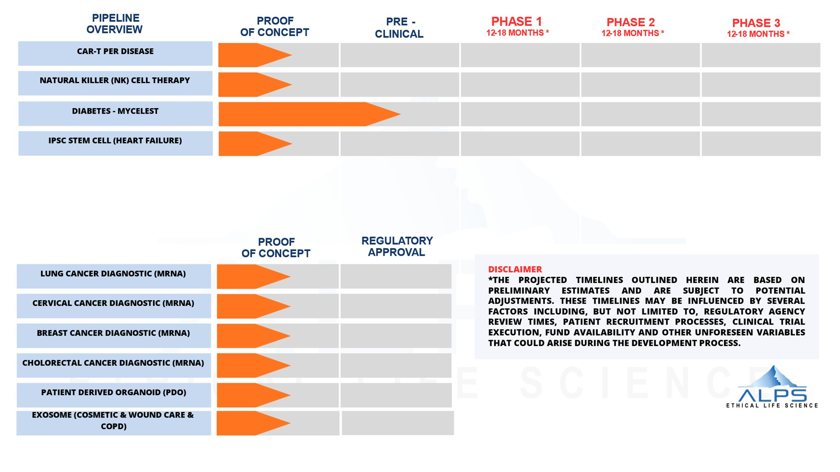
Figure 2. Overview of product candidates’ pipeline.

* The timelines presented in Figure 1 for Phase 1, Phase 2, and Phase 3 clinical trials are derived from industry standards and typical study durations for comparable trials. These estimates are based on standard timelines but may vary due to factors such as patient recruitment rates, trial design complexities, and regulatory requirements. Alps relies on historical data and industry benchmarks to project these durations. It is important to note that these timelines are preliminary and may be subject to adjustments. Various factors, including regulatory review periods, patient recruitment challenges, trial execution, and unforeseen variables during the development process, could potentially influence these timelines.

** The bottom half of the pipeline table, specifically, the mRNA diagnostics for lung cancer, cervical cancer, breast cancer and colorectal cancer, as well as exosome applications for cosmetic and wound care, represent product candidates that are designed to be used as diagnostic tools and cosmetic treatments rather than therapeutic interventions. As such, they follow a different regulatory pathway. In Malaysia, regulatory approval for these types of products may not necessitate the same extensive pre-clinical or clinical testing required for new therapeutic drugs. Instead, these products must meet specific regulatory standards and provide sufficient statistical evidence of safety and efficacy through documentation and studies appropriate for regulatory approval.

44

Updates to Our Pipeline Candidates

Following a review of our pipeline, we have discontinued further development of two product candidates previously included in our portfolio: (i) our COVID-19 mRNA vaccine program, developed through our subsidiary, MyGenome; and (ii) our cholera vaccine program, developed in collaboration with Universiti Sains Malaysia (“USM”) through Vax Biotech Sdn. Bhd. (“VaxBio”). This decision allows us to concentrate our research and development resources on our core pipeline.We do not expect the discontinuation of the abovementioned pipelines to have a material effect on our business, financial condition or results of operations.

Further we have added a new product candidate to our pipeline. MyGenome intends to establish a Patient Derived Organoids (“PDO”) laboratory and to conduct research and development activities relating to clinical-grade PDO lines and proprietary culture media, with an initial focus on colorectal and breast cancer indications. Our PDO program is currently at the preclinical research and development stage.

Details of our current pipeline development stages and next anticipated milestones are summarized below:

No. |  | Pipeline |  | Current Phase |  | Next Anticipated Milestones
1. |  | Natural Killer  (“NK”) Cell Therapy–MyImmune |  | The POC for NK cell therapy comprises of discovery, optimization, and process validation phase. Celestialab has completed the optimization phase, which aimed at culturing NK cells to achieve high-yield and high-purity. Currently, Celestialab is in the process validation phase, which is a critical stage of the manufacturing verification process to verify the consistency, quality and reproducibility of the manufacturing process across production batches. |  | Upon completion of the process validation phase, Celestialab intends to expand its manufacturing capabilities by preparing all necessary documentation and processes to transition the NK cell profile into a strict PIC/S GMP-compliant framework. Following this transition, Celestialab will initiate pre-clinical studies to evaluate the efficacy, safety, toxicology and dosage profile of the NK cell therapy in support of future clinical development.
2. |  | Chimeric Antigen Receptor (“CAR”)-T Cell |  | Celestialab has concluded the discovery phase of its POC, identifying (i) CD19, (ii) CD20, or (iii) dual targeting of CD19 and CD22, as key targets for B-cell acute lymphoblastic leukemia and B-cell lymphoma. Celestialab is now preparing to start the optimization phase, which will include creating plasmid DNA (“pDNA”) templates. |  | Upon completing the optimization phase, Celestialab will initiate the validation phase for the pDNA templates targeting CD19 and/or CD20.
3. |  | Diabetes – MYCELEST |  | Celestialab is completing the preclinical studies phase for MYCELEST and is currently preparing the preclinical data for submission of the clinical trial application to the NPRA. |  | Once Celestialab obtains the necessary approvals from NPRA, Celestialab will initiate clinical trials on patients with diagnosed type 1 and type 2 diabetes mellitus.

45

No. |  | Pipeline |  | Current Phase |  | Next Anticipated Milestones
4. |  | Heart Failure – iPSC |  | This pipeline has implemented and proved the construct/design of the product candidate, which involved the differentiation of human induced pluripotent stem cells (iPSCs) into cardiomyocytes using cord blood, which was a step in validating the approach. Additionally, this pipeline completed the study to test the therapeutic potential of these iPSC-derived cardiomyocytes by applying them to treat cryoinjured rat hearts (manuscript under preparation)., The current focus involves generating human iPSC cells from adult peripheral blood and manufacturing clinical-grade iPSCs under GMP conditions. |  | Upon completion of generating human iPSC cells, the next step will involve conducting pre-clinical trials. This phase includes preparing the trial design, and conducting studies to assess efficacy, toxicology, dosage, and safety.
5. |  | mRNA (Diagnostic) |  | This pipeline is currently undergoing the POC stage, focusing on recruiting patients for breast, lung, cervical, and colorectal cancers and collecting data to develop diagnostic kits for these cancers. |  | Upon completing the data gathering phase, MyGenome will commence the development of diagnostic prototypes for the identification of differentially expressed genes.
6. |  | CELESOME(+) |  | Alps has completed its POC phase, which involved evaluating and refining exosome isolation methods and characterization. Alps is now finalizing an in-house protocol for further exosome characterization. |  | After characterizing the exosomes, Alps plans to conduct toxicity studies, including cytotoxicity tests and acute toxicity studies in animal models.
7. |  | PATIENT-DERIVED ORGANOIDS (“PDO”) |  | Our PDO program is currently at the preclinical research and development stage. We are establishing a PDO laboratory and conducting research and development activities relating to clinical-grade PDO lines and proprietary culture media, with an initial focus on colorectal and breast cancer indications. |  | The next milestones for our PDO program include completing the laboratory setup, submitting the Medical Research Ethics Committee application, establishing colorectal and breast PDO lines with drug-sensitivity validation, and, subject to obtaining the necessary regulatory approvals, submitting applications to the MREC and Medical Device Authority for PDO-based clinical testing.

46

MyImmune - NK Cell Therapy

Development Status of NK Cells Therapy

Celestialab is currently conducting research and development activities for MyImmune with the objective of optimizing its efficacy and safety before progressing to preclinical studies. The POC for its NK cell therapy comprises three stages: discovery, optimization and process validation. Celestialab has completed the optimization phase, which focused on establishing a high-yield, highly active NK cell culture process, and is currently preparing to commence the process validation phase. This phase is a critical component of the manufacturing verification process, intended to demonstrate the consistency, quality, purity and reproducibility of the manufacturing process across multiple production batches. Concurrently, Celestialab is preparing the necessary documentation and manufacturing processes to transition its NK cell manufacturing platform into compliance with the Pharmaceutical Inspection Co-operation Scheme Good Manufacturing Practice (“PIC/S GMP”) standards.

Upon successful completion of the process validation phase, Celestialab expects to commence preclinical studies in early 2027. These studies are expected to include the development of study protocols and comprehensive evaluations of efficacy, toxicology, dosage and safety to support future regulatory submissions. Subject to satisfactory preclinical results and the receipt of all required regulatory approvals, Celestialab intends to submit a Clinical Trial Application (“CTA”) and subsequently initiate Phase I clinical trials to evaluate the safety, tolerability and appropriate dosage of MyImmune in human subjects.

Overview

Natural killer (NK) cells, a vital component of the lymphocyte group, play a pivotal role in the innate immune system. These cells are instrumental in inducing apoptosis in infected or abnormal cells without the need for prior sensitization to specific antigens. NK cells, integral to the human innate immune response, possess the unique ability to selectively identify and eliminate cancerous or diseased cells. This capability is distinguished from that of the adaptive immune response system’s cells, such as T cells, which necessitate prior sensitization or co-stimulation to activate. The autonomous activation of NK cells, without the requirement for prior exposure to their targets, earns them the designation of “natural” killers. This intrinsic property enables NK cells to rapidly initiate an immune response within the human body, contrasting with the adaptive response where T cells may require a week or more to proliferate to significant numbers capable of mounting an effective defense against new antigens.

Key Challenges to Existing Treatment

Diseases are characterized by complex biological interactions, which diminish the effectiveness of existing therapeutics that are restricted to single mechanisms of action and are incapable of adapting to the dynamic nature of disease progression. We have identified the following key challenges:

 | ● | The immune systems of cancer patients are often weakened, impairing the body’s natural defenses and diminishing the effectiveness of treatments. For example, chemotherapy can suppress the immune response, rendering the patient more susceptible to opportunistic infections.
 | ● | The current application of chemical therapies, like chemotherapy and radiotherapy agents, often results in significant harm to the patient’s body. These treatments lack specificity, affecting not only diseased or cancerous cells but also healthy cells throughout the body. As a result, patients frequently experience severe side effects including persistent body pain, hair loss, and weight loss.

47

 | ● | The pharmacodynamics of each patient renders it impractical for one form of generalized drug or treatment to be effective in treating diseases. For example, adverse drug reactions occur when some patients develop allergic reactions to the same drug in which others have not showed any side effects (e.g. sulperazone that can induce skin and eye inflammations among some patients).

Our Strategy and Solution - MyImmune

We aim to develop autologous NK cell therapy – MyImmune to overcome the limitations identified in previous approaches by concentrating on the optimization of parameters that we believe are critical for MyImmune to drive clinical and commercial success. These optimization parameters include, but are not limited to:

 | ● | a high purity and viability rate of NK cells to maximize therapeutic efficacy;
 | ● | ensuring the production process is scalable and cost-effective for widespread clinical use; and
 | ● | the ability to generate NK cells using cGMP processes at a commercial scale.

Immunotherapy is regarded as the current, state-of-the-art weapon in combating cancers, both solid (e.g. breast cancer, colon cancer and ovarian cancer) and liquid tumors (e.g. leukemia). In this approach, autologous mode of treatment which uses/isolates the patients’ own immune cells, augmenting/expanding them in-vitro and re-infusing them back to the patients, represent the safest manner of immunotherapy. Although there exist many different human immune cells that are utilized for autologous immunotherapy, NK cells are widely sought-after as these immune cells are known to be capable of targeting diseased cells (i.e. cancer, viral-infected, unhealthy, damaged cells) without a directed immune sensitization or immunological priming, such as through the MHC-antigen presentation route. There are several established methods for the in vitro culture and expansion of NK cells, including, but not limited to, the use of multiple combinations of cytokines, prior NK cell isolation through magnetic beads, antibodies which stimulate the cell expansions or using specific-growth medias which may exponentially increase end-user’s therapy cost. Hence, the need for a cost-effective, easy-to-handle and cGMP-compliant methodology that can yield higher folds of NK cell production and concurrently with high purity of NK cells per batch.

2 Business Wire. (July 4, 2022). Global Natural Killer Cells Therapeutics Market 2022 to 2027 - Industry Trends, Share, Size, Growth, Opportunity and Forecasts. Retrieved from Business Wire.

We are developing MyImmune for the potential treatment of oncological diseases based on activated NK cells. Within our MyImmune therapy protocol, blood samples will be obtained from the patient, from which NK cells will be isolated and purified. These NK cells will undergo a multiplication process through culturing and stimulation for a duration of three (3) weeks in the presence of NK cell-specific culture cocktail. Subsequently, the expanded NK cells will be reinfused back into the patients.

48

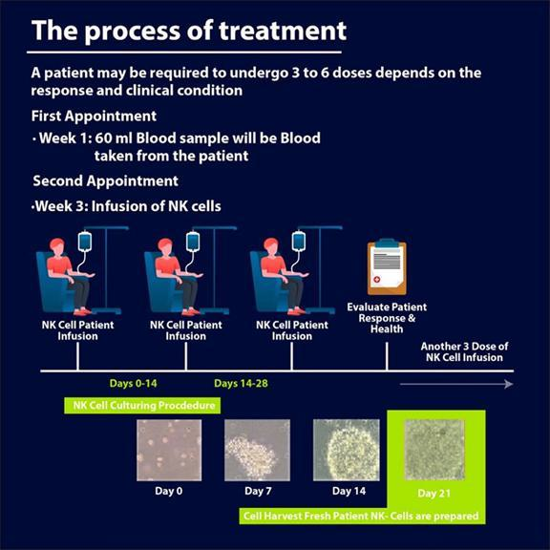

Figure 3. Overview of the autologous process of isolating, culturing, and treating patients with NK cells therapy.

Healthy cells present peptides derived from their internal proteins on their surface via MHC class I molecules. Upon encountering these molecules, NK cells utilize inhibitory receptors, including KIRs and CD94/NKG2A, to recognize and engage with them. This binding transmits inhibitory signals to the NK cell, thereby preventing it from destroying the healthy cell.

49

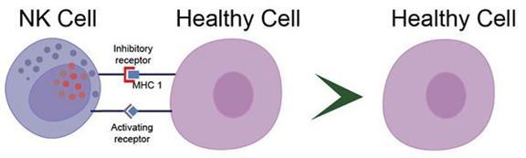

Figure 4. Mechanism of NK cells discrimination against healthy cells.

Cancer cells frequently exhibit a deficiency in MHC class I molecules on their surface. This reduced expression of MHC class I serves as a trigger for the activation of NK cells, which then proceed to target and eliminate the cancerous cells.

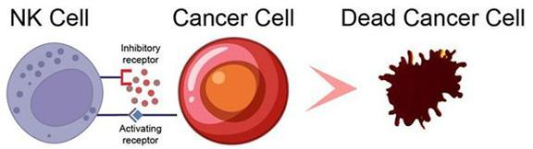

Figure 5. NK cell-induced apoptosis of a cancer cell.

The innovation described herein provides a streamlined and cost-effective method for the production of NK cells with high purity and yield. This manufacturing process generates cultured NK cells characterized by the expression of CD56+ markers and the absence of CD3, confirming the purity of the cell populations. The established methodology yielding NK cells that maintain stable cytotoxicity against cancer cells. Celestialab is currently preparing to commence the process validation phase of this manufacturing method. This phase is a critical component of the manufacturing verification process and is intended to demonstrate the consistency, quality, purity and reproducibility of the manufacturing process across multiple production batches. In addition, aseptic manufacturing procedures are implemented throughout the production process, with sterility testing performed to confirm the absence of microbial contamination and other contaminants.

50

Proof-of-concept study of NK Cells Culture

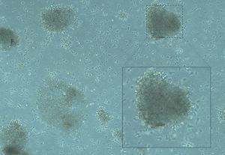

Figure 6. Show an image of NK cells cluster formations cultured at magnification of 40X taken on the day of harvest, which conducted by Celestialab.

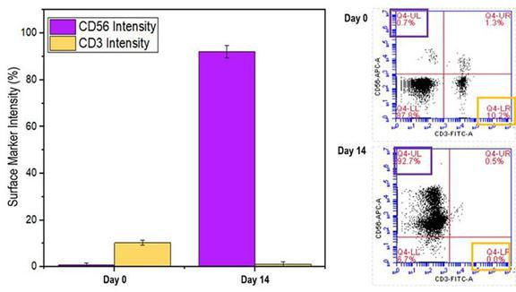

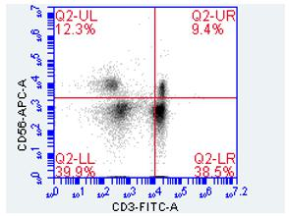

Pure PBMC (before NK cell culture)

51

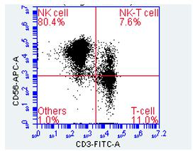

High percentage of NK cells during product release

Figure 7. Shows the intensity of surface markers that indicate the presence of high-percentage of NK cells during product release.

The culture of NK cell at the end of batch production can be confirmed through both morphological and cell biology indications. From Figure 6, we can see that cellular clumping’s can be identified when viewed under the microscope. This translates to the presence of NK cells which have the natural ability to form clumping formations. From Figure 7, we have analyzed the surface maker CD56 which is used to identify the existence of NK cell populations while CD3 markers are used as negative indicators that corroborate to the existence of T-cells or non-relevant cells. The results indicate a high percentage of the CD56 marker.

Competitive Analysis Industry Leaders

Incyte Corporation and Fate Therapeutics are notable industry leaders in pharmaceutical and cellular immunotherapy, respectively. While these companies focus on oncology and immune disorders, Alps aims to carve its niche in autologous NK cell therapy, offering a unique approach to disease treatment.

CAR-T Cell

Our subsidiary, Celestialab operates a manufacturing facility in accordance with cGMP standards and intends to equip such facility with the capability to manufacture CAR-T cells at a large scale. Our immediate focus is on advancing our CAR-T pipeline through clinical development stages. Celestialab has concluded the discovery phase of its POC, identifying CD19, CD20, and dual targeting of CD19 and CD22 as key targets for B-cell acute lymphoblastic leukemia and B-cell lymphoma. Celestialab is now preparing to start the optimization phase, which will include creating pDNA templates. Upon completing the optimization phase, Celestialab will initiate the validation phase for the pDNA templates targeting CD19 and CD20. Based on the foregoing developments, , we intend to conduct preclinical trials targeting CD19, CD20 and dual targeting of CD19 and CD22in chronic B cell leukemias.

Celestialab currently manufactures and produces umbilical cord-derived mesenchymal stem cells, NK cells, exosomes and induced pluripotent stem cells. Building on this experience, Celestialab also intends to develop and produce CAR-T cells using lentiviral vectors to introduce the genes encoding the CAR into the patient’s T cells, enabling them to recognize and target specific cancer cells. Although capable of producing CAR-T cells, Celestialab does not yet produce CAR-T cells at a large scale. Celestialab plans to commence full scale CAR-T cells production within 12 to 18 months following the Closing, eventually incorporating fully automated closed-system production technology. The planned timing to commence full-scale CAR-T cell production within 12 to 18 months following the Closing is underpinned by its existing infrastructure and expertise in manufacturing a variety of cell products. Celestialab’s experience in operating a CPC with cGMP facilities, which includes the necessary clean rooms, laboratory equipment, and controlled environment facilities, demonstrates its capability to adapt these resources for CAR-T cell production. Our strategy also involves developing CAR vectors specifically targeting CD and creating bispecific target CAR-T therapies, aiming to establish valuable in-house intellectual property. Additionally, we plan to design a viral-free delivery system for CAR-T cells using electroporation technology. This approach is intended to enhance the safety and efficacy of CAR-T cell therapies while potentially offering a unique solution in the field.

52

Our Strategy

Our objective is to commercialize CAR-T and related cell therapies for treating hematologic malignancies and solid tumors. Our strategy to achieve this goal is as follows: -

 | ● | Advance our CAR-T pipeline into clinical development. Our immediate focus is on advancing our CAR-T pipeline through clinical development stages. Our CAR-T product candidate is currently undergoing POC validation and, subject to NPRA regulatory process for review of applications, we intend to conduct clinical trials targeting CD19 and CD20 within 12 months from the Closing, thereby progressing towards regulatory approval and eventual market entry.
 | ● | Expand our manufacturing capabilities: We currently have a manufacturing facility in Malaysia supplying clinical materials for our upcoming clinical trials. As we prepare for the potential commercialization of our products, we plan to further expand the commercial-scale manufacturing capacities by incorporating fully automated closed-system production technologies at our facility. This expansion is expected to enable rapid scale-up capabilities and ensure a steady supply of our products at a commercial scale, facilitating a smoother transition from clinical trials to market availability.

Key Challenges

The principal challenges stemming from conventional treatments are delineated as follows:

 | ● | Relapse and Refractory Cases in Acute Lymphoblastic Leukemia and B Cell Lymphoma Patients. Addressing the recurrence and resistance observed in patients with acute lymphoblastic leukemia and B Cell Lymphoma poses a significant hurdle. Finding effective therapeutic approaches to combat relapse and refractory cases remains paramount in improving patient outcomes.
 | ● | Limited Responsiveness to Standard Treatments in Acute Lymphoblastic Leukemia Patients. Many patients afflicted with acute lymphoblastic leukemia exhibit a lack of response to conventional or readily available treatments. Overcoming this challenge requires the development of innovative therapies capable of eliciting favorable responses in otherwise unresponsive patients.
 | ● | Organ Shortage for Transplantation. The scarcity of organ donors presents a persistent obstacle in the realm of transplantation. The difficulty in sourcing organs for transplantation necessitates alternative strategies or technologies to alleviate the burden on patients awaiting organ transplants.

Our Position in CAR-T Therapy

The biotechnology and pharmaceutical industries are increasingly engaged in T cell engineered therapies and sponsoring clinical trials. The production of CAR-T cells involves the utilization of lentiviruses in a process known as genetic engineering. Lentiviral vectors are commonly employed to introduce protein-encoding cDNAs. In the realm of gene therapy, lentiviral vectors have proven successful in modifying hematopoietic stem cells, leading to restored immune function or the correction of defects in hemoglobin, among other applications. The efficacy of CAR-T cells in treating B cell leukemias and lymphomas has been particularly noteworthy, with this approach heavily relying on lentivirus-mediated gene transfer.

The cell therapy industry in Malaysia is in its early stages, with only hospitals and biopharmaceutical companies currently involved in cellular immunotherapy for cancer treatment. We are inspired by the proven clinical efficacy of existing CAR-T cells in addressing hematological malignancies. In our pursuit, we are actively sourcing lentiviral vectors with potential partners and aiming to manufacture and produce CAR-T cells that are cost-effective and widely accessible. In line with this vision, we are strategically constructing our own pipeline to focus on revolutionizing medicine by re-engaging the body’s immune system to treat cancer through CAR-T therapy that will recognize and kill cancer cells.

We aim to develop a solution utilizing autologous CAR-T therapy to combat B cell leukemias. Our approach harnesses the power of existing CAR technology to stimulate a patient’s own T cells to target cancer cells, empowering them to target and destroy cancer cells with precision and efficacy. Autologous CAR-T therapy represents a personalized treatment strategy tailored to each patient’s unique biological makeup. By utilizing the patient’s own immune cells, we minimize the risk of rejection and maximize the potential for a targeted immune response against cancer.

53

As depicted below, our process initiates with the collection of the patient’s white blood cells, followed by the selection and activation of specific T cells. We will then genetically modify these cells to express CARs tailored to tumor-associated antigens. The gene sequences for the CAR construct are integrated into the T cell DNA via a lentiviral vector. These engineered CAR-T cells are subsequently expanded and reintroduced into the patient, where they target and destroy cancer cells while preserving healthy tissues.

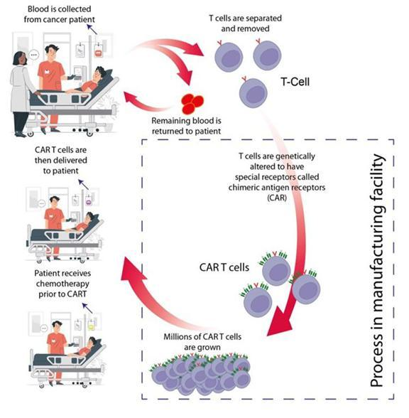

Figure 8. Diagrammatic representation of the CAR-T Cell Therapy Workflow.

Our solution not only leverages the proven effectiveness of CAR technology but also addresses key challenges associated with traditional cancer treatments, such as systemic toxicity and tumor heterogeneity. By precisely targeting cancer cells while minimizing damage to healthy tissues, autologous CAR-T therapy offers an avenue for improving patient outcomes and advancing the field of oncology.

54

To advance our product pipeline, we aim to develop three (3) CAR-T therapies targeting B-cell acute lymphoblastic leukemia (B-ALL) and B-cell lymphoma. Our CAR-T therapy clinical trial designs will target: (1) CD19, (2) CD20, and (3) dual targeting of CD19 and CD22, which Celestialab is in the POC stage. CAR-T therapy has demonstrated significant efficacy in targeting specific antigens on the surface of cancer cells, particularly in haematological malignancies5. CAR-T therapy targeting CD19 involves engineering T-cells to express receptors that specifically bind to the CD19 antigen, which is prevalent on the surface of B-cells. This approach has replicated in Malaysia6 and has shown high effectiveness in treating conditions such as ALL7 leading to substantial remission rates and prolonged responses in many patients.

Similarly, CAR-T therapy targeting CD20 operates on a comparable mechanism but focuses on the CD20 antigen. This therapy is beneficial for patients with CD19-B-cell malignancies or those who relapse after CD19 CAR-T therapy. Clinical trials conducted have shown positive results for CD20-targeted CAR-T therapy, providing alternative or complementary treatment option to CD19-targeted approaches.

To address CD19 antigen loss in haematological malignancies, we also aim to explore dual targeting of CD19 and CD22. Dual CAR-T therapies have shown promising efficacy in relapsed or refractory B-ALL, both alone and in combination with CD19 CAR-T cell therapies. Celestialab has initiated the POC stage for an autologous dual CAR T-cell targeting both CD19 and CD22 antigens, to overcome current mechanisms of resistance to CAR T-cell therapy in B-ALL, while providing a potential alternative to CD19 directed therapy.

Celestialab operates a Cell Processing Centre (CPC) with cGMP facility, and is our intention for this CPC to be well positioned to excel in the production of CAR-T cells.

Our Strength

 | ● | cGMP-compliant Facility: Celestialab is the only facility within Alps that operates with cGMP certification. Celestialab adheres to strict cGMP guidelines to ensure the quality and safety. Equipped with industry-standard equipment and technology, Celestialab has the capability to produce CAR-T cell products efficiently and in compliance with regulatory requirements.
 | ● | Expert Scientific Support: Celestialab has assembled a team of experienced scientists and technicians that can provide expert scientific support throughout the manufacturing process. This pipeline is led by Dr Heilly Chong @ Azlinda Abd Halik, Ph.D. in Biochemistry/Biotechnology from University of Malaya, our Deputy Chief Scientific Officer. Dr Heilly has over 15 years of biotechnology research experience, including but not limited to, biologics (monoclonal antibody) drug development, antibody/protein engineering, assay/diagnostic development, molecular biology (high expression systems in mammalian cells), cell culture technology, cell characterization and banking, bioprocessing/biomanufacturing (upstream and downstream processes), and current good tissue practices manufacturing (CAR-T).
 | ● | Cost Effectiveness: Celestialab intends to position itself to offer CAR-T cells at a significantly lower cost in Malaysia compared to other countries. This cost advantage is a result of several factors, including efficient manufacturing processes, optimized supply chain management, and favorable regulatory environments. By providing affordable CAR-T cell production, Celestialab aims to improve accessibility and affordability for patients in Malaysia, ensuring that innovative therapies are accessible to those who need them most.

55

MYCELEST

Mesenchymal Stem Cells (“MSCs”) are an important area of research within the regenerative medicine sector. Human umbilical cord-derived Wharton’s Jelly MSCs (“WJ-MSCs”) have demonstrated potential advantages compared with certain adult tissue-derived MSC sources, including higher proliferative capacity, reduced donor age-related effects and immunomodulatory properties. Alps Group is developing WJ-MSC-based technologies with the aim of leveraging these biological characteristics to develop potential therapeutic applications for chronic and degenerative diseases.

Manufacturing Foundation and PIC/S GMP Accreditation

To support the development and potential commercialization of its cell therapy products, Alps operates through its manufacturing subsidiary, Celestialab, which has established a manufacturing facility designed to comply with Pharmaceutical Inspection Co-operation Scheme Good Manufacturing Practice (“PIC/S GMP”) standards. The PIC/S GMP framework provides internationally recognized guidelines for pharmaceutical manufacturing quality systems.

Celestialab’s manufacturing capabilities include established cleanroom facilities, standard operating procedures and quality management systems intended to support the consistent production of cell therapy products in accordance with applicable quality and regulatory requirements.

Clinical Indications and Regulatory Pathway

Alps Group is developing MYCELEST, an allogeneic, off-the-shelf WJ-MSC-based cell therapy candidate, with an initial focus on Type 2 Diabetes Mellitus (“T2DM”). MYCELEST is being developed with the aim of addressing biological mechanisms associated with chronic inflammation and pancreatic β-cell dysfunction.

Celestialab is currently compiling preclinical data, including in vitro and in vivo safety, toxicology and exploratory efficacy assessments, to support a future Clinical Trial Application (CTA) submission to the NPRA of Malaysia. Subject to the completion of preclinical studies and receipt of the necessary regulatory approvals, Celestialab intends to initiate clinical trials to evaluate the safety, tolerability, efficacy and appropriate dosing of MYCELEST in human subjects.

iPSC (Heart Failure)

We have entered into two (2) research collaboration agreements with USM for the research and development of this iPSC product candidate. On December 16, 2019, Alps Biotech, one of our subsidiaries, entered into a research collaboration agreement with USM (as supplemented on March 15, 2023) to jointly undertake a research project titled “Establishing Heart Failure Model in Rats for Preclinical Assessment of Cardiovascular Regenerative Therapy” (“RCA for Preclinical Assessment of Cardiovascular Regenerative Therapy”). This project focuses on the development of an iPSC model for cardiac valve and cardiac muscle regeneration to address cardiovascular diseases. It is agreed that all rights, titles and interest of intellectual property created or developed as a result of this project shall be jointly owned by USM and Alps Biotech.

On February 10, 2020, Alps Global Holding Berhad entered into another research collaboration agreement with USM to jointly undertake a research titled “Cell Therapy for Heart Disease”. This project focuses on the development of pre-epicardial cells through the establishment of the USM-Alps Joint Laboratory for Cardiac Research. It is agreed that all rights, titles and interest of intellectual property created or developed as a result of this project shall be jointly owned by USM and Alps.

Both agreements have since expired in accordance with their terms. Alps has elected not to renew either agreement. No intellectual property was created or developed by either party in the course of the collaboration, and accordingly no rights, obligations, licences or IP ownership arrangements survive the expiry of either agreement.

56

Following the expiry of the agreements, this equipment has been relocated to Celestialab. USM will not have any continuing role in the research and development of this iPSC pipeline. Alps, through Celestialab, intends to continue development of the pipeline independently, and is in the process of hiring in-house research personnel for this purpose.

The development effort of Alps Biotech and USM up to the point of expiry involved generating human iPSC cells from adult peripheral blood and manufacturing clinical-grade iPSCs under GMP conditions. As of the date of this report, there have been no further developments beyond these results, and the pipeline remains at this stage pending the in-house transition described above.

Overview of Heart Disease

According to the WHO, non-communicable diseases (NCDs), including cardiovascular diseases (CVDs), are leading causes of mortality in the Western Pacific region, significantly impacting countries throughout Asia Pacific and Southeast Asia. Rapid urbanization, lifestyle changes, and aging populations contribute to the increasing burden of heart disease. Over 250 known genetically defined disorders primarily affect the heart, contributing to morbidity and mortality, yet few approved products target these genetic causes. Recent analyses have shown that after decades of declining mortality rates from heart failure, these rates are once again rising, underscoring the need for improved treatments.

The heart’s complexity, due to its biological structure and the tightly regulated coordination of its electrophysiological and biomechanical properties, complicates the treatment of heart disease. Heart disease manifests in various forms, affects individuals of many ages, and results from numerous factors. As illustrated in the Figure 17 below, heart disease can be categorized as either resulting directly from issues associated with the heart organ, such as heart failure, arrhythmia, and heart valve disease, or indirectly from vascular problems, such as coronary artery disease (CAD). The underlying causes can be genetic, due to aging, or environmental factors. The table below outlines four broad categories of heart disease:

CATEGORIES |  | DESCRIPTION
  Heart Failure |  | Heart failure is a condition where the heart cannot pump enough blood and oxygen to meet the body’s needs. It can result from conditions that weaken the heart muscle, including heart attacks, uncontrolled high blood pressure, congenital heart defects, and genetic cardiomyopathies.
  Arrhythmia |  | Arrhythmia is a common heart condition, involves any deviation from the heart’s normal electrical impulses, affecting its pumping function. Arrhythmias can lead to a range of symptoms, sudden death, and stroke.

57

  Heart Valve Disease |  | Heart value disease occurs when one or more of the heart’s four valves malfunction, disrupting blood flow through the heart’s chambers.
  Coronary Artery  Disease (CAD) |  | CAD is a prevalent form of heart disease, arises when plaque accumulates in the coronary arteries’ walls, restricting blood flow to the heart muscle and potentially leading to a heart attack.

Figure 17. Heart disease can be categorized as either resulting directly from issues associated with the heart organ, such as heart failure, arrhythmia, and heart valve disease, or indirectly from vascular problems, such as coronary artery disease (CAD).

While there is a significant unmet need in the field of heart disease, challenges have historically hindered the development of novel therapies. The IPSC Collaborators aim to focus on heart failure, particularly myocardial infarction, as the most common cause of heart failure. If the dead, ischemic heart tissues could be regenerated with viable and functional cardiomyocytes, the disease could potentially be treated.

Advancements and Challenges in Cardiac Repair Post-Myocardial Infarction

Myocardial infarction (MI), a common cause of heart failure (HF), results from the partial or complete occlusion of the coronary artery, reducing oxygen and nutrient delivery to the myocardium. Approximately 25% of patients with myocardial infarction experience severe left ventricular dysfunction, risking progressive heart remodeling. The first non-invasive treatment option typically includes pharmacological approaches with drugs such as thrombolytic agents, β-blockers, and angiotensin-converting enzyme inhibitors. In more severe cases, such as ST-elevated myocardial infarction (STEMI), invasive procedures like balloon angioplasty and stent insertion may be recommended for myocardial reperfusion. Coronary artery bypass grafting, a highly invasive procedure, is advised for severe, irreversible coronary occlusion. These methods alleviate symptoms and enhance life quality, but none can remove fibrotic scars or replace lost myocardium with new cardiomyocytes. The presence of akinetic tissue limits cardiac performance, compelling the remaining myocytes to increase contractility to maintain adequate cardiac output. This trigger sudden changes in cardiac architecture, leading to cardiomyocyte hypertrophy, further myocyte loss, ventricular wall thinning, weakened contractility, and eventually, the cessation of cardiomyocyte function. To date, heart transplantation remains the only curative option. Despite successful heart transplants, the long waiting times, high patient-to-donor ratio, high incidence of post-procedural complications, and limited availability of transplantable hearts underscore the urgent need for alternative solutions.

Bone marrow-derived stem cells are the most common first-generation cell candidates used in clinical transplantation (Refer Figure 18 below). A weighted regression and meta-analysis of 49 trial reports using autologous bone marrow stem cells revealed discrepancies among these trials, with none showing benefits from bone marrow mononuclear cells (BMNCs). However, it is widely accepted that the therapeutic benefits of bone marrow-derived cells mainly result from a paracrine mechanism that activates endogenous healing. Reconstituting injured myocardium with cardiomyocytes may require second-generation cardiogenic cells, such as more defined, homogeneous cardiac-derived stem/progenitor cells or pluripotent stem cells, some of which have been used in clinical trials. Careful selection of cell candidates, delivery methods, cell engraftment enhancement strategies, thorough investigation of efficacy mechanisms, and clinically meaningful endpoints in experimental studies can advance cardiac cell therapy. To date, consensus is reached that pluripotent stem cells are by far the most promising cell source for deriving functional cardiomyocytes for testing and therapy.

58

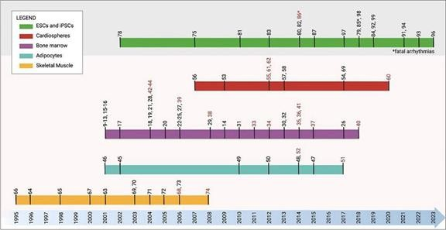

Figure 16. Timeline schematic portraying cell-based regenerative studies using both adult stem cells (skeletal muscle, adipocytes, bone marrow, and cardiosphere-derived cells) and ESCs/iPSCs.

[Pezhouman, Arash, et al. “Cardiac regeneration–Past advancements, current challenges, and future directions.” Journal of Molecular and Cellular Cardiology (2023)]

Potential Solution in Revolutionizing Cardiac Regeneration with Pluripotent Stem Cell Technologies

Stem cells offer hope for remuscularizing weakened, injured myocardium and reversing cardiac remodeling. Compelling evidence indicates that pluripotent stem cells (hPSCs), such as embryonic stem cells (ESCs) or human-induced pluripotent stem cells (hiPSCs), provide an indefinite source of CMs and are the only cells scalable to produce a clinically relevant number for myocardium remuscularization. Studies have demonstrated that intramyocardially injected hPSC-cardiomyocytes engraft, integrate synchronously with the host myocardium, regenerate remodeled, thin myocardium, and improve cardiac function.

While the clinical benefits of other adult stem cells, such as mesenchymal stromal cells or cardiac-derived progenitor cells, in cardiac regeneration are recognized, remuscularization in injured hearts using hPSC-cardiomyocytes has been more encouraging. Directed CMs differentiation of hiPSCs, employing systematic biochemical treatments, can generate spontaneously contracting cardiomyocytes with high efficiency in vitro. The application of hiPSC-derived CMs could have broad therapeutic applications in cardiac cellular therapy, myocardial tissue engineering, disease modeling, and drug screening for heart failure treatment. If hiPSC-derived epicardial cells can retain effects observed in the developing heart in vivo, they could theoretically enhance myocardial complexity and maturity in vitro.

Successful remuscularization requires the regeneration of dead myocardial tissue to restore muscle density and contractile strength. Various methods have been introduced to administer cells into the heart, aiming to maximize cell homing, retention, engraftment, survival, and function.

59

Generation of CM from autologous human induced pluripotent stem cells

Strategies to produce cardiomyocytes from hiPSCs have been well-established. However, the differentiation efficiency, purity, and homogeneity depend greatly on factors such as the choice of somatic cells used in reprogramming, the reprogramming method, the culture medium, colony selection, and expansion conditions. Here, we seek to develop a CM differentiation protocol that would consistently work for iPSCs reprogrammed from donor peripheral CD34 cells. This innovative approach aims to pinpoint specific iPSC colonies from reprogrammed populations, identify homogenous cardiac mesodermal cells through characterizing the metabolic attributes, surface markers and signaling, that could direct differentiate into homogenous, chamber specific CMs.

Allogenic human induced pluripotent stem cells remain the favorable cell source because they are cost effective, off-the-shelf cells with greater feasibility for clinical translation. However, patients receiving allogenic CMs are required to be on lifelong immunosuppression to ensure the transplanted CMs are not rejected by the host immunity. While manufacturing allogeneic cells for broad therapy is more cost-effective than producing personalized autologous cells, the long-term financial and health benefits for patients remain uncertain. Strategies to reduce the immunogenic reactivity of allogenic cells for transplantation, including the creation of hypoimmunogenic PSCs through gene editing, are still in the early phases of investigation, and the long-term consequences of gene-edited cell products have yet to be fully understood. Haplo-banking of iPSCs with selected haplotypes may be an alternative to serve a larger patient pool, if not all. However, this approach requires extensive donor cell typing and may pose challenges in nations with significant racial heterogeneity. Given these considerations, the refinement of existing methodologies to enable autologous cell therapy emerges as a compelling avenue. By refining and optimizing current processes, we aim to enhance the feasibility and effectiveness of personalized cell therapies, ultimately offering a more tailored and sustainable approach to regenerative medicine.

Potential Use of Non-Myocyte Cells to Enhance CM Functions: Key to Cardiac Regeneration

The IPSC Collaborators are building upon previous work in cardiac tissue formation to demonstrate a simple method for generating pre-epicardial cells (PECs) from hiPSCs (Refer Figure 19). PECs, a premature form of epicardial cells expressing typical epicardial genes WT1, TBX18, SEMA3D, and SCX, can develop into more mature epicardial cells (expressing additional markers UPK1B, ITGA4, ALDH1A2) after contact with CMs, recapitulating developmental roles in embryonic heart formations. Derived from the epicardium, a cell layer covering the heart’s surface, PECs significantly contribute to cardiac development and repair. Originating from the pro-epicardial organ, a transient organ from the lateral plate mesoderm (LPM) near the venous pole of the developing heart, these cells can transform into various cardiac cell types, including smooth muscle cells, fibroblasts, and endothelial cells, crucial for heart muscle regeneration, vascularization, and repair.

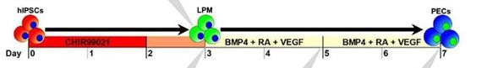

Figure 17. Stages of hiSPC Differentiation into Pre-Epicardial Cells (PECs) via Defined Growth Factor Modulation.

[Tan, J.J., Guyette, J.P., Miki, K. et al. Human iPS-derived pre-epicardial cells direct cardiomyocyte aggregation expansion and organization in vitro. Nat Commun 12, 4997 (2021).]

The current pipeline of the IPSC Collaborators focuses on developing a robust and efficient protocol to differentiate hiPSCs into highly pure and functional CMs and use PECs as the non-myocyte support cells to enhance the functionality and the outcome of CM therapy. This process involves precise manipulation of the cellular microenvironment, using specific growth factors and signaling molecules to mimic natural developmental cues directing PEC formation in the human heart.

Previous Success and Path to Clinical Application

The IPSC Collaborators have been working towards developing cardiomyocytes derived from human pluripotent stem cells that engraft, function, and persist in the human heart in vivo. The groundwork for potential future clinical development has been laid by key breakthroughs such as its preclinical studies have demonstrated the potential of hiPSC CMs to integrate into cardiac tissue, promoting repair and regeneration in damaged heart models. Combining non-myocyte support cells into CM therapy, the strategy is expected to not only contribute to reconstituting the infarct with functional cardiac muscle cells but also enhance the heart’s vascular network, improving blood supply and overall heart function.

60

Studies have shown that BMP4, RA, and Wnt signaling were key mechanisms driving PDGRFA+ and KDR+ LPM cells or cardiac progenitors, to an epicardial fate, some of which observed better efficiency with simultaneous activation of the signaling. The IPSC Collaborators have adapted the signaling model to develop an efficient BMP4/VEGF/RA based protocol, which generated >86% WT1+ pre-epicardial cells (PECs) in 7 days from monolayer hiPSC culture without the need of embryoid body generation, or fluorescence sorting. Taken together, this evidence suggests that hiPSC-derived PECs are functional and able to interact with CMs to enhance the function and structural organization in three-dimensional PEC/ CM microtissues. The IPSC Collaborators believe this work lends to continued efforts in directed morphogenesis, in which the strategic combination of early-stage cardiac cell types can enable the creation of more sophisticated and mature cardiac grafts.

Building upon these promising results, the IPSC Collaborators are advancing towards enabling the production of CMs and integrating non-myocyte support cells such as PECs into cellular therapy or the engineering of heart tissue for treating heart failure patients. The IPSC Collaborators’ objective is to develop a scalable and GMP-compliant production process that ensures the highest purity, potency, and safety of human induced pluripotent stem cell-derived cardiomyocytes (hiPSC-CMs), as well as the support cells, for therapeutic use.

Challenges and Innovations in hiPSC-PEC Therapy

Despite these achievements, hiPSC-derived CMs remain phenotypically immature, with underdeveloped organization and electromechanical function. Furthermore, bioengineered heart tissues using defined cardiac cells still lack the cellular and structural complexity of native myocardium, which could be greatly improved by implementing techniques that recapitulate and integrate important cues from heart development.

Developing hiPSC-PEC integrated CM tissue therapy involves overcoming several challenges, from ensuring the genetic stability and purity of the hiPSCs to achieving efficient differentiation into functional CM PECs. The Collaborators intend to pioneer innovative solutions to these challenges, including advanced genetic engineering techniques to enhance the safety profile of hiPSCs and novel bioreactor systems for large-scale PEC production.

Future Directions and Impact

Recent advancements in the worldwide scientific community’s iPSC technology have enabled the IPSC Collaborators to differentiate iPSCs into cardiac myocytes with high purity and consistency under GMP conditions—a significant step toward clinical application. Under the RCA for Preclinical Assessment of Cardiovascular Regenerative Therapy, the IPSC Collaborators have established heart failure rat models through ligating the left anterior descending coronary artery and cryoinjury. Additionally, the Collaborators have completed a preclinical trial using human iPSC-derived CMs to treat cryoinjured rat hearts. Early results demonstrate that the regenerative effect is superior when combining CMs with hiPSC-differentiated PECs, leading to enhanced regional vascularization and increased CM survival four weeks after injection (refer Figure 20 below). These findings represent a significant milestone, especially as the scientists extend the trial to examine the long-term therapeutic effects in large animals and ultimately prove the product’s safety in human trials. Nonetheless, the process of iPSC generation, the differentiation protocol, quality control, assessment of the cell product, and cell storage are marketable as services to customers and stakeholders (including research institutions, patients with special needs, mothers of newborn babies, etc.) during the development of the iPSC production pipeline on a large scale for human therapy.

61

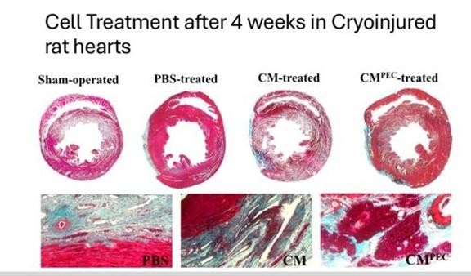

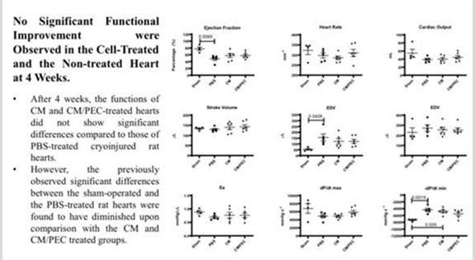

Figure 18. Regenerative Effect in Cell Treatment After 4 Weeks in Cryoinjured Rat Hearts.

Internationally, iPSC-based cardiac therapy research is evolving, with clinical trials in various phases. For instance, in Japan, pioneering efforts are underway to assess iPSC-derived cardiomyocytes in treating heart disease. The United States has seen substantial investment, as evidenced by a significant award granted for trials aimed at heart regeneration. Germany also contributes to this global effort, with advancements that may complement the wide-ranging international research landscape. Collectively, these efforts underline the potential of iPSCs to revolutionize cardiac therapy and highlight the substantial commercial and therapeutic promise of this technology.

62

The IPSC Collaborators’ objective is to establish the production of iPSCs derived from adult peripheral blood within a GMP-compliant framework, coupled with the strategic banking of these cells from donors with unique medical profiles. This endeavor will serve as the foundation for bespoke regenerative treatments. In the subsequent year, the IPSC Collaborators will focus on refining in-house protocols for the expansion and differentiation of iPSCs, with the aim of crafting cardiac cells of exceptional purity and reliability, again under cGMP guidelines. A patent application to safeguard our methods in iPSC production is slated for 2025. This lays the path for the commercial rollout of these groundbreaking cells over the next three to five years. The IPSC Collaborators’ commercialization efforts will include the provision of personalized cardiomyocyte production for therapy, development of robust heart cells for in vitro cardiotoxicity testing, and offering iPSC manufacturing services for individual or institutional needs, including cell storage and academic research. Additionally, the IPSC Collaborators aim to provide a comprehensive iPSC quality assessment service, meticulously evaluating iPSC karyotypes, genomic stability, and adaptations upon request. As the trial is collaborative effort between the IPSC Collaborators, the timing of subsequent clinical trial is not under our control, and is subject to change by USM.

mRNA (Diagnostic)

MyGenome is currently working on a comprehensive study and data collection on gene expression profiling, specifically targeting breast, lung, colorectal, and cervical cancers. The primary objective is to develop a diagnostic tool for these cancers, leveraging data from the nCounter PanCancer IO 360™ Panel. As of the date of this annual report, Alps has not yet developed any diagnostic products or kits for commercial use. MyGenome is still in the process of collecting and analyzing data for the targeted breast, lung, colorectal and cervical cancers to support the development of the diagnostic tools.

One of our pipeline diagnostic candidates involves leveraging mRNA biomarkers for cancer diagnosis. Through our research and development efforts, this candidate focuses on analyzing specific mRNA molecules associated with cancerous cells to provide valuable insights into disease onset, progression, and treatment response. By examining the expression profiles of these mRNA biomarkers, we aim to develop highly sensitive and accurate diagnostic tools that can detect diseases at early stages with precision. Currently, we, in partnership with USM, are gathering specific cancer data for our mRNA diagnosis initiatives, with a targeted focus on breast, lung, colorectal, and cervical cancers. This pipeline is currently undergoing the POC stage, focusing on recruiting patients for breast, lung, cervical, and colorectal cancers and collecting data to develop diagnostic kits for these cancers. Upon completing the data gathering phase, MyGenome will commence the development of diagnostic prototypes for the identification of differentially expressed genes.

Overview of mRNA

Messenger RNA (mRNA) is a large family of RNA molecules that convey genetic information from DNA to specify the protein products of gene expression. mRNA gene expression profiling stands at the forefront of cutting-edge molecular biology, poised to revolutionize healthcare by offering advanced diagnostic and therapeutic solutions. mRNA biomarkers have the potential to shape the future of medical innovation and patient care. At its essence, mRNA serves as the conduit for translating genetic information from DNA into functional proteins, orchestrating fundamental cellular processes essential for health. Leveraging the power of molecular messengers, we are working to develop a cutting-edge platform that harnesses mRNA transcripts as dynamic biomarkers, providing unparalleled insights into disease pathology.

With one in four Malaysians affected by cancer, the urgency to advance diagnostic capabilities and therapeutic interventions are apparent.

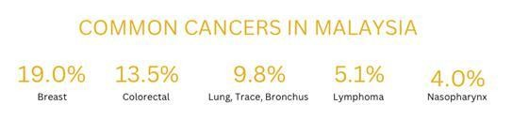

Figure 19. Prevalence of Common Cancers in Malaysia from 2012-2016 according to the National Cancer Registry (2019).

63

Breast cancer is the most common cancer in Malaysia. The common sites for invasive breast cancer to metastasize are the lung, liver, bone and brain while for cervical cancer, the frequent metastatic sites are the lungs, extra-pelvic nodes, liver and bones.

One of the standout advantages of mRNA biomarkers lies in their ability to deliver early and predictive insights, offering a proactive approach to healthcare management. mRNA testing serves several critical purposes in healthcare:

● | Early Disease Detection. mRNA testing enables the early detection of diseases, providing clinicians with valuable insights that can facilitate timely intervention and potentially prevent the onset or progression of illnesses. By detecting abnormalities in gene expression patterns, mRNA testing can identify subtle changes indicative of disease onset before symptoms manifest, allowing for proactive management and improved patient outcomes. This preemptive capability not only enhances treatment efficacy but also has the potential to mitigate disease burden and improve patient outcomes.
● | Monitoring Disease Relapse. mRNA testing is beneficial in monitoring disease progression and detecting signs of relapse, particularly in conditions such as cancer. Changes in gene expression profiles can serve as early indicators of disease recurrence, prompting clinicians to adjust treatment strategies promptly and optimize patient care. Through regular mRNA testing, healthcare providers can closely monitor disease status and tailor therapeutic interventions to mitigate the risk of relapse.
● | Personalized Treatment Approaches. mRNA testing facilitates personalized treatment approaches by analyzing dynamic gene expression patterns. Unlike static DNA tests, mRNA testing offers insights into real-time gene expression changes influenced by lifestyle and environmental factors. This dynamic nature allows for a more comprehensive understanding of disease progression and treatment response, enabling clinicians to tailor interventions to individual patient’s needs.

There is a distinction between DNA and mRNA testing. While DNA tests offer insights into lifetime genetic risks, mRNA testing provides real-time assessments of present disease dynamics. This differentiation empowers healthcare providers with actionable information for personalized patient care, facilitating timely interventions and enhancing overall treatment efficacy.

Aspect |  | DNA Testing |  | mRNA Testing
Genetic Material |  | DNA (Deoxyribonucleic Acid) |  | mRNA (Messenger Ribonucleic Acid)
Risk Assessment |  | Evaluates lifetime risks of cancer/disease |  | Evaluates current risk of cancer/disease
Genetic Stability |  | Genes do not change (static) |  | Gene expression can be influenced by lifestyle, diet, and other external factors
Test Consistency |  | Repeated tests will reveal the same results |  | Repeated tests will reveal current gene expression levels
Frequency of Testing |  | Typically performed once in a lifetime |  | Often performed annually to monitor improvements in gene expression levels

64

Our Solution

In the landscape of cancer diagnosis and monitoring, traditional approaches encounter significant challenges. These include limitations in clinical sampling for high-frequency detection and the constraints of early diagnosis and monitoring. Currently, reliance on tumor markers for screening and early cancer detection predominates in commercial labs’ practices. However, the inherent limitations of tumor markers underscore the urgent need for a more robust and reliable diagnostic paradigm.

Pursuant to the Research Collaboration Agreement, Alps Biotech has initiated a collaborative effort with USM to gather cancer data, specifically focusing on breast, lung, colorectal and cervical cancer. As of the date of this annual report, the parties have agreed to extend the collaboration period through 2027 to facilitate the continuation of data collection activities and further research and development efforts under the collaboration.

Our objective is to advance mRNA gene expression profiling, utilizing the latest advancements in molecular biology and bioinformatics to transform the standards of care, empower healthcare providers, and ultimately improve patient outcomes.

Our capabilities extend to investigating a multitude of gene expressions that intricately intertwine vital components within the complex dynamics of tumors, microenvironments, and immune responses in cancer. By employing the technology, it is possible to simultaneously identify over-expressed and under-expressed genes, offering a comprehensive view of gene expression dynamics. This unique capability enables for discerning genes undergoing significant changes during pivotal processes such as development, carcinogenesis, and disease progression.

11 MarketsandMarkets, “Gene Expression Analysis Market Size, Share, Trends and Revenue Forecast,” March 2024. Available at: Gene Expression Analysis Market Report.

Presently, the MyGenome biomarker laboratory uses the nCounter PanCancer IO 360™ Panel (the “Panel”) which is a unique 770 gene expression panel. According to the Panel’s manufacturer, the Panel integrates key elements essential for understanding the complex interactions between tumors, their surrounding environments, and the body’s immune response, thereby enabling a comprehensive analysis of disease biology and the exploration of immune evasion mechanisms. By leveraging the gene expression profiling capabilities of the Panel, MyGenome’s laboratory can predict the risk of incidence of the following 31 types of diseases:

 | ● | Bladder cancer
 | ● | Endometrial cancer
 | ● | Liver cancer
 | ● | Ovarian cancer
 | ● | Brain Glioma
 | ● | Esophagus cancer
 | ● | Lung cancer
 | ● | Pancreatic cancer
 | ● | Breast cancer
 | ● | Gastric cancer
 | ● | Lymphoma
 | ● | Prostate cancer
 | ● | Cervical cancer
 | ● | Head and neck cancer
 | ● | Muscular sarcoma
 | ● | Skin melanoma
 | ● | Colorectal cancer
 | ● | Kidney cancer
 | ● | Nasopharyngeal cancer
 | ● | Thyroid cancer
 | ● | Alzheimer’s
 | ● | Asthma

65

 | ● | Atopic Eczema
 | ● | Autism (Babies)
 | ● | Cardiovascular disease
 | ● | Diabetes
 | ● | Hypertension
 | ● | Obesity
 | ● | Osteoarthritis
 | ● | Parkinson’s
 | ● | Bipolar disorder

The Panel is not a standalone diagnostic tool and does not detect the presence of such 31 diseases. Instead, the data and information provided by the Panel, when integrated with additional bioinformatic data sequenced by MyGenome, will enhance its predictive ability. In addition to using the Panel to develop its mRNA diagnostic products, MyGenome also uses the Panel to provide genetic screening services in its wellness clinic.

MyGenome does not have any formal agreements, partnerships, or exclusive arrangements with the manufacturer of the Panel. Alps acquired the Panel as a standard purchaser and utilizes it within its facilities alongside other tools and methodologies to support its genetic screening services and mRNA diagnostic product development. The relationship with the Panel manufacturer is limited strictly to that of a buyer and manufacturer.

MyGenome’s mRNA diagnostic pipeline is currently dedicated to four (4) cancers – breast, lung, colorectal, and cervical cancers (the “Targeted Diseases”) – out of the 31 diseases mentioned above. To create its diagnostic products, in addition to relying on the gene expression capabilities of the Panel, MyGenome will need to accumulate data to enhance the precision of disease detection. As such, MyGenome selected the Targeted Diseases due to their high prevalence in Malaysia and clinical need for early detection. MyGenome’s current efforts are focused on gene expression profiling and data collection to advance the development of its proprietary diagnostic tool for the Targeted Diseases. While MyGenome is in the POC stage and actively gathering data, its studies and data indicate that each of the Targeted Disease exhibits distinct mRNA and genetic patterns, demonstrating correlations between the gene expression changes specifically associated with the Targeted Diseases. As MyGenome’s bioinformatics database expands, driven by the continuous accumulation of gene expression data, its ability to detect and characterize the molecular signatures of the Targeted Diseases will be further enhanced. This increase in bioinformatics data will provide deeper insights into the underlying gene expression patterns specific to each Targeted Disease, thereby improving the precision of MyGenome’s proprietary diagnostic tool for the Targeted Diseases.

Our mRNA Profiling Process

Our primary objective is the development of diagnostic tools for predicting the prognosis of the Targeted Diseases, thereby enabling early intervention for treatment. As at the date of this annual report, MyGenome offers mRNA profiling services, which also serve as a channel for collecting bioinformatic data.

Our screening process begin with blood samples collected from the patient, either collected in-house or other healthcare providers.

Upon receipt of the blood sample, we initiate a meticulously structured workflow for mRNA testing, ensuring both accuracy and efficiency. The process unfolds as follows:

1. | Sample Logging and Identification: Each received blood sample is logged into our laboratory system, receiving a unique identifier to facilitate comprehensive tracking throughout the testing journey.
2. | mRNA Extraction: Employing the QIAamp RNA Blood mini extraction kit and protocol (Qiagen), our scientists extract mRNA from the blood sample. This crucial step ensures the attainment of high-quality mRNA is essential for subsequent analysis.
3. | mRNA Quantification: The concentration and purity of the extracted mRNA are determined using the NanoDrop One (Thermo Scientific). This ensures that the mRNA sample meets stringent quality standards required for downstream analysis.
4. | Hybridization and Detection: Following extraction, the mRNA undergoes hybridization with the probes in the nCounter PanCancer IO 360™ panel. Utilizing the cutting-edge NanoString nCounter sequencing platform, we accurately detect the expression levels of target genes. This analysis provides quantitative data on gene expression levels and the presence of disease biomarkers, furnishing crucial insights for precise diagnosis and treatment planning.

66

5. | Analysis and Data Interpretation: The generated data then undergoes thorough interpretation utilizing the nSolver™ Analysis Software before uploading the results to Alps’ in-house mRNA system which generates the final report.
6. | Reporting: A comprehensive report summarizing the mRNA testing results is generated by the Alps’ in-house mRNA system. This report encapsulates pertinent findings, insightful interpretations, and recommendations tailored to inform patient management. This report can be used by the patient and the patient’s physician to plan future tests and therapies. Figure 22 below details the diagnostics and recommendations the report provides based on the screening results.
7. | Quality Control: Throughout the entire process, we adhere to stringent quality control measures to uphold the accuracy, reproducibility, and reliability of mRNA testing outcomes. This encompasses rigorous monitoring of instrument performance, adherence to validated protocols, and meticulous documentation of procedures.

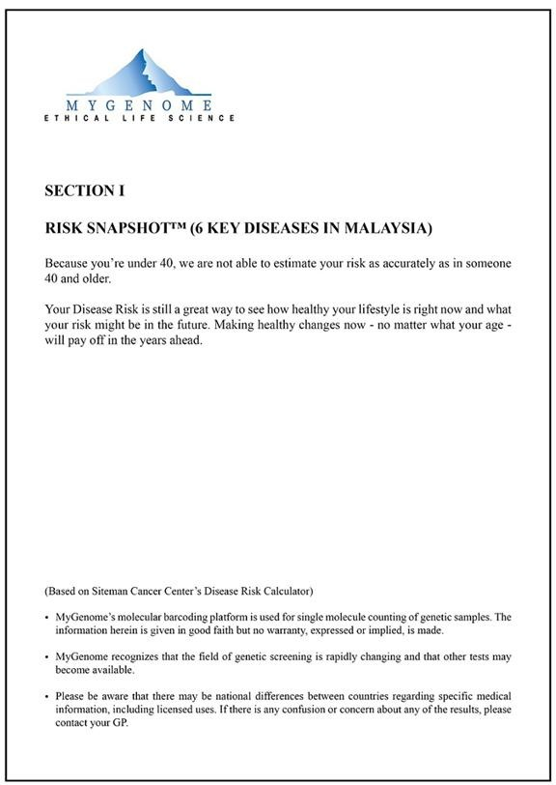

67

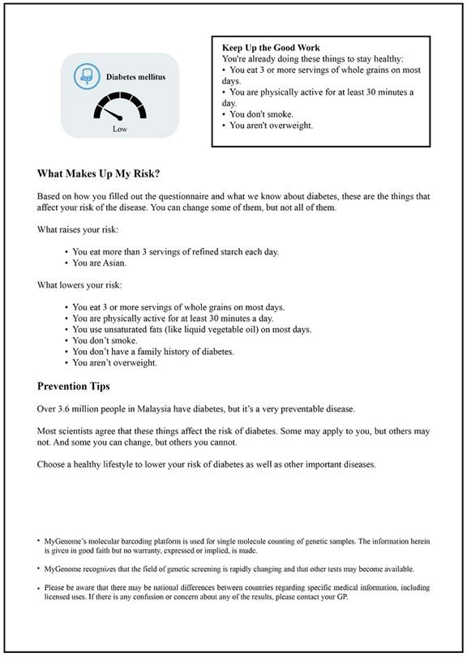

68

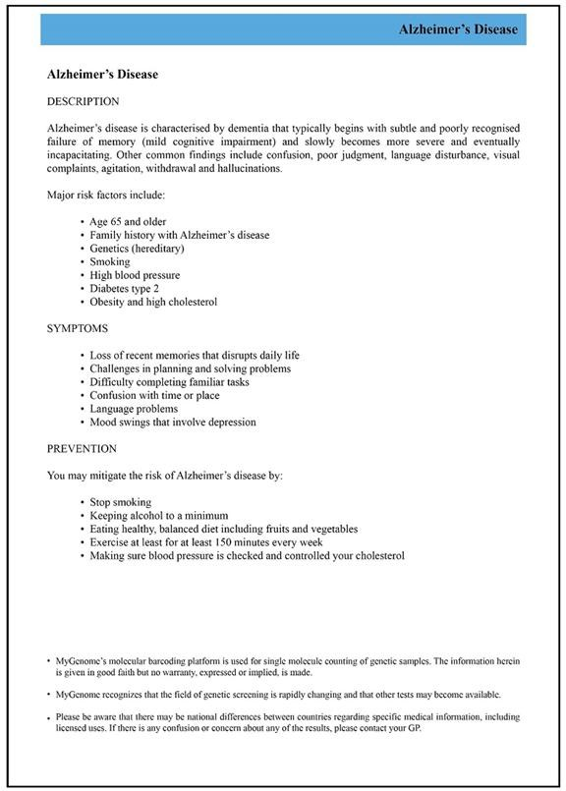

Figure 20. Sample pages from a report generated for the mRNA testing.

69

Through this systematic and meticulously executed process flow, we ensure the integrity and precision of mRNA testing results, thereby facilitating predictive disease detection and enabling personalized patient care.

Our Competitive Advantage

● | Established Wholly Owned Infrastructure: With a robust and fully owned infrastructure, Alps operates with autonomy and agility. Our dedicated team of scientists, renowned for their expertise in biomedicine and biotechnology, collaborates seamlessly within this infrastructure, enabling efficient execution of research and development initiatives.
● | Facilitating Broader Access to Early-Stage Precision Medicine: We aim to broaden access to early-stage precision medicine, particularly in the realm of cancer treatments. Through efficient processes and resource optimization, we seek to offer cost-effective solutions that equip patients and healthcare providers with a range of diagnostic and therapeutic options.
● | Maximizing Resources and Fostering Knowledge Sharing: At Alps, we recognize the importance of collaboration and knowledge exchange in driving innovation. Through strategic partnerships and alliances with external scientists and research centers, we maximize resources and leverage collective expertise to advance the frontier of WGS and mRNA gene expression profiling, ultimately enhancing patient care and outcomes globally.

Development Status and Future Outlook

Currently, our mRNA profiling solely functions as a predictive test, with no ongoing development of new technologies or methodologies. Our primary focus is on accumulating sufficient data in respect of the Targeted Diseases, and we are actively engaged in the data collection process to ensure the accuracy of our tests and facilitate the development of its diagnostic products. MyGenome believes that with a sufficient volume of data, the diagnostic products will achieve higher accuracy in prognostic assessments of the Targeted Diseases. Our ultimate objective is to leverage these data to commercialize diagnostic kits for the Targeted Diseases, contingent upon obtaining necessary regulatory approvals.

Our mRNA Platform and Broader Applications

Through MyGenome, we have developed mRNA-related laboratory capabilities, including genetic sequencing and screening and in mRNA profiling and synthesis, which were previously applied in the development of our COVID-19 mRNA vaccine candidates prior to that program’s discontinuation.

In particular, we intend to explore the application of these capabilities to the development of cancer vaccines that target tumor-specific antigens to stimulate an immune response; to gene-therapy approaches that introduce mRNA sequences encoding therapeutic proteins; and to cell-therapy approaches in which mRNA is used to engineer cells to enhance their therapeutic potential, which would leverage the versatility of mRNA for precision medicine across multiple therapeutic areas. These are statements of our current strategic intent; they do not represent product candidates currently in our development pipeline, and we may not pursue any of them.

CELESOME(+)

Exosome-infused cosmetic products hold potential for transforming skincare and beauty routines. By leveraging the potent properties of exosomes, we are committed to creating cosmetic formulations that enhance skin health, stimulate collagen production, alleviate inflammation, and enhance overall complexion. With Celestialab’s cGMP-accredited cell cultivation laboratory, Celestialab intends to develop, a robust and reproducible exosome manufacturing process. This process will be designed for large-scale operation, ensuring high productivity, purity, and quality, assuring compliance with regulatory standards, including good manufacturing practices.

70

Alps has completed its POC phase, which involved evaluating and refining exosome isolation methods and characterization. Alps is now finalizing an in-house protocol for further exosome characterization. After characterizing the exosomes, Alps plans to conduct comprehensive toxicity studies, including cytotoxicity tests and acute toxicity studies through animal models.

On January 30, 2026, Alps announced the potential expansion of its exosome-based therapeutic pipeline beyond its existing CELESOME(+)following the publication of a preliminary retrospective clinical case series relating to nebulized hUCMSC-derived exosome therapy in patients with asthma and/or chronic obstructive pulmonary disease (“COPD”). Based on the findings reported in the case series and its existing expertise in exosome-related research and development, Alps is evaluating potential opportunities to further develop exosome-based therapeutic applications. Any such potential pipeline expansion remains subject to further research and development activities, regulatory requirements and other factors.

Exosomes in Cosmetic Industry

Exosomes, which are nano-sized vesicles ranging from 30 to 200 nanometers in diameter, are enriched with a diverse array of proteins, lipids, and genetic materials, including mRNA and microRNA (miRNA). These vesicles are produced by a wide range of cell types, notably stem cells, and are disseminated throughout the body via the bloodstream. The genesis of exosomes involves the inward budding of multivesicular bodies (MVBs), which contain intraluminal vesicles (ILVs); these are subsequently released into the extracellular space through the endosomal-lysosomal pathway. Playing a pivotal role in cellular communication, exosomes are instrumental in numerous biological functions, including the repair of tissue, modulation of the immune system, and facilitation of messaging between cells. Their anti-inflammatory and immunomodulatory properties are particularly valuable in procedures such as skin flap reconstructions.

The cosmetic industry is increasingly leveraging the potential of exosomes, incorporating them into various topical formulations such as creams, serums, and masks. These applications exploit the therapeutic and anti-aging properties of exosomes, delivering essential proteins, lipids, and other beneficial molecules that promote skin healing, hydration, and protection from environmental stressors. Notably, exosomes significantly contribute to the enhancement of collagen production, reduction of inflammation, and reinforcement of skin defense mechanisms. Additionally, the synergistic interaction of exosomes with other active ingredients, including hyaluronic acid, peptides, and antioxidants, potentiates their effectiveness.

Illustrative of their impact, adipose stem cell-derived conditioned media (ASC-CM) and bone marrow stem cell-derived (BMSC) exosomes have been shown to reduce levels of reactive oxygen species (ROS) and TNF-α while concurrently increasing TGF-β. This biochemical modulation results in elevated levels of MMP-1 and pro-collagen type I, leading to enhanced collagen synthesis, improved skin elasticity, and the visible reduction of wrinkles. Such outcomes establish a solid foundation for exosomes as an effective anti-aging treatment modality. By stimulating collagen production, exosomes aid in the diminishment of wrinkles and fine lines, support the repair of skin damage from sun exposure and acne scars, and contribute to overall skin plumpness and hydration. The inclusion of a spectrum of bioactive compounds within exosomes, such as cytokines, nucleic acids, and proteins, provides comprehensive protection against environmental stressors and aids in minimizing the appearance of dark spots and discoloration. Through these multifaceted therapeutic and aesthetic benefits, exosomes represent a ground-breaking and promising approach to enhancing skin tone, texture, and overall appearance in the field of regenerative medicine and cosmetic applications.

71

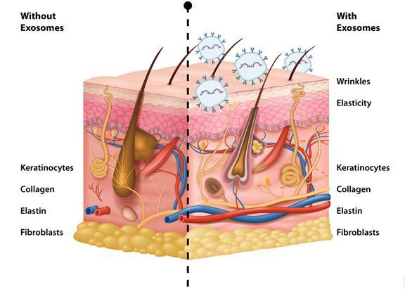

Figure 21. Role of exosomes for anti-aging treatment.

The application of adipose stem cell-derived conditioned media (ASC-CM) and bone marrow stem cell-derived exosomes (BMSC-exos) has demonstrated significant impacts on skin health, particularly in the context of anti-aging treatments. These interventions lead to a notable reduction in the production of reactive oxygen species (ROS), effectively minimizing oxidative stress within the skin. Concurrently, there’s a marked decrease in the expression levels of tumor necrosis factor-alpha (TNF-α), a cytokine known for its role in inflammation. In contrast, the expression of transforming growth factor-beta (TGF-β) is increased, which is crucial for its healing and regenerative properties.

The biochemical shifts induced by ASC-CM and BMSC-exos administration catalyze a series of downstream effects that are beneficial for skin rejuvenation. Specifically, there is an upregulation in the production of matrix metalloproteinase-1 (MMP-1) and pro-collagen type I. MMP-1 plays a pivotal role in the degradation of damaged collagen fibers, facilitating the turnover and renewal of the extracellular matrix. The increase in pro-collagen type I, a precursor of collagen, is particularly significant for the skin’s structural integrity and health.

These molecular and cellular responses cumulatively foster an environment conducive to enhanced collagen synthesis. As the foundational protein responsible for the skin’s strength and elasticity, collagen’s augmented production directly translates to improvements in skin elasticity and firmness. This not only aids in reducing the visibility of existing wrinkles but also prevents the formation of new ones, underscoring the effectiveness of ASC-CM and BMSC-exos as potent anti-aging therapies. By addressing the underlying causes of skin aging at a molecular level, these treatments offer a promising approach to achieving healthier, more youthful-looking skin, making them a cornerstone in the advancement of regenerative dermatology.

Evolving Demand in the Cosmetics Industry

The cosmetics industry is currently experiencing a significant surge in consumer demand, particularly in the realm of skincare products. This uptrend is attributed to a confluence of cultural and societal shifts, including a heightened emphasis on self-care, the pervasive influence of social media, and an increased awareness regarding the health implications of sun exposure. The philosophy underpinning the self-care movement posits skincare not just as a routine but as a form of personal stewardship for the body’s largest organ. Consequently, there’s a growing preference for products that are not only effective but also formulated with natural, organic, and ethically sourced ingredients.

72

Social media platforms have emerged as pivotal arenas for beauty discourse, with influencers and content creators sharing insights and recommendations that shape consumer preferences and behaviors. This digital proliferation of skincare knowledge has fostered a demand for products that cater to specific beauty ideals and skincare routines. Moreover, the recognition of sun damage’s long-term effects has catalyzed a demand for products offering robust protection against UV radiation, with sunscreens and SPF-infused moisturizers seeing heightened consumer interest.

Within this burgeoning market for skincare products, exosome-based therapies represent a novel frontier. Exosomes are being explored for their potential to rejuvenate facial skin and promote hair health. However, their integration into consumer products faces hurdles, primarily due to the absence of formal approval from regulatory bodies. Currently, the only stem cell treatments approved by FDA are products that treat certain cancers and disorders of the blood and immune system.

Our Ongoing Developments in Regenerative Dermatology and Cosmetology

Insights gathered from our own research endeavors, in conjunction with findings from parallel studies, underscore a probable correlative relationship between the specific composition of exosomes and their originating cells. This suggests that various cell types secrete uniquely characterized exosomes, each carrying distinct molecular payloads reflective of the parent cell’s function. Notably, human umbilical mesenchymal stem cells (hUMSCs) have been identified for their critical roles in modulating the immune response, facilitating cell growth, and managing cell turnover—key processes in the body’s healing, repair, and regeneration pathways. The remarkable capability of hUMSCs to produce functionally potent exosomes underpins our strategic decision to harness these cells for our advanced exosome-based therapies.

hUMSCs exhibit paracrine effects, releasing a variety of soluble factors that significantly enhance the body’s intrinsic repair and regeneration mechanisms upon topical application. This aspect of hUMSCs has paved the way for the development of cell therapies showing immense clinical promise, as evidenced by encouraging outcomes from pre-clinical and clinical evaluations. These studies have explored the efficacy and safety of hUMSC-based treatments across a spectrum of dermatological applications, including the management of skin burns, wounds, scars, wrinkles, and conditions such as psoriasis vulgaris and Romberg’s syndrome.

Our commitment to advancing regenerative dermatology and cosmetology solutions is supported by our in-house production facilities, which has the potential to source for high-quality hUMSCs exosomes. Our approach ensures a reliable and consistent supply of umbilical cords derived hUMSCs, ethically sourced in collaboration with our partner maternity clinics and based on informed consent from donors. The exosomes derived from these cells exhibit a concentration of 3.36e+10 +/- 1.96e+09 particles/ml, one of the highest concentration level of exosomes amongst the Malaysian players of similar scale and focus.

Potential products may be derived from this product candidate include facial masks, and treatments for both the face and scalp, incorporating our exosomes. By infusing such potential products with growth factor-rich exosomes from hUMSCs, we aim to redefine the standards of skincare and haircare.

The exosomes we utilize, approximately 62.1 nanometers in diameter, are enveloped in a lipid bilayer that not only safeguards their cargo but also enhances absorption by the skin, bolstering the skin’s moisture barrier. By delivering these growth factors topically, products can significantly rejuvenate the skin’s moisture barrier, promoting a healthier, more radiant complexion. Additionally, our ongoing research into the use of our exosomes in hair serums, face serums, ampoules, facial mesotherapy, and micro needling treatments is aimed at exploring their potential to visibly reduce hair shedding and improve scalp health.

73

We are also currently in the early stages of evaluating the adjunctive and topical use of our exosomes on through the use of pipeline hair serums, face serums, ampoules, facial mesotherapy, and facial micro needling. We hope our studies will show that if topically applied, our hUMSC’s exosomes will have a positive impact as it relates to noticeably reducing the appearance of hair shedding. We anticipate this effect will be primarily through hydrating and nourishing the scalp and topically applying nutrients to the scalp.

We operate a cGMP Stem Cell Research and Cultivation Laboratory, certified by the Ministry of Health in Malaysia. Our facility’s cleanrooms are classified as Grade B and C, as per the specified table of cleanroom classification:

Cleanliness Level |  | Grade |  | Maximum concentration limits (particles/m3 of air) for particles equal to and larger than the considered sizes shown
 |  |  |  |  | At rest |  |  |  |  |  |  |  | In operation
 |  |  |  |  | ≥0.5 µm |  |  |  | ≥5.0 µm |  |  |  | ≥0.5 µm |  |  |  | ≥5.0 µm
Extremely clean |  | A |  |  | 3,520 |  |  |  | 20 |  |  |  | 3520 |  |  |  | 20
 |  | B |  |  | 3,520 |  |  |  | 29 |  |  |  | 352,000 |  |  |  | 2,900
Clean |  | C |  |  | 352,000 |  |  |  | 2,900 |  |  |  | 3,520,000 |  |  |  | 29,000
 |  | D |  |  | 3,520,000 |  |  |  | 29,000 |  |  |  | Not Defined |  |  |  | Not Defined

Table 1: Cleanliness level classification and maximum particle concentration limits.

As part of our endeavour to introduce innovative exosome-infused cosmetic products into the Malaysian market, we are aligning with the regulatory framework established by the NPRA under the MOH. Unlike pharmaceuticals, clinical trials are not mandatory for cosmetic products. Our focus is on navigating the regulatory landscape efficiently, leveraging the unique positioning of cosmetic products within this framework.

Under the Malaysian regulatory framework, entities planning to introduce cosmetic products must follow a structured notification process. This entails formally declaring to the Director of Pharmaceutical Services (DPS) through the NPRA. The designated Cosmetic Notification Holder (CNH) must adhere to all specified requirements outlined in the relevant guidelines. Compliance encompasses various aspects, including product safety, quality, labeling, and advertising standards. Our potential product candidates, distinguished by their inclusion of in-house manufactured exosomes, benefit strategically from this regulatory pathway. As these products fall under the cosmetic category, they are exempt from the rigorous clinical trial requirements typically mandated for therapeutic products. This classification not only speeds up the time-to-market but also provides greater flexibility in product development and marketing strategies.

Microbiological Test

TEST PARAMETER |  | UNIT |  | METHOD USED |  | RESULTS
Bacterial Endotoxin |  | EU/ml |  | In-house Method (ML-14) Based On USP<85> Using Limulus Amebocyte Lysate (LAL) kit by Cape Cod |  | ND(<0.25)

Table 2: This table presents the results of a microbiological test for bacterial endotoxin levels in our exosomes sample. The sample tested indicating that the sample has very low to negligible levels of endotoxins.

Chemical/ Physical Test

TEST PARAMETER |  | UNIT |  | METHOD USED |  | RESULTS
Mycoplasma |  | - |  | In-house Method, NA/PH/001, Using Real-time PCR |  | ABSENT

74

Table 3: This table displays information about a microbiological test conducted to detect the presence of Mycoplasma in a sample. The result “ABSENT” indicates that the test did not detect any Mycoplasma DNA in the sample, suggesting that the sample is free from Mycoplasma contamination.

Microbiological Test

MICROBIOLOGICAL TEST |  |  |  | RESULT
TEST PARAMETER |  | METHOD USED |  | Day 3 |  | Day 7 |  | Day 14
Sterility Test |  | BP 2019, Vol. IV, Appendix XVIA |  | NO GROWTH |  | NO GROWTH |  | NO GROWTH

Table 4: This table provides information about a sterility test performed on a sample, with results recorded over a 14-day period. The repeated confirmation of ‘NO GROWTH’ results across a two-week span is significant, as it not only supports the immediate sterility of the sample but also indicates stability in its sterility over time, which is essential for ensuring the safety of products with a longer shelf life.

PATIENT-DERIVED ORGANOIDS (PDO)

Overview

Patient-derived organoids, or PDOs, are three-dimensional “mini-tumors” grown in the laboratory from a patient’s own cancer tissue. PDOs are designed to retain certain characteristics of the original tumor, including morphology, cellular heterogeneity, biomarkers and genetic characteristics of the original tumor, and may be used to predict how an individual patient’s tumor may respond to different therapies before treatment begins, and to screen drug candidates in a human-relevant preclinical model. We intend to apply PDO technology to personalized oncology testing, preclinical drug and biomarker screening, and the development of proprietary PDO culture media.

Our Program and Collaboration

On June 18, 2026, our subsidiary MyGenome Sdn. Bhd. entered into a Research Consultancy and Collaboration Agreement (“PDO Agreement”) with Dr. Kong Wai Mun, a biomedical scientist with over 17 years of experience in translational research, PDO technology and preclinical model development and the Executive Director of Axiocell Biotech. Under the PDO Agreement, Dr. Kong provides research, technical and consultancy services to establish a clinically validated PDO platform in Malaysia. The objectives of the program include the establishment of clinical-grade PDO lines for colorectal, breast and lung cancers; the development and optimization proprietary PDO culture media; validation of PDO drug-sensitivity testing against standard-of-care drugs; submission of applications to the Medical Research Ethics Committee (“MREC”) and Medical Device Authority (“MDA”) in connection with potential PDO-based clinical testing; establishment of a PDO biobank for preclinical drug screening and biomarker analysis; and potential future clinical evaluation of PDO-based personalised oncology testing. Any PDO lines, biobank and intellectual property developed under this collaboration are intended to be owned by MyGenome, subject to the terms of the PDO Agreement and applicable laws and regulations.

Development Status and Anticipated Milestones

The PDO program is currently at an early, preclinical research and development stage. Our planned milestones include completion of laboratory setup and submission of an initial MREC application in the second half of 2026; establishment of colorectal and breast PDO lines, together with drug-sensitivity validation and indication-specific culture media development, in the first half of 2027; and, subject to applicable regulatory approvals, submission of relevant applications to the MREC and MDA for potential PDO-based clinical testing and further clinical development activities..

75

Our Income Streams

Alps currently generates revenue through its subsidiaries, Alps Wellness Sdn. Bhd. and TMC Global Holdings Sdn. Bhd. These entities operate the Alps Wellness Centre and Alps Medical Centre, respectively. They offer a range of services, including surgical aesthetic treatments, non-surgical aesthetic treatments, and general healthcare and other wellness services. In the competitive biotechnology sector where high cash burn is typical for product and pipeline development, these revenue streams which allows Alps to sustain its operations and partially fund research and our product pipelines and reduce reliance on external funding. Additionally, Alps collaborates with third-party service providers to deliver certain services, enhancing its operational efficiency.

(A) | Cosmetic and Aesthetic Services

Our aesthetic services and cosmetic surgery services include:

Non-Surgical Aesthetic Services

Our non-surgical aesthetic services can be categorized into (i) skin treatments; (ii) facial sculpting; and (iii) body contouring. All treatments are performed by our qualified team of utilizing non-invasive or minimally-invasive procedures, and are personalized to each individual based on the analysis of their skin and personal objective.

 | (i) | Skin Treatments
 |  | Consistent facial and skin treatments are essential for maintaining optimal skin health. However, factors such as an unhealthy diet and the use of inappropriate off-the-shelf products can pose challenges in achieving and sustaining good skin health. Upon consultation, our doctors will create a customized treatment plan tailored to address each customer’s unique conditions and concerns.
 |  | To effectively address common skin issues such as acne, pigmentation, and scarring, we provide treatments that incorporate a variety of topical products and advanced medical equipment. For more complex procedures during skin treatments, we employ potent topical products like chemical solutions to induce skin peeling, along with specialized medical machinery and equipment.

 | Skin Treatments |  | Description
 | Chemical Peels |  | Chemical peels are effective in stimulating collagen and elastin production, thereby enhancing skin elasticity, reducing the appearance of fine lines, and promoting a more even skin tone by lightening dark spots and scars. These peels utilize an exfoliating acid solution that is both safe and gentle on the skin, making them a non-invasive option. This treatment is particularly beneficial for addressing deeper-set wrinkles and dark spots.
 | Fractional CO2 Laser |  | The procedure involves directing short-pulsed energy onto the skin’s surface in a scanning pattern, removing damaged outer layers in thin increments. This process eliminates dead skin cells and activates the production of microthermal zones within the skin, stimulating the body’s natural healing response and promoting collagen production for skin remodeling. The goal of this treatment is to replace old and damaged skin cells with new, healthy ones.
 | Radiofrequency (RF) |  | RF treatment is a non-invasive cosmetic procedure that uses radiofrequency energy to heat the skin’s deeper layers, promoting collagen production and tightening the skin. During the treatment, a device delivers controlled RF energy to the targeted area, generating heat that stimulates the production of new collagen fibers. This helps to improve skin elasticity, reduce the appearance of wrinkles and fine lines, and firm up sagging skin.
 | Q-Switch Laser |  | This is a type of laser therapy that delivers short bursts of high-energy laser light to target specific pigments in the skin, such as melanin (responsible for pigmentation like freckles, age spots, and sun spots) or tattoo ink. In addition to targeting pigmentation, Q-switched lasers can also stimulate collagen production and improve overall skin texture, leading to a more youthful and radiant complexion.

76

 | (ii) | Facial Sculpting
 |  | As we age, the natural contours of our face can diminish, leading to an older appearance or asymmetry. We provide non-invasive facial sculpting treatments aimed at restoring a youthful look and enhancing natural beauty. Through professional consultation and personalized treatment planning by our doctors, we offer treatments designed to rejuvenate and enhance natural beauty. Key treatments offered by Alps include:

 | ● | Dermal Fillers
 |  | Hyaluronic Acid fillers are proven safe as dermal fillers and are effective to smoothen the appearance of deep grooves and facial wrinkles, enhancing facial features and restoring lost volume and facial structure. Dermal fillers give a natural result without affecting the facial expression.
 | ● | Botox
 |  | Botox treatment is the single most popular aesthetic procedure worldwide and is incredibly safe. It helps to correct facial lines and dynamic wrinkles such as frown lines, forehead creases and crow’s feet. It also helps in treating hyperhidrosis.
 | ● | High Intensity Focused Ultrasound (HIFU)
 |  | HIFU lifting is a non-invasive alternative to traditional facelift surgery to perform a skin tightening treatment. This procedure utilises ultrasound energy to target the layers of skin below the surface to encourage the production of collagen for firmer skin.

 | ● | Platelet Rich Plasma (PRP)
 |  | PRP is effective for facial rejuvenation. It uses the patient’s own blood to obtain a high concentration of platelet and growth factors. It is injected into the whole face, and this ignites tissue regeneration, blood vessel formation and collagen production. Wrinkles, photodamaged skin, and skin discoloration can be treated by PRP injections.
 | ● | Non-Surgical Thread Lifts
 |  | Thread lift is one of the most effective ways to lift the loose skin without surgery. This procedure is suitable for the eyebrows, areas around the eyes, the cheeks, the jowls and the neck. Thread lifts treatments result in an instant and natural looking improvement in the appearance of the sagging skin.

 | (iii) | Body Contouring

 | ● | Cryolipolysis
 |  | Cryolipolysis treatment is a procedure commonly known as fat freezing, is a non-surgical fat reduction procedure that uses intense cold temperatures to freeze the layer of fat cells underneath the skin. The cold temperatures damage the fat cells which triggers an inflammatory response by the body which causes the body to dispel the fat cells.
 | ● | Fat Melting Injection
 |  | Fat Melting Injection is a non-surgical cosmetic procedure aimed at reducing localized fat deposits in various areas of the body. It involves the injection of a solution directly into the targeted fatty tissue, which breaks down the fat cells over time. It offers a minimally invasive alternative to traditional liposuction, with minimal downtime.

77

Surgical Aesthetic Services

We provide customary surgical aesthetic services, including double eye lid surgery, nasal augmentation, lip augmentation, breast augmentation, fat transfer, liposuction, lifts and tucks operation and thread lifts, among others. Surgical aesthetic treatments typically involve local or full anesthesia, and an extended recovery time. All of our surgical aesthetic treatments are performed in fully equipped operating rooms in our treatment center.

Treatment |  | Description
Double Eye Lids Surgery |  | Enhances the appearance of the eyes by creating or refining double eyelids for symmetry.
Nose Surgery |  | Change the shape or appearance of the nose by adding fillers or cartilage.
Lip Augmentation |  | Enhances the volume, shape, or definition of the lips using fillers or implants for a fuller appearance.
Breast Augmentation |  | Procedures designed to enlarge/reduce or change the shape of the breasts.
Fat Transfer |  | Transfers fat from one area of the body to another to add volume or improve contours, commonly used for the face, buttocks, or breasts.
Liposuction |  | Procedure in which excess fatty tissue is removed from a specific part of the body through suction
Lifts & Tucks Operation |  | Tightens and removes excess skin from various body areas to improve contours and firmness, commonly performed on the face, neck, arms, or abdomen.
Thread lift |  | Uses dissolvable threads inserted under the skin to lift and tighten sagging facial tissues.

Due to their complexity, we require all our surgical aesthetic procedures be conducted by highly experienced doctors. We implement a standardized process for treatments to uphold consistent quality and safety standards. Our surgeon, Dr. Benjamin GEORGE Jr., who is also the Medical Director for Alps Medical Centre, graduated from Royal College of Surgeons in Ireland with a Bachelor of Medicine and Surgery (M.B.B.Ch.) and obtained his Fellows of the Royal College of Surgeons FRCS (Ed) Surgery in the Royal College of Surgeons, Edinburgh. With over 30 years of experience in cosmetic, plastic, and reconstructive surgery, he holds an LCP certification and is an active member of several medical associations, including the Malaysian Association of Plastic and Cranio-Facial Surgeons, Academy of Medicine, Malaysia, and Malaysian Medical Association.

(B) | Hair Transplant Solutions

We provide hair transplant procedures, including techniques for natural looking hair, beard, scar revision on scalp, and eyebrow transplantation, as well as other non-surgical hair loss treatments. Factors such as stress, genetics, hormonal imbalances, and environmental pollutants contribute to hair loss. These modern influences, combined with lifestyle choices like poor diet and styling practices, play a significant role in causing hair loss among individuals.

At Alps, we specialize in the follicular unit extraction (FUE) method for hair restoration. This technique involves harvesting hair follicles from a donor area and transplanting them to areas experiencing hair loss. Our approach is tailored to each individual’s needs, ensuring personalized care and optimal results. Unlike the follicular unit transplantation (FUT) method, FUE leaves minimal scarring, making it a preferred option for many clients.

Our medical team consists of highly skilled specialists with extensive experience in hair transplantation. With a track record of thousands of successful procedures, we demonstrate our dedication to achieving excellence in every aspect of our practice. Each patient’s journey begins with a thorough private consultation, during which we conduct a detailed scalp analysis and develop a comprehensive plan tailored to promote hair regrowth.

Our facilities are equipped with technology to maintain the success rates for every graft implanted. Our methodology combines the latest medical advancements with a deep understanding of human biology to optimize the health and longevity of transplanted hair.

78

We distinguish ourselves from competitors through meticulous processes that include the use of optimal hair holding solutions, growth-promoting nutritional formulas, and precision temperature-controlled environments for graft preservation.

What makes Alps unique is our ability to conduct comprehensive genetic screenings to uncover underlying causes of hair loss related to inherited genes. This service allows us to offer personalized solutions and preventive strategies to slow down or reverse hair loss.

(C) | General Medical and Wellness Services

We offer a range of general health and wellness services, including medical consultation, health screenings, cellular therapy and research and COVID-19 testing. For the medical consultations, our doctors will conduct an assessment to provide a diagnosis, medical advice, and offer a relevant treatment plan for our customers. In addition, we offer a comprehensive range of health screenings – such as diabetic screening tests, liver function tests, mineral tests, general tumor markers, lipid profiles, and more, to identify and address potential health concerns.

Additionally, Alps Medical Center provides professional dietetic consultation and guidance. We offer personalized nutritional and dietary advice tailored to individual needs, along with lifestyle recommendations. Our services include specialized weight management programs and one-on-one nutrition coaching. To complement our consultations, we offer a range of supplements, designed to support various health needs and enhance overall well-being.

(D) | Whole Genome Sequencing (WGS) and Pharmacogenomics

Apart from the above, we currently offer comprehensive genomic services, specializing in WGS, and are strategically positioned to expand our offerings to include pharmacogenomics. Our services are aimed at personalized healthcare and precision medicine dedicated to empowering individuals and healthcare providers with actionable genetic insights. Leveraging our advance technology and expertise, we offer a wide range of genomic services tailored to meet the diverse needs of our clients.

Our pharmacogenomics analysis system is currently in the development stage, where we are currently in the process of refining the algorithm required for interpreting genetic data to ensure a comprehensive result generated. We anticipate launching our pharmacogenomics analysis service within a year from the date of this annual report.

On June 9, 2026, we announced the expansion of the laboratory accreditation of MyGenome Sdn. Bhd. to include WGS under MS ISO 15189:2022. This accreditation enhances MyGenome’s laboratory capabilities and supports its genomic testing and research activities.

Background of Genetic Sequencing

In living organisms, genetic information is transmitted through deoxyribonucleic acid (DNA), which stores information in linear sequences of chemical bases (adenine (“A”), cytosine (“C”), guanine (“G”), and thymine (“T”)). Within cells, these sequences form pairs in a double helix structure by complementary base pairing. An organism’s entire DNA sequence, its genome, comprises approximately three billion base pairs in humans. The arrangement of these bases on the DNA molecule creates the genetic code, which contains instructions for protein synthesis and regulating biological functions. DNA replication, transcription, and translation are essential biological activities that depend on the structure and function of DNA.

Genetic sequencing involves determining the sequence of nucleotide bases (A, C, G, or T) in a sample, comprising three main phases: sample preparation, sequencing, and raw data analysis. Initially, during sample preparation, the target genome is fragmented into smaller pieces or amplified, depending on the available DNA amount. In the sequencing phase, individual bases within each fragment are identified, forming sequence reads, with the length of contiguous bases termed “read length”. Sequencing throughput is calculated as the product of the number of sequence reads and their average length. Subsequently, bioinformatics tools are used in the analysis phase to align overlapping reads, reconstructing the original genome sequence.

79

Exploring genomes aids in understanding biological inheritance, developmental processes, and normal and pathological cell and organism states. Genetic variability contributes to individual differences, including traits like eye color and blood type, and influences disease susceptibility, such as cancer, heart disease, or diabetes. Moreover, genetic variability affects individual responses to drug therapies.

Genetic sequencing, the foundation of WGS and Pharmacogenomics, provides insights into biological inheritance, disease susceptibility, and individual responses to drug therapies. As healthcare trends shift towards personalized medicine, integrating genomic data enables more precise predictive outcomes and treatment strategies. This transition towards precision-personalized medicine promises earlier disease detection, reduced healthcare costs, and optimized treatment efficacy, ultimately enhancing patient quality of life.

Current genomic testing offers insights into disease predisposition and medication response based on an individual’s unique genetic makeup. Researchers recognize the genomics potential, facilitating health assessment, early disease detection, treatment selection, monitoring treatment response, and identifying adverse effects.

Overview of Pharmacogenomics

Pharmacogenomics is an innovative approach that customizes treatment strategies to improve the effectiveness and safety of drug prescriptions. This field acknowledges the impact of genetic backgrounds on drug responses, highlighting the significance of personalized medicine. It offers the potential in optimizing drug therapy by tailoring treatments to each patient’s genetic profile based on the understanding that genetic differences among individuals influence how their body respond to medications of specific drug.

The primary goals and applications of pharmacogenomics are multifaceted. Firstly, it aims to optimize drug therapy by tailoring treatments based on a patient’s genotype, with the ultimate goal of achieving maximum efficacy while minimizing adverse effects. Additionally, pharmacogenomics contributes to the advancement of precision medicine, shifting away from the traditional “one-dose-fits-all” approach towards personalized medicine, where drugs are optimized for specific subsets of patients or even customized to an individual’s unique genetic profile. Furthermore, pharmacogenomics plays a crucial role in reducing trial and error in medication management by providing physicians with genetic insights to make informed decisions about drug dosages. This approach not only minimizes trial-and-error but also provides explanations for past treatment failures, paving the way for more effective and personalized healthcare interventions.

Market Industry

The global DNA sequencing market is projected to reach USD 23.56 billion by 2026, with a compound annual growth rate (CAGR) of 20.85% from 2021.12 The demand for services facilitating the sequencing of the entire human genome is increasing, driven by the need to convert vast amounts of raw genetic data into medically valuable insights. Automation in pre-sequencing protocols, post-sequencing protocols, and data analysis is expected to positively impact the whole genome sequencing (WGS) market. Additionally, the adoption of novel platforms for personalized medicine development at a genetic level is anticipated to drive demand for WGS in the coming years.

The demand for disease management, prevention, and treatment, along with advancements in bioinformatics, will further fuel the market, aligning with Alps’ core focus on utilizing in-house WGS capabilities. Additionally, the global rise in cancer prevalence and the availability of advanced healthcare facilities are expected to drive market growth. According to GLOBOCAN 2020, new cancer cases are projected to increase from 192,927,89 in 2020 to 288,879,40 by 2040, thereby stimulating cancer research and accelerating growth in the Next-Generation Sequencing (NGS) market.

80

The Problem

The challenges inherent in conventional treatments are multifaceted:

● | The pervasive use of conventional, uniform treatment modalities has led to widespread drug resistance, diminishing the efficacy of therapies provided to patients. This “one-size-fits-all” approach fails to account for the individual variability in drug response, leading to suboptimal outcomes.
● | In oncology, the majority of diseases are associated with genetic mutations, some of which are hereditary. These life-threatening conditions are seldom detected during the initial stages when interventions could be more effective. Targeted treatment on specific genetic mutations potentially minimize treatment needed.
● | Finding the right medication often involve a lengthy process of trial and error. Prolonged trial and error delay achieving the desired therapeutic outcomes, while patient’s condition may worsen and potentially leading to complications that could have been avoided with more immediate effective treatment. Furthermore, this can also put a strain on healthcare resources.

Advancements in Genomic Sequencing

Personalized medicine represents a paradigm shift in healthcare, aiming to tailor medical treatments to the unique needs of individual patients. This specialized field holds promise for the future expansion of genomic sequencing technologies, offering unprecedented insights into disease susceptibility, treatment efficacy, and patient outcomes. Ongoing research in evolutionary biology is leveraging genomic sequencing to deepen our understanding of disease susceptibility and predict individual responses to medications. By deciphering the intricate genetic makeup of patients, genomic sequencing emerges as an invaluable tool in driving healthcare advancements and improving patient care.

Personalized targeted sequencing plays a crucial role in accelerating the identification of mutations and pinpointing cancer targets or pathways, facilitating the development of pharmacological treatments. The integration of NGS protocols into global-scale projects is leading to the generation of new foundational knowledge in oncology precision medicine.

12 Research and Markets. (November 16, 2022). Global DNA Sequencing Market to Grow by $23.56 Billion During 2022-2026 - ResearchAndMarkets.com. Business Wire. Retrieved from https://www.businesswire.com/news/home/20221116005663/en/ Global-DNA-Sequencing-Market-to-Grow-by-23.56-Billion-During-2022-2026—ResearchAndMarkets.com
13 Please refer to https://www.technavio.com/report/next-generation-sequencing-market-size-industry-analysis

Alps’ subsidiary, MyGenome, is leveraging on its current WGS analysis pipeline by integrating pharmacogenomics analysis into the existing framework. While our in-house WGS analysis has traditionally focused on analyzing patients’ traits and wellness, this integration represents a groundbreaking leap forward in genetic analysis capabilities. By incorporating insights into the characteristics of drug treatment for individual patients, we achieve a more comprehensive understanding of each individual’s genetic profile. This holistic approach not only enhances our ability to provide personalized healthcare but also enables us to offer tailored treatment strategies based on an individual’s unique genetic makeup. This integration promises to revolutionize genomic analysis, empowering both patients and healthcare providers with actionable insights for optimized treatment outcomes and patient safety.

Effectiveness of Pharmacogenomics

1. | Optimization of Therapeutics: Pharmacogenomics testing has demonstrated its potential in optimizing therapeutics. From genetic variations, pharmacogenomic analysis can enhance treatment efficacy and safety, ensuring that medications are tailored to individual genetic profiles for improved outcomes.
2. | Reducing Adverse Drug Reactions (ADRs): Pharmacogenomics analysis enables the identification of risk of ADRs based on an individual’s genetic profiles. Predictive capability from pharmacogenomics analysis can significantly reduce the incidence of ADRs which may lead to hospitalization or death.
3. | Personalized Medicine: Unlike traditional approaches that rely on population averages, pharmacogenomics testing predicts medication responses based on an individual’s genetic variations. This personalized approach ensures that treatments are tailored to each patient’s genetic makeup, optimizing effectiveness and minimizing adverse reactions. By offering insights into how genetic variations of an individual handle a specific drug differently, pharmacogenomics testing enables personalized medication selection and dosage, leading to improved treatment outcomes and patient safety.

Our Methodology

WGS allows for genetic assessment, delivering comprehensive insights by mapping the entire DNA sequence. For individual’s intent on uncovering their complete genetic profile, WGS requires just a one-time analysis. This methodology is a foundational element in the evolution of personalized medicine, offering clarity on the functions and variations of genes. Our services efficiently furnish detailed genetic information that can be pivotal in transforming patient-specific treatment modalities, refining existing drugs and therapies, and even paving the way for curing diseases.

Leveraging public established genetic data, our WGS technology decodes every segment of the genome, including the often-overlooked intronic regions, as well as the coding exons. With the capacity to promptly generate data comprising billions of base pairs at a 30x read depth, we produce what can be considered clinical-grade data. We believe that the comprehensive scope and the non-discriminatory nature of our genomic analysis means that clinical-grade whole-genome sequencing (cWGS) is on the cusp of setting a new standard in medical practice, with the potential to be integrated as a routine element in clinical diagnostics.

81

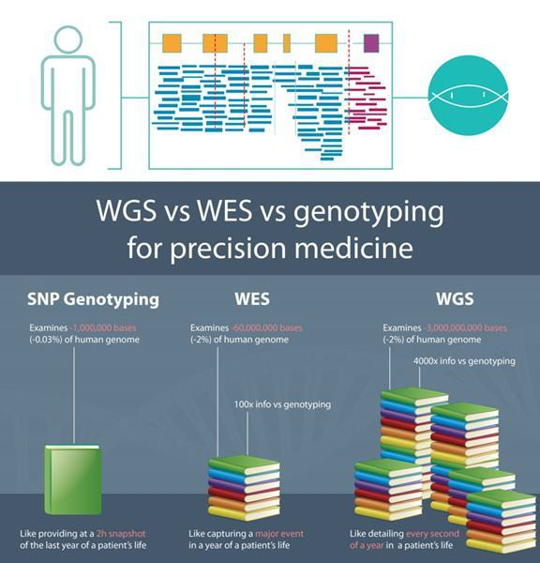

Figure 22. Comparative Analysis of SNP Genotyping, Whole Exome Sequencing (WES), and WGS in Precision Medicine.

Moreover, we are utilizing a platform that merges raw genomic data with sophisticated bioinformatics software, known as novoClinic. This platform equips end users with the means to optimize health and wellness decisions by granting them access to an in-depth understanding of their genetic makeup. It provides actionable insights that are both relevant and tailored to individual health profiles, enabling users to make informed choices about their well-being.

Our process begins with the collection of a blood sample from the patient. Subsequently, the blood sample undergoes processing, during which DNA is extracted. This extracted DNA is then subjected to WGS to obtain the raw genetic data. Following this, a comprehensive genetic analysis is conducted on the obtained data, enabling the identification of genetic variations.

82

These genetic variations are then interpreted in the context of pharmacogenomics markers and drug-gene interactions. This interpretation process allows us to derive actionable insights that inform decision-making processes, including personalized medication selection, dosage adjustments, or tailored treatment plans for individual patients, optimizing therapeutic outcomes and enhancing patient safety and efficacy. A comprehensive report of the testing results will be generated. We utilize the findings from the pharmacogenetic test, in conjunction with other pertinent information about the patient’s condition, to tailor their treatment regimen or make adjustments as necessary. This may involve recommending the most suitable type of medication for their body and determining the optimal dosage to maximize therapeutic benefits. Additionally, the test results can help predict whether the client is likely to experience any adverse side effects from certain medications. Should the test results indicate that a particular medication is not well-suited, we will explore alternative treatment options that may better suit the genetic makeup and medical needs.

NovoClinic is the analysis software used for our whole genome sequencing data. NovoClinic is a platform for NGS targeted sequence analysis, focusing on personalized medicine. It is a patient-centric NGS targeted sequence analysis platform that provides integrated sample tracking for quality control and compliance. This software resolves the burden of data mining and interpretation, allowing researchers to focus on genetic changes and mutations. NovoClinic allows built-in customizable analysis of pipeline including data trimming, sequence alignment, variant calling and variant annotation from various established databases including GWAS, clinvar, dbSNP, COSMIC, etc., to generate both wellness and clinical reports.

Our Unique Capabilities

We believe our services impart the following unique capabilities, which serve as the core tenets for the development:

Built-in customizable analysis of pipeline: Having our built-in customizable analysis pipeline for whole genome sequencing empowers our researchers with:

 | ● | Flexibility: customizable pipelines allow researchers to tailor the analysis workflow to their specific research questions, experimental design, and data characteristics;
 | ● | Efficiency: customizable pipelines streamline the analysis process by automating repetitive tasks and integrating multiple analysis steps into a coherent workflow. This automation reduces the manual effort required for data processing, analysis, and result interpretation, allowing researchers to focus on higher-level tasks and insights, scalability, integration, community support, and adaptability, enabling comprehensive and customized analysis of genomic data for various research and clinical applications; and
 | ● | Adaptability: our researchers are able to incorporate updates, improvements, and new features into the pipeline as advances in technology, algorithms, and genomic knowledge emerge, ensuring that the analysis workflow remains current and relevant.

In-House Laboratory: Equipped with our own laboratory facilities, we have full control over the entire genetic testing process. This ensures the highest standards of quality control, confidentiality, and efficiency in delivering results to our clients. By managing the entire testing process in-house, we can expedite turnaround times and maintain the integrity of the genetic data, enhancing the overall reliability and accuracy of our services.

High accuracy: The DNBSEQ™ WGS sequencer, which is our current genetic sequencing tool is designed to provide high sensitivity and accuracy for each base detected during sequencing for reliable data generation. According to the specifications and performance benchmarks provided by MGI Tech Co., Ltd , the sequencer is anticipated to achieve an SNP and Indel calling rate of 99.9% and 99%, respectively, along with a decreased duplication rate of less than 2 percent, and an almost negligible Index mis-assignment rate.

Competition

The biotechnology sector, particularly the cell therapy segment, is characterized by rapid technological advancements, intense competition, and a strong focus on intellectual property. Despite our belief in the competitiveness of our approach, strategy, technology, knowledge, and experience, we face significant competition both in our current product development pipeline and in potential future product candidates. Competitors include major pharmaceutical and biotechnology companies, academic research institutions, governmental agencies, and public/private research institutions worldwide. Many of these competitors possess greater financial resources and expertise across various stages of product development, from research and development to regulatory approval and marketing. Mergers and acquisitions within the industry may further concentrate resources among fewer competitors, while smaller or early-stage companies could also pose significant competition, either independently or through partnerships with larger entities.

83

Competition extends beyond product development to areas such as recruitment and retention of scientific and management talent, establishing clinical trial sites, patient enrollment, and acquiring complementary technologies. Consequently, competitors may introduce products that are safer, more effective, have fewer side effects, are more convenient, or are less expensive than ours, potentially reducing or eliminating our commercial opportunity. Rapid regulatory approvals by competitors could also result in them establishing a dominant market position before we can enter. Key factors influencing the success of our programs include efficacy, safety, convenience, pricing, and reimbursement considerations.

We aim to research and develop cell-based therapies for a broader spectrum of diseases, including cancers, general wellness, and anti-aging, demonstrating a more expansive and inclusive approach to addressing health and wellness challenges.

Additionally, the aesthetic and beauty-related care industry in Malaysia is highly competitive. We face competition from various providers of cosmetic and aesthetic services, including aesthetic medical clinics and private hospitals. Furthermore, some of our competitors, such as private hospitals, have a longer operating history with stronger financial strength and more resources compared to us.

Competitive Strengths

We believe that we possess numerous competitive advantages. These strengths include:

 | ● | Regional Efficacy and Efficiency: Alps is strategically positioned to deliver highly effective and efficient vaccines tailored for the Southeast Asian region. By understanding the unique epidemiological landscape and healthcare infrastructure of the region, Alps aim to develop vaccines that address specific regional needs, thereby enhancing their efficacy and impact.
 | ● | Proprietary Platform Technology: Alps possesses its own development platform, enabling the rapid and streamlined production. This proprietary platform allows for faster turnaround times from product conceptualization to market launch, providing a competitive edge in responding to emerging infectious diseases and public health crises.
 | ● | Strategic Location in Malaysia: Malaysia’s status as a member of the Pharmaceutical Inspection Cooperation Scheme (PICs) enhances Alps’ regulatory capabilities and facilitates smoother international collaborations. The country’s favorable regulatory environment and infrastructure support expedited approval processes, enabling Alps to bring product candidates to market more efficiently.
 | ● | Cost Effectiveness: Alps prioritizes cost-effectiveness in product development and manufacturing processes across all pipelines and our services. Through efficient resource utilization, streamlined operations, and strategic partnerships, Alps aims to deliver high-quality products and services at competitive prices, making them accessible to a broader population.
 | ● | Expertise and Talent: Alps boasts a multidisciplinary team comprising experts in various fields, including scientific research, clinical trials, manufacturing, business development, and leadership. This diverse talent pool brings together extensive experience and knowledge in biotechnology, platform research, drug discovery, and development, enabling Alps to innovate and excel in the various competitive markets.
 | ● | Tax Incentives: Malaysia’s favourable tax policies and incentives further enhance Alps’ competitive advantage. Lower taxes and investment incentives encourage business growth and innovation, allowing Alps to allocate resources more efficiently towards research and development efforts.

84

Medical Tourism in Malaysia

Malaysia has emerged as a premier destination for medical tourism, attributed to its provision of high-quality services, competitive medical rates, and access to advanced medical facilities. The government has implemented various initiatives to promote healthcare travel, aiming to bolster Malaysia’s reputation as a hub for top-notch healthcare by enhancing medical treatment quality, embracing medical digitization, and ensuring affordability.

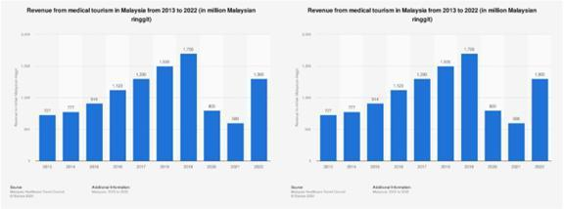

Chart 1 and 2 illustrate a consistent upward trend in both Malaysia’s revenue and the number of tourists visiting for medical purposes from 2015 (859,000 travelers, USD 205 million) to 2019 (1.2 million tourists, USD 382 million) according to the statistics reported by the Malaysian Healthcare Travel Council.14

The majority of medical tourism in Malaysia is facilitated through private medical facilities, offering a wide range of services including dental care, cosmetic surgery, elective surgery, and reproductive therapy. Malaysia distinguishes itself by integrating both modern and traditional medical practices within its healthcare sector. The enactment of the Traditional and Complementary Medicine Act 2016 exemplifies Malaysia’s commitment to integrating traditional and complementary medicine into its healthcare system, ensuring the delivery of high-quality care through proper registration and education of practitioners. This has contributed to the growing popularity of traditional and complementary medicine among medical tourists seeking alternative yet safe treatments for various ailments.

In addition, the Malaysia Healthcare Travel Industry Blueprint 2021-2025 established by the Malaysia Healthcare Travel Council (MHTC) outlines a strategic roadmap for the development and enhancement of the healthcare travel sector in Malaysia over the next five years. This blueprint aims to leverage Malaysia’s strengths in healthcare to position the country as a leading destination for medical tourism globally. Its key strategies include improving the quality of medical care, digitizing the patient journey and continuing efforts to be a world-leading destination that provides affordable medical offerings to healthcare travelers.

Malaysia’s excellence in healthcare has garnered international recognition, with accolades such as being named the ‘Best Country in the World for Healthcare’ by US-based International Living magazine from 2015 to 2017 and in 2019. Additionally, the UK-based International Medical Travel Journal recognized Malaysia as the ‘Destination of the Year’ for healthcare travel from 2015 to 2017, coinciding with the milestone achievement of one million medical tourism arrivals in Malaysia in 2017.

14 Please see: https://www.mhtc.org.my/statistics/

Intellectual Property

We strive to protect the proprietary technology that we believe is important to our business, including seeking and maintaining patents intended to cover our product candidates and technologies that are important to the development of our business, either directly or in collaboration with third parties. We also rely on trade secrets to protect aspects of our business that are not amenable to, or that we do not consider appropriate for, patent protection, as well as know-how, trademarks, continuing technological innovation and in-licensing opportunities to develop and maintain its proprietary position. We have not sought but may in the future seek appropriate patent protection for our product candidates, as well as other proprietary technologies and their uses by filing patent applications in Malaysia, the U.S. and other select countries.

85

Patent License

On March 31, 2021, Alps Global Holding Berhad entered into a lease agreement with Celestialab Sdn. Bhd. (“Lease Agreement”), pursuant to which Alps Global Holding Berhad granted Celestialab Sdn. Bhd. a right to use a patented process, specifically the dual channel – liposuction system for the collection and separation of adipose tissue-derived primary stem cells (the “Patent”), for a term of 10 years commencing on March 31, 2021 and expiring on March 31, 2031. Under this Lease Agreement, Celestialab Sdn. Bhd. is required to pay Alps Global Holding Berhad a monthly fee of RM12,500.00 (approximately US$2,612.88). Celestialab Sdn. Bhd. is a wholly-owned subsidiary of Alps Global Holding Berhad and utilizes the Patent in the course of its health and wellness business activities. The Lease Agreement was established and entered to ensure that this Celestialab’s usage of the patent is conducted on arm’s length, to comply with transfer pricing regulations in Malaysia.

On March 3, 2024, Alps entered into a patent license agreement with Dr. THAM Seng Kong, pursuant to which Alps received (i) an exclusive, royalty-free and non-transferable right and license ten (10) patents co-owned by Dr. THAM Seng Kong and the other individuals, as detailed in the table below, and (ii) the right to use, license, sublicense, manufacture, produce, develop, market and/or sell the licensed products and licensed processes. Unless otherwise agreed upon by the parties, the term of the patent license is for the life and duration of the licensed patents from the date of the patent license agreement, including any renewals subsequently granted for each licensed patent.

Description of the Patent |  | Patent No./Application No. |  | Patentee |  | Expiration Date |  | Jurisdiction Covered
A kind of cell-penetrating peptide-acetyl group Argireline nano-emulsion and preparation method thereof |  | CN108714111A |  | Yang Yong Peng  Tham Seng Kong  Ding KeXiang |  | May 5, 2038 |  | China
A hierarchical extraction element that is arranged in external cell culture liquid skin cell growth factor |  | CN214345637U |  | Yang Yong Peng  Tham Seng Kong  Ding KeXiang |  | January 28, 2031 |  | China
Instrument for rapidly extracting and separating stem cell exosomes |  | CN212476724U |  | Tham Seng Kong  Yang Yong Peng  Ding KeXiang |  | June 1, 2030 |  | China
For the fat-derived primary stem cell collection piece-rate system of binary channels of human body liposuction |  | CN207452106U |  | Tham Seng Kong  Yang Yong Peng  Ding KeXiang |  | June 27, 2027 |  | China
Synchronous multi-person continuous automatic infusion system capable of keeping constant temperature for stem cell exosomes |  | CN219963615U |  | Tham Seng Kong  Ding KeXiang |  | May 16, 2033 |  | China
Rapid preparation instrument for skin external stem cell membrane dressing loaded with cell growth support |  | CN217014449U |  | Tham Seng Kong  Ding KeXiang |  | January 19, 2032 |  | China
Device for simply and rapidly preparing nanoemulsion |  | CN219111470U |  | Tham Seng Kong  Ding KeXiang  Ding Yu |  | December 28, 2032 |  | China
A continuous grading extraction system for natural bioactive peptide |  | CN219804616U |  | Tham Seng Kong  Ding KeXiang |  | October 10, 2033 |  | China
Liquid gel spray preparation and treatment system for stem cell exosomes and secretion factors |  | CN218687190U |  | Tham Seng Kong  Ding KeXiang |  | June 30, 2032 |  | China
Liquid stem cell temperature-sensitive gel spraying operation system with adjustable cell density |  | CN217854156U |  | Tham Seng Kong  Ding KeXiang |  | April 28, 2032 |  | China

86

On March 3, 2024, Alps entered into a patent license agreement with YANG YongPeng, pursuant to which Alps received (i) an exclusive, royalty-free and non-transferable right and license four (4) patents co-owned by YANG Yong Peng and other individuals, as detailed in the table below, and (ii) the right to use, license, sublicense, manufacture, produce, develop, market and/or sell the licensed products and licensed processes. Unless otherwise agreed upon by the parties, the term of the patent license is for the life and duration of the licensed patents from the date of the patent license agreement, including any renewals subsequently granted for each licensed patent.

Description of the Patent |  | Patent No./Application No. |  | Patentee |  | Expiration Date |  | Jurisdiction Covered
A kind of cell-penetrating peptide-acetyl group Argireline nano-emulsion and preparation method thereof |  | CN108714111A |  | Yang Yong Peng  Tham Seng Kong  Ding KeXiang |  | May 5, 2038 |  | China
A hierarchical extraction element that is arranged in external cell culture liquid skin cell growth factor |  | CN214345637U |  | Yang Yong Peng  Tham Seng Kong  Ding KeXiang |  | January 28, 2031 |  | China
Instrument for rapidly extracting and separating stem cell exosomes |  | CN212476724U |  | Tham Seng Kong  Yang Yong Peng  Ding KeXiang |  | June 1, 2030 |  | China
For the fat-derived primary stem cell collection piece-rate system of binary channels of human body liposuction |  | CN207452106U |  | Tham Seng Kong  Yang Yong Peng  Ding KeXiang |  | June 27, 2027 |  | China

87

On March 3, 2024, Alps entered into a patent license agreement with DING KeXiang. In consideration for an aggregate payment of Five Million Chinese Yuan (CNY5,000,000.00) (approximately US$696,262) by Alps, DING KeXiang has granted Alps (i) an exclusive, royalty-free and non-transferable right and license fifteen (15) patents co-owned by DING KeXiang and other individuals, as detailed in the table below, and (ii) the right to use, license, sublicense, manufacture, produce, develop, market and/or sell the licensed products and licensed processes. Unless otherwise agreed upon by the parties, the term of the patent license is for the life and duration of the licensed patents from the date of the patent license agreement, including any renewals subsequently granted for each licensed patent.

Description of the Patent |  | Patent No./Application No. |  | Patentee |  | Expiration Date |  | Jurisdiction Covered
A kind of cell-penetrating peptide-acetyl group Argireline nano-emulsion and preparation method thereof |  | CN108714111A |  | Yang Yong Peng  Tham Seng Kong  Ding KeXiang |  | May 5, 2038 |  | China
A hierarchical extraction element that is arranged in external cell culture liquid skin cell growth factor |  | CN214345637U |  | Yang Yong Peng  Tham Seng Kong  Ding KeXiang |  | January 28, 2031 |  | China
Instrument for rapidly extracting and separating stem cell exosomes |  | CN212476724U |  | Tham Seng Kong  Yang Yong Peng  Ding KeXiang |  | June 1, 2030 |  | China
For the fat-derived primary stem cell collection piece-rate system of binary channels of human body liposuction |  | CN207452106U |  | Tham Seng Kong  Yang Yong Peng  Ding KeXiang |  | June 27, 2027 |  | China
Synchronous multi-person continuous automatic infusion system capable of keeping constant temperature for stem cell exosomes |  | CN219963615U |  | Tham Seng Kong  Ding KeXiang |  | May 16, 2033 |  | China
Rapid preparation instrument for skin external stem cell membrane dressing loaded with cell growth support |  | CN217014449U |  | Tham Seng Kong  Ding KeXiang |  | January 19, 2032 |  | China
Device for simply and rapidly preparing nanoemulsion |  | CN219111470U |  | Tham Seng Kong  Ding KeXiang  Ding Yu |  | December 28, 2032 |  | China
A continuous grading extraction system for natural bioactive peptide |  | CN219804616U |  | Tham Seng Kong  Ding KeXiang |  | October 10, 2033 |  | China
Liquid gel spray preparation and treatment system for stem cell exosomes and secretion factors |  | CN218687190U |  | Tham Seng Kong  Ding KeXiang |  | June 30, 2032 |  | China
Liquid stem cell temperature-sensitive gel spraying operation system with adjustable cell density |  | CN217854156U |  | Tham Seng Kong  Ding KeXiang |  | April 28, 2032 |  | China
Freezing-dried and non-freezing-dried hydroquinone mono-propionate beautifying effect nanometer emulsion and preparation method thereof |  | CN100508952C |  | Ding KeXiang |  | October 24, 2027 |  | China
Rapid separation, purification and concentration system for preparing high-capacity stem cell exosomes |  | CN215517397U |  | Ding KeXiang |  | June 25, 2031 |  | China
Skin externally-applied liquid state and solid state kreotoxin (liushengtai) composite nano emulsion and preparation thereof |  | CN101214200B |  | Ding KeXiang |  | January 21, 2028 |  | China
Novel method for analyzing human thymidine kinase fluorescence immune based on magnetic nanometer particular |  | CN101231288A |  | Ding KeXiang |  | January 31, 2028 |  | China
Breast cancer early warning chip for easily rapid measuring human I type thymidine kinase gene protein |  | CN101275954A |  | Ding KeXiang |  | May 9, 2028 |  | China

88

On March 3, 2024, Alps entered into a patent license agreement with DING Yu, pursuant to which Alps received (i) an exclusive, royalty-free and non-transferable right and license one (1) patent co-owned by DING Yu, Dr. THAM Seng Kong and DING Kexiang, as detailed in the table below, and (ii) the right to use, license, sublicense, manufacture, produce, develop, market and/or sell the licensed products and licensed processes. Unless otherwise agreed upon by the parties, the term of the patent license is for the life and duration of the licensed patent from the date of the patent license agreement, including any renewals subsequently granted for the licensed patent.

Description of the Patent |  | Patent No./Application No. |  | Patentee |  | Expiration Date |  | Jurisdiction Covered
Device for simply and rapidly preparing nanoemulsion |  | CN-219111470-U |  | Ding Yu;  Tham Seng Kong; and  Ding Kexiang |  | December 28, 2032 |  | China

Alps currently does not own any patents. However, pursuant to the patent license agreements dated March 3, 2024, as mentioned above, Alps has exclusively in-licensed fifteen (15) foreign patents in China. The actual protection afforded by a patent varies on a product-by-product basis and depends upon many factors, including the type of patent, the scope of its coverage, the availability of regulatory-related extensions, the availability of legal remedies in a particular country and the validity and enforceability of the patent. As of the date of this annual report, Alps has identified five (5) of the fifteen (15) in-licensed patents as material and important to its business (“Material Patents”). These in-licensed patents cover stem cell and/or exosome processing technologies, which would be expected to expire between June 27, 2027 and January 19, 2032, without taking into account any possible patent term adjustment or extension and assuming payment of all appropriate maintenance, renewal, annuity or other governmental fees.

A tabular summary of the Material Patents is set forth below:

Description of the Patent |  | Patent No./Application No. |  | Expiration Date |  | Jurisdiction Covered
A rapid separation, purification and concentration system to prepare high-capacity stem cell exosomes |  | CN215517397U |  | June 25, 2031 |  | China
Rapid preparation instrument for skin external stem cell membrane dressing loaded with cell growth support |  | CN217014449U |  | January 19, 2032 |  | China
Instrument for rapidly extracting and separating stem cell exosomes |  | CN212476724U |  | June 1, 2030 |  | China
Liquid gel spray preparation and treatment system for stem cell exosomes and secretion factors |  | CN218687190U |  | June 30, 2032 |  | China
For the fat-derived primary stem cell collection piece-rate system of binary channels of human body liposuction |  | CN207452106U |  | June 27, 2027 |  | China

Trade Secrets

Various agreements among contracting member states and legislation in certain countries may provide some level of protection for trade secrets. Remedies available for breaches of such agreements vary, ranging from the destruction of products manufactured using illegally obtained proprietary information to punitive damages, injunctive relief, provisional relief to prevent infringement and preserve evidence, and even criminal sanctions. As our reliance on trade secrets to safeguard our proprietary information, know-how, and technologies is paramount, we are committed to continuously exploring and implementing proactive measures to protect them. This includes entering into confidentiality agreements with our employees and third parties and refraining from conducting business in environments where such protection is insufficient.

However, despite our efforts, breaches of these agreements may occur, and we may lack adequate remedies in such instances. Furthermore, there is a risk that our trade secrets could be acquired or independently discovered by competitors. Disputes may also arise regarding the rights to related or resulting know-how and inventions if our contractors, commercial partners, collaborators, employees, or consultants utilize intellectual property owned by others in their work for us. For more details, please refer to the section titled “Risk Factors—Risks Related to Alps’ Business and Industry—Risks Related to Our Intellectual Property”.

89

We are also committed to maintaining the integrity and confidentiality of our data and trade secrets by ensuring continual physical security for our premises, enhancing the physical and electronic security of our information technology systems, and regularly backing up our information.

Trademarks

We have registered trademark protection for “Ethical Life Science” in Malaysia on March 11, 2021 and we have submitted applications to register the mark “MYGENOME” in Malaysia on March 17, 2021. We have also submitted an application to register the mark “ALPS” in Malaysia on March 29, 2025. However, such application has been provisionally rejected. We are currently taking the necessary steps in connection with the provisional rejection.

Domain Names

In addition, we also have registered domain names for websites that we use in our business, such as https://alps-holdings.com; https://alpsmedical.com; https://mygenome.asia; https://celestialab.com; https://celebre.com.my; https://alpscap.com.my; and https://alpsglobemedic.com.

Employees

Alps had 89 employees as of March 31, 2026, 93 employees as of March 31, 2025, and 88 employees as of March 31, 2024. All of our employees are full-time, consisting of clinical, research, operations, regulatory, finance and business development personnel. There are no collective bargaining agreements that pertain to our employees, and we have never experienced a work stoppage.

Insurance

Our employees presently are covered by SOCSO and EPF. We do not maintain business interruption insurance or key person insurance. Our insurance coverage is consistent with industry standards and is sufficient to cover our key assets, facilities, and liabilities. As part of our business, we also maintain burglary content risks, fire, malpractice liability, burglary money risk, public liability, special contingency, group health plan and group term life insurances.

Legal Proceedings

To the best of our knowledge, we are not subjected to nor engaged in any litigation, arbitration, or claim of material importance, and no litigation, arbitration, or claim of material importance is known to us to be pending or threatened by or against us that would have a material adverse effect on our Group’s results of operations or financial condition.

Regulatory Regime

Laws And Regulations Relating to Our Business and Operations

Local Government Act 1976 (“LGA 1976”)

According to the LGA 1976 and the by-laws of the relevant local authorities in Peninsular Malaysia, we are required to obtain and maintain business and advertisement licenses to carry out our operations and to display our signboard at our offices. A person to whom such license has been granted is generally required to exhibit the license at all times in some prominent place of the licensed premises and to produce the license if required to do so by any officer of the local authority authorized to demand the same. Any person who contravenes any of the provisions of the LGA 1976 and /or the by-laws of the relevant local authorities in Peninsular Malaysia shall be liable for an offence and shall on conviction, be liable to a fine not exceeding RM2,000 or to imprisonment for a term not exceeding one (1) year or to both.

90

Personal Data Protection Act 2010 (“PDPA 2010”)

The PDPA 2010 regulates the processing of personal data in commercial transactions and provides for connected and incidental matters. The PDPA 2010 applies to (a) any person who processes and (b) any person who has control over or authorizes the processing of any personal data in respect of commercial transactions (“Data User”).

Our business activities customarily involve the processing of personal data belonging to third parties. The processing of personal data by a Data User shall be in compliance with the personal data protection principles as stipulated in the PDPA 2010, namely (a) the General Principle; (b) the Notice and Choice Principle; (c) the Disclosure Principle; (d) the Security Principle; (e) the Retention Principle; (f) the Data Integrity Principle; and (g) the Access Principle (collectively, “the Personal Data Protection Principles”). A Data User who contravenes the Personal Data Protection Principles commits an offence and shall, on conviction, be liable to a fine not exceeding RM300,000.00 or to imprisonment for a term not exceeding two (2) years or to both.

Private Healthcare Facilities and Services Act 1998 (“PHFSA 1998”)

Private medical clinics are regulated by MOH in accordance with the PHFSA 1998 and its relevant regulations, including Private Healthcare Facilities and Services (Private Medical Clinics or Private Dental Clinics) Regulations 2006 (“Private Medical Clinic Regulation”). Under the PHFSA 1998, no one shall establish, maintain, operate or provide a private medical clinic or private dental clinic unless it is registered with the Director General of Health of Malaysia (“DG”). The PHFSA 1998 provides that a person who establishes, maintain, operate or provide any private medical clinic without a certificate of registration or approval from the DG shall commit an offence under the PHFSA 1998. The certificate of registration to operate private medical clinic will only be issued to a registered medical practitioner under the PHFSA 1998.

The holder of a certificate of registration or a person in charge of a private medical clinic shall ensure that all healthcare professional staff are registered under any law regulating their registration and in the absence of such law, hold such qualifications and possess such experience as are recognized by the DG and have such qualification, training, experience and skill to practice in his particular or other healthcare profession as are recognized by the DG.

Medical Act 1971 (“MA 1971”)

A medical practitioner is required to register with the MMC to practice medicine in Malaysia as per the Medical Act of 1971. According to this act, any fully registered individual who intends to practice as a medical practitioner after December 21st of any year must submit an application for a certificate to practice before December 1st of that same year. Upon application, the Registrar of Medical Practitioners will issue an Annual Practicing Certificate (APC) authorizing the applicant to practice as a medical practitioner for the following year.

Furthermore, the Medical Act of 1971 stipulates that only individuals whose names are entered into the register are allowed to practice as specialists in their respective specialties. Practicing medicine without registration with the MMC is considered a violation, and individuals who do so are subject to the disciplinary jurisdiction of the MMC.

Guidelines on Aesthetic Medical Practice for Registered Medical Practitioners (“Guidelines on Aesthetic Medical Practice”)

Guidelines on Aesthetic Medical Practice issued by the MOH provides that a medical practitioner who intends to practice aesthetic medical practice must be fully registered with the MMC and possess with a current and valid APC.

The Guidelines on Aesthetic Medical Practice also provides that all registered medical practitioners who intends to practice aesthetic medical practice to have a minimum of 2 years of clinical experience as a medical officer or equivalent after registration, and subsequently complete 2 years of relevant training in aesthetic medical practice under supervision/attachment and practicing as a general practitioner. Besides, the medical practitioner must be free from any disciplinary actions, exercise strict patient selection criteria, communicate to the potential patient the risks involved, the possible outcome, obtain valid consent for the aesthetic medical procedure planned, generally observe all aspects of the Code of Professional Conduct of the Malaysian Medical Council, place patient safety as the primary concern and should provide aesthetic medical services in a healthcare facility licensed or registered under the PHFSA 1998 and Private Medical Clinic Regulation.

91

All registered medical practitioners who qualify and wish to practice aesthetic medical practice are required to have an LCP for the aesthetic procedure(s) which he intends to perform and register under the National Registry of Registered Medical Practitioners Practicing Aesthetic Medical Practice, MOH. Pursuant to the Guidelines on Aesthetic Medical Practice, general practitioners who wish to embark on aesthetic medical practice as a new area of practice are required to undergo training.

Medicine (Advertisement and Sale) Act 1956 (“MA 1956”)

The MA 1956 and its relevant regulations and guidelines which include Medicine Advertisements Board Regulations 1976 that regulates the advertisement and dissemination of information in relation to healthcare matters to general public.

The information provided in the advertisements must be factually accurate and capable of being substantiated. It must not be exaggerated, false, misleading or deceptive. The authenticity and the accuracy of the information imparted in the advertisements should be verifiable by the Medicine Advertisements Board (“MAB”). The MA 1956 also provides that no person shall take part in the publication of any advertisement which refers to any skill or service relating to the treatment, prevention or diagnosis of any ailment, disease, injury, infirmity or condition affecting the human body and which is capable of inducing, or which contains an invitation, whether express or implied, to, any person to seek advice of the advertiser or any person referred to in the advertisement in connection with such skill or service provided that the requirements shall not apply to any advertisement published with the approval of MAB, by any professional body related to the medical profession or to any other allied profession which is established by or registered under any written law or with the approval of the MAB established by the MOH, by any private hospitals or by any private clinic, private radiological clinic, and private medical laboratory operated by a registered medical practitioner having a valid APC under the MA 1971.

Guidelines for Stem Cell Research and Therapy 2009 (“Guidelines for Stem Cell”)

The Guidelines for Stem Cell provide that all stem cell research and applications must be reviewed by the relevant institutional review board (IRB) or institutional ethics committee (IEC) for approval. Research on human adult stem cells, stem cells derived from fetal tissues from legally performed termination of pregnancies, non-human stem cells and human embryonic stem (HES) cell lines derived from surplus embryos are allowed. This soft law prohibits among others, the following matters:

 | (i) | creation of human embryos by means such as assisted reproductive technology or somatic cell nuclear transfer for scientific research purposes;
 | (ii) | research involving in vitro culture of any intact human embryo for longer than 14 days or until formation of the primitive streak begins;
 | (iii) | research in which HES cells are introduced into non-human primate blastocysts or in which any embryonic stem cells are introduced into human blastocysts;
 | (iv) | no animal into which HES cells have been introduced at any stage of development should be allowed to breed; and
 | (v) | fusion of human stem cell or other cells of pluripotent nature with cells of non-human origin, longer than 14 days, or until the formation of the primitive streak begins, whichever occurs first.

Sale of Drugs Act 1952 (“SDA 1952”)

In Malaysia, clinical trials are regulated by the NPRA, which is an agency under the MOH. The NPRA oversees the approval and conduct of clinical trials to ensure the safety, efficacy, and quality of investigational products, as well as the protection of participants’ rights and welfare. The IRB/IEC of the respective institutions also assist in the regulation of clinical trials in Malaysia, as their approval is mandatory before a trial can commence.

The primary legislation governing the regulation of clinical trials in Malaysia is the SDA 1952. Section 26 of the SDA 1952 empowers the MOH to impose regulations with respect to drugs, including the regulation of clinical trials as provided for under the Control of Drugs and Cosmetics Regulations 1984 (“Drugs and Cosmetics Regulations”).

92

Generally, clinical trials in Malaysia can be categorized in 4 phases:

 | ● | For phase 1 trials, the aim is to determine the safety and tolerance of the investigational product. Examples of Phase 1 trials include first-in-human (FIH) studies, pharmacokinetics and pharmacodynamics studies, and drug-drug interaction studies. The number of subjects involved are usually small numbers of healthy volunteers or patients (10-100 subjects).
 | ● | For phase 2 trials, the aim is to determine the efficacy and safety of the investigational product. Phase 2 trials explore the therapeutic dose range of the investigational product to treat a disease or condition and gathering more information on the investigational products’ safety in a larger group of patients (100-300 subjects).
 | ● | For phase 3 trials, the aim is to determine the safety, efficacy or effectiveness of the investigational product. Phase 3 trials are confirmatory trials conducted to determine the therapeutic effect in patient populations for which the investigational product is intended. They also provide a definitive assessment of risk-benefit balance (to support drug registration or change in clinical practice). The number of subjects involved usually includes a large group of patients, ranging from several hundred to several thousand (300-3000 subjects).
 | ● | For phase 4 trials, the aim is to conduct a post-marketing surveillance to monitor safety in real-world populations, including the long-term benefits and risks of the product. These trials take place after the product is approved and is on the market, and usually involve a large group of patients (1000 subjects).

Drugs and Cosmetics Regulations 1984

Except as otherwise provided in the Drugs and Cosmetics Regulations, no person shall manufacture, sell, supply, import, possess or administer any medicinal product unless the product is registered or notified (for cosmetics) and the person holds a CTIL. Any person who wishes to manufacture any product solely for the purpose of producing samples for clinical trials, for registration or issuance of notification note under the Drugs and Cosmetics Regulations may on application be exempted from Regulation 7(1) (CTX). Only a person responsible for the conduct of the clinical trial at a trial site or an authorized person from a locally registered pharmaceutical company, sponsor or contract research organization with a permanent address in Malaysia can apply for a CTIL or CTX. The CTIL or CTX holder need not necessarily conduct the clinical trial him or herself. The NPRA shall not issue the approved CTIL or CTX application if the investigator fails to declare that he or she has attended any of the courses or training sessions certified by the National Committee for Clinical Research.

Guideline for Application of Clinical Trial Import License and Clinical Trial Exemption Eighth Edition

This guidance document provides a step by step procedure on submitting the documents for the CTIL/CTX application including a requirement to contact officers from the Investigational Product Evaluation and Safety Section (IPESS), Centre of Product and Cosmetic Evaluation (CPCE) to schedule for an appointment to submit the CTIL application in person. A flow chart of the CTIL/CTX application process and CTIL/CTX application process involving the First-in-Human Clinical Trial is included in the document for the applicants.

The Drug Control Authority (“DCA”) should be informed by the CTIL/CTX holder in case there are any changes in information or any information received by him/her that may cast doubt on the validity of the data which was submitted for the CTIL. This guidance document also entails information on how the applicants should proceed and engage with the DCA when the trial is completed and communicate with the authorities in the event of early termination of trials.

93

Guideline for Good Clinical Practice Forth Edition

The Malaysian Guideline for Good Clinical Practice mandates that all clinical trials in Malaysia should be conducted in accordance with the ethical principles of the Declaration of Helsinki. An IRB or IEC that reviews proposed clinical trials must consist of not fewer than five members with at least one member who specialises in a non-scientific field and one member who is independent of the trial site. Prior to commencing the trial, the investigator should have the IRB or IEC’s written approval or favourable opinion of the written informed consent form and any other written information to be provided to the subjects. A qualified physician (or dentist, when appropriate), who is an investigator or a sub-investigator for the trial, is responsible for all trial-related medical or dental decisions.

All serious adverse events (SAEs) detected or being notified should be reported immediately to the sponsor except for those SAEs that the protocol or other document identifies as not needing immediate reporting. If the trial is prematurely terminated or suspended, the investigator should promptly inform the subjects and provide them with the appropriate follow-up therapy and inform the regulatory authorities and the IRB or IEC. Upon completion of the trial, the investigator should inform the institution and where applicable provide the IRB or IEC with a summary of the trial’s outcome. If required by the applicable regulatory requirements, the sponsor should provide insurance or should indemnify the investigator against claims arising from the trial except for claims that arise from malpractice or negligence.

Laws and Regulations relating to Intellectual Property Rights

Intellectual property system in Malaysia is administered by the Intellectual Property Corporation of Malaysia (MyIPO), an agency under the Ministry of Domestic Trade and Consumer Affairs.

Trademarks Act 2019 (Act 815)

Trademark in Malaysia is governed by Trademarks Act 2019 (Act 815) (“TMA 2019”). Malaysia is also a member of various trademark-related treaties, including:

 | (i) | Protocol relating to the Madrid Agreement concerning the International Registration of Marks since December 27, 2019;
 | (ii) | Nice Agreement concerning the International Classification of Goods and Services since September 28, 2007;
 | (iii) | Paris Convention for the Protection of Industrial Property since January 1, 1989; and
 | (iv) | Agreement on Trade-related Aspects of Intellectual Property Rights (TRIPS) since January 1, 1995.

The TMA 2019 provides that any person who claims to be the bona fide proprietor of a trademark may apply for the registration of the trademark if:

 | (i) | the person is using or intends to use the trademark in the course of trade; or
 | (ii) | the person has authorized or intends to authorize another person to use the trademark in the course of trade.

The TMA 2019 has also expanded the types of trademarks recognized for registration to be more than just word, logo, numbers, name. signature, letter and to include shape of goods or their packaging, color, sound, scent, hologram, positioning marks and sequence of motion of any combination thereof; provided that they must be signs capable of being represented graphically.

In general, Malaysia provides for protection for both registered and unregistered trademarks. Unregistered trademarks are protected under common law rights, particularly in the tort of passing off. In fact, even during the examination of trademark, the Registrar shall refuse, under relative grounds of Section 24(4) of the TMA 2019, to register it if the mark’s use in Malaysia is prevented by virtue of any rule of law protecting an unregistered trademark or other sign used in the course of trade including the law of passing of.

94

The scope of trademark infringement and its exemptions has been substantially expanded by the TMA 2019. There could now be infringement even in the use of a similar mark on similar goods or services (as opposed to being identical). Secondary users who know or have reason to believe that such use is without authorization of the trademark proprietor may also become liable under TMA 2019.

The TMA 2019 and relevant regulation are applicable to our trademark, brand, word, logo, numbers, name. signature, letter and to include shape of goods or their packaging, color, sound, scent, hologram, positioning marks and/or sequence of motion of any combination.

Patents Act 1983 (“PA 1983”) and Patents Regulations 1986 (“PR 1986”)

The PA 1983 and PR 1986 are the laws and regulations which govern patent protection in Malaysia. PA 1983 would cover amongst others, the criteria for patentability, rights attached to patents, duration of patents and acts relating to infringement, whereas the PR 1986 predominantly encompass the procedures for the application of patents.

An invention is patentable if it is new, involves an inventive step, is industrially applicable and is not explicitly excluded by the PA 1983. An invention which may relate to a product or process means an idea of an inventor which permits in practice the solution to a specific problem in the field of technology. Registration of a patent grants the patent owner rights to exploit the patented invention, to assign or transmit the patent and to conclude license contacts.

A patent shall be deemed granted and shall take effect on the date the certificate of grant of patent is issued. The duration of a patent will generally be for a period of 20 years from the filing date of the application.

Copyright Act 1987 (“CA 1987”)

Copyright protection in Malaysia is governed by the CA 1987 which provides comprehensive protection for copyrightable works. The CA 1987 outlines the nature of works eligible for copyright (which includes computer software), the scope of protection, and the manner in which the protection is accorded. A unique feature of the CA 1987 is the inclusion of provisions for enforcing the Act, which include such powers to enter premises suspected of having infringing copies and to search and seize infringing copies and contrivances. Malaysia is a signatory of the Berne Convention. Foreign works of non-Berne member countries are also protected if they are made in Malaysia and are published in Malaysia within thirty days of their first publication in the country of origin.

Unlike trademarks, designs and patents (other intellectual property rights), there is no specific system of registration for copyright in Malaysia. Although copyright is a non-registrable right in Malaysia and enjoys automatic protection, ownership of copyright is difficult to establish. As such, proper documentation can be prepared to prove ownership. Copyright owners can claim ownership by way of a Statutory Declaration or by filing a Voluntary Notification at the MyIPO.

The definition of a literary work now includes table or compilations “whether or not expressed in words, figures or symbols and whether or not in a visible form”. The owner of copyright in a work including a derivative work, will have the exclusive right to control “the transmission of a work through wire or wireless means to the public, including the making available of a work to the public in such a way that members of the public may access the work from a place and at a time individually chosen by them”.

It is also an infringement of copyright to circumvent any effective technological measures aimed at restricting access to works, removal or alteration of any electronic rights management information without authority, or distribution, importation for distribution or communication to the public, without authority, works or copies of works in respect of which electronic rights management information has been removed or altered without authority.

The CA 1987 and the relevant regulations are benefited us which we are eligible to claim ownership by compiling proper documentation to prove ownership via a Statutory Declaration or by filing a Voluntary Notification at the MyIPO.

95

Laws and Regulations relating to Employment and Social Security

Employment Act 1955 (“EA 1955”)

The EA 1955 is the primary legislation on labor matters in Malaysia. The EA 1955 provides for minimum work requirements and benefits of employment, such as maximum working hours, overtime entitlement, leave entitlement, maternity protection and termination benefits.

Employees’ Provident Fund Act 1991 (“EPF 1991”)

The EPF 1991 imposes the statutory obligations on employers and employees to make contribution towards the Employees Provident Fund, which is essentially a fund established as a scheme of savings for employees’ retirement and the management of savings for the retirement purposes. Under the EPF 1991, any employer who fails to pay the necessary contributions shall be liable to imprisonment for a term not exceeding three years or to a fine not exceeding ten thousand ringgit or to both.

Employee’ Social Security Act 1969 (“ESSA 1969”)

The ESSA 1969 was implemented to provide protection for employees and their families against economic and social distress in situations where the employees sustain injury or death. The schemes of social security under the ESSA 1969 are administered by Social Security Organization (“SOCSO”) and are financed by compulsory contributions made by the employers and the employees. Under the ESSA 1969, any person who fails to make contribution shall be all be punishable with imprisonment for a term which may extend to two years, or with fine not exceeding ten thousand ringgit, or with both.

Employment Insurance System Act 2017 (“EIS 2017”)

EIS 2017 was introduced and enforced with the aim to provide protection and assist workers who have lost employment through two (2) main components namely, the Employment Insurance and Active Labor Market Policies. The Employment Insurance System (EIS) provides protection to workers who have lost their employment through income replacement, reskilling and upskilling training to enhance their employability as well as employment services so that they can secure other suitable jobs fast.

Our all employees which under definition of the EA 1955 are subject to the provision of EPF 1991, ESSA 1969, and EIS 2017.

Laws and Regulations relating to Consumer Protection

Consumer Protection Act 1999 (“CPA 1999”)

The principal law for consumer protection in Malaysia is the CPA 1999. The CPA 1999 establishes various consumer protection mechanisms in Malaysia, and bridge gaps that may occur in other major laws, which may be inadequate in protecting consumers. The government agency which is primarily responsible for policy-making and law enforcement on consumer protection in Malaysia and receiving consumer complaints is the Ministry of Domestic Trade and Consumer Affairs.

The CPA 1999 covers almost every aspects of consumer protection; ranging from misleading and deceptive conducts, false representation and unfair practices; safety of goods and services; unfair contract terms; guarantees in respect of the supply of goods and services; and product liability; to the establishment, structure and functions of the National Consumer Advisory Council; the Committee on Advertisement; the Tribunals for Consumer Claims; and other matters related to enforcement, offences, remedies, and compensation.

C. | Organizational Structure

See “—A. History and Development of the Company.”

96

D. | Property, Plant and Equipment

The Company’s principal executive office is Unit E-18-01 & E-18-02, Level 18, Icon Tower (East), No. 1, Jalan 1/68F, Jalan Tun Razak, 50400 Kuala Lumpur, Wilayah Persekutuan, Malaysia.

As of the date of this Report, we currently occupy the following properties:

Company Name |  | Address |  | Purpose |  | Tenancy Period |  | Monthly Rental
Celestialab Sdn. Bhd. |  | Suites G-05, Ground Floor Menara See Hoy Chan, No. 374, Jalan Tun Razak, 50400 Kuala Lumpur, Malaysia. |  | Cell manufacturing lab, R&D (approx. 5,301 sq. ft.) |  | 1 March 2025 to 28 February 2028 |  | RM 25,179.75 ((approximately US$ 6,111.59)
MyGenome Sdn. Bhd. |  | Suites G-03 & G-04, Ground Floor, Menara See Hoy Chan, No. 374, Jalan Tun Razak, 50400, Kuala Lumpur, Malaysia. |  | Molecular lab, R&D (approx. 4,853 sq. ft.) |  | 1 March 2025 to 28 February 2028 |  | RM 23,051.75 (approximately US$ 5595.08)
Alpscap Berhad |  | E-18-01 & E-18-02, Level 18, The ICON, No 1, Jalan 1/68F, Jalan Tun Razak, 50400 Kuala Lumpur, Malaysia. |  | HQ office (approx. 14,180 sq. ft.) |  | 1 July 2026 to 30 June 2029 |  | RM 67,000.50 (approximately US$ 16,262.14)
TMC Global Holding Sdn. Bhd. |  | Suite 02-06, 2nd Floor Menara See Hoy Chan , No. 374, Jalan Tun Razak, 50400 Kuala Lumpur, Malaysia. |  | Wellness center focusing on hair transplant, men’s health, joint & knee pain relief, aesthetics center (approx. 3,691 sq. ft.) |  | 1 December 2024 to 30 November 2027 |  | RM 13,066.14 (approximately US$ 3,171.39)
TMC Global Holding Sdn Bhd |  | Suite 02-05, 2nd Floor Menara See Hoy Chan, No. 374, Jalan Tun Razak, 50400 Kuala Lumpur |  | Medical centre (approx. 2,168 sq. ft.) |  | 1 April 2024 to 31 March 2027 |  | RM11,444.90 (approximately US$ 2,777.89)
TMC Global Holding Sdn. Bhd. |  | Suites 02-03 & 02-04, 2nd Floor Menara See Hoy Chan, No. 374, Jalan Tun Razak, 50400 Kuala Lumpur |  | Ambulatory care center for cellular therapy and plastic surgery (approx. 6,116 sq. ft.) |  | 1 April 2024 to 31 March 2027 |  | RM 32,414,80 (approximately US$ 7,867.67)

[Exchange Rate: USD 1.00 = MYR 4.12]

97

cGMP Facility

Celestialab’s cGMP facility, located at Suites G-03 & G-04, Ground Floor, Menara See Hoy Chan, No. 374, Jalan Tun Razak, 50400 Kuala Lumpur, is equipped with the capacity to manufacture our cell therapy product candidates. Our cleanrooms for sterile manufacturing of cellular products adhere to the cGMP standards of the Pharmaceutical Inspection Co-operation Scheme, ISO cleanroom guidelines, and WHO guidelines on GMP, ensuring compliance and quality in our manufacturing processes.

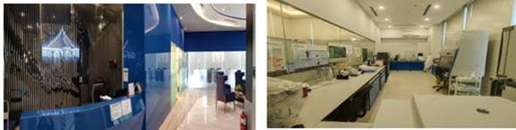

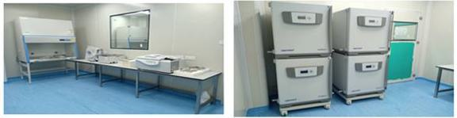

Figure 25. Celestialab’s cGMP facility.

Item 4A. UNRESOLVED STAFF COMMENTS

Not applicable.

ITEM 5. OPERATING AND FINANCIAL REVIEW AND PROSPECTS

You should read the following discussion and analysis of the Company’s financial condition and results of operations in conjunction with the Company’s consolidated and combined financial statements and the related notes included elsewhere in this annual report. This discussion may contain forward-looking statements based upon current expectations that involve risks and uncertainties. The Company’s actual results may differ materially from those anticipated in these forward-looking statements as a result of various factors, including those set forth under “Item 3. Key Information — 3.D. Risk Factors” or in other parts of this annual report.

Overview

Our group consists of Alps Group Inc, Alps Life Sciences Inc, Alps Global Holding Berhad and our subsidiaries, namely, Alps Biotech Sdn. Bhd., Alps Wellness Centre Sdn. Bhd., Alpscap Berhad, Celebre Pro Medic Sdn. Bhd., Celestialab Sdn. Bhd., Mont Life (M) Sdn. Bhd., MyGenome Sdn. Bhd., TMC Global Holdings Sdn. Bhd., and Alps Insurance PCC Inc..

Both Alps Group (“the Company”) and Alps Life Sciences Inc (“Alps Holdco”) are exempted companies incorporated in the Cayman Islands with limited liability, and Alps Global Holding Berhad (“Alps Malaysia”) is a public limited company incorporated in Malaysia on April 14, 2017. Alps Malaysia became the wholly-own subsidiary of Alps Holdco in July 2024. Alps Malaysia’ primary objective is to evolve into a fully integrated bench-to-bedside platform encompassing biotechnology research, medical services, and wellness solutions. Alps Malaysia’ principal activities are research and development in various biotechnology-related products and services, with a focus on the use of precision and preventive medicine.

98

Alps intends to take a targeted approach to addressing challenges in the biotech and healthcare sector in ASEAN. Its efforts focus on the following areas:

 | ● | Transitioning scientific discoveries into commercially viable products and treatments, thereby improving access to healthcare solutions.
 | ● | Enhancing research capabilities by facilitating the development of infrastructure and establishing dependable supply chains to support innovation.
 | ● | Implementing programs to recruit, train, and retain skilled professionals in specialized biotech disciplines.
 | ● | Enabling collaboration among startups, corporations, and research institutions to build cohesive ecosystems that support growth.
 | ● | Addressing funding gaps for early-stage research and development by working to reduce risk perceptions and facilitating investment opportunities.]

The Company completed the Business Combination with Globalink on October 28, 2025. Pursuant to the terms of the Merger Agreement, the Business Combination between Globalink and Alps was effected in two steps: (i) Globalink merged with and into the Company, with into the Company remaining as the surviving publicly traded entity (the “Redomestication Merger”); and (ii) Merger Sub merged with and into Alps Holdco, resulting in Alps Holdco remaining as the surviving entity and a wholly-owned subsidiary of into the Company (the “Acquisition Merger”).

Accounting Treatment

The Business Combination was accounted for as capital reorganization with no goodwill or other intangible assets recorded, in accordance with International Financial Reporting Standards (IFRS). A capital reorganization does not result in a new basis of accounting, and the financial statements of the combined entity represent the continuation of the financial statements of Alps Holdco. As Globalink is a shell / non-operating company (and does not meet the definition of a “business” pursuant to IFRS 3 Business Combinations), the transaction is accounted for as a share-based payment / capital reorganization rather than a IFRS 3 acquisition. This transaction is also referred to as the De-SPAC transaction.

Under this method of accounting, Globalink will be treated as the “acquired” company for financial reporting purposes. For accounting purposes, Alps Holdco will be deemed to be the accounting acquirer in the transaction and, consequently, the transaction will be treated as a recapitalization of Alps Holdco (i.e., a capital transaction involving the issuance of shares by the Company for the shares of Alps Holdco). Accordingly, the consolidated assets, liabilities and results of operations of Alps Holdco will become the historic financial statements of the Company, and Globalink’s assets, liabilities and results of operations will be consolidated with Alps Holdco beginning on the acquisition date. Operations prior to the Business Combination will be presented as those of Alps Holdco in future reports. The net assets of Globalink will be recognized at carrying value, with no goodwill or other intangible assets recorded.

Alps Holdco has been determined to be the accounting acquirer based on evaluation of the following facts and circumstances:

 | ● | Alps Holdco Shareholders will have the largest voting interest in the Combined Company;
 | ● | The board of directors of the Company were designated solely by Alps Holdco, with at least three (3) directors qualifying as independent directors under the Securities Act and the Nasdaq rules;
 | ● | Alps Holdco’s senior management will be the senior management of the Company;
 | ● | The business of the Combined Company will comprise the ongoing operations of Alps Holdco; and
 | ● | Alps Holdco is the larger entity, in terms of substantive assets.

99

Accordingly, the historical audited consolidated and combined financial statements for Alps Group Inc and its subsidiaries for the fiscal years ended March 31, 2025 and March 31, 2024 presented in this Annual Report shall be that of Alps Holdco and its subsidiaries.

A. Operating Results

Comparison of Results of Operations for the Fiscal Years Ended March 31, 2026, 2025 and 2024

The following table summarizes the consolidated and combined results of operations for the fiscal years ended March 31, 2026, 2025 and 2025:

 |  | 2026 |  |  |  | 2025 |  |  |  | 2024
 |  | USD |  |  |  | USD |  |  |  | USD
Revenue |  |  | 4,856,320 |  |  |  | 3,371,037 |  |  |  | 2,403,552
Cost of sales |  |  | (3,298,046 | ) |  |  | (2,069,772 | ) |  |  | (1,804,622 | )
Gross profit |  |  | 1,558,274 |  |  |  | 1,301,265 |  |  |  | 598,930
Other operating income |  |  | 1,331,816 |  |  |  | 31,282 |  |  |  | 49,977
Finance income |  |  | 3,856 |  |  |  | 123 |  |  |  | -
Distribution expenses |  |  | (205,601 | ) |  |  | (273,487 | ) |  |  | (160,855 | )
Administrative expenses |  |  | (3,497,725 | ) |  |  | (2,400,790 | ) |  |  | (1,929,680 | )
Other operating expenses |  |  | (1,235,928 | ) |  |  | (1,128,526 | ) |  |  | (917,524 | )
Share results of associate |  |  | 14,449 |  |  |  | (10,760 | ) |  |  | 3,421
 |  |  | (2,030,859 | ) |  |  | (2,480,893 | ) |  |  | (2,355,731 | )
Finance costs |  |  | (50,459 | ) |  |  | (48,283 | ) |  |  | (42,844 | )
Loss before tax |  |  | (2,081,318 | ) |  |  | (2,529,176 | ) |  |  | (2,398,575 | )
Income tax expense |  |  | (5,137 | ) |  |  | (95,562 | ) |  |  | 7,414
Loss for the financial year |  |  | (2,086,455 | ) |  |  | (2,624,738 | ) |  |  | (2,391,161 | )
Other comprehensive (loss)/income, net of income tax
Changes in fair value of other investment |  |  | (76,988 | ) |  |  | - |  |  |  | -
Foreign currency translation |  |  | (145,949 | ) |  |  | 57,830 |  |  |  | (121,298 | )
Total comprehensive loss for the year |  |  | (2,345,525 | ) |  |  | (2,566,908 | ) |  |  | (2,512,459 | )

100

Revenue

 |  | 2026 |  |  |  | 2025 |  |  |  | 2024
 |  | USD |  |  |  | USD |  |  |  | USD
Cellular therapy |  |  | 883,016 |  |  |  | 586,440 |  |  |  | 407,443
Medical testing, laboratory and aesthetics beauty services |  |  | 3,149,193 |  |  |  | 2,617,110 |  |  |  | 1,755,910
Consultation fee |  |  | 92,331 |  |  |  | 157,467 |  |  |  | 232,173
Sales of medicine and healthcare product |  |  | 731,780 |  |  |  | 10,020 |  |  |  | 8,026
 |  |  | 4,856,320 |  |  |  | 3,371,037 |  |  |  | 2,403,552

For the fiscal year ended March 31, 2026, Alps Group continued to record a 44% growth in revenue as compared to fiscal year ended March 31, 2025, led strongly by the 51% growth in cellular therapy sales and a 20% increase in sales from the medical testing, laboratory and aesthetics beauty services segment.

This is followed strongly by the sale of medicine and health products, registering a revenue of $731,780 for the fiscal year ended March 31, 2026 as the sale of products complements the aesthetic beauty services segment. In contrast, consultation fee income continued to decline from 2024 to 2026 due to the promotion of bundled packages whereby individual consultations are no longer charged separately.

For the fiscal year ended March 31, 2025, Alps Group recorded a revenue growth of 40.3%, with total revenue increasing from $2,403,522 in financial year ended March 31, 2024 to $3,371,037 in financial year ended March 31, 2025. This growth was primarily attributable to the revenue increase in medical testing, laboratory, and aesthetics beauty services segment, delivering a 49% year-on-year revenue increase, which added approximately $861,200 to total revenue.

In parallel, the cellular therapy segment recorded revenue growth of 43.9%, contributing an additional $178,997 compared to the previous financial year. Revenue from sales of medicine and healthcare products grew by 25%. Conversely, consultation fee income declined by 32.2%, primarily due to bundled packages whereby individual consultations are no longer charged separately

In the immediate future, we expect to continue to derive our revenues mainly from cellular therapy sales and from the provision of medical testing, laboratory and aesthetics beauty services as we continue to advance our product candidates through and beyond the pre-clinical phase.

Cost of sales

 |  | 2026 |  |  |  | 2025 |  |  |  | 2024
 |  | USD |  |  |  | USD |  |  |  | USD
Cost of inventories |  |  | 1,129,660 |  |  |  | 585,298 |  |  |  | 833,774
Direct labour costs |  |  | 111,174 |  |  |  | 334,686 |  |  |  | 432,315
Profit sharing on aesthetic services |  |  | 1,978,651 |  |  |  | 1,085,830 |  |  |  | 522,066
Cellular therapy cost |  |  | 77,818 |  |  |  | 59,354 |  |  |  | 15,499
Others |  |  | 743 |  |  |  | 4,604 |  |  |  | 968
 |  |  | 3,298,046 |  |  |  | 2,069,772 |  |  |  | 1,804,622

Alps Group’s cost of sales comprises mainly the cost of inventories for services performed and products sold, profit sharing on aesthetic services (hair implant, bone joint, aesthetic and men’s health services) and cellular therapy cost.

101

The overall increase in cost of sales for the fiscal year ended March 31, 2026 of $1,228,274 comparing to corresponding year was mainly due to the increase in costs of aesthetic services of $892,821 and cost of inventories of $544,362. The overall increase in cost of sales was in line with the growth of revenue which was driven mainly from the provision of testing, laboratory and aesthetics beauty services.

For the fiscal year ended March 31, 2025, the Group’s cost of sales increased by 14.7% to $2,069,772, compared to $1,804,622 in the previous year. The increase was also primarily attributable to a 108% rise in costs associated with the aesthetic and related products and services which amounted to $1,085,830.

The Group’s revenue from specialized medical and aesthetic services is primarily generated from collaboration with third party service providers whereby the service partner undertakes marketing efforts and delivers the services while the Group provides the facilities and equipment, and related operational and financial support. These services are normally complemented by sale of related products to the customers.

In 2023, Alps Wellness Centre Sdn. Bhd. (“Alps Wellness”) entered into multiple agreements with three (3) partners to provide specialized medical and aesthetic services. Alps Wellness entered into a Memorandum of Agreement dated November 1, 2023 (the “MoA”) with Advanced Hair Transplant Specialist Sdn. Bhd. (“Advanced Hair”), under which Advanced Hair agreed to provide hair transplant, mesotherapy, and hair filler services using Alps Wellness’s facilities and equipment. Pursuant to the MoA, Alps Wellness is responsible in providing the facilities and financial support, while Advanced Hair will deliver the services and conduct marketing efforts. The agreement was valid for two years, from November 1, 2023, to October 31, 2025, with an option for extension. Profits, after deducting the cost of goods sold, was distributed with 40% to Alps Wellness and 60% to Advanced Hair.

Alps Wellness also entered into a Memorandum of Understanding dated November 21, 2023 (the “MOU”) with Advanced Bone Joints Health Centre Sdn. Bhd. (“ABJHC”), under which ABJHC agreed to provide bone joint care and physiotherapy services, including orthopedic consultations, physical therapy, joint injections, pain management, spinal care, osteoporosis management, nutritional counseling, wellness programs, patient education, and telehealth services, using Alps Wellness’s facilities and equipment. Alps Wellness provided the facilities, financial support for equipment, and rent-free clinic space, while ABJHC delivered professional services, provided skilled staff, and conducted marketing efforts. The MOU was effective for two years, from November 21, 2023, to November 20, 2025, with an option for extension. Profits, after deducting expenses such as marketing and cost of goods sold, was allocated with 29.8% to Alps Wellness and 70% to ABJHC.

Additionally, Alps Wellness was a party to a Memorandum of Agreement dated December 1, 2023 (the “MOA”) with Advanced Aesthetic Specialist Sdn. Bhd. (“AAS”), pursuant to which AAS agreed to provide aesthetic services, including beauty, skin, hair, and body treatments, using Alps Wellness’s facilities and equipment. Alps Wellness provided the facilities, financial support for equipment, and collect payments directly from clients, while AAS referred clients to Alps Wellness and delivered the professional services. The MOA was valid for two years, from December 1, 2023, to November 30, 2025, with an option for extension. Profits, after deducting expenses such as marketing and cost of goods sold, was shared between Alps Wellness and AAS in the proportion of 40% and 60% respectively.

Following the expiry of these agreements, the parties continued with the respective arrangements on monthly basis while negotiating new agreements. The parties subsequently entered into the new agreements as described below.

On July 1, 2026, Alps Wellness entered into a collaboration agreement with Dr A Advanced Holdings Sdn Bhd (“Dr A”) for a term of two years from July 1, 2026 to June 30, 2028, pursuant to which Dr A agreed to provide hair rejuvenation and scalp micro pigmentation services using Alps Wellness’s facilities, equipment and supporting resources.

On the same date, our subsidiary, TMC Global Holdings Sdn Bhd (“TMC”) entered into a collaboration agreement with Dr A also for a term of two years from July 1, 2026 to June 30, 2028, pursuant to which Dr A agreed to provide hair transplant, bone and joint health services, men’s health services and advanced aesthetic services using TMC’s facilities, equipment and supporting resources.

During the fiscal years under review, the Group’s gross profit margin from the above aesthetic beauty services ranged from 20% to 40% of revenue, depending on the types of services.

Other Operating Income

 |  | 2026 |  |  |  | 2025 |  |  |  | 2024
 |  | USD |  |  |  | USD |  |  |  | USD
Other income |  |  | 56,250 |  |  |  | - |  |  |  | -
Refund of research fees |  |  | - |  |  |  | - |  |  |  | 48,457
Refund of HR software |  |  | - |  |  |  | 6,224 |  |  |  | -
Sundry income |  |  | 4,191 |  |  |  | 6,597 |  |  |  | 1,305
Wages subsidy |  |  | - |  |  |  | 7,114 |  |  |  | -
Realized foreign exchange gain |  |  | 210,319 |  |  |  | 11,347 |  |  |  | -
Fair value gain on warrant liability |  |  | 477,972 |  |  |  | - |  |  |  | -
Gain on loan modification |  |  | 583,084 |  |  |  | - |  |  |  | -
Gain on disposal of investment |  |  | - |  |  |  | - |  |  |  | 215
 |  |  | 1,331,816 |  |  |  | 31,282 |  |  |  | 49,977

Other operating income for the fiscal year ended March 31, 2026 comprised mainly the gain of $583,084 associated with the modification of loan for the advances from a director, fair value gain on warrant liability of $477,972 and the realized gain on foreign exchange of $210,319 due to the strengthening of the Ringgit Malaysia against the US dollar during the fiscal year.

For the fiscal year ended March 31, 2025, the Group recorded other income of $31,282, compared to $49,977 in the previous financial year. The decrease of $18,685 was mainly attributable to the absence of one-off income items recorded in 2024, including a refund of research fees of $48,457 and a gain on disposal of an investment of $215.

102

Offsetting this decline, the Group recognized several new or increased income items in 2025. These included a refund of HR software totaling $6,224, sundry income of $6,597 representing a 405.5% increase from $1,305 in the previous year as well as a wage subsidy of $7,114 and a realized foreign exchange gain of $11,347.

Finance income

The finance income for both fiscal years ended March 31, 2026 and March 31, 2025 were in relation to interest income.

Distribution expenses

 |  | 2026 |  |  |  | 2025 |  |  |  | 2024
 |  | USD |  |  |  | USD |  |  |  | USD
Agent commission |  |  | 124,675 |  |  |  | 240,717 |  |  |  | 159,998
Advertisement and promotion |  |  | 80,926 |  |  |  | 32,770 |  |  |  | 857
 |  |  | 205,601 |  |  |  | 273,487 |  |  |  | 160,855

During the fiscal year ended March 31, 2026, distribution expenses which comprised agent commissions decreased to $124,675 in tandem with the lower cellular therapy revenue during the year. However, the Company continued to spend on advertising and promotion expenditure in 2026 to increase brand awareness and market visibility for Alps’ products and services.

For the financial year ended March 31, 2025, distribution expenses increased by 70.0% to $273,487, compared to $160,855 in the previous financial year. This increase was primarily driven by higher agent commissions, which rose by 50.5% to $240,717, reflecting stronger sales performance and expanded distribution efforts. In addition, advertisement and promotion expenses increased substantially to $32,770 from $857 in the prior year, representing a 3,723.8% increase. This increase was attributable to Alps Group’s strategic investment in brand awareness and promotional activities to support revenue growth and enhance market visibility.

Administrative expenses

 |  | 2026 |  |  |  | 2025 |  |  |  | 2024
 |  | USD |  |  |  | USD |  |  |  | USD
Staff and related costs |  |  | 1,245,851 |  |  |  | 1,076,211 |  |  |  | 962,102
Research expenses* |  |  | 61,155 |  |  |  | 169,987 |  |  |  | 276,957
Professional fees - Dè-SPAC related |  |  | 1,155,458 |  |  |  | 214,239 |  |  |  | 102,090
Professional fees – Others |  |  | 246,466 |  |  |  | 370,845 |  |  |  | 262,938
Professional fees - Tax and secretary statutory filing |  |  | 18,977 |  |  |  | 24,690 |  |  |  | 10,600
Subscription & membership fees |  |  | 25,930 |  |  |  | 29,501 |  |  |  | 27,504
Travelling expenses |  |  | 54,865 |  |  |  | 30,838 |  |  |  | 40,089
Telephone & Fax charges |  |  | 13,082 |  |  |  | 26,401 |  |  |  | 12,894
Water & electricity |  |  | 74,068 |  |  |  | 66,210 |  |  |  | 58,299
Repair and maintenance |  |  | 84,345 |  |  |  | 44,897 |  |  |  | 66,898
Others |  |  | 517,528 |  |  |  | 346,971 |  |  |  | 109,309
Total |  |  | 3,497,725 |  |  |  | 2,400,790 |  |  |  | 1,929,680
Total, excluding professional fee – De-SPAC related |  |  | 2,342,267 |  |  |  | 2,186,551 |  |  |  | 1,827,590

*Alps has excluded salaries and payroll costs for employees engaged in research activities from the research expenses component and instead included them in the payroll costs component.

During the fiscal year ended March 31, 2026, the Company completed the Business Combination (accounted for as a capital reorganization and also referred to as the “De-SPAC transaction). The professional fees for this transaction totaled $1,155,458 representing 33% of the Group’s total administrative expenses for the year.

For the fiscal year ended March 31, 2025, administrative expenses increased by 24.4% to $2,400,790, compared to $1,929,680 in the previous year. This increase was primarily attributable to higher payroll costs, which rose by 11.9% to $1,076,211, reflecting annual salary adjustments and additional headcount in administrative functions. Administrative expenses primarily consist of expenses incurred on research expenses, salaries, welfare benefits, and other related costs for employees in finance, operations, and administrative roles. Professional fees related to de-SPAC activities also increased significantly by 109.9% to $214,239, in line with Alps Group’s listing efforts.

During the financial year ended March 31, 2025, miscellaneous expenses also increased by 217.4% to $346,971 compared to $109,309 in 2024. The increase was primarily attributable to several additional or one-off items incurred in 2025, including the rental of signage space on the façade of the office tower housing the Group’s leased premises which amount to an increase of $31,062. Donation to community organizations recorded an increase of $26,883. Contribution to staff welfare covering the company’s annual dinner attributed an increase of $21,460 as well as sponsorship for staff training, development and education. Repair and maintenance cost recorded an increase of $26,949, while service tax, bank charges and postage and courier charges collectively increased $30,908, consistent with higher revenue activity during the year.

Excluding the professional fees relating to the de-SPAC transaction, total administrative expenses have increased only about $155,719 in 2026 as compared to 2025.

103

Research and Development Costs |  | 2026 |  |  |  | 2025 |  |  |  | 2024
 |  | USD |  |  |  | USD |  |  |  | USD
NK Cell Therapy - MyImmune* |  |  | 33,035 |  |  |  | 62,851 |  |  |  | 22,195
CAR-T Cell* |  |  | * |  |  |  | * |  |  |  | *
COVID-19 Vaccine (mRNA)* |  |  | - |  |  |  | 13,093 |  |  |  | 18,513
MYCELEST* |  |  | 11,977 |  |  |  | 65,932 |  |  |  | 221,291
BioAge |  |  | 1,016 |  |  |  | - |  |  |  | -
iPSC (Heart Failure)* |  |  | - |  |  |  | 8,659 |  |  |  | 218
Pharmaco-Interaction |  |  | - |  |  |  | 11,385 |  |  |  | -
mRNA (Diagnostic)* |  |  | 15,127 |  |  |  | 8,067 |  |  |  | 11,845
CELESOME(+)* |  |  | - |  |  |  | - |  |  |  | 2,895
 |  |  | 61,155 |  |  |  | 169,987 |  |  |  | 276,957

*In these pipelines, certain expenses, particularly salaries and payroll costs, are not individually tracked. These expenses are shared across research and development of various pipelines, and Alps Group does not allocate them to any specific pipeline.

Research and development expenses for the year ended March 31, 2026 decreased by $108,832 as compared to the previous year. The Company has been rather selective in its research and development activities with focus mainly on NK cell therapy – MyImmune, MYCELEST and mRNA (diagnostics) only during this fiscal year.

Research and development expenses totaled $169,987 for the fiscal year ended March 31, 2025, compared to $276,957 in 2024. Key R&D activities during the year included expenditures in the NK Cell Therapy MyImmune program ($62,851, FY2024: $22,195), MYCELEST ($65,932, FY2024: $221,291), and Pharmaco-Interaction studies ($11,385, FY2024: nil). Other pipelines, such as the COVID-19 mRNA vaccine and iPSC for heart failure, recorded expenditures of $13,093 and $8,659, respectively.

Other Operating Expenses

 |  | 2026 |  |  |  | 2025 |  |  |  | 2024
 |  | USD |  |  |  | USD |  |  |  | USD
Amortisation of intangible assets |  |  | 173,451 |  |  |  | 163,095 |  |  |  | 44,807
Amortisation of right-of-use assets |  |  | 474,871 |  |  |  | 500,144 |  |  |  | 403,019
Depreciation of property, plant and equipment |  |  | 481,173 |  |  |  | 465,287 |  |  |  | 455,613
Property, plant and equipment written off |  |  | - |  |  |  | - |  |  |  | 14,085
Allowance for slow moving inventories |  |  | 67,558 |  |  |  | - |  |  |  | -
Impairment loss on trade receivables |  |  | 33,583 |  |  |  | - |  |  |  | -
Others |  |  | 5,292 |  |  |  | - |  |  |  | -
 |  |  | 1,235,928 |  |  |  | 1,128,526 |  |  |  | 917,524

104

Other operating expenses of the Group primarily comprised the amortization of right-of-use assets, amortization of intangible assets and depreciation charge on property, plant and equipment.

For the current fiscal year ended March 31, 2026, the Group also adopted the prudent approach of making allowances for slow moving inventories relating to chemicals and reagents totaling $67,558 which were purchased mainly for certain vaccine developments and expected credit losses from trade receivables of $33,583.

For the fiscal year ended March 31, 2025, other operating expenses have increased by 23.0% or $211,002, to $1,128,526 compared to $917,524 in 2024. This increase reflects the commencement of amortization on intellectual property acquired in March 2024, which began impacting expenses in the financial year ended March 31, 2025.

Finance Costs

 |  | 2026 |  |  |  | 2025 |  |  |  | 2024
 |  | USD |  |  |  | USD |  |  |  | USD
Interest expense on lease liabilities |  |  | 50,459 |  |  |  | 48,245 |  |  |  | 42,250
Hire purchase interests |  |  | - |  |  |  | 38 |  |  |  | 594
 |  |  | 50,459 |  |  |  | 48,283 |  |  |  | 42,844

Finance costs of the Group for the three years relate mainly to the interest-bearing lease liabilities for the Group’s properties.

The hire purchase interest costs in 2025 and 2024 were related to the purchase of motor vehicles and all hire purchase liabilities have been fully settled as at March 31, 2025.

Income Tax Expense

 |  | 2026 |  |  |  | 2025 |  |  |  | 2024
 |  | USD |  |  |  | USD |  |  |  | USD
Tax payable:
Current year provision |  |  | 19,623 |  |  |  | 74,319 |  |  |  | -
Over provision for prior years |  |  | (13,779 | ) |  |  | - |  |  |  | -
 |  |  | 5,844 |  |  |  | 74,319 |  |  |  | -
Deferred taxation:
Current year |  |  | (1,520 | ) |  |  | 21,243 |  |  |  | (7,414 | )
Under provision in prior years |  |  | 813 |  |  |  | - |  |  |  | -
 |  |  | 5,137 |  |  |  | 95,562 |  |  |  | (7,414 | )

For the fiscal year ended March, 2026, the income tax expense is made up of current year provision of $19,623 which is partially offset by over provision for tax in 2025 of $13,779. The tax payable for 2026 and 2025 are mainly in respect of revenue from the aesthetic beauty segment.

105

Other Comprehensive Loss

Other comprehensive loss for the year ended March 31, 2026 comprised foreign current translation of $182,082 and the unrealized loss of $76,988 arising from the change in the fair value of the Group’s investment in Cylo Cybin Holdings Limited (the “Cilo Cybin”), a company listed on the Johannesburg Stock Exchange, whose principal activities are in the Biotech, Biohacking and Pharmaceutical businesses.

During the fiscal year ended March 31, 2026, Cilo Cybin completed its acquisition of Cilo Cybin Pharmaceutical, which resulted in the enlargement of Cilo Cybin’s issued share capital post-acquisition, thereby reducing Alps Group’s shareholding to approximately 9.98% of the total issued capital of the combined post-acquisition entity. The investment in Cilo Cybin was reclassified from investment in associates to other investment, and measured at fair value, with unrealized gain or loss as at end of the financial year recorded under other comprehensive income (loss).

Factors Affecting the Group’s Performance and Related Trends

Our results of operations for the financial years ended March 31, 2026 (“FY2026”), 2025 (“FY2025”) and 2024 (“FY2024”) have been, and we expect will continue to be, influenced by the following key factors and trends. This discussion should be read together with our consolidated financial statements and the related notes, and with “Item 3.D Risk Factors”. Historical results are not necessarily indicative of results to be expected in any future period.

Growth in revenue from our commercial healthcare and wellness operations. Our revenue increased to $4,856,320 in FY2026 from $3,371,037 in FY2025 and $2,403,552 in FY2024, representing year-over-year growth of approximately 44.1% and 40.3%, respectively. This growth was driven principally by our medical testing, laboratory and aesthetic beauty services line, which grew approximately 20.3% to $3,149,193 in FY2026 and represented approximately 65% of our total revenue, reflecting increased patient and customer volumes across our clinics and laboratory operations. We also recorded a substantial increase in sales of medicine and healthcare products, to $731,780 in FY2026 from $10,020 in FY2025, as we expanded this offering. We expect the continued development of these established, revenue-generating businesses to remain the principal contributor to our revenue while our biotechnology pipeline advances toward commercialization. As part of our strategy to grow our commercial healthcare operations, our management also intends to expand our service offering into post-care, including survivorship, monitoring and follow-up care for patients who have completed cancer treatment/ disease treatment, which we intend to deliver through our existing clinical channels. We believe this represents a potential avenue for the future growth of our commercial revenue; however, this initiative reflects our current strategic intent, and we may not implement it on the timeline we currently expect, or at all, and any revenue it may generate is uncertain.

Revenue mix and gross margin. Our gross profit increased to $1,558,274 in FY2026 from $1,301,265 in FY2025 and $598,930 in FY2024. Our gross margin was approximately 32.1% in FY2026, compared with 38.6% in FY2025 and 24.9% in FY2024. The change in FY2026 margin principally reflects the growing contribution of our aesthetic services business, which carries profit-sharing arrangements recorded within cost of sales, and a shift in revenue mix. Because our revenue lines carry differing cost structures—including profit-sharing on aesthetic services and the cost of cellular therapy and healthcare-product sales—our overall gross margin in any period is affected by the relative mix of these activities, and we expect our margin to continue to vary with that mix.

Composition of our business and stage of pipeline development.
We combine revenue-generating commercial operations with a biotechnology pipeline that is at the research, preclinical or development stage. Substantially all of our revenue in the periods presented was generated by our commercial operations, principally our medical, diagnostic and laboratory services, aesthetic and wellness services, and sales of healthcare products, together with related consultation activities. Our period-to-period results are therefore affected by the performance of our commercial businesses and by the level and timing of the investment we make in advancing our pipeline.

Disciplined and prioritized research and development investment. Our research and development expense was $61,155 in FY2026, compared with $169,987 in FY2025 and $276,957 in FY2024, as we focused our resources on our priority programs. During the financial year ended March 31, 2026, we discontinued the development of our COVID-19 mRNA vaccine product candidate and incurred no research and development expenditure in respect of that program during the year. We do not expect its discontinuation to have a material effect on our financial condition or results of operations. See ‘Item 4.B Business Overview: Our Pipeline. We regard the amount and timing of research and development expense as a key driver of our results, and we expect this expense to vary from period to period as programs progress and as we make prioritization decisions. There can be no assurance that our research and development activities will result in regulatory approval or commercialization of any product candidate.

106

Non-recurring costs of the Business Combination and becoming a public company. We completed our Business Combination with Globalink and the listing of our ordinary shares on the Nasdaq on October 28, 2025, which was accounted for as a capital reorganization. Our FY2026 results include significant non-recurring professional fees associated with the transaction, which increased to $1,155,458 from $214,239 in FY2025. Excluding these non-recurring de-SPAC professional fees, our administrative expenses were approximately $2,342,267 in FY2026, compared with $2,186,551 in FY2025, an increase of approximately 7.1%. As a newly public foreign private issuer, we expect to continue to incur higher recurring costs than in prior periods including for audit, legal and professional services, investor relations, directors’ and officers’ liability insurance, and Nasdaq and SEC compliance, although we expect these transaction-related professional fees to be significantly lower in future periods.

Net loss for the financial year Our loss for the financial year narrowed to $2,086,455 in FY2026 from $2,624,738 in FY2025. This improvement was achieved notwithstanding the higher non-recurring transaction costs described above, and reflects the growth in our revenue and gross profit together with total non-cash gain of $1,061,056 arising from the change in fair value of warrant liability recognized in connection with the Business Combination and modification of debt due to a director. We remain in an investment phase and have not yet achieved profitability.

B. Liquidity and capital resources

Cash Flows for the Fiscal Year Ended March 31, 2026, 2025 and 2024

The following table sets forth a summary of our cash flow for the year ended March 31, 2026, 2025 and 2024:

 |  | 2026 |  |  |  | 2025 |  |  |  | 2024
 |  | USD |  |  |  | USD |  |  |  | USD
Summary consolidated cash flows
Net cash used in operating activities |  |  | (2,575,649 | ) |  |  | (1,608,785 | ) |  |  | (1,366,743 | )
Net cash used in investing activities |  |  | (64,490 | ) |  |  | (100,062 | ) |  |  | (1,714,272 | )
Net cash generated from financing activities |  |  | 2,931,489 |  |  |  | 1,866,596 |  |  |  | 3,278,576
Net increase in cash and cash equivalents |  |  | 281,350 |  |  |  | 157,749 |  |  |  | 197,561
Effect of exchange differences |  |  | (2,809 | ) |  |  | (299,284 | ) |  |  | 1,092
Cash and cash equivalents at beginning of year |  |  | 318,932 |  |  |  | 460,467 |  |  |  | 261,814
Cash and cash equivalents at end of year |  |  | 607,473 |  |  |  | 318,932 |  |  |  | 460,467

Historically, for the fiscal years ended March 31, 2024 to March, 31 2026, we financed our operations primarily through equity funding from our shareholders, advances from our directors and payments from customers in the ordinary course of business.

The Group did not have any bank borrowings and did not use financial instruments for hedging during the fiscal years under review.

Operating activities

The cash flows used in operating activities for the fiscal year ended March 31, 2026 of $2,575,649 comprised loss before tax of $2,081,318, positive non-cash adjustments of $209,941, net negative change in assets and liabilities of $687,114, interest received of $3,856, tax paid of $81,953 and tax refund of $60,939. Non-cash adjustments primarily included amortization of right-of-use assets, depreciation of property, plant and equipment and amortization of intangible assets. The net positive change in assets and liabilities was primarily due to a decrease in receivables and payables. The increase in net cash used in operating expenses is primarily due to increase in operational costs in line with the increase in revenue and one-off De-SPAC transactional costs during the fiscal year.

The cash flows used in operating activities for the fiscal year ended March 31, 2025 of $1,608,785 comprised loss before tax of $2,529,176, positive non-cash adjustments of $1,187,567, net negative change in assets and liabilities of $155,623, tax paid of $122,030 and tax refund of $10,477. Non-cash adjustments primarily included amortization of right-of-use assets, depreciation of property, plant and equipment and amortization of intangible assets. The net negative change in assets and liabilities was primarily due to an increase in inventories, trade payables and advance from customers.

107

The cash flows used in operating activities for the fiscal year ended March 31, 2024 of $1,366,743 comprised loss before tax of $2,398,575, positive non-cash adjustments of $956,730, net positive change in assets and liabilities of $191,793 and tax paid of $116,691. Non-cash adjustments primarily included amortization of right-of-use assets, depreciation of property, plant and equipment, amortization of intangible assets and property, plant and equipment written off. The net negative change in assets and liabilities was primarily due to an increase in inventories, trade receivables, trade payables and other payables and accruals.

Investing activities

The cash flows used in investing activities for the fiscal year ended March 31, 2026 of $64,490 was mainly in relation to payment towards the purchase of property, plant and equipment of $56,413.

The cash flows used in investing activities for the financial year ended March 31, 2025 of $100,062 comprised purchase of property, plant and equipment of $83,772 and net advances to associate companies of $16,290.

The cash flows used in investing activities for the year ended March 31, 2024 of US$1,714,272 comprised purchase of property, plant and equipment of US$221,317, acquisition of associates of $1,492,955 and net advances to associate companies of US$159.

Financing activities

The cash flows from financing activities for the fiscal year ended March 31, 2026 of $2,931,489 was mainly in relation to the proceeds from the PIPE investors of $3,107,731 which have been utilized for payment of our leases and for working capital.

The cash flows from financing activities for the financial year ended March 31, 2025 of $1,866,596 comprised repayment of hire purchase of $7,260, net repayment of lease liabilities of $460,170, advances from directors of $2,361,546, interest paid of $48,283 and advances from associates of $20,763.

The cash flows from financing activities for the financial year ended March 31, 2025 of $3,278,576 comprised proceeds from issuance of shares of $2,295,012, repayment of hire purchase of $10,544, repayment of lease liabilities of $414,819, advances from directors $1,451,612 and interest paid of $42,844.

Capital Expenditure

As at March 31, 2026, the Group has capital commitments of $170,543 in respect of the purchase of laboratory equipment by our subsidiary, MyGenome Sdn. Bhd., for the expansion of its laboratory service offerings.

Contractual Obligations

The following table summarizes our contractual commitments and obligations as at March 31, 2026:

 |  |  |  |  |  | Payment Due By Period
 |  | Total |  |  |  | Less Than 1 year |  |  |  | Within 1-5 years |  |  |  | More than 5 years
 |  | USD |  |  |  | USD |  |  |  | USD |  |  |  | USD
Capital Expenditure |  |  | 170,543 |  |  |  | 170,543 |  |  |  | - |  |  |  | -
Lease Liabilities |  |  | 586,774 |  |  |  | 405,346 |  |  |  | 181,428 |  |  |  | -
 |  |  | 757,317 |  |  |  | 575,889 |  |  |  | 181,428 |  |  |  | -

The lease obligations are in relation to the leases for our office, medical centre, wellness centre, cell manufacturing laboratory and molecular laboratory used for our operations.

108

Liquidity and Funding Requirements

The Group manages its liquidity risk by continuously monitoring forecast and actual cashflows, and matching the maturity profiles of financial assets and liabilities. The Group’s daily operations, revenue, expenses, financial assets and contractual financial liabilities are predominantly denominated and settled in the functional currency of the operating subsidiaries (Ringgit Malaysia).

As at March 31, 2026, the Group’s current liabilities exceeded its current assets by USD3,501,194 and we are currently working on mitigation plans to improve our liquidity position.

The mitigation plans include realizing cash from the Group’s other investment valued at approximately USD 1,738,074 and negotiating extended payables terms or deferred debt repayment terms as necessary to support working capital requirements.

The Group also executed a loan agreement with a director under which the director agreed to defer all demands for repayment until at least twelve months from the date of authorization of these financial statements except for an amount of USD1,155,835 which remains due and payable within the financial year ending March 31, 2027. However, in the event that the Group is unable to settle any short-term amount due to the director when due, the director has undertaken not to demand or enforce repayment. The director has also provided an undertaking to provide financial support for payment to a creditor for the Group’s purchase of intangible assets.

We intend to continue enhancing our clinical pipeline development capabilities while expanding our commercial service offerings and laboratory business lines, including within the Southeast Asian markets we currently serve. To support these initiatives, we may seek additional financing through equity issuances, convertible notes, collaboration agreements or strategic partnerships, depending on prevailing market conditions and our capital requirements at the relevant time. There can be no assurance that additional financing will be available to us on commercially acceptable terms. If we are unable to obtain financing when needed, we may be required to delay, reduce or eliminate certain of our pipeline development or expansion activities as necessary.

Off Balance Sheet Arrangements

We did not have during the periods presented, and we do not currently have, any off-balance sheet arrangements that have, or reasonably likely to have a material current or future effect, on our financial condition, changes in financial condition, revenues or expenses, results of operations, liquidity, cash requirements or capital resources.

C. Research and Development, Patents and Licenses, etc.

See “Item 4. Information on the Company—B. Business Overview—Intellectual Property.”

D. Trend Information

Other than as disclosed in this annual report, we are not aware of any trends, uncertainties, demands, commitments or events for the current year that are reasonably likely to have a material effect on our net revenues, income, profitability, liquidity or capital reserves, or that caused the disclosed financial information to be not necessarily indicative of future operating results or financial conditions.

E. Critical Accounting Estimates

Alps prepares its consolidated and combined financial statements in accordance with International Financial Reporting Standards (“IFRS”) issued by the International Accounting Standards Board. In doing so, it has to make estimates and assumptions that affect its reported amounts of assets, liabilities, revenues and expenses, as well as related disclosure of contingent assets and liabilities. To the extent that there are material differences between these estimates and actual results, Alps’ financial condition or operating results and margins would be affected. Alps bases its estimates on past experience and other assumptions that it believes are reasonable under the circumstances, and it evaluates these estimates on an ongoing basis. Alps refers to accounting estimates of this type as critical accounting policies and estimates, which is discussed further below.

109

Impairment of Financial Assets

The impairment provisions for trade receivables are based on assumptions about risk of default and expected loss rate. The Group uses judgement in making these assumptions and selecting inputs to the impairment calculation, based on the Group’s past history, existing market conditions as well as forward looking estimates at the end of each reporting period.

The Group uses a provision matrix to calculate expected credit losses for trade receivables. The provision rates are depending on the number of days that a trade receivable is past due. The Group uses the grouping according to the customer segments that have similar loss patterns.

The provision matrix is initially based on the Group’s historical observed default rates. The Group will calibrate the matrix to adjust the historical credit loss experience with forward-looking information. At the end of each reporting period, the historical observed default rates are updated and changes in the forward-looking estimates are analyzed.

The assessment of the correlation between historical observed default rates, forward-looking estimates and expected credit losses is a significant estimate. The amount of expected credit losses is sensitive to changes in circumstances and of forecast economic conditions over the expected lives of the financial assets. The Group’s historical credit loss experience and forecast of economic conditions may also not be representative of customer’s actual default in the future.

Inventories valuation

Inventories are measured at the lower of cost and net realizable value. The Group estimates the net realizable value of inventories based on an assessment of expected sales prices less estimated cost to sell. Demand levels and pricing competition could change from time to time. If such factors result in an adverse effect on the Group’s products, the Group might be required to reduce the value of its inventories. Details of inventories are disclosed in Note 10 to the financial statements.

Discount rate used in leases

Where the interest rate implicit in the lease cannot be readily determined, the Group uses the incremental borrowing rate to measure the lease liabilities. The incremental borrowing rate is the interest rate that the Group would have to pay to borrow over a similar term, the funds necessary to obtain an asset of a similar value to the right-of-use asset in a similar economic environment. Therefore, the incremental borrowing rate requires estimation, particularly when no observable rates are available or when they need to be adjusted to reflect the terms and conditions of the lease. The Group estimates the incremental borrowing rate using observable inputs when available and is required to make certain entity-specific estimates.

Fair value measurement of financial instruments

Management uses valuation techniques in measuring the fair value of financial instruments where active market quotes are not available. Details of the assumptions used are given in the notes regarding financial assets and liabilities. In applying the valuation techniques management makes maximum use of market inputs, and uses estimates and assumptions that are, as far as possible, consistent with observable data that market participants would use in pricing the instrument. Where applicable data is not observable, management uses its best estimate about the assumptions that market participants would make. These estimates may vary from the actual prices that would be achieved in an arm’s length transaction at the end of the reporting period.

Income taxes

Judgement is involved in determining the provision for income taxes. There are certain transactions and computations for which the ultimate tax determination is uncertain during the ordinary course of business.

The Group recognizes liabilities for tax based on estimates of whether additional taxes will be due. Where the final tax outcome of these tax matters is different from the amounts that were initially recognized, such differences will impact the income tax and/or deferred tax provisions in the period in which such determination is made.

Recent accounting pronouncements

A list of recently issued accounting pronouncements that are relevant to the Group is included in Note 3 to the consolidated and combined financial statements included elsewhere in this annual report.

110

ITEM 6. DIRECTORS, SENIOR MANAGEMENT AND EMPLOYEES

A. Directors and Senior Management

The following table sets forth information regarding our directors and executive officers as of the date of this annual report.

Name |  | Age |  | Position
Dr. THAM Seng Kong |  | 57 |  | Director and Chief Executive Officer
CHEW Yoke Ling |  | 54 |  | Director
LOW Wei Sim |  | 31 |  | Chief Operating Officer
CHEING Lye-Ping, Penny |  | 53 |  | Chief Financial Officer
Professor Manickam RAVICHANDRAN |  | 57 |  | Chief Scientific Officer
Professor POH Chit Laa |  | 75 |  | Chief Vaccine Development Officer
Tan Sri Dato’ Seri Dr. Suleiman bin MOHAMED |  | 77 |  | Independent Director
CHUA Boon Ping |  | 42 |  | Independent Director
Intan Ilyani binti Ghazali |  | 46 |  | Independent Director
Lee Hee Hang |  | 62 |  | Independent Director

Dr. THAM Seng Kong serves as Managing Director on the Company’s board of director. Dr. Tham has served as Alps’ Managing Director, Group Chief Executive Officer and Group Chief Research Scientist since its inception. Dr. Tham is a veteran in the field of life sciences, with a focus in the field of Cellular Therapy. He is an established member of the Malaysian Society for Stem Cell Research & Therapy and the Malaysia Association for Cell Therapy. He has been involved in ongoing extensive research on anti-aging cellular therapy since 2006. Dr. Tham also actively participates in cancer research. Dr. Tham obtained his Bachelor of Medicine from Xiamen University in 1994, and Masters of Business Administration from the Business Institute of Pennsylvania in 2012. Dr. Tham obtained his Ph.D. in Integrated Chinese Medicine & Western Clinical Medicine (Oncology) from Guangzhou University of Chinese Medicine (GUCM) in 2017. On January 1, 2025, Dr. Tham was appointed as a Visiting Professor by HELP University, where he undertakes teaching and supervision responsibilities, and on May 21, 2026, he was appointed as an Adjunct Professor by Perdana University for research collaboration. Dr. Tham will bring to the Company his deep expertise in the field of life sciences and cellular therapy.

111

CHEW Yoke Ling serves as a Director on the Company’s board of director. She has served as a Director of Alps since 2017. With a background in the beauty industry, Ms. Chew has leveraged her expertise to drive strategic initiatives within our organization. In her role as a marketing director, Ms. Chew oversees sales and marketing activities for Alps’ products and services. Her responsibilities extend to the planning and coordination of Alps medical tourism efforts, catering to both local and international clients. She obtained a Diploma in Marketing from Stamford Group of Colleges, in 1992, and a Diploma in Secretarial Studies from RIMA College, in 1990. Ms. Chew will bring to the Company her expertise and knowledge in marketing and medical tourism

LOW Wei Sim (Amanda) serves as the Chief Operating Officer of the Company. Ms. Amanda has been appointed as our Deputy Chief Operating Officer from April 1, 2024. Prior to this role, she held a senior executive position within the same company. Since December 1, 2018, Ms. Amanda has served as a director at Aiiot Technologies Sdn. Bhd., which specializes in information system development and supporting services ancillary to the Internet of Things (IoT). Additionally, she also serves as the executive director in Alps Globemedic Sdn. Bhd., a company dedicated to healthcare business developments, since November 2018. Amanda obtained her Bachelor of Science (BSc) Hons. in Business Studies from Sunway University, Malaysia in 2018. Ms. Low will bring to the Company her expertise in healthcare and wellness operations.

CHEING Lye-Ping (Penny) serves as the Chief Financial Officer of the Company. Ms. Penny has over 30 years of experience in finance and accounting, including senior leadership roles in public-listed and private companies across multiple industries. Prior to joining Alps Group Inc, from 2014 to 2025, Ms. Penny served as the Chief Financial Officer of a property development company primarily involved in an integrated mixed-use development project in the city centre. From 2009 to 2013, she served as Chief Executive Officer of Premier Asia Capital Sdn. Bhd., where she led the company’s investment strategies and managed its investment and joint venture portfolios. From 2003 to 2008, she headed the corporate affairs department of Equine Capital Berhad, a property development company listed on the Main Market of Bursa Malaysia. In this role, her key responsibilities included financial reporting, corporate finance, corporate governance, risk management, and investor relations. Earlier in her career, from 1995 to 2002, she was with the audit division of Arthur Andersen & Co, where she worked across a range of industries including manufacturing, aviation and logistics, and services. Ms. Penny holds a Bachelor of Business (Accountancy) from RMIT University, Australia, and a Master of Business Administration from Deakin University, Australia. She is a Chartered Accountant registered with the Malaysian Institute of Accountants and a Fellow of CPA Australia (FCPA). Ms. Penny brings to the Company extensive expertise in strategic planning, financial management, and corporate governance.

Professor Manickam RAVICHANDRAN serves as the Company’s Chief Scientific Officer. Professor Ravichandran has been Alps’ Chief Scientific Officer since December 1, 2022. He is responsible for overseeing the scientific and research-related activities. He also serves as the Dean of the Faculty of Applied Sciences at AIMST University, and previously served as the Vice-Chancellor of AIMST University, Malaysia. Professor Ravichandran received his Bachelor of Science in Botany from Madurai Kamaraj University, India in 1988. He obtained his M.Sc. in Medical Microbiology from Christian Medical College, Vellore in 1991, and gained his Ph.D. in Biotechnology from Anna University, Chennai, India in 1977. Professor Ravichandran also contributes to the academic community as an Editorial Board Member of the Tropical Biomedicine Journal, a position he has held since July 7, 2020. Professor Ravichandran’s academic and research excellence has been recognized with 44 national and international awards, including honors from prestigious exhibitions such as IENA in Nuremberg, Germany, and the International Exhibition of Inventions in Geneva. He has also been awarded the Anugerah Inovasi Negara in Malaysia. As an associate member and committee member of ‘Top Research Scientists Malaysia’ at the Academy of Sciences Malaysia. On December 12, 2025, he received The Doctor of Science (D.Sc.) degree from the honorable Governor of Tamil Nadu, Mr. R. N. Ravi, at a convocation held at Madurai Kamaraj University. Professor Ravichandran will bring to the Company his deep knowledge and expertise in scientific and research related activities.

Professor POH Chit Laa serves as the Company’s Chief Vaccine Development Officer. Professor Poh is Alps’ Chief Vaccine Development Officer since 2024. Professor Poh has a prestigious career in higher education, focusing on medical microbiology, bacteriology, and biotechnology. She has served as distinguished professor and Head of the Centre for Virus and Vaccine Research at Sunway University from 2011 to 2024. Professor Poh held numerous academic positions, including Professor of Environmental Biotechnology at Swinburne University of Technology (Australia) from 2007 to 2009, and Professor of Biomedical Science at Curtin University of Technology (Australia) from 2005 to 2006. Earlier in her career, Professor Poh was an Associate Professor at the National University of Singapore from 1982 to 2007. Professor Poh obtained a Bachelor of Science (BSc) with First Class Honors in 1975, and a Ph.D. in Medical Microbiology and Bacteriology from Monash University, Australia in 1980. Additionally, Professor Poh contributes to the academic community as a member of the Editorial Committee of the Journal of Bioscience and Bioengineering, published by the Society for Biotechnology in Japan, a role she has held since 2023. Professor Poh will bring to the Company her expertise and knowledge in medical microbiology, bacteriology and biotechnology.

112

Non-Executive and Independent Directors

Tan Sri Dato’ Seri Dr. Suleiman bin Mohamed serves as an independent director of the Company. Tan Sri Suleiman has had a distinguished career in journalism, government, and education. Since 2009, he has been the founder and Chairman of Koperasi Khazanah Suria (KL) Berhad, a company focused on business consulting and promoting financial literacy, education, and planning for its members. From 2012 to 2016, he served as the Chairman of UNITAR International University. Tan Sri Suleiman was elected as a Member of the Parliament of Malaysia for four consecutive terms from 1986 to 2004. During his tenure, he held several significant positions, Deputy Minister of Health from 1999 to 2004, Deputy Minister of Information from 1995 to 1999, and Deputy Minister of the Prime Minister’s Department from 1987 to 1995. Tan Sri Suleiman holds a Doctorate in Philosophy in Malay Literature Studies from Universiti Kebangsaan Malaysia. He obtained a Doctorate in Journalism and a Bachelor’s Degree in Communication Science from Universitas Negeri Padjadjaran, Bandung, Indonesia. Tan Sri Suleiman will bring to the board his deep experience and knowledge of Malaysia’s governmental policies and structure in the healthcare field.

CHUA Boon Ping serves as an independent director of the Company. Mr. Chua possesses over 18 years of experience in internal auditing, risk management, internal controls, sustainability reporting and corporate governance. Since August 2021, he has served as Head of Risk Management and Internal Audit at Kossan Rubber Industries Bhd, overseeing the company’s risk assessment activities, internal audit functions, sustainability-related matters and regulatory compliance matters. From November 2014 to July 2021, he was with AYS Ventures Berhad where he held various senior roles and responsibilities in overall corporate matters, including corporate governance, strategic planning, sustainability reporting, risk management, internal audits, ISO and regulatory compliances. Mr. Chua began his career as a Business Analyst with Deloitte Enterprise Risk Services Sdn Bhd and subsequently held internal audit roles in several public listed companies in Malaysia across diverse sectors including trading and manufacturing, leisure and hospitality, milling, healthcare, construction, and property development. Mr. Chua holds a Bachelor’s Degree in Accounting (with Honours) from the University of Hertfordshire, United Kingdom, in 2005. He is a Chartered Accountant registered with the Malaysian Institute of Accountants (C.A.(M)), a Fellow of the Association of Chartered Certified Accountants (FCCA), and a Professional Member of The Institute of Internal Auditors Malaysia (CMIIA). Mr. Chua brings to the board his expertise in internal auditing, internal controls, risk management, sustainability and corporate governance.

Intan Ilyani binti Ghazali serves as an independent director of the Company. Ms. Intan has extensive experience in strategic partnerships, branding, and stakeholder management. Since August 2024, she has served as Vice President of Retail & eCommerce at Shui Xing Group Ventures. From July 2021 to July 2024, Ms. Intan was the Head of Strategic Partnership & Branding at JLand Group, where she managed partnerships with companies including Petronas Gentari and Mitsui. Previously, she held roles at Maybank Group, including Special Officer to the Chairman from 2008 to 2014 and Executive, Corporate Services & Legal from 2006 to 2008. Ms. Intan also founded Face & Co, a skincare brand, and managed it from 2017 to 2020. Ms. Intan holds a Master of Business Administration from the University of Technology, Malaysia, awarded in 2023, and a Diploma in Executive Secretaryship from MARA University of Technology, Malaysia, awarded in 2000. She brings expertise in partnership development and branding to the board.

Lee Hee Hang serves as an independent director of the Company. Mr. Lee has over 30 years of experience in the financial services sector. He served as a Partner at Ernst & Young LLP from July 2002 to June 2025, during which period he established and led the Americas Financial Accounting Advisory Services practice. In addition, he served as an advisor to the International Swaps and Derivatives Association for more than 20 years. Mr. Lee holds a Master of Accountancy and Financial Information Systems from Cleveland State University and a Bachelor of Business Administration from the University of Louisiana at Lafayette. He is a member of the American Institute of Certified Public Accountants and a Certified Public Accountant licensed in the State of New York. Mr. Lee brings abroad extensive knowledge of capital markets, governance structure, SEC and international financial reporting frameworks, and broad business and relevant professional experience to the Company.

113

Family relationships

There are no family relations among any of our executive officers or directors.

There are no related party transactions with the executive officers or directors, including family members, other than disclosed elsewhere in this annual report.

B. Compensation

Compensation of Directors and Executive Officers

The following table sets forth the aggregate compensation paid to directors and executive officers during the fiscal year ended March 31, 2026:

 |  | Name |  | Designation |  | Salary |  |  |  | Allowance |  |  |  | Bonus |  |  |  | Others |  |  |  | Total
 |  |  |  |  |  | USD |  |  |  | USD |  |  |  | USD |  |  |  | USD |  |  |  | USD
1 |  | Dr Tham Seng Kong |  | Director / Chief |  |  | 127,665 |  |  |  | - |  |  |  | - |  |  |  | - |  |  |  | 127,665
 |  |  |  | Executive Officer
2 |  | Chew Yoke Ling |  | Marketing Director |  |  | 49,647 |  |  |  | 19,859 |  |  |  | - |  |  |  | - |  |  |  | 69,506
3 |  | Low Wei Sim (Amanda) |  | Chief Operating Officer |  |  | 11,348 |  |  |  | 2,837 |  |  |  | - |  |  |  | - |  |  |  | 14,185
4 |  | Cheing Lye-Ping (Penny) |  | Chief Financial Officer |  |  | 25,167 |  |  |  | 142 |  |  |  | - |  |  |  | - |  |  |  | 25,309
5 |  | Professor Manickam |  | Chief Scientific Officer |  |  | 37,827 |  |  |  | 33,098 |  |  |  | - |  |  |  | - |  |  |  | 70,925
 |  | Ravichandran
6 |  | Professor Poh Chit Laa |  | Chief Vaccine Officer |  |  | 50,357 |  |  |  | 1,182 |  |  |  | - |  |  |  | - |  |  |  | 51,539
 |  |  |  |  |  |  | 302,010 |  |  |  | 57,118 |  |  |  | - |  |  |  | - |  |  |  | 359,128

None of the above compensation was paid pursuant to a bonus, profit sharing plan or a stock option plan.

There were no amounts set aside or accrued by the Company or its subsidiaries to provide pension, retirement or similar benefits.

C. Board Practices

Committees of the Board of the Directors

The Company’s board of directors has an audit committee, compensation committee and nominating and corporate governance committee. All of the committees comply with all applicable requirements of the Sarbanes-Oxley Act, Nasdaq and SEC rules and regulations as further described below. The responsibilities of each of the committees of the Company’s board of directors are described below. Each member of these committees is appointed by the Company’s board of directors and will serve for such term or terms as the board may determine or until such member’s earlier resignation or death.

Audit Committee

The Company has established an audit committee consisting of at least three independent directors in accordance with the Nasdaq listing standards and applicable SEC rules. The audit committee is composed of four independent directors: Mr. Chua Boon Ping (chair), Tan Sri Dato’ Seri Dr. Suleiman bin Mohamed, Ms. Intan Ilyani binti Ghazali and Mr. Lee Hee Hang. The parties have determined that Mr. Chua Boon Ping qualifies as the “audit committee financial expert” under Nasdaq listing standards and under Rule 10-A-3(b)(1) under the Exchange Act.

The audit committee’s role is to compile the necessary audit committee report for the SEC to be included in the Company’s filings with the SEC and to support the Company’s board of directors in supervising (1) the integrity of the financial reports, (2) adherence to legal and statutory obligations, (3) the qualifications and autonomy of Alps’ independent accountants, (4) the internal audit function’s efficacy, and (5) the performance of the independent accounting firm engaged by the Company.

Compensation Committee

The Company’s compensation committee is composed of Tan Sri Dato’ Seri Dr. Suleiman bin Mohamed (chair), Ms. Intan Ilyani binti Ghazali, Mr. Chua Boon Ping and Mr. Lee Hee Hang. The Company’s board of directors has determined that each member of the Compensation Committee is independent under the Nasdaq listing standards and applicable SEC rules, including the additional independence requirements applicable to the members of a remuneration committee.

114

The Company’s board of directors has adopted a charter setting forth the responsibilities of the committee, which are consistent with the Nasdaq listing standards and applicable SEC rules, and include among others:

 | ● | recommending to the Company’s board of directors for its approval a compensation policy in accordance with the requirements of Cayman Islands law as well as other compensation policies, incentive-based compensation plans and equity-based compensation plans, and overseeing the development and implementation of such policies and recommending to Company’s board of directors any amendments or modifications the committee deems appropriate, including as required under Cayman Islands law;
 | ● | implementing and administering our incentive compensation equity-based remuneration plans;

 | ● | assisting management in complying with the proxy statement and annual report disclosure requirements;
 | ● | approving all special perquisites, special cash payments and other special compensation and benefit arrangements for the officers and employees;
 | ● | if required, producing a report on executive compensation to be included in the annual proxy statement; and
 | ● | reviewing, evaluating and recommending changes, if appropriate, to the remuneration for directors.

Nomination Committee

The Company maintains a nominating and corporate governance committee composed of Ms. Intan Ilyani binti Ghazali (chair), Tan Sri Dato’ Seri Dr. Suleiman bin Mohamed, and Mr. Chua Boon Ping. The primary purposes of the nominating and corporate governance committee are to (A) (i) identify individuals qualified to serve on the board of directors, consistent with criteria approved by the board of directors, (ii) recommend that the board of directors approve a slate of director nominees for election by the shareholders of the Company at the annual meeting of the shareholders of the Company and (iii) recommend director nominees in the event of a vacancy on the board of directors, (B) (i) develop and recommend to the board of directors a set of corporate governance policies and principles to be applicable to the Company and (ii) periodically re-evaluate such policies and guidelines for the purpose of recommending amendments to them if appropriate, (C) oversee an annual evaluation of the board of directors, each of the committees of the board of directors, and management of the Company, (D) (i) review the stock ownership guidelines applicable to each of the directors, the Chief Executive Officer and each other individual identified as an executive officer of the Company, (ii) determine compliance with such guidelines at least annually, (iii) review such guidelines annually, and (iv) recommend any necessary changes to the board of directors, and (E) perform such other duties and responsibilities as may be delegated to it from time to time by the board of directors.

Code of Business Conduct and Ethics

The Company has a code of ethics that applies to all of its executive officers, directors and employees, including its principal executive officer, principal financial officer, principal accounting officer or controller or persons performing similar functions. The code of ethics is available on the Company’s website. The Company intends to make any legally required disclosures regarding amendments to, or waivers of, provisions of its code of ethics on its website rather than by filing a Current Report on Form 6-K.

Employment Agreements and Independent Director Agreements

Following the closing of the Business Combination, the employment arrangements with each of Alps’ executive officers and officers remain substantially unchanged from those in place prior to the closing of the Business Combination. The existing employment agreements with such executive directors and officers continue to govern their respective employment terms, including their roles, responsibilities, compensation and other applicable terms.

Prior to the consummation of the Business Combination, the Company entered into Director Retainer Agreements with each of its independent directors . Pursuant to the terms of such agreements, the independent directors serve as independent contractors and not as employees of the Company. Each independent director is entitled to a compensation with the form and amount of which is determined by the Board and the Compensation Committee, and to reimbursement for reasonable out-of-pocket expenses incurred in connection with the performance of Board duties, subject to the Company’s prior written approval. The foregoing description of the form of Director Retainer Agreement is qualified in its entirety by the terms of the Director Retainer Agreement attached hereto and incorporated herein as Exhibit 4.28.

115

D. Employees

See “—B. Business Overview.”

E. Share Ownership

The following table sets forth information regarding the beneficial ownership of our Shares as of the date of this annual report by our officers, directors, and 5% or greater beneficial owners of Shares. There is no other person or group of affiliated persons known by us to beneficially own more than 5% of our Shares. Holders of our Shares are entitled to one (1) vote per share and vote on all matters submitted to a vote of our shareholders, except as may otherwise be required by law.

We have determined beneficial ownership in accordance with the rules of the SEC. These rules generally attribute beneficial ownership of securities to persons who possess sole or shared voting power or investment power with respect to those securities. The person is also deemed to be a beneficial owner of any security of which that person has a right to acquire beneficial ownership within 60 days. Unless otherwise indicated, the person identified in this table has sole voting and investment power with respect to all shares shown as beneficially owned by him, subject to applicable community property laws.

Name and Address of Beneficial Owners |  | Number of  Shares  (All Classes)  (#) |  |  |  | Pct.  (%) |  |  |  | Vot. Pct.  (%)
Executive Officers and Directors(1):
Dr. Tham Seng Kong |  |  | 77,144,380 |  |  |  | 46.36 | % |  |  | 46.36 | %
Chew Yoke Ling |  |  | 6,882,720 |  |  |  | 4.14 | % |  |  | 4.14 | %
Low Wei Sim, Amanda |  |  | 821,083 |  |  |  | * |  |  |  | *
Cheing Lye-Ping, Penny |  |  | - |  |  |  | - |  |  |  | -
Professor Manickam Ravichandran |  |  | 20,000 |  |  |  | * |  |  |  | *
Professor Poh Chit Laa |  |  | 2,000 |  |  |  | * |  |  |  | *
Tan Sri Dato’ Seri Dr. Suleiman bin Mohamed |  |  | - |  |  |  | - |  |  |  | -
Chua Boon Ping |  |  | 150,000 |  |  |  | * |  |  |  | *
Intan Ilyani binti Ghazali |  |  | 10,000 |  |  |  | * |  |  |  | *
Lee Hee Hang |  |  | 20,000 |  |  |  | * |  |  |  | *
All Directors and Executive Officers as a Group (10 Individuals) |  |  | 84,724,445 |  |  |  | 50.90 | % |  |  | 50.90 | %
Greater than 5% Holders:
Dr. Tham Seng Kong |  |  | 77,144,380 |  |  |  | 46.36 | % |  |  | 46.36 | %
Lim Kuang Sia |  |  | 17,171,873 |  |  |  | 10.32 | % |  |  | 10.32 | %
Crystal Propel Sdn. Bhd. |  |  | 15,750,454 |  |  |  | 9.46 | % |  |  | 9.46 | %

* | Less than 1%.
(1) | Unless otherwise noted, the business address of each shareholder is Unit E-18-01 & E-18-02, Level 18, Icon Tower (East), No. 1, Jalan 1/68F, Jalan Tun Razak, 50400 Kuala Lumpur, Wilayah Persekutuan, Malaysia.

116

F. Disclosure of a registrant’s action to recover erroneously awarded compensation.

N/A

ITEM 7. MAJOR SHAREHOLDERS AND RELATED PARTY TRANSACTIONS

A. Major Shareholders

See “Item 6. Directors, Senior Management and Employees—E. Share Ownership.”

B. Related Party Transactions

Globalink Related Party Transactions

On August 19, 2021, the Sponsor purchased an aggregate of 2,875,000 shares of Globalink common stock for an aggregate purchase price of $25,000, or approximately $0.009 per share. We refer to these shares throughout this section as the “insider shares.” The number of insider shares issued was determined based on the expectation that such insider shares would represent 20% of the outstanding shares after the IPO (not including the shares underlying the private units). On October 14, 2021, the Sponsor transferred 15,000 insider shares to Globalink’s Chief Executive Officer, 10,000 insider shares to Mr. Cliff (Ming Hong) Chong, Globalink’s former Chief Financial Officer, and 5,000 insider shares to each of the independent directors at their original purchase price.

Globalink’s private investor and an affiliate of the Sponsor, Public Gold Marketing Sdn Bhd (“PGM”), purchased an aggregate of 570,000 private units at a price of $10.00 per unit ($5,700,000 in aggregate) in a private placement that closed simultaneously with the closing of the IPO. The private units are identical to the units sold in the IPO. Additionally, Globalink’s private investor agreed not to transfer, assign or sell any of the private units or underlying securities (except to the same permitted transferees as the insider shares and provided the transferees agree to the same terms and restrictions as the permitted transferees of the insider shares must agree to, each as described above) until the completion of Globalink’s initial business combination.

In order to meet its working capital needs following the consummation of the IPO, Globalink’s insiders, officers and directors may, but were not obligated to, loan funds to Globalink, from time to time or at any time, in whatever amount they deem reasonable in their sole discretion. Each loan would be evidenced by a promissory note. The notes would either be paid upon consummation of Globalink’s initial business combination, without interest, or, at the lender’s discretion, up to $1,500,000 of the notes may be converted upon consummation of Globalink’s business combination into additional private units at a price of $10.00 per unit. Globalink stockholders approved the issuance of the private units upon conversion of such notes, to the extent the holder wished to so convert such notes at the time of the consummation of Globalink’s initial business combination. If Globalink did not complete a business combination, any outstanding loans from Globalink’s insiders or their affiliates, will be repaid only from amounts remaining outside the Trust Account, if any. As of close of Business Combination, no loans from Globalink’s insiders, officers and directors were outstanding to Globalink.

The holders of the insider shares, as well as the holders of the private units and any units Globalink’s insiders or their affiliates may be issued upon conversion of working capital loans or extension loans made to Globalink (and any securities underlying the private units or units issued upon conversion of the working capital loans or extension loans), would be entitled to registration rights pursuant to the terms of a registration rights agreement entered into with such holders. The holders of a majority of these securities were entitled to make up to two demands that Globalink registers such securities. The holders of the majority of the insider shares can elect to exercise these registration rights at any time commencing three months prior to the date on which these shares of common stock were to be released from escrow. The holders of a majority of the private units and any units issued upon conversion of working capital loans or extension loans made to Globalink can elect to exercise these registration rights at any time after Globalink consummates a business combination. In addition, the holders had certain “piggy-back” registration rights with respect to registration statements filed subsequent to the consummation of Globalink’s initial business combination. Globalink would bear the expenses incurred in connection with the filing of any such registration statements.

117

The Sponsor agreed that, commencing on the date of the IPO prospectus through the earlier of the consummation of Globalink’s initial business combination or liquidation, it would make available to Globalink certain general and administrative services, including office space, utilities and administrative support, as Globalink may require from time to time. Globalink agreed to pay $10,000 per month for these services. However, pursuant to the terms of such agreement, Globalink may delay payment of such monthly fee upon a determination by its audit committee that Globalink lacks sufficient funds held outside the Trust Account to pay actual or anticipated expenses in connection with its initial business combination. Such unpaid amount accrues without interest and would be due and payable no later than the date of the consummation of Globalink’s initial business combination. On each of September 5, 2023, September 29, 2023 and November 7, 2023, an affiliate of the Company’s sponsor advanced $130,000 to the Company, for a total advance of $390,000. The $390,000 advance to fund trust extension deposits is reflected in “Due to related parties” on the consolidated balance sheets of Globalink. As of September 30, 2025, March 31, 2025, December 31, 2024 and 2023, the balance of unpaid amount due to the Sponsor was $277,000, $277,000, $607,000, and $127,000, respectively. On September 30, 2023, Globalink terminated the administrative services agreement. As a result, Globalink was not required to pay the sponsor $10,000 monthly starting from September 30, 2023.

Simultaneously with the closing of the IPO, Globalink consummated the sale of 517,500 units, or private units, at a price of $10.00 per private unit in a private placement to PGM, generating gross proceeds of $5,175,000.

Simultaneously with the exercise of the over-allotment, Globalink consummated a private sale of an additional 52,500 private units to PGM at a price of $10.00 per unit, generating additional gross proceeds of $525,000. Since Chardan’s over-allotment was exercised in full, the Sponsor did not forfeit any Founder Shares.

On March 3, 2023, Globalink entered into a promissory note subscription term sheet with Public Gold Marketing Sdn Bhd (“PGM”) for an amount of $390,000 for the purpose of extension fees payment. The promissory note bears an interest of 6% per annum and repayable upon consummation of an initial business combination. At close of the Business Combination, the full $390,000 had been borrowed and no amount was available under this note for borrowing.

On March 23, 2023, Globalink entered into a promissory note subscription term sheet with PGM for an amount of up to $250,000 for working capital needs. The promissory note bears an interest of 6% per annum and repayable upon consummation of an initial business combination. At close of the Business Combination, the full $250,000 had been borrowed and no amount was available under this note for borrowing.

On June 2, 2023, Globalink entered into a promissory note subscription term sheet with PGM for an amount of up to $700,000 for working capital needs. The promissory note bears an interest of 6% per annum and repayable upon consummation of an initial business combination. At close of the Business Combination, the full $700,000 had been borrowed and no amount was available under this note for borrowing.

On October 10, 2023, Globalink entered into a promissory note subscription term sheet with PGM for an amount of $250,000 for the purpose of working capital. The promissory note bears an interest of 6% per annum and repayable upon consummation of an initial business combination. At close of the Business Combination, the full $250,000 had been borrowed and no amount was available under this note for borrowing.

On December 8, 2023, Globalink entered into a promissory note subscription term sheet with PGM for an amount of $110,000 for the purpose of working capital. The promissory note bears an interest of 6% per annum and repayable upon consummation of an initial business combination. At close of the Business Combination, the full $110,000 had been borrowed and no amount was available under this note for borrowing.

On each of September 5, 2023, September 29, 2023 and November 11, 2023, an affiliate of the Sponsor, Ng Yan Xun, advanced $130,000 to Globalink, for a total advance of $390,000. As of December 31, 2023, $390,000 of advance is reflected in “Due to Affiliate” on Globalink’s consolidated balance sheet. On March 24, 2025, Ng Yan Xun, Globalink and PubCo, entered into an agreement to convert the total advance of $390,000 into ordinary shares of PubCo at a conversion price of $10.0 per share, immediately upon and subject to the closing of the Business Combination.

118

On January 5, 2024, Globalink entered into a promissory note subscription term sheet with PGM for an amount of $250,000 for the purpose of working capital. The promissory note bears an interest of 6% per annum and repayable upon consummation of an initial Business Combination. At close of the Business Combination, the full $250,000 had been borrowed and no amount was available under this note for borrowing.

On January 25, 2024, Globalink entered into a promissory note subscription term sheet with PGM for an amount of $300,000 for the purpose of working capital. The promissory note bears an interest of 6% per annum and repayable upon consummation of an initial Business Combination. At close of the Business Combination, the full $300,000 had been borrowed and no amount was available under this note for borrowing.

On February 22, 2024, Globalink entered into a promissory note subscription term sheet with PGM for an amount of $300,000 for the purpose of working capital. The promissory note bears an interest of 6% per annum and repayable upon consummation of an initial Business Combination. At close of the Business Combination, the full $300,000 had been borrowed and no amount was available under this note for borrowing.

On April 4, 2024, Globalink entered into a promissory note subscription term sheet with PGM for an amount of $300,000 for the purpose of working capital. The promissory note bears an interest of 6% per annum and repayable upon consummation of an initial Business Combination. At close of the Business Combination, the full $300,000 had been borrowed and no amount was available under this note for borrowing.

On June 5, 2024, Globalink entered into a promissory note subscription term sheet with PGM for an amount of $400,000 for the purpose of working capital. The promissory note bears an interest of 6% per annum and repayable upon consummation of an initial Business Combination. At close of the Business Combination, the full $400,000 had been borrowed and no amount was available under this note for borrowing.

On August 14, 2024, Globalink entered into a promissory note subscription term sheet with PGM for an amount of $300,000 for the purpose of working capital. The promissory note bears an interest of 6% per annum and repayable upon consummation of an initial Business Combination. At close of the Business Combination, the full $300,000 had been borrowed and no amount was available under this note for borrowing.

On October 3, 2024, Globalink entered into a promissory note subscription term sheet with PGM for an amount of $300,000 for the purpose of working capital. At close of the Business Combination, the full $300,000 had been borrowed and no amount was available under this note for borrowing

On December 9, 2024, Globalink entered into a promissory note subscription term sheet with PGM for an amount of $350,000 for the purpose of working capital. At close of the Business Combination, the full $350,000 had been borrowed and no amount was available under this note for borrowing

On March 6, 2025, the Company, Globalink and PGM entered into an agreement, pursuant to which the parties agreed that $2 million of the outstanding balance under the Promissory Notes shall be due and payable in cash within 60 days from the close of the Business Combination, and the remaining balance under the Promissory Notes shall be converted into ordinary shares of the Company at the close of the Business Combination, at a conversion price of $10.00 per share. As at the date of this annual report, the $2 million cash payment has been made in full, and the remaining balance under the said Promissory Notes have been converted into ordinary shares of the Company at the close of Business Combination. Accordingly, the Company has no further obligations under the Promissory Notes.

On March 25, 2025, Globalink entered into a promissory note with Dr. Tham Seng Kong, a director of the Company, for an amount of $300,000 for the purpose of working capital. The promissory note is non-interest bearing and repayable upon consummation of the Business Combination. At the close of Business Combination, the full $300,000 had been drawn down by Globalink, and the Company assumed Globalink’s obligation under this Promissory Note. This amount has been included in the amount owing by Alps Group to the director as at March 31, 2026 as disclosed under “Certain Relationships and Transactions of Alps” below.

119

On May 27, 2025, Globalink entered into a promissory note with Dr. Tham Seng Kong, a director of the Company, for an amount of $350,000 for working capital purposes. This promissory note is non-interest bearing and repayable upon consummation of the Business Combination. At the close of Business Combination, the full $350,000 had been drawn down borrowed by Globalink, and the Company assumed Globalink’s obligation under this Promissory Note. This amount has been included in the amount owing by Alps Group to the director as at March 31, 2026 as disclosed under “Certain Relationships and Transactions of Alps” below.

On August 11, 2025, Globalink entered into a promissory note with Dr. Tham Seng Kong, a director of the Company, for an amount of $250,000 for working capital purposes. This promissory note is non-interest bearing and repayable upon consummation of the initial Business Combination. At the close of Business Combination, total amount drawn down by Globalink was $240,000, and the Company assumed Globalink’s obligation under this Promissory Note. This amount has been included in the amount owing by Alps Group to the director as at March 31, 2026 as disclosed under “Certain Relationships and Transactions of Alps” below.

On October 13, 2025, Globalink entered into a promissory note with Dr. Tham Seng Kong for an amount of $130,000, for working capital purposes. This promissory note is non-interest bearing and has been repaid by the Company at the close of Business Combination.

GL Sponsor LLC, the Sponsor, was the record holder of 2,835,000 shares of Globalink common stock. GL Sponsor LLC was managed by Ng Yan Xun. Ng Yan Xun may be deemed to beneficially own the shares held by the Sponsor by virtue of his control of the Sponsor. Ng Yan Xun disclaimed beneficial ownership of the shares held by the Sponsor except to the extent of his pecuniary interest therein.

Other than the fees described above, no compensation or fees of any kind, including finder’s fees, consulting fees or other similar compensation, were be paid to Globalink’s insiders or any of the members of its management team, for services rendered to Globalink prior to, or in connection with the consummation of its initial business combination (regardless of the type of transaction that it is). However, such individuals may receive reimbursement for any out-of-pocket expenses incurred by them in connection with activities on behalf of Globalink, such as identifying potential target businesses, performing business due diligence on suitable target businesses and business combinations as well as traveling to and from the offices, plants or similar locations of prospective target businesses to examine their operations. There was no limit on the amount of out-of-pocket expenses reimbursable by Globalink; provided, however, that to the extent such expenses exceed the available proceeds not deposited in the Trust Account and the interest income earned on the amounts held in the Trust Account, such expenses would not be reimbursed by Globalink unless Globalink consummated an initial business combination.

After the initial business combination, members of Globalink’s management team who remain with Globalink, if any, may be paid consulting, Board, management or other fees from the Combined Company with any and all amounts being fully disclosed to shareholders, to the extent then known, in the proxy solicitation materials furnished to Globalink’s stockholders. It was unlikely the amount of such compensation will be known at the time of a stockholder meeting held to consider Globalink’s initial business combination, as it will be up to the directors of the post-combination business to determine executive and director compensation. In this event, such compensation will be publicly disclosed at the time of its determination in a current report as required by the SEC.

All ongoing and future transactions between Globalink and any of its officers and directors or their respective affiliates will be on terms believed by Globalink to be no less favorable to Globalink than are available from unaffiliated third parties. Such transactions will require prior approval by Globalink’s audit committee and a majority of its uninterested independent directors, in either case who had access, at its expense, to its attorneys or independent legal counsel. Globalink will not enter into any such transaction unless its audit committee and a majority of its disinterested independent directors determine that the terms of such transaction are no less favorable to Globalink than those that would be available to Globalink with respect to such a transaction from unaffiliated third parties.

After the close of Business Combination and up to the date of this report, none of the members of Globalink’s management team were paid consulting, management or other fees by the Company.

120

Certain Relationships and Transactions of Alps

On March 31, 2021, Alps Global Holding Berhad entered into a Lease Agreement with Celestialab Sdn. Bhd. to lease a patent to Celestialab from Alps for a ten-year term with an annual payment of RM150,000 (approximately $36,400).

On April 1, 2021, Alps Global Holding Berhad entered into a Management Service Agreement with Alpscap Berhad for the provision of management services for the establishment, development, operation, strategy formulation, financial, and human resources management for an initial term of 36 months, with a service fee of RM12,000 (approximately $2,900) annually for the first year and RM24,000 (approximately $5,800) annually for the second and third years. On April 1, 2024, the Management Service Agreement with Alpscap Berhad was renewed for a further term of two (2) years, with an option to extend for an additional one (1) year, on the same service fee terms applicable during the immediately preceding term.

On February 1, 2022, TMC Global Holdings Sdn. Bhd. entered into a Scientific Research Cooperation Agreement with Ding KeXiang, wherein the parties agreed to collaborate on a scientific research project focused on anti-aging between China and Malaysia for a term of three (3) years, from February 1, 2022, to January 31, 2025.

On November 1, 2022, Alps Global Holding Berhad entered into a Management Service Agreement with Celebre Pro Medic Sdn. Bhd. for the provision of management services for the establishment, development, operation, strategy formulation, financial, and human resources management for an initial term of 24 months, with a service fee of RM60,000 (approximately $14,600) annually. On April 1, 2024, the Management Service Agreement with Celebre Pro Medic Sdn. Bhd. was renewed for a further term of two (2) years, with an option to extend for an additional one (1) year, on the same service fee terms applicable during the immediately preceding term.

On November 1, 2022, Alps Global Holding Berhad entered into a Management Service Agreement with Alps Wellness Centre Sdn. Bhd. for the provision of management services for the establishment, development, operation, strategy formulation, financial, and human resources management for an initial term of 24 months, with a service fee of RM60,000 (approximately $14,600) annually. On April 1, 2024, the Management Service Agreement with Alps Wellness Centre Sdn. Bhd. was renewed for a further term of two (2) years, with an option to extend for an additional one (1) year, on the same service fee terms applicable during the immediately preceding term.

On November 1, 2022, Alps Global Holding Berhad entered into a Management Service Agreement with Alps Globemedic Sdn. Bhd. for the provision of management services for the establishment, development, operation, strategy formulation, financial, and human resources management for an initial term of 24 months, with a service fee of RM60,000 (approximately $14,600) annually. On April 1, 2024, the Management Service Agreement with Alps Globemedic Sdn. Bhd. was renewed for a further term of two (2) years, with an option to extend for an additional one (1) year, on the same service fee terms applicable during the immediately preceding term.

121

On November 1, 2022, Alps Global Holding Berhad entered into a Management Service Agreement with Celetialab Sdn. Bhd., for the provision of management services for the establishment, development, operation, strategy formulation, financial, and human resources management for an initial term of 24 months, with a service fee of RM60,000 (approximately $14,600) annually. On April 1, 2024, the Management Service Agreement with Celetialab Sdn. Bhd. was renewed for a further term of two (2) years, with an option to extend for an additional one (1) year, on the same service fee terms applicable during the immediately preceding term.

On November 1, 2022, Alps Global Holding Berhad entered into a Management Service Agreement with TMC Global Holdings Sdn. Bhd., for the provision of management services for the establishment, development, operation, strategy formulation, financial, and human resources management for an initial term of 24 months, with a service fee of RM96,000 (approximately $23,300) annually. On April 1, 2024, the Management Service Agreement with TMC Global Holdings Sdn. Bhd. was renewed for a further term of two (2) years, with an option to extend for an additional one (1) year, on the same service fee terms applicable during the immediately preceding term.

On February 15, 2023, a Share Subscription Agreement was entered into between Alps Global Holding Berhad, Dr. Tham Seng Kong, Cilo Cybin Holdings Limited and Gabriel Theron for the subscription of Cilo Cybin Holdings Limited’s ordinary shares by Alps Global Holding Berhad and Dr. Tham Seng Kong for a total consideration of USD3,000,000.

On August 1, 2023, TMC Global Holdings Sdn. Bhd. entered into a Service Agreement with Alps Globemedic Sdn. Bhd. for the provision of medical aesthetics, wellness, cosmetic and plastic surgery, cellular therapy related products and services, as well as facility to use the premises for a term of two (2) years.

On September 11, 2023, Dr. Tham Seng Kong, Mohd. Razef Bin Abdullah, Poon Kian Huat (collectively, “Vendors”) and Alpscap Berhad entered into a Sale Shares (Share Swap) Agreement for sale of all shares held by the Vendors in Alps Insurance PCC Inc. to Alpscap Berhad.

On January 11, 2024, MyGenome Sdn. Bhd. entered into a Service Agreement with Celetialab Sdn. Bhd., wherein MyGenome Sdn. Bhd. provides Microbiology Examination services including Bacterial Endotoxin, Sterility Test, and Mycoplasma tests, while Celestialab Sdn. Bhd. is responsible for providing information, evaluating service provider competence, and ensuring proper sample packaging and labeling.

On March 3, 2024, Alps Global Holding Berhad entered into a Patent License Agreement with Ding KeXiang, wherein Ding KeXiang shall grant to Alps Global Holding Berhad the rights to exploit, use, license and sublicense all the patents owned by Ding KeXiang and develop, produce, manufacture, market, sell, import and distribute the products and practice the processes under such patents, at the consideration of CNY 5,000,000 (approximately US$ 690,684).

On March 3, 2024, Alps Global Holding Berhad entered into a Patent License Agreement with Dr. Tham Seng Kong, wherein Dr. Tham Seng Kong shall grant to Alps Global Holding Berhad an exclusive, royalty-free and non-transferable right and license all the patents stated therein.

As at March 31, 2026, Dr Tham Seng Kong, director and Chief Executive Office of the Company, advanced to Alps Group a total of $9,054,535.50 for working capital purposes, of which an amount of $2,917,163.50 was converted into such number of ordinary shares of the Company at a conversion price of $10 per share, resulting in outstanding amount due to him of $6,137,372 as at March 31, 2026 and up to the date of this annual report. This advance is unsecured, interest free and repayable over a period of 2 years.

As at March 31, 2026, Chew Yoke Ling, a director of the Company, advanced to Alps Group a total of $127,781 for working capital purposes, of which all was converted into such number of ordinary shares of the Company at a conversion price of $10 per share. There is no amount owing to her as at March 31, 2026 and up to the date of this annual report.

As at date of this annual report, Alps Global Holding Berhad advanced to ANH Healthcare Sdn. Bhd. a total amount of $ 3,306 for working capital purposes. This advance is unsecured, interest free and repayable on demand.

As at March 31, 2026, Alps Global Holding Berhad advanced to Vax Biotech Sdn. Bhd a total of $7,793 for working capital purposes. This advance was written off upon disposal of Vax Biotech Sdn Bhd during the current fiscal year.

122

Related Person Transaction Policy

Alps Group’s Audit Committee is responsible for reviewing and approving all related party transactions, which include any transaction, arrangement, or relationship requiring disclosure under Item 404 of Regulation S-K, or any transaction between Alps Group and (i) any director or executive officer, (ii) any nominee for election as a director, (iii) any holder of more than 5% of any class of Alps Group securities, or (iv) any immediate family member of the foregoing. In evaluating such transactions, the Committee considers all relevant facts and circumstances, including whether the terms are no less favorable than those generally available to unaffiliated third parties and the related party’s interest in the transaction.

C. Interests of Experts and Counsel

Not applicable.

ITEM 8. FINANCIAL INFORMATION

A. Consolidated Statements and Other Financial Information

We have appended the combined and consolidated financial statements filed as part of this annual report. See “Item 18. Financial Statements.”

B. Significant Changes

Except as disclosed elsewhere in this annual report, we have not experienced any significant changes since the date of our audited consolidated financial statements included in this annual report.

ITEM 9. THE OFFER AND LISTING

A. Offer and Listing Details

Our Ordinary Shares are listed on the Nasdaq Global Market under the symbol “ALPS”. Our Warrants are listed on the OTCID under the symbol “ALPWF.”

B. Plan of Distribution

Not applicable.

C. Markets

Our Ordinary Shares have been listed on the Nasdaq Global Market and commenced trading under the ticker symbol “ALPS” on October 31, 2025. Our Warrants are listed on the OTCID under the symbol “ALPWF”.

D. Selling Shareholders

Not applicable.

123

E. Dilution

Not applicable.

F. Expenses of the Issue

Not applicable.

ITEM 10. ADDITIONAL INFORMATION

A. Share Capital

Not applicable.

B. Memorandum and Articles of Association

The Memorandum and Articles of Association of the Company were most recently amended and restated upon the closing of the Business Combination and are filed as Exhibit 3.1 to this Report.

Ordinary Shares

The following includes a summary of the terms of the Company’s ordinary shares, based on its amended and restated memorandum and articles of association (the “Memorandum and Articles of Association”) and Cayman Islands law.

General. All of the Company’s issued and outstanding ordinary shares are fully paid and non-assessable. Unless the board of directors determine otherwise, each holder of ordinary shares will not receive a certificate in respect of such ordinary shares. The Company may not issue share or warrant to bearer. The Company’s shareholders who are non-residents of the Cayman Islands may freely hold and transfer their ordinary shares.

Dividends. The holders of ordinary shares are entitled to such dividends as may be declared by its board of directors subject to its Memorandum and Articles of Association and the Companies Act. In addition, the Company’s shareholders may by ordinary resolution declare a dividend, but no dividend may exceed the amount recommended by its directors. Dividends may also be declared and paid out of share premium account with the sanction of an ordinary resolution or any other lawfully available fund or account which can be authorized for this purpose in accordance with the Companies Act. No dividend may be declared and paid unless the Company’s directors determine that, immediately following the date on which the dividend is proposed to be paid, the Company will be able to pay its debts as they fall due in the ordinary course of business and the Company has funds lawfully available for such purpose. Holders of ordinary shares will be entitled to the same amount of dividends, if declared.

Voting Rights. A resolution put to the vote of a meeting of shareholders shall be decided on a poll. Subject to any rights or restrictions as to voting attached to any shares, unless any share carries special voting rights, on a poll, every shareholder who is present in person and every person representing a shareholder by proxy shall have one vote for each share of which he or the person represented by proxy is the holder. In addition, all shareholders holding shares of a particular class are entitled to vote at a meeting of the holders of that class of shares. Votes may be given either personally or by proxy.

124

A quorum required for a meeting of shareholders consists of one or more shareholders holding not less than one-third of the issued and outstanding shares entitled to vote at general meetings present in person or by proxy or, if a corporation or other non-natural person, by its duly authorized representative. As a Cayman Islands exempted company, the Company is not obliged by the Companies Act to call shareholders’ annual general meetings. The Company’s Memorandum and Articles of Association provide that the Company may (but are not obliged to) in each year hold a general meeting as its annual general meeting in which case the Company will specify the meeting as such in the notices calling it, and the annual general meeting will be held at such time and place as may be determined by its directors. We, however, will hold an annual shareholders’ meeting during each fiscal year, as required by the Nasdaq Listing Rules. Each general meeting, other than an annual general meeting, shall be an extraordinary general meeting. Shareholders’ annual general meetings and any other general meetings of the Company’s shareholders may be called by the majority of all its directors or all of its Class A directors or, upon a requisition of one or more shareholders who together holding at least 10% of the rights to vote at such general meeting, in which case the directors are obliged to call such meeting and to put the resolutions so requisitioned to a vote at such meeting.

An ordinary resolution to be passed at a meeting by the shareholders requires the affirmative vote of a simple majority of the votes cast by those shareholders entitled to vote who are present in person or by proxy at a general meeting, while a special resolution also requires the affirmative vote of no less than two-thirds of the votes cast by those shareholders entitled to vote who are present in person or by proxy at a general meeting. A special resolution will be required for important matters such as a change of name or making changes to the Company’s Memorandum and Articles of Association.

Transfer of Ordinary Shares. Subject to any applicable requirements set forth in the Company’s Memorandum and Articles of Association and provided that a transfer of ordinary shares complies with applicable rules of the Nasdaq, a shareholder may transfer ordinary shares to another person by completing an instrument of transfer in a common form or in a form prescribed by Nasdaq or in any other form approved by the directors, executed:

 | ● | where the ordinary shares are fully paid, by or on behalf of that shareholder; and
 | ● | where the ordinary shares are partly paid, by or on behalf of that shareholder and the transferee.

The transferor shall be deemed to remain the holder of an ordinary share until the name of the transferee is entered into our register of members.

Where the ordinary shares in question are not listed on or subject to the rules of the Nasdaq, the board of directors may, in its absolute discretion, decline to register any transfer of any ordinary share that has not been fully paid up or is subject to a company lien. The board of directors may also decline to register any transfer of such Ordinary Share unless:

 | ● | the instrument of transfer is lodged with the company, accompanied by the certificate for the ordinary shares to which it relates and such other evidence as the board of directors may reasonably require to show the right of the transferor to make the transfer;
 | ● | the instrument of transfer is in respect of only one class of ordinary shares;
 | ● | the instrument of transfer is properly stamped, if required;
 | ● | the ordinary share transferred is fully paid and free of any lien in favor of the company;
 | ● | any fee related to the transfer has been paid to us; and
 | ● | the transfer is not more than four joint holders.

If the directors refuse to register a transfer, they are required, within one month after the date on which the instrument of transfer was lodged, to send to each of the transferor and the transferee notice of such refusal.

The registration of transfers may, on 14 clear days’ notice being given by advertisement in such one or more newspapers or by electronic means, be suspended and our register of members closed at such times and for such periods as the directors may, in their absolute discretion, from time to time determine. The registration of transfers, however, may not be suspended, and the register may not be closed, for more than 30 clear days in any year.

125

Liquidation. If the Company is wound up, the shareholders may, subject to the articles and any other sanction required by the Companies Act, pass a special resolution allowing the liquidator to do either or both of the following:

 | ● | to divide in specie among the shareholders the whole or any part of assets of the company and, for that purpose, to value any assets and to determine how the division shall be carried out as between the shareholders or different classes of shareholders; and
 | ● | to vest the whole or any part of the assets in trustees for the benefit of shareholders and those liable to contribute to the winding up.

The directors have the authority to present a petition for our winding up to the Grand Court of the Cayman Islands on our behalf without the sanction of a resolution passed at a general meeting.

Redemption, Repurchase and Surrender of Ordinary Shares. The Company may issue shares on terms that such ordinary shares are subject to redemption, at the Company’s option or at the option of the holders thereof, on such terms and in such manner as may be determined, before the issue of such ordinary shares, by a board resolution of the Company’s directors. The Company may also repurchase any of its ordinary shares in such manner and on such other terms as agreed between the board of directors and the relevant shareholder. Under the Companies Act, the redemption or repurchase of any share may be paid out of the Company’s profits, out of any combination of capital, profits and the proceeds of a fresh issue of shares if the Company can, immediately following the date on which the payment is proposed to be paid, pay its debts as they fall due in the ordinary course of business.

In addition, under the Companies Act no such ordinary shares may be redeemed or repurchased (a) unless it is fully paid up, or (b) if such redemption or repurchase would result in there being no shares outstanding, other than shares held as treasury shares.

General Meetings of Shareholders. The Company may, but shall not (unless required by the rules and regulations of the Nasdaq or any other national securities exchange on which the Shares are listed for trading) be obliged to, hold an annual general meeting in each year at such time and place as the board of directors of the Company will determine. At least five (5) clear days’ notice shall be given for any general meeting. The majority of all the directors or all the Class A directors of the Company may call general meetings, and they shall on a shareholders’ requisition forthwith proceed to convene an extraordinary general meeting. One or more shareholders who together hold not less than one-third of the issued and outstanding ordinary shares entitled to attend and vote at such meeting, being individuals present in person or by proxy shall be a quorum.

Variations of Rights of Shares. If at any time the Company’s ordinary shares capital is divided into different classes of shares, the rights attached to any class of shares (unless otherwise provided by the terms of issue of the shares of that class) may be varied only with consent in writing of the holders of not less than two-thirds of the issued shares of that class, or with the approval of a special resolution passed by at a separate general meeting of the members holding the issued shares of such class. Unless the terms on which a class of shares was issued state otherwise, the rights conferred upon the holders of the shares of any class issued shall not be deemed to be varied by the creation or issue of further shares ranking pari passu therewith.

Inspection of Books and Records. The board of directors of the Company or the shareholders by ordinary resolution will determine whether, to what extent, at what times and places and under what conditions or regulations the accounts and books of the Company will be open to the inspection by the Company’s shareholders, and no shareholder will otherwise have any right of inspecting any account or book or document of the Company except as required by the Companies Act.

Changes in Capital

The Company may from time to time by ordinary resolution:

 | ● | increase its share capital by new shares of the amount fixed by that ordinary resolution;
 | ● | consolidate and divide all or any of its share capital into shares of a larger amount than its existing shares;

126

 | ● | convert all or any of its paid-up shares into stock and reconvert that stock into paid-up shares of any denomination;
 | ● | sub-divide its shares or any of them into shares of a smaller amount; or
 | ● | cancel any shares that at the date of the passing of the ordinary resolution have not been taken or agreed to be taken by any person and diminish the amount of its share capital by the amount of the shares so cancelled.

Exempted Company

The Company is an exempted company with limited liability incorporated under the laws of Cayman Islands. The Companies Act distinguishes between ordinary resident companies and exempted companies. Any company that is registered in the Cayman Islands but conducts business mainly outside of the Cayman Islands may apply to be registered as an exempted company. The requirements for an exempted company are essentially the same as for an ordinary company except for the exemptions and privileges listed below:

 | ● | an exempted company’s register of members is not open to inspection;
 | ● | an exempted company does not have to hold an annual general meeting;
 | ● | an exempted company may issue no par value shares;
 | ● | an exempted company may obtain an undertaking against the imposition of any future taxation (such undertakings are usually given for 20 years in the first instance);
 | ● | an exempted company may register by way of continuation in another jurisdiction and be deregistered in the Cayman Islands;
 | ● | an exempted company may register as a limited duration company; and
 | ● | an exempted company may register as a segregated portfolio company.

Warrants

As of the date of this annual report, the Company had 11,500,000 public warrants and 570,000 private warrants outstanding. Each warrant entitles the registered holder to purchase one half of a share of common stock at a price of $11.50 per full share, subject to adjustment as discussed below. However, except as set forth below, no warrants will be exercisable for cash unless we have an effective and current registration statement covering the shares of common stock issuable upon exercise of the warrants and a current prospectus relating to such shares. Notwithstanding the foregoing, if a registration statement covering the shares of common stock issuable upon exercise of the warrants is not effective by January 26, 2026, warrant holders may, until such time as there is an effective registration statement and during any period when we shall have failed to maintain an effective registration statement, exercise warrants on a cashless basis pursuant to the exemption from registration provided by Section 3(a)(9) of the Securities Act provided that such exemption is available. If an exemption from registration is not available, holders will not be able to exercise their warrants on a cashless basis. The warrants will expire on October 28, 2030 at 5:00 p.m., Eastern Time, or earlier upon redemption or liquidation.

The private warrants are identical to the public warrants except that such private warrants will be exercisable for cash (even if a registration statement covering the shares of common stock issuable upon exercise of such warrants is not effective) or on a cashless basis, at the holder’s option, and will not be redeemable by us, in each case so long as they are still held by the Sponsor or its permitted transferees.

We may call the warrants for redemption (excluding the private warrants), in whole and not in part, at a price of $0.01 per warrant:

 | ● | at any time while the warrants are exercisable;
 | ● | upon not less than 30 days’ prior written notice of redemption to each warrant holder;

127

 | ● | if, and only if, the reported last sale price of the shares of common stock equals or exceeds $16.50 per share, for any 20 trading days within a 30 trading day period ending on the third business day prior to the notice of redemption to warrant holders (the “Force-Call Provision”); and
 | ● | if, and only if, there is a current registration statement in effect with respect to the shares of common stock underlying such warrants at the time of redemption and for the entire 30-day trading period referred to above and continuing each day thereafter until the date of redemption.

The right to exercise will be forfeited unless the warrants are exercised prior to the date specified in the notice of redemption. On and after the redemption date, a record holder of a warrant will have no further rights except to receive the redemption price for such holder’s warrant upon surrender of such warrant.

If we call the warrants for redemption as described above, our management will have the option to require all holders that wish to exercise warrants to do so on a “cashless basis.” In such event, each holder would pay the exercise price by surrendering the whole warrants for that number of shares of common stock equal to the quotient obtained by dividing (x) the product of the number of shares of common stock underlying the warrants, multiplied by the difference between the exercise price of the warrants and the “fair market value” (defined below) by (y) the fair market value. The “fair market value” shall mean the volume weighted average trading price of our common stock for the 20 trading days ending on the third trading day prior to the date on which the notice of redemption is sent to the holders of warrants. Whether we will exercise our option to require all holders to exercise their warrants on a “cashless basis” will depend on a variety of factors, including the price of our shares of common stock at the time the warrants are called for redemption, our cash needs at such time and concerns regarding dilutive share issuances.

The exercise price and number of shares of common stock issuable on exercise of the warrants may be adjusted in certain circumstances including in the event of a stock capitalizations, extraordinary dividend or our recapitalization, reorganization, merger or consolidation. However, the warrants will not be adjusted for issuances of shares of common stock at a price below their respective exercise prices.

The warrants may be exercised upon surrender of the warrant certificate on or prior to the expiration date at the offices of the warrant agent, with the exercise form on the reverse side of the warrant certificate completed and executed as indicated, accompanied by full payment of the exercise price, by certified or official bank check payable to us, for the number of warrants being exercised. The warrant holders do not have the rights or privileges of holders of shares of common stock and any voting rights until they exercise their warrants and receive shares of common stock. After the issuance of shares of common stock upon exercise of the warrants, each holder will be entitled to one vote for each share held of record on all matters to be voted on by stockholders.

Except as described above, no warrants will be exercisable and we will not be obligated to issue shares of common stock unless at the time a holder seeks to exercise such warrant, a prospectus relating to the shares of common stock issuable upon exercise of the warrants is current and the shares of common stock have been registered or qualified or deemed to be exempt under the securities laws of the state of residence of the holder of the warrants. Under the terms of the warrant agreement, we have agreed to use our best efforts to meet these conditions and to maintain a current prospectus relating to the shares of common stock issuable upon exercise of the warrants until the expiration of the warrants. However, we cannot assure you that we will be able to do so and, if we do not maintain a current prospectus relating to the shares of common stock issuable upon exercise of the warrants, holders will be unable to exercise their warrants and we will not be required to settle any such warrant exercise. If the prospectus relating to the shares of common stock issuable upon the exercise of the warrants is not current or if the shares of common stock is not qualified or exempt from qualification in the jurisdictions in which the holders of the warrants reside, we will not be required to net cash settle or cash settle the warrant exercise, the warrants may have no value, the market for the warrants may be limited and the warrants may expire worthless.

Warrant holders may elect to be subject to a restriction on the exercise of their warrants such that an electing warrant holder (and his, her or its affiliates) would not be able to exercise their warrants to the extent that, after giving effect to such exercise, such holder (and his, her or its affiliates) would beneficially own in excess of 9.99% of the shares of common stock issued and outstanding. Notwithstanding the foregoing, any person who acquires a warrant with the purpose or effect of changing or influencing the control of our company, or in connection with or as a participant in any transaction having such purpose or effect, immediately upon such acquisition will be deemed to be the beneficial owner of the underlying shares of common stock and not be able to take advantage of this provision.

128

No fractional shares will be issued upon exercise of the warrants. If, upon exercise of the warrants, a holder would be entitled to receive a fractional interest in a share (as a result of a subsequent share capitalizations payable in ordinary shares, or by a split up of the shares of common stock or other similar event), we will, upon exercise, round up or down to the nearest whole number the number of shares of common stock to be issued to the warrant holder.

We have agreed that, subject to applicable law, any action, proceeding or claim against us arising out of or relating in any way to the warrant agreement, including under the Securities Act, will be brought and enforced in the courts of the State of New York or the United States District Court for the Southern District of New York, and we irrevocably submit to such jurisdiction, which jurisdiction will be the exclusive forum for any such action, proceeding or claim. This provision applies to claims under the Securities Act but does not apply to claims under the Exchange Act or any claim for which the federal district courts of the United States of America are the sole and exclusive forum. We note, however, that there is uncertainty as to whether a court would enforce these provisions and that investors cannot waive compliance with the federal securities laws and the rules and regulations thereunder. Section 22 of the Securities Act creates concurrent jurisdiction for state and federal courts over all suits brought to enforce any duty or liability created by the Securities Act or the rules and regulations thereunder.

Contractual Arrangements with respect to the Certain Warrants

We have agreed that so long as the private warrants are still held by PGM or its permitted transferees, we will not redeem such warrants and we will allow the holders to exercise such warrants on a cashless basis (even if a registration statement covering the shares of common stock issuable upon exercise of such warrants is not effective). However, once any of the foregoing warrants are transferred from PGM or its affiliates, these arrangements will no longer apply. Furthermore, because the private warrants will be issued in a private transaction, the holders and their transferees will be allowed to exercise the private warrants for cash even if a registration statement covering the shares of common stock issuable upon exercise of such warrants is not effective and receive unregistered shares of common stock.

C. Material Contracts

On June 18, 2026, MyGenome Sdn. Bhd., a wholly owned subsidiary of Alps Global Holding Berhad, entered into a Research Consultancy and Collaboration Agreement with Dr. Kong Wai Mun in relation to the research and development of patient-derived organoid (PDO) technology. Pursuant to the PDO Agreement, Dr. Kong agrees to provide research, technical and consultancy services to support the establishment and development of MyGenome’s PDO platform, including the development of PDO lines, proprietary PDO culture media and related research activities. The PDO Agreement will remain effective until completion of the agreed milestones. MyGenome is responsible for funding the research activities under the PDO Agreement, and MyGenome owns the intellectual property developed pursuant to the collaboration.

D. Exchange Controls

There are no foreign exchange controls or foreign exchange regulations under the currently applicable laws of the Cayman Islands.

E. Taxation

The following summary of the certain material Cayman Islands and U.S. federal income tax considerations generally applicable to the ownership of our Ordinary Shares and Warrants to acquire our ordinary shares, sometimes referred to collectively in the summary as our “securities,” is based upon laws and relevant interpretations thereof in effect as of the date of this Report, all of which are subject to change. This summary does not deal with all possible tax consequences relating to an investment in our securities, such as the tax consequences under state, local and other tax laws.

129

Cayman Islands Taxation

The Cayman Islands currently levies no taxes on individuals or corporations based upon profits, income, gains or appreciation and there is no taxation in the nature of inheritance tax or estate duty. There are no other taxes likely to be material to us levied by the government of the Cayman Islands except for stamp duties which may be applicable on instruments executed in, or, after execution, brought within the jurisdiction of the Cayman Islands. The Cayman Islands is a party to a double tax treaty entered with the United Kingdom in 2010 but is otherwise is not party to any double tax treaties that are applicable to any payments made to or by our company. There are no exchange control regulations or currency restrictions in the Cayman Islands.

Payments of dividends and capital in respect of our Shares will not be subject to taxation in the Cayman Islands and no withholding will be required on the payment of a dividend or capital to any holder of our Shares, nor will gains derived from the disposal of our Shares be subject to Cayman Islands income or corporation tax.

The Cayman Islands enacted the International Tax Co-operation (Economic Substance) Act (Revised) together with the Guidance Notes published by the Cayman Islands Tax Information Authority from time to time. The Company is required to comply with the economic substance requirements from July 1, 2019 and make an annual report in the Cayman Islands as to whether or not it is carrying on any relevant activities and if it is, it must satisfy an economic substance test.

Malaysia Tax Considerations

The following discussion is a summary of Malaysian income tax, capital gains tax, stamp duty and sales and service tax considerations relevant to the acquisition, ownership and disposition of our ordinary shares. The statements made herein regarding taxation are general in nature and based upon certain aspects of the current tax laws of Malaysia, including the Income Tax Act 1967, the Stamp Act 1949, the Real Property Gains Tax Act 1976 and the Sales Tax Act 2018 and Service Tax Act 2018, together with administrative guidelines and rulings issued by the Inland Revenue Board of Malaysia (“IRBM”) in force as of the date hereof, and are subject to any changes in such laws, guidelines or rulings, or the interpretation thereof, occurring after such date, which changes could be made on a retrospective basis. The statements made herein do not purport to be a comprehensive or exhaustive description of all of the tax considerations that may be relevant to a decision to acquire, own or dispose of our Ordinary Shares and do not purport to deal with the tax consequences applicable to all categories of investors, some of which (such as dealers in securities, insurance companies or collective investment schemes) may be subject to special rules. Prospective shareholders are advised to consult their own tax advisers as to the Malaysian or other tax consequences of the acquisition, ownership of or disposal of our ordinary shares, taking into account their own particular circumstances. It is emphasized that neither we, our counsels, nor any other persons involved in this annual report accept responsibility for any tax effects or liabilities resulting from the acquisition, holding or disposal of our ordinary shares.

Taxation of Dividends

Malaysia adopts a single-tier corporate tax system. Under this system, income tax on a company’s chargeable income is a final tax, and dividends paid, credited or distributed by a Malaysian tax resident company are exempt from further Malaysian income tax in the hands of the recipient shareholder, whether or not the shareholder is resident in Malaysia. No withholding tax is imposed on dividends paid by a Malaysian company to holders of our ordinary shares.

Taxation of Gains on Disposal

Individual shareholders. Malaysia does not, as a general rule, impose income tax on gains derived by individuals from the disposal of shares, including our ordinary shares, save where the shares constitute shares in a “real property company” within the meaning of the Real Property Gains Tax Act 1976 (“RPGT Act”), in which case such gains remain subject to real property gains tax (“RPGT”) rather than capital gains tax. RPGT is chargeable on a tiered basis depending on the holding period and the residency status of the disposer.

Corporate and other non-individual shareholders — Capital Gains Tax. With effect from 1 January 2024 (and, in relation to gains from the disposal of shares in unlisted Malaysian-incorporated companies, from 1 March 2024), Malaysia introduced a capital gains tax (“CGT”) regime under the Income Tax Act 1967, applicable to companies, limited liability partnerships, trust bodies and co-operative societies (but, as noted above, generally not to individuals). CGT is chargeable on gains or profits from the disposal of:

 | ● | shares of an unlisted company incorporated in Malaysia;

130

 | ● | shares of a controlled company incorporated outside Malaysia which derives its value, directly or indirectly, from real property situated in Malaysia and/or shares of another Malaysian real-property-rich controlled company (a “Section 15C” company); and
 | ● | capital assets situated outside Malaysia, to the extent the gains are received or remitted into Malaysia.

Shares listed on Bursa Malaysia are expressly excluded from the scope of CGT. As our Ordinary Shares are not listed on Bursa Malaysia, disposals of our Ordinary Shares by non-individual shareholders may fall within scope depending on how the shares and any nominee arrangements are structured; prospective shareholders should obtain specific advice on this point.

The prevailing CGT rate is 10% on the net chargeable gain (disposal consideration less allowable acquisition cost and incidental expenses) for shares acquired on or after 1 January 2024. For shares acquired before that date, the disposer may elect between 10% on the net chargeable gain or 2% on the gross disposal price, whichever produces the lower liability. Gains from the disposal of foreign capital assets that are remitted into Malaysia are instead taxed at the disposer’s prevailing corporate income tax rate (currently up to 24%), rather than at the CGT rate, subject to a time-limited exemption where prescribed economic substance requirements are met.

Conditional exemptions are available for, among others, qualifying group restructurings (disposals to a Malaysian tax-resident acquirer within the same group) and share disposals undertaken in connection with an approved initial public offering on Bursa Malaysia, in each case subject to application to, and approval by, the IRBM within prescribed time limits.

A CGT return must generally be filed and any CGT liability settled within 60 days of the date of disposal (via the e-CKM form on the MyTax portal), save that gains from foreign capital assets are instead reported and taxed upon remittance into Malaysia.

Recent developments. With effect from 1 January 2026, the scope of the CGT regime was expanded pursuant to the Finance Act 2025 (Budget 2026 measures). In particular: (i) the definition of “disposal” for CGT purposes was broadened to capture a wider range of events, including share redemptions, capital reductions and the extinguishment of rights on the winding-up or dissolution of a company, which may bring certain corporate actions (such as share buy-backs and restructurings) within the charge to CGT where they would previously have fallen outside it; and (ii) where shares are held through a nominee, liability for CGT is placed on the underlying beneficial owner rather than the nominee. The time-limited exemption for foreign-sourced gains remitted into Malaysia, referable to economic substance requirements, has also been proposed to be extended. Prospective shareholders should note that this is a comparatively new and evolving area of Malaysian tax law, that further guidance and legislative amendment can be expected, and that they should seek current, transaction-specific advice before relying on the position described above.

Stamp Duty

Instruments effecting the transfer of shares in a Malaysian-incorporated company are chargeable with ad valorem stamp duty under the Stamp Act 1949. For shares in an unlisted company, duty is generally charged at 0.3% on the higher of the consideration paid or the market value of the shares transferred (market value being determined, broadly, by reference to the company’s net tangible assets or, for profitable companies, an earnings-based valuation methodology applied by the IRBM). For contract notes relating to the sale of shares listed on Bursa Malaysia, duty is currently charged at 0.1% of the transaction value, subject to a cap of RM1,000 per contract note (this remitted rate is presently scheduled to apply to contract notes executed up to 12 July 2028, after which the unremitted statutory rate of 0.15% would otherwise apply absent further extension).

As our Ordinary Shares are not listed on Bursa Malaysia, transfers of our Ordinary Shares effected by an instrument of transfer would, in the absence of an applicable relief or exemption, be expected to attract ad valorem stamp duty on the above unlisted-share basis. Reliefs from stamp duty may be available for transfers between associated companies and in connection with approved corporate restructurings, subject to conditions under the Stamp Act 1949. Instruments chargeable with duty must generally be stamped within 30 days of execution (or, if executed outside Malaysia, within 30 days of first receipt in Malaysia); Malaysia is in the process of phasing in a self-assessment stamp duty regime, with instruments effecting transfers of ownership currently scheduled to move to self-assessment from 1 January 2027.

131

Sales and Service Tax

Malaysia currently operates a sales tax and service tax (“SST”) regime under the Sales Tax Act 2018 and the Service Tax Act 2018. The acquisition, holding and disposal of our Ordinary Shares should not, of themselves, constitute a taxable supply of goods or a taxable service for SST purposes, and no SST should be chargeable on such transactions.

Certain Material United States Federal Income Tax Considerations

The following discussion is a summary of certain material U.S. federal income tax considerations generally applicable to U.S. Holders (as defined below) of the ownership and disposition of our Shares and Warrants (which we refer to collectively as our “securities”). This summary applies only to U.S. Holders that hold our securities as capital assets (generally, property held for investment) and that have the U.S. dollar as their functional currency. This summary is based on U.S. tax laws in effect as of the date of this annual report, on U.S. Treasury regulations in effect or, in some cases, proposed as of the date of this annual report, and judicial and administrative interpretations thereof available on or before such date. All of the foregoing authorities are subject to change, which could apply retroactively and could affect the tax consequences described below. No ruling has been sought from the IRS with respect to any U.S. federal income tax considerations described below, and there can be no assurance that the IRS or a court will not take a contrary position. Moreover, this summary does not address the 3.8% Medicare tax imposed on certain investment income, the U.S. federal estate, gift, backup withholding, and alternative minimum tax considerations, or any state, local, and non-U.S. tax considerations, relating to the ownership and disposition of our securities. The following summary does not address all aspects of U.S. federal income taxation that may be important to particular investors in light of their individual circumstances or to persons in special tax situations such as:

 | ● | financial institutions or financial services entities;
 | ● | underwriters;
 | ● | insurance companies;
 | ● | pension plans;
 | ● | cooperatives;
 | ● | regulated investment companies;
 | ● | real estate investment trusts;
 | ● | grantor trusts;
 | ● | broker-dealers;
 | ● | personal holding companies;
 | ● | subchapter S corporations and beneficial owners of such entities;

 | ● | taxpayers that elect to use a mark-to-market method of accounting;
 | ● | governments or agencies or instrumentalities thereof;
 | ● | certain former U.S. citizens or long-term residents;
 | ● | tax-exempt entities (including private foundations);
 | ● | persons liable for alternative minimum tax;
 | ● | persons holding stock as part of a straddle, hedging, conversion or other integrated transaction;

132

 | ● | persons whose functional currency is not the U.S. dollar;
 | ● | passive foreign investment companies;
 | ● | controlled foreign corporations;
 | ● | the Company’s officers or directors;
 | ● | holders who are not U.S. Holders;
 | ● | persons that actually or constructively own 5% or more (by vote or value) of the issued shares of the Company; or
 | ● | partnerships (including any entity or arrangement taxable as partnerships for U.S. federal income tax purposes), or persons holding securities through such partnerships.

For purposes of this discussion, a “U.S. Holder” is a beneficial owner of our securities that is, for U.S. federal income tax purposes:

 | ● | an individual who is a citizen or resident of the United States;
 | ● | a corporation (or other entity taxable as a corporation for U.S. federal income tax purposes) created or organized in the United States or under the laws of the United States, any state thereof or the District of Columbia;
 | ● | an estate, the income of which is subject to U.S. federal income taxation regardless of its source; or
 | ● | a trust that (1) is subject to the primary supervision of a court within the United States and the control of one or more U.S. persons for all substantial decisions, or (2) has a valid election in effect under applicable U.S. Treasury regulations to be treated as a U.S. person.

If a partnership (or any arrangement or entity treated as a partnership for U.S. federal income tax purposes) is a beneficial owner of our securities, the tax treatment of a partner in the partnership will generally depend upon the status of the partner and the activities of the partnership. Partnerships holding our securities and their partners are urged to consult their tax advisors regarding an investment in our securities.

Persons considering an investment in our SECURITIES should consult their own tax advisors as to the particular tax consequences applicable to them relating to the purchase, ownership and disposition of our SECURITIES including the applicability of U.S. federal, state and local tax laws and non-U.S. tax laws.

Taxation of Dividends and Other Distributions on Our Shares

Subject to the PFIC rules discussed below, a U.S. Holder generally will be required to include in gross income, in accordance with such U.S. Holder’s method of accounting for United States federal income tax purposes, as dividends the amount of any distribution paid on the Shares to the extent the distribution is paid out of our current or accumulated earnings and profits (as determined under United States federal income tax principles). Such dividends paid by us will be taxable to a corporate U.S. Holder as dividend income and will not be eligible for the dividends-received deduction generally allowed to domestic corporations in respect of dividends received from other domestic corporations. Dividends received by certain non-corporate U.S. Holders (including individuals) may be “qualified dividend income,” which is taxed at the preferential capital gains rate, provided that our Shares are readily tradable on an established securities market in the United States and the U.S. Holder satisfies certain holding period and other requirements. In this regard, Shares generally are considered to be readily tradable on an established securities market in the United States if they are listed on Nasdaq, on which our Shares are currently listed.

133

Distributions in excess of such earnings and profits generally will be applied against and reduce the U.S. Holder’s basis in its Shares (but not below zero) and, to the extent in excess of such basis, will be treated as gain from the sale or exchange of such Shares. In the event that we do not maintain calculations of our earnings and profits under United States federal income tax principles, a U.S. Holder should expect that all cash distributions will be reported as dividends for United States federal income tax purposes. U.S. Holders should consult their own tax advisors regarding the availability of the preferential rate for any cash dividends paid with respect to our Shares.

Dividends paid on our Shares will generally be treated as income from foreign sources for U.S. foreign tax credit purposes and will generally constitute passive category income. Depending on the U.S. Holder’s individual facts and circumstances, a U.S. Holder may be eligible, subject to a number of complex limitations, to claim a foreign tax credit not in excess of any applicable treaty rate in respect of any foreign withholding taxes imposed on dividends received on our Shares. A U.S. Holder who does not elect to claim a foreign tax credit for foreign tax withheld may instead claim a deduction, for U.S. federal income tax purposes, in respect of such withholding, but only for a year in which such U.S. Holder elects to do so for all creditable foreign income taxes. The rules governing the foreign tax credit are complex and their applicability depends in large part on the U.S. Holder’s individual facts and circumstances. Accordingly, U.S. Holders are urged to consult their tax advisors regarding the availability of the foreign tax credit under their particular circumstances.

Possible Constructive Distributions

The terms of the Warrants provide for an adjustment to the number of our Shares for which the Warrants may be exercised or to the exercise price of the Warrants in certain events. An adjustment which has the effect of preventing dilution generally is not taxable. U.S. Holders of Warrants would, however, be treated as receiving a constructive distribution from us if, for example, the adjustment increases the warrantholders’ proportionate interest in our assets or earnings and profits (e.g., through an increase in the number of our Shares that would be obtained upon exercise or through a decrease in the exercise price of the Warrants) as a result of a distribution of cash or other property to the U.S. Holders of our Shares. Any such constructive distribution would be treated in the same manner as if U.S. Holders of Warrants received a cash distribution from us generally equal to the fair market value of the increased interest and would be taxed in a manner similar to distributions to U.S. Holders of our Shares. Please see the section entitled “—Taxation of Dividends and Other Distributions on Our Shares” above.

Taxation of Sale or Other Disposition of Our Shares and Warrants

Subject to the discussion below under “Passive Foreign Investment Company Rules,” a U.S. Holder will generally recognize capital gain or loss upon the sale or other taxable disposition of our Shares or Warrants (which, in general, would include a redemption of our Shares or Warrants that is treated as a sale of such securities) in an amount equal to the difference between the amount realized upon the disposition and the U.S. Holder’s adjusted tax basis in such Shares or Warrants. Any capital gain or loss will be long term if the Shares or Warrants, as applicable, have been held for more than one year and will generally be U.S.-source gain or loss for U.S. foreign tax credit purposes. Long-term capital gains of non-corporate taxpayers are currently eligible for preferential rates of taxation. The deductibility of a capital loss may be subject to limitations. U.S. Holders are urged to consult their tax advisors regarding the tax consequences if a foreign tax is imposed on a disposition of our Shares or Warrants, including the availability of the foreign tax credit under their particular circumstances.

Exercise or Lapse of a Warrant

Subject to the PFIC rules discussed below, a U.S. Holder generally will not recognize gain or loss on the acquisition of our Shares upon the exercise of two Warrants for cash. The U.S. Holder’s initial tax basis in our Shares received upon exercise of two Warrants generally will be an amount equal to the sum of the U.S. Holder’s tax basis in the Warrants and the exercise price of such Warrants. It is unclear whether a U.S. Holder’s holding period for our Shares received upon exercise of the Warrants will commence on the date of exercise of the Warrants or the immediately following date. In either case, the holding period will not include the period during which the U.S. Holder held the Warrants. If a Warrant is allowed to expire unexercised, a U.S. Holder generally will recognize a capital loss equal to such U.S. Holder’s tax basis in the Warrant. The deductibility of capital losses is subject to certain limitations.

The tax characterization of a cashless exercise of a Warrant is not clear under current U.S. federal tax law. A cashless exercise could potentially be characterized as any of the following for U.S. federal income tax purposes: (i) not a realization event and thus tax-deferred, (ii) a realization event that qualifies as a tax-deferred “recapitalization,” or (iii) a taxable realization event. The tax consequences of all three characterizations are generally described below. U.S. Holders should consult with their own tax advisors regarding the tax consequences of a cashless exercise.

If a cashless exercise were characterized as either not a realization event or as a realization event that qualifies as a recapitalization, a U.S. Holder generally would not recognize any gain or loss on the exchange of Warrants for our Shares. A U.S. Holder’s initial basis in our Shares received would generally equal the U.S. Holder’s aggregate basis in the exchanged Warrants. If the cashless exercise were not a realization event, it is unclear whether a U.S. Holder’s holding period in our Shares would be treated as commencing on the date of exchange of the Warrants or on the immediately following date, but the holding period would not include the period during which the U.S. Holder held the Warrants. On the other hand, if the cashless exercise were characterized as a realization event that qualifies as a recapitalization, the holding period of our Shares would include the holding period of the Warrants exercised therefor.

If the cashless exercise were treated as a realization event that does not qualify as a recapitalization, the cashless exercise could be treated in whole or in part as a taxable exchange in which gain or loss would be recognized by the U.S. Holder. Under this characterization, a portion of the Warrants to be exercised on a cashless basis would be deemed to have been surrendered in payment of the exercise price of the remaining portion of such Warrants, which would be deemed to be exercised. In such a case, a U.S. Holder would effectively be deemed to have sold a number of Warrants having an aggregate value equal to the exercise price of the remaining Warrants deemed exercised. The U.S. Holder would recognize capital gain or loss in an amount generally equal to the difference between the value of the portion of the Warrants deemed sold and its adjusted tax basis in such Warrants (generally in the manner described in the section entitled “—Taxation of Sale or Other Disposition of Our Shares and Warrants” above), and the U.S. Holder’s tax basis in our Shares received would generally equal the sum of the U.S. Holder’s tax basis in the remaining Warrants deemed exercised and the exercise price of such Warrants. It is unclear whether a U.S. Holder’s holding period for our Shares would commence on the date of exercise of the Warrants or on the date following the date of exercise of the Warrants, but the holding period would not include the period during which the U.S. Holder held the Warrants.

Due to the absence of authority on the U.S. federal income tax treatment of a cashless exercise, there can be no assurance which, if any, of the alternative tax characterizations and resultant tax consequences would be adopted by the IRS or upheld by a court of law. Accordingly, U.S. Holders should consult with their own tax advisors regarding the tax consequences of a cashless exercise.

Redemption or Repurchase of Warrants for Cash

Subject to the PFIC rules discussed below, if we redeem the Warrants for cash as permitted under the terms of the warrant agreement or if we repurchase Warrants in an open market transaction, such redemption or repurchase generally will be treated as a taxable disposition to the U.S. Holder, taxed as described in the section entitled “—Taxation of Sale or Other Disposition of Our Shares and Warrants” above.

Passive Foreign Investment Company Rules

A non-U.S. corporation, such as our company, will be classified as a PFIC, for U.S. federal income tax purposes for any taxable year, if either (i) 75% or more of its gross income for such year consists of certain types of “passive” income or (ii) 50% or more of the value of its assets (determined on the basis of a quarterly average) during such year is attributable to assets that produce or are held for the production of passive income. For this purpose, cash and cash equivalents may be categorized as passive assets and the company’s goodwill and other unbooked intangibles may be taken into account as non-passive assets. Passive income generally includes, among other things, dividends, interest, rents, royalties, and gains from the disposition of passive assets. We will be treated as owning a proportionate share of the assets and earning a proportionate share of the income of any other corporation in which we own, directly or indirectly, more than 25% (by value) of the stock.

No assurance can be given as to whether we may be or may become a PFIC, as this is a factual determination made annually that will depend, in part, upon the composition of our income and assets. Under circumstances where our revenue from activities that produce passive income significantly increase relative to our revenue from activities that produce non-passive income, or where we determine not to deploy significant amounts of cash for active purposes, our risk of becoming classified as a PFIC may substantially increase. In addition, because there are uncertainties in the application of the relevant rules, it is possible that the IRS may challenge our classification of certain income and assets as non-passive or our valuation of our tangible and intangible assets, each of which may result in our becoming a PFIC for the current or other taxable years. If we were classified as a PFIC for any year during which a U.S. Holder held our Shares or Warrants, we generally would continue to be treated as a PFIC for all succeeding years during which such U.S. Holder held our Shares or Warrants even if we cease to be a PFIC in subsequent years, unless certain elections are made. Our U.S. counsel expresses no opinion with respect to our PFIC status for any taxable year.

134

If we are classified as a PFIC for any taxable year during which a U.S. Holder holds our Shares or Warrants, and unless the U.S. Holder makes a mark-to-market election (as described below), the U.S. Holder will generally be subject to special tax rules that have a penalizing effect, regardless of whether we remain a PFIC, on (i) any excess distribution that we make to the U.S. Holder (which generally means any distribution paid during a taxable year to a U.S. Holder that is greater than 125 percent of the average annual distributions paid in the three preceding taxable years or, if shorter, the U.S. Holder’s holding period for the Shares), and (ii) any gain realized on the sale or other disposition of Shares or Warrants. Under these rules,

● | the U.S. Holder’s gain or excess distribution will be allocated ratably over the U.S. Holder’s holding period for the Shares and Warrants;
● | the amount allocated to the current taxable year and any taxable years in the U.S. Holder’s holding period prior to the first taxable year in which we are classified as a PFIC (each, a “pre-PFIC year”), will be taxable as ordinary income;
● | the amount allocated to each prior taxable year, other than a pre-PFIC year, will be subject to tax at the highest tax rate in effect for individuals or corporations, as appropriate, for that year; and
● | an additional tax equal to the interest charge generally applicable to underpayments of tax will be imposed in respect of the tax attributable to each prior taxable year, other than a pre-PFIC year, of the U.S. Holder.

If we are treated as a PFIC for any taxable year during which a U.S. Holder holds our Shares, or if any of our subsidiaries is also a PFIC, such U.S. Holder would be treated as owning a proportionate amount (by value) of the shares of any lower-tier PFICs for purposes of the application of these rules. U.S. Holders are urged to consult their tax advisors regarding the application of the PFIC rules to any of our subsidiaries.

As an alternative to the foregoing rules, a U.S. Holder of “marketable stock” in a PFIC may make a mark-to-market election with respect to such stock, provided that such stock is “regularly traded” within the meaning of applicable U.S. Treasury regulations. If our Shares qualify as being regularly traded, and an election is made, the U.S. Holder will generally (i) include as ordinary income for each taxable year that we are a PFIC the excess, if any, of the fair market value of Shares held at the end of the taxable year over the adjusted tax basis of such Shares and (ii) deduct as an ordinary loss the excess, if any, of the adjusted tax basis of the Shares over the fair market value of such Shares held at the end of the taxable year, but such deduction will only be allowed to the extent of the amount previously included in income as a result of the mark-to-market election. The U.S. Holder’s adjusted tax basis in the Shares would be adjusted to reflect any income or loss resulting from the mark-to-market election. If a U.S. Holder makes a mark-to-market election in respect of a corporation classified as a PFIC and such corporation ceases to be classified as a PFIC, the U.S. Holder will not be required to take into account the gain or loss described above during any period that such corporation is not classified as a PFIC. If a U.S. Holder makes a mark-to-market election, any gain such U.S. Holder recognizes upon the sale or other disposition of our Shares in a year when we are a PFIC will be treated as ordinary income and any loss will be treated as ordinary loss, but such loss will only be treated as ordinary loss to the extent of the net amount previously included in income as a result of the mark-to-market election. Under current law, a mark-to-market election may not be made with respect to our Warrants.

Because a mark-to-market election cannot be made for any lower-tier PFICs that we may own, a U.S. Holder may continue to be subject to the PFIC rules with respect to such U.S. Holder’s indirect interest in any investments held by us that are treated as an equity interest in a PFIC for U.S. federal income tax purposes.

Furthermore, as an alternative to the foregoing rules, a U.S. Holder that owns stock of a PFIC generally may make a “qualified electing fund” election regarding such corporation to elect out of the PFIC rules described above regarding excess distributions and recognized gains. However, we do not intend to provide information necessary for U.S. Holders to make qualified electing fund elections which, if available, would result in tax treatment different from the general tax treatment for PFICs described above. Under current law, a qualified electing fund election may not be made with respect to our Warrants.

If a U.S. Holder owns our Shares during any taxable year that we are a PFIC, the U.S. Holder must generally file an annual IRS Form 8621 and provide such other information as may be required by the U.S. Treasury Department, whether or not a mark-to-market election is or has been made. If we are or become a PFIC, you should consult your tax advisor regarding any reporting requirements that may apply to you.

You should consult your tax advisors regarding how the PFIC rules apply to your investment in our Shares and Warrants.

135

Information Reporting and Backup Withholding

Certain U.S. Holders are required to report information to the IRS relating to an interest in “specified foreign financial assets,” including shares issued by a non-United States corporation, for any year in which the aggregate value of all specified foreign financial assets exceeds $50,000 (or a higher dollar amount prescribed by the IRS), subject to certain exceptions (including an exception for shares held in custodial accounts maintained with a U.S. financial institution). These rules also impose penalties if a U.S. Holder is required to submit such information to the IRS and fails to do so.

In addition, dividend payments with respect to our Shares and proceeds from the sale, exchange or redemption of our Shares or Warrants may be subject to additional information reporting to the IRS and possible U.S. backup withholding. Backup withholding will not apply, however, to a U.S. Holder who furnishes a correct taxpayer identification number and makes any other required certification on IRS Form W-9 or who is otherwise exempt from backup withholding. U.S. Holders who are required to establish their exempt status generally must provide such certification on IRS Form W-9. U.S. Holders are urged to consult their tax advisors regarding the application of the U.S. information reporting and backup withholding rules.

Backup withholding is not an additional tax. Any amounts withheld as backup withholding may be credited against your U.S. federal income tax liability, if any, and you may obtain a refund of any excess amounts withheld under the backup withholding rules by filing the appropriate claim for refund with the IRS and furnishing any required information. We do not intend to withhold taxes for individual Shareholders. However, transactions effected through certain brokers or other intermediaries may be subject to withholding taxes (including backup withholding), and such brokers or intermediaries may be required by law to withhold such taxes.

EACH PROSPECTIVE INVESTOR SHOULD CONSULT ITS OWN TAX ADVISOR REGARDING THE PARTICULAR U.S. FEDERAL, STATE, LOCAL AND NON-U.S. TAX CONSEQUENCES OF PURCHASING, HOLDING AND DISPOSING OF OUR SECURITIES, INCLUDING THE CONSEQUENCES OF ANY PROPOSED CHANGE IN APPLICABLE LAWS.

F. Dividends and Paying Agents

Not applicable.

G. Statement by Experts

Not applicable.

H. Documents on Display

We are subject to certain of the informational filing requirements of the Exchange Act. Since we are a “foreign private issuer,” we are exempt from the rules and regulations under the Exchange Act prescribing the furnishing and content of proxy statements. In addition, we are not required to file reports and financial statements with the SEC as frequently or as promptly as U.S. companies whose securities are registered under the Exchange Act. However, we are required to file with the SEC an Annual Report on Form 20-F containing financial statements audited by an independent accounting firm. The SEC also maintains a website at http://www.sec.gov that contains reports and other information that we file with or furnish electronically with the SEC.

I. Subsidiary Information

For a listing of our subsidiaries, see “Item 4. Information on the Company—A. History and Development of the Company.”

136

ITEM 11. QUANTITATIVE AND QUALITATIVE DISCLOSURES ABOUT MARKET RISK

The Group is exposed to financial risk arising from its operations and the use of financial instruments.

The following sections provide details regarding the Group’s exposure to the above-mentioned financial risks and the objectives, policies and processes for the management of those risks.

(i) | Credit risk

Credit risk is the risk of a financial loss to the Group that may arise if a customer or counterparty to a financial instrument fails to meet its contractual obligations. The Group’s exposure to credit risk mainly from trade receivables, other receivables and refundable deposits and amount due from associates.

The management has in place a credit procedure to monitor and minimises the exposure of default. Receivables are monitored on a regular and an ongoing basis. Credit evaluations are performed on all customers requiring credit over certain amount.

For cash and cash equivalents, the Group minimises credit risk by dealing exclusively with high credit rating counterparties.

The Group provides advances to associates. The Group monitors the results of the associates regularly.

The carrying amount of the financial assets recorded on the consolidated statement of financial position at the end of the reporting period represents the Group’s maximum exposure to credit risk in relation to financial assets. No financial assets carry a significant exposure to credit risk.

(ii) | Liquidity risk

Liquidity risk is the risk that the Group encounters difficulty in meeting its obligations due to shortage of funds. The Group’s exposure to liquidity risk arises primarily from trade payables, other payables and accruals, amounts due to directors, hire purchase liabilities and lease liabilities.

The Group’s funding requirements and liquidity risk are managed with the objective of meeting business obligations on a timely basis. The Group manages liquidity risk by maintaining adequate reserves and by continuously monitoring forecast and actual cash flows, and by matching the maturity profiles of financial assets and liabilities.

(iii) | Interest rate risk

Interest rate risk is the risk that the fair value or future cash flows of a financial instrument will fluctuate because of changes in market interest rates.

The Group’s exposure to interest rate risk relates primarily to its interest-bearing financial liabilities. The Group’s policy is to obtain financing through fixed-rate instruments wherever possible. At the end of the reporting period, the Group’s significant interest-bearing financial instruments consist solely of fixed-rate lease liabilities associated with its office premises. Because these lease liabilities are measured using fixed incremental borrowing rates determined at lease commencement, the Group is not exposed to cash flow interest rate risk or variable market fluctuations.

(ii) | Equity price risk

Equity price risk is the risk that the fair value or future cash flows of the Group’s financial instruments will fluctuate because of changes in market prices (other than interest or exchange rates).

The Group are exposed to equity price risk arising from its investment in quoted instruments. These investments are listed on Johannesburg Stock Exchange and are classified as financial assets measured at fair value through other comprehensive income. Management of the Group monitors investments in quoted instruments on a portfolio basis. Material investments within the portfolio are managed on an individual basis and all buy and sell decisions are approved by the Board of Directors of the Group.

137

(iii) | Foreign currency risk

Foreign currency risk is the risk that the fair value or future cash flows of a financial instrument will fluctuate because of changes in foreign exchange rates.

For the purposes of IFRS 7, currency risk does not arise from financial instruments that are translated from an entity’s local functional currency (RM) into its financial reporting presentation currency (USD).

The Group’s daily operations, revenue, expenses, financial assets, and contractual financial liabilities are predominantly denominated and settled in the functional currency of the operating subsidiaries (RM). The translation of the consolidated financial statements into USD represents a pure financial reporting presentation adjustment recorded within the Foreign Translation Reserve in equity rather than an active transactional cash flow hazard.

Accordingly, as the Group has no significant monetary assets or liabilities denominated in foreign currencies relative to its local operations, its direct transactional foreign currency risk is deemed negligible, hence, a quantitative sensitivity analysis is not presented

ITEM 12. DESCRIPTION OF SECURITIES OTHER THAN EQUITY SECURITIES

A. Debt Securities

Not applicable.

B. Warrants and Rights

Not applicable.

C. Other Securities

Not applicable.

D. American Depositary Shares

Not applicable.

138

PART II

ITEM 13. DEFAULTS, DIVIDEND ARREARAGES AND DELINQUENCIES

Not required

ITEM 14. MATERIAL MODIFICATIONS TO THE RIGHTS OF SECURITY HOLDERS AND USE OF PROCEEDS

Not required

ITEM 15. CONTROLS AND PROCEDURES

Disclosure Controls and Procedures

Our executive management is responsible for establishing and maintaining a system of disclosure controls and procedures (as defined in Rule 13a-15(e) under the Exchange Act) designed to ensure that information required to be disclosed by us in the reports that we file or submit under the Exchange Act is recorded, processed, summarized and reported within the time periods specified in the SEC’s rules and forms. Disclosure controls and procedures include, without limitation, controls and procedures designed to ensure that information required to be disclosed by an issuer in the reports that it files or submits under the Exchange Act is accumulated and communicated to the issuer’s management, including its principal executive officer and principal financial officer, or persons performing similar functions, as appropriate to allow timely decisions regarding required disclosure.

Our executive management concluded that due to the material weaknesses identified in the internal control over financial reporting as stated under “Changes in Internal Control over Financial Reporting” below and elsewhere in this annual report, our disclosure controls and procedures were not effective as of March 31, 2026.

Management’s Annual Report on Internal Control over Financial Reporting

This annual report does not include a report of management’s assessment regarding internal control over financial reporting or an attestation report of the company’s registered public accounting firm due to a transition period established by rules of the Securities and Exchange Commission for newly public companies.

Attestation Report of the Registered Public Accounting Firm

This annual report does not include an attestation report of our registered public accounting firm regarding the report of management’s assessment regarding internal control over financial report due to an exemption based on the Company’s status as an emerging growth company, as defined in 17 CFR 240.12b-2.

Changes in Internal Control over Financial Reporting

In connection with our evaluation of internal control over financial reporting, we identified a material weakness primarily relating to (i) a lack of sufficient accounting and supervisory personnel with the appropriate level of technical accounting experience and training, (ii) limited supervision over external advisors providing technical accounting services, and (iii) inconsistent application of accounting processes and procedures by our accounting personnel.

During the fiscal year ended March 31, 2026, we have appointed a Chief Financial Officer (“CFO”) to strengthen our finance leadership and support our obligations as a public company. We will continue to take, measures to remediate the identified material weakness, including enhancing our accounting and financial reporting processes, strengthening documentation and control procedures, improving segregation of duties, enhancing personnel training relating to IFRS, SEC reporting requirements and internal controls.

Other than as stated above, there were no changes in our internal control over financial reporting (as such term is defined in Rules 13a-15(f) and 15d-15(f) of the Exchange Act) during the period covered by this Report that have materially affected, or are reasonably likely to materially affect, our internal control over financial reporting.

139

ITEM 16. [RESERVED]

Not required

ITEM 16A. AUDIT COMMITTEE FINANCIAL EXPERT

Our board of directors has determined that Mr. Chua Boon Ping, an independent director and member of our audit committee, qualifies as an audit committee financial expert.

ITEM 16B. CODE OF ETHICS

Our board of directors has adopted a code of ethics and business conduct that applies to all our directors, officers and employees, including our principal executive officer, principal financial officer, principal accounting officer or controller and any other persons who perform similar functions for us. A copy of our code of business conduct and ethics is available on our website at https://alps-holdings.com.

ITEM 16C. PRINCIPAL ACCOUNTANT FEES AND SERVICES

The following table sets forth the aggregate fees by categories specified below in connection with certain professional services rendered by our principal external auditors, UHY Malaysia PLT, the independent registered public accounting firm of Alps Global Holding Berhad and our auditor after the Business Combination, and Marcum LLP (“Marcum”), the independent registered public accounting firm of Globalink before the Business Combination, for the periods indicated. We did not pay any other fees to UHY and Marcum during the periods indicated below.

 |  | Year Ended March 31,
Services |  | 2026 |  |  |  | 2025
 |  | US$ |  |  |  | US$
Audit fees(1) |  |  | 346,900 |  |  |  | -
Audit-related fees(2) |  |  | - |  |  |  | -
Tax fees(3) |  |  | - |  |  |  | -
All other fees(4) |  |  | - |  |  |  | -
Total |  |  | 346,900 |  |  |  | -

Note:

(1) | “Audit fees” means the aggregate fees billed in each of the fiscal years listed for professional services rendered by the independent registered public accounting firms for the audit of the annual financial statements and the review of the interim financial information, included in our Form 20-F, registration statements and other required filings with the SEC.
(2) | Audit-related fees. Audit-related fees consist of fees billed for assurance and related services that are reasonably related to performance of the audit or review of our financial statements and are not reported under “Audit Fees.” These services include attest services that are not required by statute or regulation and consultation concerning financial accounting and reporting standards.
(3) | Tax fees. Tax fees consist of fees billed for professional services rendered by our independent registered public accounting firm for tax compliance, tax advice, and tax planning.
(4) | All other fees. All other fees include the aggregate fees billed in each of the fiscal years for products and services provided by our independent registered public accounting firm, other than the services reported under audit fees, audit-related fees, and tax fees.

The policy of our audit committee is to pre-approve all audit and non-audit services provided by our independent registered public accounting firm, including audit services, audit-related services and tax services as described above, other than those for de minimis services which are approved by the audit committee prior to the completion of the audit.

ITEM 16D. EXEMPTIONS FROM THE LISTING STANDARDS FOR AUDIT COMMITTEES

Not required

ITEM 16E. PURCHASES OF EQUITY SECURITIES BY THE ISSUER AND AFFILIATED PURCHASERS

None

140

ITEM 16F. CHANGE IN REGISTRANT’S CERTIFYING ACCOUNTANT

None

ITEM 16G. CORPORATE GOVERNANCE

We are a company incorporated in the Cayman Islands and are listed on Nasdaq. Nasdaq rules permit a foreign private issuer like us to follow the corporate governance practices of our home country. Certain corporate governance practices in the Cayman Islands, which is our home country, may differ significantly from Nasdaq corporate governance listing standards applicable to domestic U.S. companies.

Among other things, we are not required to have: (i) a majority-independent board of directors; (ii) a compensation committee consisting of independent directors; (iii) a nominating committee consisting of independent directors; or (iv) regularly scheduled executive sessions with only independent directors each year.

We rely on the exemptions listed above. As a result, you may not be provided with the benefits of certain corporate governance requirements of Nasdaq applicable to U.S. domestic public companies.

ITEM 16H. MINE SAFETY DISCLOSURE

Not applicable.

ITEM 16I. DISCLOSURE REGARDING FOREIGN JURISDICTIONS THAT PREVENT INSPECTIONS

Not applicable.

ITEM 16J. INSIDER TRADING POLICIES

The Company has adopted an Insider Trading Policy governing the purchase, sale and other dispositions of the Company’s securities by directors, senior management and employees that is reasonably designed to promote compliance with applicable insider trading laws, rules and regulations, and all applicable listing standards. A copy of the policy is filed as Exhibit 11.1 hereto.

Effective March 18, 2026, Section 16 of the Exchange Act requires directors and officers of Foreign Private Issuers (“FPI”) to publicly report their ownership and transactions in such securities on SEC Forms 3, 4 and 5, generally within prescribed timeframes. It is intended to promote transparency in insider dealings and to deter improper use of material non-public information, and includes a “short-swing profit” rule that may require disgorgement of profits from matching purchases and sales within a six-month period. As the Company is an FPI, the Company is subject to this new requirement.

ITEM 16K. CYBERSECURITY

Although we are unable to eliminate all risks associated with cybersecurity threats and we cannot provide full assurance that our cybersecurity risk management processes will be fully complied with or effective, we have adopted policies and procedures that are designed to facilitate the identification, assessment, and management of those risks, including any such risks that have the potential to be material.

141

Risk management and strategy

We have developed and implemented a cybersecurity risk management program intended to protect the confidentiality, integrity, and availability of our critical systems and information. Our cybersecurity risk management program is aligned to the Company’s business strategy and shares common methodologies, reporting channels and governance processes that apply to other areas of enterprise risk, including legal, compliance, strategic, operational, and financial risk. Key elements of our cybersecurity risk management program include:

● | risk assessments designed to help identify material cybersecurity risks to our critical systems, information, products, services, and our broader enterprise information technology environment;
● | the use of external service providers, where appropriate, to assess, test or otherwise assist with aspects of our security controls;
● | training and awareness programs for team members that include periodic and ongoing assessments to drive adoption and awareness of cybersecurity processes and controls;
● | a cybersecurity incident response plan that includes procedures for responding to cybersecurity incidents; and a third-party risk management process for service providers, suppliers, and vendors.

As of the date of this Report, the Company has not experienced any material cybersecurity incidents, and expenses incurred from cybersecurity incidents were immaterial.

Governance

As part of our overall enterprise risk management program, we prioritize the identification and management of cybersecurity risk at several levels. Our Board of Directors has overall oversight responsibility for our risk management, and delegates cybersecurity risk management oversight to the Audit Committee, which is responsible for ensuring that management has processes in place designed to identify and evaluate cybersecurity risks and implement processes and programs to manage cybersecurity risks and mitigate cybersecurity incidents.

Management is responsible for identifying, considering and assessing material cybersecurity risks on an ongoing basis, establishing processes to ensure that such potential cybersecurity risk exposures are monitored, putting in place appropriate mitigation measures and maintaining cybersecurity programs.]

Part III

ITEM 17. FINANCIAL STATEMENTS

We have elected to provide financial statements pursuant to Item 18.

ITEM 18. FINANCIAL STATEMENTS

The consolidated and combined financial statements of the Company, and its operating entities are included at the end of this annual report.

142

ITEM 19. EXHIBITS

EXHIBIT INDEX

Exhibit No. |  | Description
2.1 |  | Merger Agreement dated as of January 30, 2024 by and among Alps Global Holding Berhad, Globalink Investment Inc., and certain other parties (incorporated by reference to Exhibit 2.1 to the Current Form on Form 8-K, filed with the Securities and Exchange Commission on January 31, 2024)
2.2 |  | Amended and Restated Merger Agreement dated as of May 20, 2024 by and among Alps Global Holding Pubco, Alps Life Sciences Inc, Globalink Investment Inc., and certain other parties (incorporated by reference to Annex A to Amendment No. 8 to the Registration Statement on Form F-4 (File No. 333-284035) filed with the Securities and Exchange Commission on September 8, 2025)
2.3 |  | First Amendment to the Merger Agreement, dated as of March 6, 2025, by and among Alps Life Sciences Inc, Globalink Investment Inc., GL Sponsor LLC and Dr. Tham Seng Kong (incorporated by reference to Annex A-2 to Amendment No. 8 to the Registration Statement on Form F-4 (File No. 333-284035), as amended, filed with the Securities and Exchange Commission on September 8, 2025)
2.4 |  | Second Amendment to the Merger Agreement, dated as of April 18, 2025, by and among Alps Life Sciences Inc, Globalink Investment Inc., GL Sponsor LLC and Dr. Tham Seng Kong (incorporated by reference to Annex A-3 to Amendment No. 8 to the Registration Statement on Form F-4 (File No. 333-284035), as amended, filed with the Securities and Exchange Commission on September 8, 2025)
2.5 |  | Third Amendment to the Merger Agreement, dated as of September 27, 2025, by and among Alps Life Sciences Inc, Globalink Investment Inc., GL Sponsor LLC and Dr. Tham Seng Kong (incorporated by reference to Exhibit 2.1 to the prospectus filed pursuant to Rule 425 (File No. 333-284035), filed with the Securities and Exchange Commission on September 8, 2025)
2.6 |  | Description of Securities registered under Section 12 of the Exchange Act
3.1 |  | Amended and Restated Memorandum and Articles of Association (incorporated by reference to Exhibit 1.1 to the Form 20-F filed with the SEC on October 31, 2025)
4.1 |  | Warrant Agreement, dated as of December 6, 2021, between Globalink and Continental Stock Transfer & Trust Company (incorporated by reference to Exhibit 4.2 the Current Form on Form 8-K, filed with the SEC on December 10, 2021)
4.2 |  | Assignment, Assumption and Amendment Agreement dated September 27, 2025, by and among Alps Global Holding Pubco, Globalink and Continental Stock Transfer & Trust Company (incorporated by reference to Exhibit 4.1 to the Form 20-F filed with the SEC on October 31, 2025)
10.1 |  | Patent License Agreement dated March 3, 2024, by and among Alps Global Holding Berhad and Tham Seng Kong (incorporated by reference to Exhibit 10.15 to the Registration Statement on Form F-4 (File No. 333-284035) filed with the Securities and Exchange Commission on December 23, 2024)
10.2 |  | Patent License Agreement dated March 3, 2024, by and among Alps Global Holding Berhad and Ding KeXiang (incorporated by reference to Exhibit 10.16 to the Registration Statement on Form F-4 (File No. 333-284035) filed with the Securities and Exchange Commission on December 23, 2024)
10.3 |  | Patent License Agreement dated March 3, 2024, by and among Alps Global Holding Berhad and Yang Yong Peng (incorporated by reference to Exhibit 10.17 to the Registration Statement on Form F-4 (File No. 333-284035) filed with the Securities and Exchange Commission on December 23, 2024)
10.4 |  | Patent License Agreement dated March 3, 2024, by and among Alps Global Holding Berhad and Ding Yu (incorporated by reference to Exhibit 10.18 to the Registration Statement on Form F-4 (File No. 333-284035) filed with the Securities and Exchange Commission on December 23, 2024)
10.5 |  | Lease Agreement dated March 31, 2021, by and among Alps Global Holding Berhad and Celestialab Sdn. Bhd. (incorporated by reference to Exhibit 10.20 to the Registration Statement on Form F-4 (File No. 333-284035) filed with the Securities and Exchange Commission on December 23, 2024)
10.6 |  | Letter of Appointment dated April 25, 2024, by and between Alps Global Holding Berhad and Dr. Tham Seng Kong (incorporated by reference to Exhibit 10.23 to Amendment No. 4 to the Registration Statement on Form F-4 (File No. 333-284035) filed with the Securities and Exchange Commission on June 9, 2025)
10.7 |  | Letter of Appointment dated April 25, 2024, by and between Celebre Pro Medic Sdn. Bhd. and Dr. Tham Seng Kong (incorporated by reference to Exhibit 10.24 to Amendment No. 4 to the Registration Statement on Form F-4 (File No. 333-284035) filed with the Securities and Exchange Commission on June 9, 2025)

143

10.8 |  | Letter of Appointment dated April 25, 2024, by and between TMC Global Holdings Sdn. Bhd. and Dr. Tham Seng Kong (incorporated by reference to Exhibit 10.25 to Amendment No. 4 to the Registration Statement on Form F-4 (File No. 333-284035) filed with the Securities and Exchange Commission on June 9, 2025)
10.9 |  | Letter of Appointment dated March 1, 2016, by and between TMC Global Holdings Sdn. Bhd. and Chew Yoke Ling (incorporated by reference to Exhibit 10.26 to Amendment No. 4 to the Registration Statement on Form F-4 (File No. 333-284035) filed with the Securities and Exchange Commission on June 9, 2025)
10.10 |  | Letter of Appointment dated January 1, 2012, by and between Celebre Pro Medic Sdn. Bhd. and Chew Yoke Ling (incorporated by reference to Exhibit 10.27 to Amendment No. 4 to the Registration Statement on Form F-4 (File No. 333-284035) filed with the Securities and Exchange Commission on June 9, 2025), as amended by those certain Supplemental Letters dated January 1, 2016 and February 1, 2019
10.11 |  | Letter of Appointment dated March 29, 2024, by and between Alps Global Holding Berhad and Professor Ravichandran Manickam (incorporated by reference to Exhibit 10.29 to Amendment No. 4 to the Registration Statement on Form F-4 (File No. 333-284035) filed with the Securities and Exchange Commission on June 9, 2025)
10.12 |  | Letter of Appointment dated April 5, 2024, by and between Alps Global Holding Berhad and Professor Poh Chit Laa (incorporated by reference to Exhibit 10.30 to the Registration Statement on Form F-4 (File No. 333-284035) filed with the Securities and Exchange Commission on December 23, 2024)
10.13 |  | Letter of Appointment dated April 25, 2024, by and between Alps Global Holding Berhad and Low Wei Sim (incorporated by reference to Exhibit 10.31 to the Registration Statement on Form F-4 (File No. 333-284035) filed with the Securities and Exchange Commission on December 23, 2024)
10.14 |  | Subscription Agreement dated June 4, 2024, by and among Globalink Investment Inc., Alps Global Holding Pubco, Alps Life Sciences Inc and PIPE Investor (incorporated by reference to Exhibit 10.32 to the Registration Statement on Form F-4 (File No. 333-284035) filed with the Securities and Exchange Commission on December 23, 2024)
10.15 |  | Subscription Agreement dated June 5, 2024, by and among Globalink Investment Inc., Alps Global Holding Pubco, Alps Life Sciences Inc and PIPE Investor (incorporated by reference to Exhibit 10.33 to the Registration Statement on Form F-4 (File No. 333-284035) filed with the Securities and Exchange Commission on December 23, 2024)
10.16 |  | Form of Employment Agreement between PubCo and PubCo’s executive officers (incorporated by reference to Exhibit 10.34 to the Registration Statement on Form F-4 (File No. 333-284035) filed with the Securities and Exchange Commission on December 23, 2024)
10.17 |  | Letter of Engagement dated October 17, 2023, by and among Alps Global Holding Berhad and IBDC Asia Sdn. Bhd. (incorporated by reference to Exhibit 10.35 to the Registration Statement on Form F-4 (File No. 333-284035) filed with the Securities and Exchange Commission on December 23, 2024)
10.18 |  | China-Malaysia Scientific Research Cooperation Agreement dated February 1, 2022, by and among TMC Global Holdings Sdn. Bhd. and Ding KeXiang (incorporated by reference to Exhibit 10.36 to the Registration Statement on Form F-4 (File No. 333-284035) filed with the Securities and Exchange Commission on December 23, 2024)

144

10.19 |  | Memorandum of Agreement dated December 1, 2023, by and among Alps Wellness Centre Sdn. Bhd. and Advanced Aesthetic Specialist Sdn. Bhd. (incorporated by reference to Exhibit 10.37 to the Registration Statement on Form F-4 (File No. 333-284035) filed with the Securities and Exchange Commission on December 23, 2024)
10.20 |  | Memorandum of Agreement dated November 1, 2023, by and among Alps Wellness Centre Sdn. Bhd. and Advanced Hair Transplant Specialist Sdn. Bhd. (incorporated by reference to Exhibit 10.38 to the Registration Statement on Form F-4 (File No. 333-284035) filed with the Securities and Exchange Commission on December 23, 2024)
10.21 |  | Subscription Agreement dated August 27, 2024, by and among Globalink Investment Inc., Alps Global Holding Pubco, Alps Life Sciences Inc and PIPE Investor (incorporated by reference to Exhibit 10.39 to the Registration Statement on Form F-4 (File No. 333-284035) filed with the Securities and Exchange Commission on December 23, 2024)
10.22 |  | Agreement dated March 7, 2025 by and among PGM, Globalink and PubCo (incorporated by reference to Exhibit 10.41 to Amendment No. 1 to the Registration Statement on Form F-4 (File No. 333-284035) filed with the Securities and Exchange Commission on April 1, 2025)
10.23 |  | Form of Director Retainer Agreement by and between PubCo and the independent directors (incorporated by reference to Exhibit 4.28 to the Form 20-F filed with the SEC on October 31, 2025)
10.24 |  | Amended and Restated Registration Rights Agreement (incorporated by reference to Exhibit 3.1 to the Form 20-F filed with the SEC on October 31, 2025)
10.25 |  | Form of Lock-up Agreement (incorporated by reference to Annex F to Amendment No. 8 to the Registration Statement on Form F-4 (File No. 333-284035) filed with the Securities and Exchange Commission on September 8, 2025)
10.26* |  | Research Consultancy and Collaboration Agreement dated as of June 18, 2026 by and between Mygenome Sdn. Bhd. and Kong Wai Mun
10.27* |  | Letter of Appointment effective as of January 5, 2026, by and between Alps Group Inc and Cheing Lye-Ping
8.1* |  | List of Subsidiaries and Affiliated Entities
11.1 |  | Code of Ethics (incorporated by reference to Exhibit 14.1 to the Registration Statement on Form F-4 (File No. 333-284035) filed with the Securities and Exchange Commission on December 23, 2024)
11.2* |  | Clawback Policy
11.3 |  | Insider Trading Policy (incorporated by reference to Exhibit 11.(b) to the Form 20-F filed with the SEC on October 31, 2025)
12.1* |  | Certification by Principal Executive Officer Pursuant to Section 302 of the Sarbanes-Oxley Act of 2002
12.2* |  | Certification by Principal Financial Officer Pursuant to Section 302 of the Sarbanes-Oxley Act of 2002
13.1** |  | Certification by Principal Executive Officer and Principal Financial Officer Pursuant to Section 906 of the Sarbanes-Oxley Act of 2002
101. INS* |  | Inline XBRL Instance Document.
101. SCH* |  | Inline XBRL Taxonomy Extension Schema Document.
101. CAL* |  | Inline XBRL Taxonomy Extension Calculation Linkbase Document.
101. DEF* |  | Inline XBRL Taxonomy Extension Definition Linkbase Document.
101. LAB* |  | Inline XBRL Taxonomy Extension Label Linkbase Document.
101. PRE* |  | Inline XBRL Taxonomy Extension Presentation Linkbase Document.
104* |  | Cover Page Interactive Data File (formatted as Inline XBRL and contained in Exhibit 101)

* | Filed with this annual report on Form 20-F
** | Furnished with this annual report on Form 20-F
^ | Certain terms have been omitted pursuant to Item 601(b)(2)(ii) of Regulation S-K. The Registrant hereby undertakes to furnish copies of any of the terms upon request by the SEC.

145

SIGNATURES

The registrant hereby certifies that it meets all of the requirements for filing on Form 20-F and that it has duly caused and authorized the undersigned to sign this annual report on its behalf.

 | Alps Group Inc
 | By: | /s/ Dr. Tham Seng Kong
 |  | Dr. Tham Seng Kong
 |  | Chief Executive Officer
 |  | (Principal Executive Officer)
Date: August 6, 2026

146

ALPS GROUP INC AND SUBSIDIARIES

INDEX TO CONSOLIDATED AND COMBINED FINANCIAL STATEMENTS

 |  | Page
Report of Independent Registered Public Accounting Firm (PCAOB ID: 2672) |  | F-2
Consolidated and Combined Statements of Financial Position |  | F-4
Consolidated and Combined Statements of Profit or Loss and Other Comprehensive Income |  | F-5
Consolidated and Combined Statements of Changes in Equity |  | F-6
Consolidated and Combined Statements of Cash Flows |  | F-7
Notes to Consolidated and Combined Financial Statements |  | F-8 to F-39

F-1

REPORT OF INDEPENDENT REGISTERED PUBLIC ACCOUNTING
FIRM TO THE SHAREHOLDERS AND THE BOARD OF DIRECTORS
OF ALPS GROUP INC
[Registration No.: OC-409916]
(Incorporated in Cayman Islands)

Opinion on the Consolidated Financial Statements

We have audited the accompanying consolidated statement of financial position of Alps Group Inc and its subsidiaries (the “Group”) as of March 31, 2026 and 2025, and the consolidated statement of profit or loss and other comprehensive income, statement of changes in equity and statement of cash flows for each of the years in the three-year period ended March 31, 2026, 2025 and 2024, including the related notes (collectively referred to as the “consolidated financial statements”). In our opinion, the consolidated financial statements present fairly, in all material respects, the financial position of the Group as of March 31, 2026 and 2025, and the results of its operations and its cash flows for each of the years in the three-year period ended March 31, 2026, 2025 and 2024, in conformity with International Accounting Standards and IFRS Accounting Standards as issued by the International Accounting Standards Board.

Basis for Opinion

These consolidated financial statements are the responsibility of the Group’s management. Our responsibility is to express an opinion on the Group’s consolidated financial statements based on our audits. We are a public accounting firm registered with the Public Company Accounting Oversight Board (United States) (PCAOB) and are required to be independent with respect to the Group in accordance with the U.S. federal securities laws and the applicable rules and regulations of the Securities and Exchange Commission and the PCAOB.

We conducted our audits of these consolidated financial statements in accordance with the standards of the PCAOB. Those standards require that we plan and perform the audit to obtain reasonable assurance about whether the consolidated financial statements are free of material misstatement, whether due to error or fraud.

The Group is not required to have, nor were we engaged to perform, an audit of its internal control over financial reporting. As part of our audits, we are required to obtain an understanding of internal control over financial reporting but not for the purpose of expressing an opinion on the effectiveness of the Group’s internal control over financial reporting. Accordingly, we express no such opinion.

F-2

REPORT OF INDEPENDENT REGISTERED PUBLIC ACCOUNTING
FIRM TO THE SHAREHOLDERS AND THE BOARD OF DIRECTORS
OF ALPS GROUP INC (CONT’D)
[Registration No.: OC-409916]
(Incorporated in Cayman Islands)

Basis for Opinion (Cont’d)

Our audit included performing procedures to assess the risks of material misstatement of the consolidated financial statements, whether due to error or fraud, and performing procedures that respond to those risks. Such procedures included examining, on a test basis, evidence regarding the amounts and disclosures in the consolidated financial statements. Our audit also included evaluating the accounting principles used and significant estimates made by management, as well as evaluating the overall presentation of the consolidated financial statements. We believe that our audit provides a reasonable basis for our opinion.

Material Uncertainty Related to Going Concern

We draw attention to Note 2 of the consolidated financial statements, which indicates that during the financial year ended March 31, 2026, the Group incurred a net loss of USD 2,086,455. As of that date, the Group’s current liabilities exceeded its current assets by USD 3,501,194 and it had a deficit in shareholders’ equity of USD 3,230,001. These conditions indicate that a material uncertainty exists that may cast significant doubt on the Group’s ability to continue as a going concern. The ability of the Group to continue as a going concern is dependent on the attaining future profitable operations of the Group, realising cash flows from the disposal of other investments held and the continuous financial support from a Director of the Company. Our opinion is not modified in respect of this matter.

/s/ UHY Malaysia PLT (2672)

We have served as the Company’s auditor since 2026

Kuala Lumpur, Malaysia

August 6, 2026

F-3

ALPS GROUP INC AND ITS SUBSIDIARIES
Consolidated and Combined Statements of Financial Position as at March 31, 2026 and 2025
(Audited)

 |  | Note |  |  | 2026 |  |  |  | 2025
 |  |  |  |  | USD |  |  |  | USD
ASSETS
Non-Current Assets
Property, plant and equipment |  | 5 |  |  |  | 2,161,206 |  |  |  | 2,378,025
Right-of-use assets |  | 6 |  |  |  | 533,493 |  |  |  | 940,155
Intangible assets |  | 7 |  |  |  | 616,569 |  |  |  | 728,313
Other investments |  | 8 |  |  |  | 1,664,593 |  |  |  | -
Investment in associates |  | 9 |  |  |  | 18,606 |  |  |  | 1,596,176
Total Non-Current Assets |  |  |  |  |  | 4,994,467 |  |  |  | 5,642,669
Current Assets
Inventories |  | 10 |  |  |  | 492,877 |  |  |  | 556,215
Trade receivables |  | 11 |  |  |  | 135,187 |  |  |  | 45,528
Other receivables, deposits and prepayments |  | 12 |  |  |  | 423,665 |  |  |  | 295,015
Amount due from associates |  | 13(b)(i) |  |  |  | 27,393 |  |  |  | 18,435
Tax recoverable |  |  |  |  |  | 288,328 |  |  |  | 256,843
Cash and bank balances |  |  |  |  |  | 607,473 |  |  |  | 318,932
Total Current Assets |  |  |  |  |  | 1,974,923 |  |  |  | 1,490,968
Total Assets |  |  |  |  |  | 6,969,390 |  |  |  | 7,133,637
EQUITY AND LIABILITIES
Capital and Reserves
Share capital |  | 14 |  |  |  | 16,640 |  |  |  | 580
Merger reserves |  | 15 |  |  |  | 10,679,360 |  |  |  | 10,463,980
Accumulated losses |  |  |  |  |  | (13,173,667 | ) |  |  | (11,165,239 | )
Fair value reserve |  | 16 |  |  |  | (76,988 | ) |  |  | -
Foreign translation reserve |  | 17 |  |  |  | (369,963 | ) |  |  | (187,881 | )
Equity Attributable to the Owners of the Company |  |  |  |  |  | (2,924,618 | ) |  |  | (888,560 | )
Non-controlling interests |  |  |  |  |  | (305,383 | ) |  |  | (227,356 | )
Capital Deficiencies |  |  |  |  |  | (3,230,001 | ) |  |  | (1,115,916 | )
Non-Current Liabilities
Amount due to directors |  | 13(b)(ii) |  |  |  | 4,398,453 |  |  |  | -
Lease liabilities |  | 18 |  |  |  | 176,410 |  |  |  | 738,245
Deferred tax liabilities |  | 19 |  |  |  | 22,883 |  |  |  | 21,561
Warrant liability |  | 20 |  |  |  | 125,528 |  |  |  | -
Total Non-Current Liabilities |  |  |  |  |  | 4,723,274 |  |  |  | 759,806
Current Liabilities
Trade payables |  | 21 |  |  |  | 349,799 |  |  |  | 321,350
Other payables and accruals |  | 22 |  |  |  | 3,455,153 |  |  |  | 878,421
Amount due to associates |  | 13(b)(i) |  |  |  | 132,468 |  |  |  | 20,763
Amount due to directors |  | 13(b)(ii) |  |  |  | 1,155,835 |  |  |  | 5,972,257
Lease liabilities |  | 18 |  |  |  | 382,862 |  |  |  | 223,630
Tax liabilities |  |  |  |  |  | - |  |  |  | 73,326
Total Current Liabilities |  |  |  |  |  | 5,476,117 |  |  |  | 7,489,747
Total Liabilities |  |  |  |  |  | 10,199,391 |  |  |  | 8,249,553
Total Equity and Liabilities |  |  |  |  |  | 6,969,390 |  |  |  | 7,133,637

The accompanying notes are an integral part of the consolidated and combined financial statements

F-4

ALPS GROUP INC AND ITS SUBSIDIARIES
Consolidated and Combined Statements of Profit or Loss and Other Comprehensive Income
For the Financial Year ended 31 March 2026, 2025 and 2024
(Audited)

 |  | Note |  |  | 2026 |  |  |  | 2025 |  |  |  | 2024
 |  |  |  |  | USD |  |  |  | USD |  |  |  | USD
Revenue |  | 23 |  |  |  | 4,856,320 |  |  |  | 3,371,037 |  |  |  | 2,403,552
Cost of sales |  |  |  |  |  | (3,298,046 | ) |  |  | (2,069,772 | ) |  |  | (1,804,622 | )
Gross profit |  |  |  |  |  | 1,558,274 |  |  |  | 1,301,265 |  |  |  | 598,930
Other operating income |  | 24 |  |  |  | 1,331,816 |  |  |  | 31,282 |  |  |  | 49,977
Finance income |  |  |  |  |  | 3,856 |  |  |  | 123 |  |  |  | -
Distribution expenses |  |  |  |  |  | (205,601 | ) |  |  | (273,487 | ) |  |  | (160,855 | )
Administrative expenses |  |  |  |  |  | (3,497,725 | ) |  |  | (2,400,790 | ) |  |  | (1,929,680 | )
Other operating expenses |  |  |  |  |  | (1,235,928 | ) |  |  | (1,128,526 | ) |  |  | (917,524 | )
Share result of associates |  |  |  |  |  | 14,449 |  |  |  | (10,760 | ) |  |  | 3,421
Loss from operations |  |  |  |  |  | (2,030,859 | ) |  |  | (2,480,893 | ) |  |  | (2,355,731 | )
Finance costs |  | 25 |  |  |  | (50,459 | ) |  |  | (48,283 | ) |  |  | (42,844 | )
Loss before tax |  | 26 |  |  |  | (2,081,318 | ) |  |  | (2,529,176 | ) |  |  | (2,398,575 | )
Income tax expense |  | 27 |  |  |  | (5,137 | ) |  |  | (95,562 | ) |  |  | 7,414
Loss for the financial year |  |  |  |  |  | (2,086,455 | ) |  |  | (2,624,738 | ) |  |  | (2,391,161 | )
Other comprehensive (loss)/income, net of income tax
Change in fair value of other investment |  |  |  |  |  | (76,988 | ) |  |  | -
Foreign currency translation |  |  |  |  |  | (182,082 | ) |  |  | 57,830 |  |  |  | (121,298 | )
Other comprehensive (loss)/income for the financial year |  |  |  |  |  | (259,070 | ) |  |  | 57,830 |  |  |  | (121,298 | )
Total comprehensive loss for the financial year |  |  |  |  |  | (2,345,525 | ) |  |  | (2,566,908 | ) |  |  | (2,512,459 | )
Loss for the financial year attributable to:
Owners of the Company |  |  |  |  |  | (2,008,428 | ) |  |  | (2,513,573 | ) |  |  | (2,304,026 | )
Non-controlling interests |  |  |  |  |  | (78,027 | ) |  |  | (111,165 | ) |  |  | (87,135 | )
Loss for the financial year |  |  |  |  |  | (2,086,455 | ) |  |  | (2,624,738 | ) |  |  | (2,391,161 | )
Total comprehensive loss for the financial year attributable to:
Owners of the Company |  |  |  |  |  | (2,267,498 | ) |  |  | (2,455,743 | ) |  |  | (2,425,324 | )
Non-controlling interests |  |  |  |  |  | (78,027 | ) |  |  | (111,165 | ) |  |  | (87,135 | )
Total comprehensive loss for the financial year |  |  |  |  |  | (2,345,525 | ) |  |  | (2,566,908 | ) |  |  | (2,512,459 | )
Loss per ordinary share attributable to owners of the Company:
Basic/Diluted |  | 28 |  |  |  | (0.02 | ) |  |  | (0.02 | ) |  |  | (0.01 | )

The accompanying notes are an integral part of the consolidated and combined financial statements

F-5

ALPS GROUP INC AND ITS SUBSIDIARIES
Consolidated and Combined Statements of Changes in Equity
For the Financial Year ended March 31, 2026, 2025 and 2024
(Audited)

 |  | Note |  |  |  | Share capital |  |  |  | Share application money |  |  |  | Non-distributable reserve - Merger (deficit)/ reserves |  |  |  | Non-distributable reserve - Fair value reserve |  |  |  | Non-distributable reserve - Foreign translation reserve |  |  |  | Distributable reserve - Accumulated losses |  |  |  | Equity attributable to owners of the Company |  |  |  | Non-controlling interests |  |  |  | Total equity / (Capital deficiencies)
 |  |  |  |  |  | USD |  |  |  | USD |  |  |  | USD |  |  |  | USD |  |  |  | USD |  |  |  | USD |  |  |  | USD |  |  |  | USD |  |  |  | USD
As at April 1, 2023 |  |  |  |  |  |  | 11,127,521 |  |  |  | 109,074 |  |  |  | (3,067,047 | ) |  |  | - |  |  |  | (124,413 | ) |  |  | (6,351,762 | ) |  |  | 1,693,373 |  |  |  | (24,934 | ) |  |  | 1,668,439
Contributions by and distribution to owners of the Company
Issuance of shares |  |  | 14 |  |  |  | 2,404,086 |  |  |  | (109,074 | ) |  |  | - |  |  |  | - |  |  |  | - |  |  |  | - |  |  |  | 2,295,012 |  |  |  | - |  |  |  | 2,295,012
Arising from part dilution of equity interest in a subsidiary |  |  |  |  |  |  | - |  |  |  | - |  |  |  | - |  |  |  | - |  |  |  | - |  |  |  | 4,122 |  |  |  | 4,122 |  |  |  | (4,122 | ) |  |  | -
Loss for the financial year |  |  |  |  |  |  | - |  |  |  | - |  |  |  | - |  |  |  | - |  |  |  | - |  |  |  | (2,304,026 | ) |  |  | (2,304,026 | ) |  |  | (87,135 | ) |  |  | (2,391,161 | )
Other comprehensive loss |  |  |  |  |  |  | - |  |  |  | - |  |  |  | - |  |  |  | - |  |  |  | (121,298 | ) |  |  | - |  |  |  | (121,298 | ) |  |  | - |  |  |  | (121,298 | )
Total comprehensive loss for the financial year |  |  |  |  |  |  | - |  |  |  | - |  |  |  | - |  |  |  | - |  |  |  | (121,298 | ) |  |  | (2,304,026 | ) |  |  | (2,425,324 | ) |  |  | (87,135 | ) |  |  | (2,512,459 | )
As at March 31, 2024 |  |  |  |  |  |  | 13,531,607 |  |  |  | - |  |  |  | (3,067,047 | ) |  |  | - |  |  |  | (245,711 | ) |  |  | (8,651,666 | ) |  |  | 1,567,183 |  |  |  | (116,191 | ) |  |  | 1,450,992
As at April 1, 2024 |  |  |  |  |  |  | 13,531,607 |  |  |  | - |  |  |  | (3,067,047 | ) |  |  | - |  |  |  | (245,711 | ) |  |  | (8,651,666 | ) |  |  | 1,567,183 |  |  |  | (116,191 | ) |  |  | 1,450,992
Loss for the financial year |  |  |  |  |  |  | - |  |  |  | - |  |  |  | - |  |  |  | - |  |  |  | - |  |  |  | (2,513,573 | ) |  |  | (2,513,573 | ) |  |  | (111,165 | ) |  |  | (2,624,738 | )
Other comprehensive income |  |  |  |  |  |  | - |  |  |  | - |  |  |  | - |  |  |  | - |  |  |  | 57,830 |  |  |  | - |  |  |  | 57,830 |  |  |  | - |  |  |  | 57,830
Total comprehensive income/(loss) for the financial year |  |  |  |  |  |  | - |  |  |  | - |  |  |  | - |  |  |  | - |  |  |  | 57,830 |  |  |  | (2,513,573 | ) |  |  | (2,455,743 | ) |  |  | (111,165 | ) |  |  | (2,566,908 | )
Transaction with owners
Issuance of shares pursuant to investment in combining entities |  |  | 14 |  |  |  | (13,531,027 | ) |  |  | - |  |  |  | 13,531,027 |  |  |  | - |  |  |  | - |  |  |  | - |  |  |  | - |  |  |  | - |  |  |  | -
As at March 31, 2025 |  |  |  |  |  |  | 580 |  |  |  | - |  |  |  | 10,463,980 |  |  |  | - |  |  |  | (187,881 | ) |  |  | (11,165,239 | ) |  |  | (888,560 | ) |  |  | (227,356 | ) |  |  | (1,115,916 | )
As at April 1, 2025 |  |  |  |  |  |  | 580 |  |  |  | - |  |  |  | 10,463,980 |  |  |  | - |  |  |  | (187,881 | ) |  |  | (11,165,239 | ) |  |  | (888,560 | ) |  |  | (227,356 | ) |  |  | (1,115,916 | )
Balance |  |  |  |  |  |  | 580 |  |  |  | - |  |  |  | 10,463,980 |  |  |  | - |  |  |  | (187,881 | ) |  |  | (11,165,239 | ) |  |  | (888,560 | ) |  |  | (227,356 | ) |  |  | (1,115,916 | )
Loss for the financial year |  |  |  |  |  |  | - |  |  |  | - |  |  |  | - |  |  |  | - |  |  |  | - |  |  |  | (2,008,428 | ) |  |  | (2,008,428 | ) |  |  | (78,027 | ) |  |  | (2,086,455 | )
Other comprehensive loss |  |  |  |  |  |  | - |  |  |  | - |  |  |  | - |  |  |  | (76,988 | ) |  |  | (182,082 | ) |  |  | - |  |  |  | (259,070 | ) |  |  | - |  |  |  | (259,070 | )
Other comprehensive income (loss) |  |  |  |  |  |  | - |  |  |  | - |  |  |  | - |  |  |  | (76,988 | ) |  |  | (182,082 | ) |  |  | - |  |  |  | (259,070 | ) |  |  | - |  |  |  | (259,070 | )
Total comprehensive loss for the financial year |  |  |  |  |  |  | - |  |  |  | - |  |  |  | - |  |  |  | (76,988 | ) |  |  | (182,082 | ) |  |  | (2,008,428 | ) |  |  | (2,267,498 | ) |  |  | (78,027 | ) |  |  | (2,345,525 | )
Total comprehensive income/(loss) for the financial year |  |  |  |  |  |  | - |  |  |  | - |  |  |  | - |  |  |  | (76,988 | ) |  |  | (182,082 | ) |  |  | (2,008,428 | ) |  |  | (2,267,498 | ) |  |  | (78,027 | ) |  |  | (2,345,525 | )
Adjustment on acquisition of subsidiaries |  |  |  |  |  |  | (580 | ) |  |  | - |  |  |  | - |  |  |  | - |  |  |  | - |  |  |  | - |  |  |  | (580 | ) |  |  | - |  |  |  | (580 | )
Transaction with owners
Effect on merger acquisition |  |  | 2 |  |  |  | - |  |  |  | - |  |  |  | 215,380 |  |  |  | - |  |  |  | - |  |  |  | - |  |  |  | 215,380 |  |  |  | - |  |  |  | 215,380
Issuance of shares during the financial year |  |  |  |  |  |  | 31 |  |  |  | - |  |  |  | - |  |  |  | - |  |  |  | - |  |  |  | - |  |  |  | 31 |  |  |  | - |  |  |  | 31
Issuance of shares pursuant to investment in combining entities |  |  | 14 |  |  |  | 16,609 |  |  |  | - |  |  |  | - |  |  |  | - |  |  |  | - |  |  |  | - |  |  |  | 16,609 |  |  |  | - |  |  |  | 16,609
As at March 31, 2026 |  |  |  |  |  |  | 16,640 |  |  |  | - |  |  |  | 10,679,360 |  |  |  | (76,988 | ) |  |  | (369,963 | ) |  |  | (13,173,667 | ) |  |  | (2,924,618 | ) |  |  | (305,383 | ) |  |  | (3,230,001 | )
Balance |  |  |  |  |  |  | 16,640 |  |  |  | - |  |  |  | 10,679,360 |  |  |  | (76,988 | ) |  |  | (369,963 | ) |  |  | (13,173,667 | ) |  |  | (2,924,618 | ) |  |  | (305,383 | ) |  |  | (3,230,001 | )

The accompanying notes are an integral part of the consolidated and combined financial statements

F-6

ALPS GROUP INC AND ITS SUBSIDIARIES
Consolidated and Combined Statements of Cash Flows
For the Financial Year ended March 31, 2026, 2025 and 2024

 |  | Note |  |  | 2026 |  |  |  | 2025 |  |  |  | 2024
 |  |  |  |  | USD |  |  |  | USD |  |  |  | USD
CASH FLOWS USED IN OPERATING ACTIVITIES
Loss before tax |  |  |  |  |  | (2,081,318 | ) |  |  | (2,529,176 | ) |  |  | (2,398,575 | )
Adjustments for:
Amortisation of intangible assets |  |  |  |  |  | 173,451 |  |  |  | 163,093 |  |  |  | 44,807
Amortisation of right-of-use assets |  |  |  |  |  | 474,871 |  |  |  | 500,144 |  |  |  | 403,019
Depreciation of property, plant and equipment |  |  |  |  |  | 481,173 |  |  |  | 465,287 |  |  |  | 455,613
Finance income |  |  |  |  |  | (3,856 | ) |  |  | (123 | ) |  |  | -
Gain on loan modification |  |  |  |  |  | (583,084 | ) |  |  | - |  |  |  | -
Gain on disposal of other investment |  |  |  |  |  | - |  |  |  | - |  |  |  | (215 | )
Interest expenses |  |  |  |  |  | 50,459 |  |  |  | 48,283 |  |  |  | 42,844
Property, plant and equipment written off |  |  |  |  |  | - |  |  |  | - |  |  |  | 14,083
Bad debts written off |  |  |  |  |  | 7,793 |  |  |  | - |  |  |  | -
Impairment loss on trade receivables |  |  |  |  |  | 33,583 |  |  |  | - |  |  |  | -
Allowance for slow moving inventories |  |  |  |  |  | 67,558 |  |  |  | - |  |  |  | -
Loss on disposal of investment in associates |  |  |  |  |  | 677 |  |  |  | - |  |  |  | -
Fair value gain on warranty liability |  |  |  |  |  | (477,972 | ) |  |  | - |  |  |  | -
Reversal of impairment loss on investment in associate |  |  |  |  |  | (263 | ) |  |  | - |  |  |  | -
Share of results of associates |  |  |  |  |  | (14,449 | ) |  |  | 10,760 |  |  |  | (3,421 | )
Operating loss before changes in working capital |  |  |  |  |  | (1,871,377 | ) |  |  | (1,341,732 | ) |  |  | (1,441,845 | )
Changes in working capital:
Inventories |  |  |  |  |  | 43,866 |  |  |  | (192,078 | ) |  |  | 26,235
Trade receivables |  |  |  |  |  | (115,796 | ) |  |  | 28,488 |  |  |  | (55,478 | )
Other receivables, deposits and prepayments |  |  |  |  |  | (102,709 | ) |  |  | (60,142 | ) |  |  | 25,595
Trade payables |  |  |  |  |  | (2,160 | ) |  |  | 145,751 |  |  |  | 46,342
Other payables and accruals |  |  |  |  |  | (510,315 | ) |  |  | (77,642 | ) |  |  | 149,099
Cash Used In Operations |  |  |  |  |  | (2,558,491 | ) |  |  | (1,497,355 | ) |  |  | (1,250,052 | )
Interest received |  |  |  |  |  | 3,856 |  |  |  | 123 |  |  |  | -
Tax paid |  |  |  |  |  | (81,953 | ) |  |  | (122,030 | ) |  |  | (116,691 | )
Tax refund |  |  |  |  |  | 60,939 |  |  |  | 10,477 |  |  |  | -
Net Cash Used In Operating Activities |  |  |  |  |  | (2,575,649 | ) |  |  | (1,608,785 | ) |  |  | (1,366,743 | )
CASH FLOWS USED IN INVESTING ACTIVITIES
Acquisition of associates |  |  |  |  |  | - |  |  |  | - |  |  |  | (1,492,955 | )
Advances to associates |  |  |  |  |  | (8,077 | ) |  |  | (16,290 | ) |  |  | -
Purchase of property, plant and equipment |  |  |  |  |  | (56,413 | ) |  |  | (83,772 | ) |  |  | (221,317 | )
Net Cash Used In Investing Activities |  |  |  |  |  | (64,490 | ) |  |  | (100,062 | ) |  |  | (1,714,272 | )
CASH FLOWS FROM FINANCING ACTIVITIES
Proceeds from issuance of shares |  | 14(c) |  |  |  | 3,107,731 |  |  |  | - |  |  |  | 2,295,012
Advances from directors |  |  |  |  |  | 165,115 |  |  |  | 2,361,546 |  |  |  | 1,451,612
Interest paid |  |  |  |  |  | (50,459 | ) |  |  | (48,283 | ) |  |  | (42,844 | )
Repayment of hire purchase liabilities |  |  |  |  |  | - |  |  |  | (7,260 | ) |  |  | (10,544 | )
Repayment of lease liabilities |  |  |  |  |  | (402,603 | ) |  |  | (460,170 | ) |  |  | (414,819 | )
Advances from associates |  |  |  |  |  | 111,705 |  |  |  | 20,763 |  |  |  | 159
Net Cash From Financing Activities |  |  |  |  |  | 2,931,489 |  |  |  | 1,866,596 |  |  |  | 3,278,576
NET INCREASE IN CASH AND CASH EQUIVALENTS |  |  |  |  |  | 291,350 |  |  |  | 157,749 |  |  |  | 197,561
Effect of exchange differences |  |  |  |  |  | (2,809 | ) |  |  | (299,284 | ) |  |  | 1,092
CASH AND CASH EQUIVALENTS AT BEGINNING OF THE FINANCIAL YEAR |  |  |  |  |  | 318,932 |  |  |  | 460,467 |  |  |  | 261,814
CASH AND CASH EQUIVALENTS AT END OF THE FINANCIAL YEAR |  |  |  |  |  | 607,473 |  |  |  | 318,932 |  |  |  | 460,467

The accompanying notes are an integral part of the consolidated and combined financial statements

F-7

ALPS GROUP INC AND ITS SUBSIDIARIES
NOTES TO CONSOLIDATED AND COMBINED FINANCIAL STATEMENTS

1. | Corporate Information

Business Description

Alps Group Inc (the “Company”) is a public limited liability company incorporated and domiciled in Cayman Islands. The registered office of the Company is located at 89, Nexus Way, Camana Bay, Grand Cayman, KY1-9009, Cayman Islands.

The Company was incorporated on May 14, 2024 and is principally engaged in the business of investment holding.

The subsidiaries are involving in the business of research and development (including stem cell) in all kinds of biotechnology related business, invest and manage business such as health and beauty centre, medical centre as well as acting as an investment holding company as disclosed in Note 36.

These consolidated financial statements comprise the results of the Group.

2. | Basis of Presentation

Statement of Compliance

The financial statements of the Company have been prepared in accordance with International Accounting Standards (“IAS”) and IFRS Accounting Standard (“IFRS”) as issued by the International Accounting Standards Board (“IASB”).

Emerging growth company

The Company is an “emerging growth company” as defined in Section 2(a) of the Securities Act, as modified by the Jumpstart Our Business Startups Act of 2012 (the “JOB Act”), and it may take advantage of certain exemptions from various reporting requirements that are applicable to other public companies that are not emerging growth companies including, but not limited to, not being required to comply with the auditor attestation requirements of Section 404 of the Sarbanes-Oxley Act, reduced the disclosure obligations regarding executive compensation in its periodic reports and proxy statements and exemptions from the requirements of holding a nonbinding advisory vote on executive compensation and stockholder approval of any golden parachute payments not previously approved.

Recapitalization

On October 28, 2025, the Company completed the reverse recapitalization (or “De-SPAC Transaction”) pursuant to the terms of the merger arrangement.

Pursuant to the terms of the merger arrangement, the De-SPAC Transaction between Globalink Investment Inc (“Globalink”), a Delaware corporation, and the Company was effected in two steps: (i) Globalink merged with and into the Company, with the Company remaining as the surviving publicly traded entity (the “Redomestication Merger”); and (ii) Alps Biosciences Merger Sub, a Cayman Islands exempted company and a wholly-owned subsidiary of the Company, merged with and into Alps Life Sciences Inc (“ALSI”), resulting in ALSI remaining as the surviving entity and a wholly-owned subsidiary of into the Company (the “Acquisition Merger”).

ALSI was determined as the accounting acquirer given it effectively controlled the combined entity after the close of the De-SPAC Transaction and the historical financial statements of ALSI became the Company’s historical financial statements, with retrospective adjustments to give effect to the reverse recapitalisation.

All of the ordinary shares of ALSI that were issued and outstanding immediately prior to the De-SPAC Transaction were cancelled and converted into an aggregate of 160,000,000 ordinary shares, which has been restated retrospectively to reflect the equity structure of the Company. Net income/(loss) per ordinary share is retrospectively restated using the historical weighted-average number of ordinary shares outstanding multiplied by the exchange ratio of 2.756.

After the transaction adjustments of ordinary shares of the Company at the closing of the De-SPAC Transaction, the net assets acquired by the Company were in the amount of USD215,380 which were recorded as an addition in the merger reserve.

The De-SPAC Transaction was accounted for as a reverse recapitalization in accordance with IFRS. Because Globalink did not meet the accounting definition of a business prior to the transaction, the recapitalization is equivalent to the Company issuing shares for the net monetary assets of the Globalink, accompanied by a recapitalization of equity.

Going concern assumption

The Group incurred a net loss of USD2,086,455 (2025: USD2,624,738; 2024: USD2,391,161) during the financial year ended March 31, 2026. As of that date, the Group’s current liabilities exceeded current assets by USD3,501,194 (2025: USD5,998,779) and it had a deficit in shareholders’ equity of USD3,230,001 (2025: USD1,115,916). These conditions indicate that a material uncertainty exists that may cast significant doubt on the Group’s ability to continue as a going concern.

To address these liquidity demand, management has implemented the following mitigation actions:

 | i. | Management plans to liquidate and realise cash flows from the Group’s other investment valued at approximately USD 1,738,074 to support working capital requirements;
 | ii. | A Director’s loan agreement has been formally executed, under which the Director has legally agreed to defer all demands for repayment until at least twelve months from the date of authorization of these financial statements except for an amount of USD1,155,835 which remains due and payable within the financial year ending March 31, 2027. However, in the event that the Group is unable to settle any short-term amount due to the Director when due, the Director has legally undertaken not to demand or enforce repayment; and
 | iii. | The Director has also provided an undertaking to provide financial support for payment to a creditor for the Group’s purchase of intangible assets.

F-8

2. | Basis of Presentation (Cont’d)

Going concern assumption (Cont’d)

Management has prepared a cash flow forecast for the twelve-months period following the date of authorisation of these financial statements. The forecast demonstrates that attaining future operational results, realising cash from other investments, utilising the extended payables terms and deferred debt repayment terms, will provide sufficient working capital for the Group to meet its liabilities as and when they fall due.

Consequently, management continues to consider that a material uncertainty exists but has concluded that the use of the going concern assumption in preparing these financial statements remain appropriate.

Adoption of amendments to IAS and IFRS

During the financial year, the Group adopted the following applicable amendments to IAS and IFRS issued by IASB:

Amendments to IAS 21 | Lack of Exchangeability

The adoption of the amendments to standards did not have any significant impact on the financial statements of the Group.

New IFRS and amendments to IAS and IFRSs issued but not yet effective

The Group has not applied the following new IFRS and amendments to IAS and IFRS that have been issued by the IASB but are not yet effective for the Group.

 |  |  |  | Effective dates for financial periods beginning on or after
Revised IFRS Practice Statement 1 |  | Management Commentary |  | 23 June 2025
Amendments to IFRS 9 and IFRS 7 |  | Amendments to the Classification and Measurement of Financial Instruments |  | 1 January 2026
Amendments to IFRS 9 and IFRS 7 |  | Contracts Referencing Nature-dependent Electricity |  | 1 January 2026
Amendments to IFRS 10, IFRS 9, IFRS 1, IAS 7, IFRS 7 |  | Annual Improvements to IFRS Accounting Standards - Volume 11 |  | 1 January 2026
IFRS 18 |  | Presentation and Disclosure in Financial Statements |  | 1 January 2027
IFRS 19 |  | Subsidiaries without Public Accountability: Disclosures |  | 1 January 2027
Amendments to IFRS 10 and IAS 28 |  | Sales or Contribution of between an Investor and its Associate or Joint Venture |  | Deferred until further notice

The Group anticipate that the abovementioned new IFRS and amendments to IAS and IFRS will be adopted in the annual financial statements of the Group when they become effective.

F-9

2. | Basis of Presentation (Cont’d)

The initial application of the above-mentioned new IFRS and amendments to IAS and IFRS are not expected to have any significant impacts on the financial statements of the Group except as disclosed below.

IFRS 18 Presentation and Disclosure in Financial Statements

IFRS 18 will replace IAS 1 Presentation of Financial Statements. It preserves the majority requirements of IAS 1 while introducing additional requirements. In addition, narrow-scope amendments have been made to IAS 7 Statement of Cash Flows and some requirements of IAS 1 have been moved to IAS 8 Basis of Preparation of Financial Statements.

IFRS 18 additional requirements are as follows:

 | (i) | Statement of Profit or Loss and Other Comprehensive Income

IFRS 18 introduces newly defined “operating profit or loss” and “profit or loss before financing and income tax” subtotal which are to be presented in the statement of profit or loss, while the net profit or loss remains unchanged. Statement of profit or loss to be presented in five categories: operating, investing, financing, income taxes and discontinued operations.

 | (ii) | Statement of Cash Flows

The standard modifies the starting point for calculating cash flows from operations using the indirect method, shifting from “profit or loss” to “operating profit or loss”. It also provides guidance on classification of interest and dividend in statement of cash flows.

 | (iii) | New disclosures of expenses by nature

Entities are required to present expenses in the operating category by nature, function or a mix of both. IFRS 18 includes guidance for entities to assess and determine which approach is most appropriate based on the facts and circumstances.

 | (iv) | Management-defined Performance Measures (MPMs)

The standard requires disclosure of explanations of the entity’s company-specific measures that are related to the statement of profit or loss, referred to MPMs. MPMs are required to be reconciled to the most similar specified subtotal in IFRS Accounting Standards.

 | (v) | Enhanced Guidance on Aggregation and Disaggregation

IFRS 18 provides enhanced guidance on grouping items based on shared characteristics and requires disaggregation when items have dissimilar characteristics or when such disaggregation is material.

The potential impact of the new standard on the financial statements of the Group has yet to be assessed.

F-10

3. | Material Accounting Policy Information

Basis of accounting

The financial statements of the Group have been prepared under the historical cost unless otherwise indicated in the material accounting policy information below.

Functional and presentation currency

The functional currency of the Group is Ringgit Malaysia (“RM”), which represents the currency of the primary economic environment in which the Group’s daily operations are conducted. The consolidated financial statements are presented in United States Dollars (“USD”), which is the presentation currency of the Public Limited Company.

In preparing the consolidated financial statements, the financial results and financial position of the operating subsidiaries are translated from RM into USD using the following procedures in accordance with International Accounting Standards (IAS 21). Under this translation methodology, all assets and liabilities in the Consolidated Statement of Financial Position are translated at the closing spot exchange rate prevailing at the end of the reporting period, which was RM4.0453 to USD1.00 as of March 31, 2026, RM4.4320 to USD1.00 as of March 31, 2025 and RM4,7285 to USD1.00 as of March 31, 2024. Conversely, all income, expenses and cash flows in the Consolidated Statement of Profit or Loss and Other Comprehensive Income and the Consolidated Statement of Cash Flows are translated at the weighted average exchange rates prevailing during each respective financial year, which approximate the exchange rates on the transaction dates. Share capital and other equity reserves are translated using historical exchange rates at the exact date the transactions occurred.

All resulting exchange differences arising from this translation are recognised directly in Other Comprehensive Income and are accumulated within the Foreign Translation Reserve in the equity section of the Consolidated Statement of Financial Position. No representation is made that the RM amounts could have been, or could be, converted, realised, or settled into USD at these specified rates or at any other rate.

Basis of consolidation

The Group adopts the merger method of accounting for consolidation.

A business combination involving entities under common control is a business combination in which all the combined subsidiary companies are ultimately controlled by the same party and parties both before and after the business combination, and that control is not transitory. Under the merger method of accounting, the results of subsidiary companies are presented as if the business combination had been affected throughout the current and previous financial years. The combined assets and liabilities are accounted for based on the carrying amounts from the perspective of the common control shareholder at the date of transfer. On consolidation, the difference between the carrying value of the investment in subsidiary companies and the share capital of the Group’s subsidiary companies is taken to merger reserve.

Non-controlling interests

At the acquisition date, components of non-controlling interests of the Group are measured at the non-controlling interest’s proportionate share of the acquiree’s identifiable assets.

F-11

3. | Material Accounting Policy Information (Cont’d)

Investment in associates

Investment in associates is accounted for in the consolidated financial statements of the Group using the equity method.

Warrant liability

Warrant liability is initially recognised at fair value on the date of issuance and are subsequently remeasured to their fair value at the end of each reporting period. Gains or losses arising from changes in the fair value of warrant liability is recognised in the statement of profit or loss and other comprehensive income

Revenue

Revenue is recognised at a point in time when they transfer control over a product or service to a customer and satisfy their performance obligation to a customer. Where applicable, rebates and discounts to customers are accounted as net of revenue according to contract. The revenue is recognised to the extent that it is highly probable that a significant reversal in the amount of cumulative revenue recognised will not occur when the uncertainty associated with the variable consideration is subsequently resolved.

The Group recognises revenue from the following major sources:

 | (a) | Cellular therapy

Cellular therapy uses living cells to treat diseases by repairing damaged tissues, replacing lost cells, or boosting the body’s ability to fight illness.

Revenue is recognised at a point in time when the services have been rendered to the customers and coincide with the delivery of services and acceptance by customers.

 | (b) | Medical testing, laboratory and aesthetics beauty services

Medical testing, laboratory, and aesthetics beauty services cover a variety of procedures for health assessment and cosmetic enhancement.

Included in aesthetics beauty services are hair implant services, whereby, the revenue recognised are based on profit sharing basis as agreed with another counterparty.

Principal versus agent

When another party is involved in providing services to a customer, the Group determines whether the nature of its promise is a performance obligation to provide the specified services itself (i.e. the Group is a principal) or to arrange for those services to be provided by the other party (i.e. the Group is an agent).

The Group is classified as a principal when it controls the specified service before it is transferred to the customer. This control implies that the Group is responsible for fulfilling the service and bears the associated risks and rewards. Conversely, the Group is an agent if its obligation is to arrange for the service to be provided by another party without controlling it before transfer. In this case, the Group recognises revenue as a fee or commission for facilitating the service.

For hair implant services, the Group exercises control over the delivery of the service before it is transferred to the customer. Consequently, the Group acts as a principal for these services and recognised revenue on a gross basis based on the total amount charged to the customer.

Revenue is recognised at a point in time when the procedure is completed and accepted by the customer.

F-12

3. | Material Accounting Policy Information (Cont’d)

Revenue (Cont’d)

The Group recognises revenue from the following major sources: (Cont’d)

 | (c) | Consultation fee

Consultation fee is the charge imposed by a doctor for providing medical advice, diagnosis, and treatment recommendations during a patient visit. This fee covers the time and expertise of the healthcare professional. Revenue from consultation fees is recognised at a point in time when the medical consultation service is fully rendered to the patient.

 | (d) | Sale of medicine and healthcare product

The sale of medicine and healthcare products involves distributing pharmaceuticals and wellness items to improve health, with strict regulations to ensure safety and effectiveness.

Revenue is recognised at a point in time when control of the goods is transferred to the customer, which typically occurs upon delivery and acceptance of the products at the clinic or wellness center.

Property, plant and equipment

Property, plant and equipment are measured at cost less any accumulated depreciation and accumulated impairment losses.

Property, plant and equipment are depreciated on straight-line basis over the estimated useful lives of the assets, at the following annual depreciation rates:
Schedule of property plant and equipment
Furniture and fittings |  |  | 10% - 20 | %
Office equipment |  |  | 10% - 20 | %
Medical equipment |  |  | 20 | %
Computer equipment |  |  | 10% - 20 | %
Renovation |  |  | 10% - 20 | %
Laboratory |  |  | 10 | %
Air conditioner |  |  | 10% - 20 | %
Mobile device |  |  | 10% - 20 | %
Laboratory equipment |  |  | 10% - 20 | %
Plant and machinery |  |  | 10 | %
Computer and ICT |  |  | 10% - 20 | %
Signboard |  |  | 20 | %
Motor vehicles |  |  | 20 | %

Leases

Lessee accounting

The Group recognises a right-of-use asset and a lease liability at the lease commencement date. Right-of-use assets are initially measured at cost less any accumulated amortisation and accumulated impairment losses, and adjusted for any remeasurement of the lease liabilities. Amortisation is computed on the straight-line basis over the lease period.

The lease liabilities are initially measured at the present value of the lease payments that are paid at commencement date, discounted using the interest rate implicit in the lease contract. If that rate cannot be readily determined, the Group uses its incremental borrowing rate.

F-13

3. | Material Accounting Policy Information (Cont’d)

Leases (Cont’d)

Lessee accounting (Cont’d)

The Group has elected not to recognise right-of-use assets and lease liabilities for short-term leases that have a lease term of 12 months or less and leases of low value assets. The Group recognises the lease payments associated with these leases as an operating expense on a straight-line basis over the lease term.

Inventories

Inventories are stated at lower of cost or net realisable value. Cost of inventories comprises the original cost of purchase plus incidental costs incurred in bringing the inventories to their present location, and accounted for on a first-in, first-out basis.

Financial instruments

A financial instrument is any contract that give rise to a financial asset of one entity and a financial liability or equity instrument of another entity.

Financial assets at amortised cost

The Group’s financial assets at amortised cost include trade and other receivables, amount due from associates and cash and cash equivalents.

Financial assets designated at fair value through other comprehensive income

The Group elected to classify irrevocably other investments under financial assets designated at fair value through other comprehensive income (equity instruments).

Financial liabilities at amortised cost

The Group’s financial liabilities at amortised cost include trade and other payables, amounts due to directors/associates.

Financial liabilities designated at fair value through profit or loss

The Group’s financial liabilities at fair value through profit or loss include only warrant liability.

Impairment of financial assets

The Group recognises an allowance for expected credit losses (“ECLs”) for all debt instruments not held at FVTPL.

Impairment for other receivables of the Group are recognised based on the general approach using the forward-looking ECL model. Impairment for trade receivables of the Group are recognised based on the simplified approach.

Impairment of non-financial assets

The recoverable amount of an asset or cash-generating unit is the greater of its value in use and its fair value less costs of disposal. In assessing value in use, the estimated future cash flows are discounted to their present value using a pre-tax discount rate that reflects current market assessments of the time value of money and the risks specific to the asset or cash-generating unit.

An impairment loss is recognised if the carrying amount of an asset or cash-generating unit exceeds its estimated recoverable amount. Impairment loss is recognised in profit or loss.

F-14

3. | Material Accounting Policy Information (Cont’d)

Impairment of non-financial assets (Cont’d)

Impairment losses recognised in prior periods are assessed at the end of each reporting period for any indications that the loss has decreased or no longer exists. An impairment loss is reversed only if there has been a change in the estimates used to determine the recoverable amount since the last impairment loss was recognised. The reversal is limited so that the carrying amount of the asset does not exceed its recoverable amount, nor exceed the carrying amount that would have been determined, net of depreciation or amortisation, had no impairment loss been recognised for asset in prior financial years. Such reversal is recognised in the profit or loss.

Segments reporting

Operating segments are reported in a manner consistent with the internal reporting provided to the chief operating decision-maker. The chief operating decision-maker is responsible for allocating resources and assessing performance of the operating segments and make overall strategic decisions. The Group’s operating segments are organised and managed separately according to the nature of the products and services provided, with each segment representing a strategic business unit that offers different products and serves different markets.

Intangible assets

The Group’s intangible assets comprise trademark, patent, and technical know-how related to Stem Cell Cultivation. These intangible assets were acquired and initially recognised at their respective purchase costs, in accordance with IFRS 38. The Group amortises the intangible assets over their estimated useful lives on a systematic basis, reflecting the pattern in which the economic benefits are expected to be consumed. The Group also assesses the intangible assets for impairment annually, or whenever there are indicators that the carrying amounts may not be recoverable.

Trademark

Trademark costs are capitalised as intangible assets when they meet the recognition criteria under IFRS 138. The trademark supports the branding and marketing of the Group’s stem cell products, contributing to future economic benefits through product recognition and market positioning. Management assesses the assets for impairment indicators annually or when events suggest the carrying amount may not be recoverable. The estimated useful lives of trade mark are 10 years.

Patent

Patent expenditures are recognised as intangible assets when it is demonstrable that the patent will generate probable future economic benefits, either through product protection, commercialisation, or licensing. The risk of impairment is considered in relation to changes in technology, regulatory environment, or market demand, with impairment reviews performed when such indicators arise. The estimated useful lives of patent are 6.25 years.

Technical Know-How Stem Cell Cultivation

Technical know-how related to the stem cell cultivation process is capitalised when development expenditures meet the recognition requirements under MFRS 138, including technical feasibility and reliable measurement. The know-how provides economic benefits through improved production efficiency and proprietary processes. Due to the evolving nature of biotechnology, there is an inherent risk of impairment, which is assessed regularly based on commercial viability and continued relevance of the processes. The estimated useful lives of technical know-how stem cell cultivation are 5 years.

F-15

4. | Critical accounting judgements and key sources of estimation uncertainty

Directors have used estimates and assumptions in measuring the reported amounts of assets and liabilities at the end of the reporting period and the reported amounts of expenses during the reporting period. Judgements and assumptions are applied in the measurement, and hence, the actual results may not coincide with the report amounts.

 | (a) | Critical judgements in applying the Group’s accounting policies

In the process of applying the Group’s accounting policies, the directors are of the opinion that there are no instances of application of judgements which are expected to have a significant effect on the amounts recognised in the financial statements, except for:

Determining the lease term of contracts with renewal and termination options - Group as lessee

The Group determines the lease term as the non-cancellable term of the lease, together with any periods covered by an option to extend the lease if it is reasonably certain to be exercised, or any periods covered by an option to terminate the lease, if it is reasonably certain not to be exercised.

The Group has several lease contracts that include extension and termination options. The Group applies judgement in evaluating whether it is reasonably certain whether or not to exercise the option to renew or terminate the lease. That is, it considers all relevant factors that create an economic incentive for it to exercise either the renewal or termination. After the commencement date, the Group reassesses the lease term if there is a significant event or change in circumstances that is within its control and affects its ability to exercise or not to exercise the option to renew or to terminate.

The Group included the renewal period as part of the lease term for leases of assets with shorter non-cancellable period. The Group typically exercises its option to renew for these leases because there will be a significant negative effect on production if a replacement asset is not readily available. The renewal periods for leases of assets with longer non-cancellable periods are not included as part of the lease term as these are not reasonably certain to be exercised. Furthermore, the periods covered by termination options are included as part of the lease term only when they are reasonably certain not to be exercised.

 | (b) | Key sources of estimation uncertainty

Directors believe that there are no key assumptions made concerning the future, and other key sources of estimation uncertainty at the end of the reporting period, that have a significant risk of causing a material adjustment to the carrying amounts of assets and liabilities within the next reporting period, except for:

Useful lives of property, plant and equipment and amortisation of right-of-use (“ROU”) assets

The Group regularly reviews the estimated useful lives of property, plant and equipment and ROU assets based on factors such as business plan and strategies, expected level of usage and future technological developments. Future results of operations could be materially affected by changes in these estimates brought about by changes in the factors mentioned above. A reduction in the estimated useful lives of property, plant and equipment and ROU assets would increase the recorded depreciation or amortisation and decrease the value of property, plant and equipment and ROU assets. The carrying amount at the reporting date for property, plant and equipment and ROU asset are disclosed in Note 5 and 6 respectively.

F-16

4. | Critical accounting judgements and key sources of estimation uncertainty (Cont’d)

 | (b) | Key sources of estimation uncertainty (Cont’d)

Impairment of financial assets

The impairment provisions for trade receivables are based on assumptions about risk of default and expected loss rate. The Group uses judgement in making these assumptions and selecting inputs to the impairment calculation, based on the Group’s past history, existing market conditions as well as forward looking estimates at the end of each reporting period.

The Group uses a provision matrix to calculate expected credit losses for trade receivables. The provision rates are depending on the number of days that a trade receivable is past due. The Group uses the grouping according to the customer segments that have similar loss patterns.

The provision matrix is initially based on the Group’s historical observed default rates. The Group will calibrate the matrix to adjust the historical credit loss experience with forward-looking information. At the end of each reporting period, the historical observed default rates are updated and changes in the forward-looking estimates are analysed.

The assessment of the correlation between historical observed default rates, forward-looking estimates and expected credit losses is a significant estimate. The amount of expected credit losses is sensitive to changes in circumstances and of forecast economic conditions over the expected lives of the financial assets. The Group’s historical credit loss experience and forecast of economic conditions may also not be representative of customer’s actual default in the future.

Inventories valuation

Inventories are measured at the lower of cost and net realisable value. The Group estimates the net realisable value of inventories based on an assessment of expected sales prices less estimated cost to sell. Demand levels and pricing competition could change from time to time. If such factors result in an adverse effect on the Group’s products, the Group might be required to reduce the value of its inventories. Details of inventories are disclosed in Note 10.

Discount rate used in leases

Where the interest rate implicit in the lease cannot be readily determined, the Group uses the incremental borrowing rate to measure the lease liabilities. The incremental borrowing rate is the interest rate that the Group would have to pay to borrow over a similar term, the funds necessary to obtain an asset of a similar value to the right-of-use asset in a similar economic environment. Therefore, the incremental borrowing rate requires estimation, particularly when no observable rates are available or when they need to be adjusted to reflect the terms and conditions of the lease. The Group estimates the incremental borrowing rate using observable inputs when available and is required to make certain entity-specific estimates.

Fair value measurement of financial instruments

Management uses valuation techniques in measuring the fair value of financial instruments where active market quotes are not available. Details of the assumptions used are given in the notes regarding financial assets and liabilities. In applying the valuation techniques management makes maximum use of market inputs, and uses estimates and assumptions that are, as far as possible, consistent with observable data that market participants would use in pricing the instrument. Where applicable data is not observable, management uses its best estimate about the assumptions that market participants would make. These estimates may vary from the actual prices that would be achieved in an arm’s length transaction at the end of the reporting period.

Income taxes

Judgement is involved in determining the provision for income taxes. There are certain transactions and computations for which the ultimate tax determination is uncertain during the ordinary course of business.

The Group recognises liabilities for tax based on estimates of whether additional taxes will be due. Where the final tax outcome of these tax matters is different from the amounts that were initially recognised, such differences will impact the income tax and/or deferred tax provisions in the period in which such determination is made.

F-17

5. | Property, plant and equipment
Schedule of detailed information about property plant and equipment
 |  | Furniture and fittings |  |  |  | Office equipment |  |  |  | Medical equipment |  |  |  | Computer equipment |  |  |  | Renovation |  |  |  | Laboratory |  |  |  | Air conditioner |  |  |  | Mobile device |  |  |  | Laboratory equipment |  |  |  | Plant and machinery |  |  |  | Computer and ICT |  |  |  | Signboard |  |  |  | Motor vehicles |  |  |  | Total
 |  | USD |  |  |  | USD |  |  |  | USD |  |  |  | USD |  |  |  | USD |  |  |  | USD |  |  |  | USD |  |  |  | USD |  |  |  | USD |  |  |  | USD |  |  |  | USD |  |  |  | USD |  |  |  | USD |  |  |  | USD
Cost
As at April 1 2024 |  |  | 70,263 |  |  |  | 89,925 |  |  |  | 22,208 |  |  |  | 187,568 |  |  |  | 612,090 |  |  |  | 2,146,949 |  |  |  | 1,121 |  |  |  | 1,132 |  |  |  | 767,253 |  |  |  | 289,977 |  |  |  | 12,932 |  |  |  | 43,922 |  |  |  | 251,750 |  |  |  | 4,497,090
Additions |  |  | 1,969 |  |  |  | 6,822 |  |  |  | - |  |  |  | 8,413 |  |  |  | - |  |  |  | - |  |  |  | 2,545 |  |  |  | - |  |  |  | 35,455 |  |  |  | 25,639 |  |  |  | 2,929 |  |  |  | - |  |  |  | - |  |  |  | 83,772
Exchange difference |  |  | 4,731 |  |  |  | 6,119 |  |  |  | 1,486 |  |  |  | 12,675 |  |  |  | 40,949 |  |  |  | 143,631 |  |  |  | 113 |  |  |  | 75 |  |  |  | 51,861 |  |  |  | 19,783 |  |  |  | 910 |  |  |  | 2,938 |  |  |  | 16,842 |  |  |  | 302,113
As at March 31, 2025/April 1, 2025 |  |  | 76,963 |  |  |  | 102,866 |  |  |  | 23,694 |  |  |  | 208,656 |  |  |  | 653,039 |  |  |  | 2,290,580 |  |  |  | 3,779 |  |  |  | 1,207 |  |  |  | 854,569 |  |  |  | 335,399 |  |  |  | 16,771 |  |  |  | 46,860 |  |  |  | 268,592 |  |  |  | 4,882,975
Additions |  |  | - |  |  |  | 564 |  |  |  | - |  |  |  | 40,013 |  |  |  | 2,712 |  |  |  | - |  |  |  | - |  |  |  | - |  |  |  | 1,925 |  |  |  | 11,199 |  |  |  | - |  |  |  | - |  |  |  | - |  |  |  | 56,413
Reclassification |  |  | - |  |  |  | - |  |  |  | - |  |  |  | - |  |  |  | - |  |  |  | (34,959 | ) |  |  | - |  |  |  | - |  |  |  | 34,959 |  |  |  | - |  |  |  | - |  |  |  | - |  |  |  | - |  |  |  | -
Exchange difference |  |  | 7,356 |  |  |  | 9,859 |  |  |  | 2,265 |  |  |  | 21,770 |  |  |  | 62,548 |  |  |  | 218,957 |  |  |  | 362 |  |  |  | 116 |  |  |  | 85,034 |  |  |  | 32,572 |  |  |  | (1,654 | ) |  |  | 4,478 |  |  |  | 25,675 |  |  |  | 469,338
As at March 31, 2026 |  |  | 84,319 |  |  |  | 113,289 |  |  |  | 25,959 |  |  |  | 270,439 |  |  |  | 718,299 |  |  |  | 2,474,578 |  |  |  | 4,141 |  |  |  | 1,323 |  |  |  | 976,487 |  |  |  | 379,170 |  |  |  | 15,117 |  |  |  | 51,338 |  |  |  | 294,267 |  |  |  | 5,408,726
Accumulated depreciation
As at April 1, 2024 |  |  | 43,952 |  |  |  | 56,547 |  |  |  | 6,904 |  |  |  | 73,143 |  |  |  | 335,735 |  |  |  | 631,811 |  |  |  | 648 |  |  |  | 699 |  |  |  | 343,502 |  |  |  | 152,292 |  |  |  | 2,645 |  |  |  | 5,601 |  |  |  | 251,750 |  |  |  | 1,905,229
Charge for the financial year |  |  | 7,290 |  |  |  | 8,261 |  |  |  | 4,669 |  |  |  | 19,916 |  |  |  | 58,831 |  |  |  | 225,676 |  |  |  | 286 |  |  |  | 80 |  |  |  | 97,370 |  |  |  | 32,223 |  |  |  | 1,534 |  |  |  | 9,151 |  |  |  | - |  |  |  | 465,287
Exchange difference |  |  | 3,051 |  |  |  | 3,907 |  |  |  | 531 |  |  |  | 5,191 |  |  |  | 23,342 |  |  |  | 45,650 |  |  |  | 49 |  |  |  | 49 |  |  |  | 24,441 |  |  |  | 10,670 |  |  |  | 200 |  |  |  | 511 |  |  |  | 16,842 |  |  |  | 134,434
As at March 31, 2025/April 1, 2025 |  |  | 54,293 |  |  |  | 68,715 |  |  |  | 12,104 |  |  |  | 98,250 |  |  |  | 417,908 |  |  |  | 903,137 |  |  |  | 983 |  |  |  | 828 |  |  |  | 465,313 |  |  |  | 195,185 |  |  |  | 4,379 |  |  |  | 15,263 |  |  |  | 268,592 |  |  |  | 2,405,950
Charge for the financial year |  |  | 6,583 |  |  |  | 9,023 |  |  |  | 4,716 |  |  |  | 23,304 |  |  |  | 62,137 |  |  |  | 219,954 |  |  |  | 364 |  |  |  | 85 |  |  |  | 110,452 |  |  |  | 33,065 |  |  |  | 1,757 |  |  |  | 9,733 |  |  |  | - |  |  |  | 481,173
Exchange difference |  |  | 5,489 |  |  |  | 6,979 |  |  |  | 1,374 |  |  |  | 10,215 |  |  |  | 42,782 |  |  |  | 96,364 |  |  |  | 109 |  |  |  | 82 |  |  |  | 49,757 |  |  |  | 20,167 |  |  |  | 499 |  |  |  | 1,905 |  |  |  | 25,675 |  |  |  | 261,397
As at March 31, 2026 |  |  | 66,365 |  |  |  | 84,717 |  |  |  | 18,194 |  |  |  | 131,769 |  |  |  | 522,827 |  |  |  | 1,219,455 |  |  |  | 1,456 |  |  |  | 995 |  |  |  | 625,522 |  |  |  | 248,417 |  |  |  | 6,635 |  |  |  | 26,901 |  |  |  | 294,267 |  |  |  | 3,247,520
Carrying amount
As at March 31, 2025 |  |  | 22,670 |  |  |  | 34,151 |  |  |  | 11,590 |  |  |  | 110,406 |  |  |  | 235,131 |  |  |  | 1,387,443 |  |  |  | 2,796 |  |  |  | 379 |  |  |  | 389,256 |  |  |  | 140,214 |  |  |  | 12,392 |  |  |  | 31,597 |  |  |  | - |  |  |  | 2,378,025
As at March 31, 2026 |  |  | 17,954 |  |  |  | 28,572 |  |  |  | 7,765 |  |  |  | 138,670 |  |  |  | 195,472 |  |  |  | 1,255,123 |  |  |  | 2,685 |  |  |  | 328 |  |  |  | 350,965 |  |  |  | 130,753 |  |  |  | 8,482 |  |  |  | 24,437 |  |  |  | - |  |  |  | 2,161,206
Property,plant and equipment, carrying amount |  |  | 17,954 |  |  |  | 28,572 |  |  |  | 7,765 |  |  |  | 138,670 |  |  |  | 195,472 |  |  |  | 1,255,123 |  |  |  | 2,685 |  |  |  | 328 |  |  |  | 350,965 |  |  |  | 130,753 |  |  |  | 8,482 |  |  |  | 24,437 |  |  |  | - |  |  |  | 2,161,206

F-18

6. | Right-of-use assets

Information about leases for which the Group is lessees are presented below:
Schedule of right of use assets
 |  | Commercial premises
 |  | USD
Cost
As at April 1, 2024 |  |  | 1,396,730
Additions |  |  | 921,737
Derecognition arising from lease termination |  |  | (269,876 | )
Exchange difference |  |  | 103,211
As at March 31, 2025/April 1, 2025 |  |  | 2,151,802
Right of use assets at cost |  |  | 2,151,802
Exchange difference |  |  | (469,369 | )
As at March 31, 2026 |  |  | 1,682,433
Right of use assets at cost |  |  | 1,682,433
Accumulated amortisation
As at April 1, 2024 |  |  | 916,607
Charge for the financial year |  |  | 500,144
Derecognition arising from lease termination |  |  | (269,876 | )
Exchange difference |  |  | 64,772
As at March 31, 2025/April 1, 2025 |  |  | 1,211,647
Right of use assets accumulated amortization |  |  | 1,211,647
Charge for the financial year |  |  | 474,871
Exchange difference |  |  | (537,578 | )
As at March 31, 2026 |  |  | 1,148,940
Right of use assets accumulated amortization |  |  | 1,148,940
Carrying amount
As at March 31, 2026 |  |  | 533,493
As at March 31, 2025 |  |  | 940,155

The Group leases commercial premises, some of which include options to extend or terminate the leases. Management has assessed these options on a lease-by-lease basis and has excluded extension periods and early termination clauses from the lease term where it is not reasonably certain that the respective options will be exercised. Accordingly, the related lease liabilities and right-of-use assets have been measured based on the lease term excluding such optional periods.

F-19

7. | Intangible assets
Schedule of intangible assets
 |  | Trademark |  |  |  | Patent |  |  |  | Technical know-how of stem cells cultivation |  |  |  | Total
 |  | USD |  |  |  | USD |  |  |  | USD |  |  |  | USD
Cost
As at April 1, 2024 |  |  | 7,443 |  |  |  | 969,547 |  |  |  | 211,484 |  |  |  | 1,188,474
Exchange difference |  |  | 498 |  |  |  | 64,863 |  |  |  | 14,148 |  |  |  | 79,509
As at March 31, 2025/April 1, 2025 |  |  | 7,941 |  |  |  | 1,034,410 |  |  |  | 225,632 |  |  |  | 1,267,983
Intangible assets |  |  | 7,941 |  |  |  | 1,034,410 |  |  |  | 225,632 |  |  |  | 1,267,983
Additions |  |  | - |  |  |  | 776,508 |  |  |  | - |  |  |  | 776,508
Exchange difference |  |  | 759 |  |  |  | (677,629 | ) |  |  | 21,568 |  |  |  | (655,302 | )
As at March 31, 2026 |  |  | 8,700 |  |  |  | 1,133,289 |  |  |  | 247,200 |  |  |  | 1,389,189
Intangible assets |  |  | 8,700 |  |  |  | 1,133,289 |  |  |  | 247,200 |  |  |  | 1,389,189
Accumulated amortisation
As at April 1, 2024 |  |  | 7,221 |  |  |  | 131,966 |  |  |  | 211,484 |  |  |  | 350,671
Charge for the financial year |  |  | 33 |  |  |  | 163,060 |  |  |  | - |  |  |  | 163,093
Exchange difference |  |  | 484 |  |  |  | 11,274 |  |  |  | 14,148 |  |  |  | 25,906
As at March 31, 2025/April 1, 2025 |  |  | 7,738 |  |  |  | 306,300 |  |  |  | 225,632 |  |  |  | 539,670
Intangible assets accumulated depreciation |  |  | 7,738 |  |  |  | 306,300 |  |  |  | 225,632 |  |  |  | 539,670
Charge for the financial year |  |  | 35 |  |  |  | 173,416 |  |  |  | - |  |  |  | 173,451
Exchange difference |  |  | 742 |  |  |  | 37,189 |  |  |  | 21,568 |  |  |  | 59,499
As at March 31, 2026 |  |  | 8,515 |  |  |  | 516,905 |  |  |  | 247,200 |  |  |  | 772,620
Intangible assets accumulated depreciation |  |  | 8,515 |  |  |  | 516,905 |  |  |  | 247,200 |  |  |  | 772,620
Carrying amount
As at March 31, 2026 |  |  | 185 |  |  |  | 616,384 |  |  |  | - |  |  |  | 616,569
As at March 31, 2025 |  |  | 203 |  |  |  | 728,110 |  |  |  | - |  |  |  | 728,313
Intangible assets, carrying amount |  |  | 203 |  |  |  | 728,110 |  |  |  | - |  |  |  | 728,313

The amortisation of the intangible assets of the Group included in “other operating expenses” in the consolidated statements of profit or loss and other comprehensive income of the Group.

Impairment assessments

The Group performed an assessment during the financial year on the recoverable amount of the intangible assets to determine whether the carrying amount of the intangible assets is recoverable. The view was carried out in accordance with IAS 36 “Impairment of Assets”. The estimated recoverable amount is determined based on value in use (“VIU”). Cash flow projections used in these calculations were based on financial budgets approved by management covering a five-to-ten-year period.

Key assumptions used in the value in use calculations for the intangible assets impairment assessment are gross profit margin of 30% (2025: 30%) and revenue growth rate of 20% (2025: 20%). The values assigned to the key assumptions represent management’s assessment of future trends in the industry and are based on both external sources and internal sources.

A discount rates of 10.6% were applied in determining the recoverable amounts of the intangible assets. The discount rate was estimated based on the weighted average cost of capital of the subsidiary.

F-20

7. | Intangible assets (Cont’d)

Sensitivity to changes in assumptions

With regards to the assessment of VIU, management believes that there is no reasonably possible changes in any of the key assumptions would cause the carrying values of these units to differ materially from their recoverable amounts except for the changes in prevailing operating environment which is not ascertainable.

8. | Other investments

Schedule of other investments
 |  | 2026 |  |  |  | 2025
 |  | USD |  |  |  | USD
Financial assets at fair value through other comprehensive income
Quoted shares
As at April 1 |  |  | - |  |  |  | -
Reclassification from Investment in Associates during the financial year (Note 9) |  |  | 1,492,955 |  |  |  | -
Reclassification from Investment in Associates during the financial year (Note 9) |  |  | 1,492,955 |  |  |  | -
Fair value through other comprehensive income |  |  | (76,988 | ) |  |  | -
Exchange Differences |  |  | 248,626 |  |  |  | -
As at March 31 |  |  | 1,664,593 |  |  |  | -
Financial assets at fair value through profit of loss
Unquoted shares, at cost
As at April 1 |  |  | - |  |  |  | -
Disposal during the financial year |  |  | - |  |  |  | -
Exchange Differences |  |  | - |  |  |  | -
Unquoted shares at cost , net |  |  | - |  |  |  | -
As at March 31 |  |  | 1,664,593 |  |  |  | -

9. | Investment in associates
Schedule of investment in associates

 |  | 2026 |  |  |  | 2025
 |  | USD |  |  |  | USD
Unquoted shares - at cost
As at April 1 |  |  | 1,493,850 |  |  |  | 1,493,850
Unquoted shares - at cost beginning |  |  | 1,493,850 |  |  |  | 1,493,850
Disposal during the financial year |  |  | (677 | ) |  |  | -
Reclassification to Other Investment during the financial year (Note 8) |  |  | (1,492,955 | ) |  |  | -
As at March 31 |  |  | 218 |  |  |  | 1,493,850
Unquoted shares- at cost end |  |  | 218 |  |  |  | 1,493,850
Less: Accumulated impairment loss
As at April 1 |  |  | (257 | ) |  |  | (257 | )
Accumulated impairment loss beginning |  |  | (257 | ) |  |  | (257 | )
Reversal of impairment during the financial year |  |  | 263 |  |  |  | -
Exchange difference |  |  | (6 | ) |  |  | -
As at March 31 |  |  | - |  |  |  | (257 | )
Accumulated impairment loss ending |  |  | - |  |  |  | (257 | )
Unquoted shares- at cost, net |  |  | 218 |  |  |  | 1,493,593
Share of post-acquisition reserve
As at April 1 |  |  | 3,151 |  |  |  | 13,911
Share of post-acquisition reserve beginning |  |  | 3,151 |  |  |  | 13,911
Share profit((loss) during the financial year |  |  | 14,449 |  |  |  | (10,760 | )
As at March 31 |  |  | 17,600 |  |  |  | 3,151
Share of post-acquisition reserve ending |  |  | 17,600 |  |  |  | 3,151
Share of post- acquisition reserve, net |  |  | 17,818 |  |  |  | 1,496,744
Exchange differences |  |  | 788 |  |  |  | 99,432
Investment in associates |  |  | 18,606 |  |  |  | 1,596,176

The details of associates are as follows:

Schedule of details of associates
 |  | Place of business/ Country of |  | Effective equity
Name of Company |  | incorporation |  | interest |  |  |  |  |  |  |  | Principal activities
 |  |  |  | 2026 |  |  |  | 2025
 |  |  |  | % |  |  |  | %
Vax Biotech Sdn. Bhd. (“Vax Biotech”) |  | Malaysia |  |  | - |  |  |  | 30 | % |  | Manufacture of medicaments
Alps Globemedics Sdn. Bhd. (“Alps Globemedics”) |  | Malaysia |  |  | 30 | % |  |  | 30 | % |  | Marketing of health and beauty product and services
Cilo Cybin Holdings Limited (“Cilo Cybin”) |  | South Africa |  |  | - |  |  |  | 40.5 | % |  | Investment in biotech, biohacking and pharmaceutical businesses

Investment in Vax Biotech

During the financial year, the Group disposed of its entire equity interest in Vax Biotech for a total consideration of USD0.47. The disposal resulted in a loss of USD677 which has been recognized in “other operating expenses” in the consolidated statements of profit or loss and other comprehensive income (loss) of the Group.

F-21

9. | Investment in associates (Cont’d)

Investment in Cilo Cybin

During the financial year, Cilo Cybin completed its acquisition of Cilo Cybin Pharmaceutical, which resulted in the enlargement of Cilo Cybin’s issued share capital post-acquisition, thereby reducing the Group’s shareholding to approximately 9.98% of the total issued share capital of the combined post-acquisition entity. Accordingly, the Group’s investment in Cilo Cybin was reclassified from investment in associates to other investment.

Investment in Alps Globemedics

Summarised financial information of Alps Globemedics is set out below. The summarised financial information represents the amount in the financial statements of the associate and not the Group’s share of those amounts.
Schedule of financial information represents the amount in the financial statements
Alps Globemedic Sdn Bhd |  | 2026 |  |  |  | 2025
 |  | USD |  |  |  | USD
Statement of financial position
Non-current assets |  |  | 3,274 |  |  |  | 3,529
Current assets |  |  | 190,038 |  |  |  | 36,502
Total assets |  |  | 193,312 |  |  |  | 40,031
Current liabilities |  |  | (131,329 | ) |  |  | (16,483 | )
Total liabilities |  |  | (131,329 | ) |  |  | (16,483 | )
Net assets of the associate |  |  | 61,983 |  |  |  | 23,548
Statement of comprehensive income
Revenue for the financial year |  |  | 268,615 |  |  |  | 187,465
Profit for the financial year |  |  | 34,606 |  |  |  | 7,375
Share of profit of the associate |  |  | 10,382 |  |  |  | 2,213

Reconciliation of the above summarised financial information to the carrying amount of the interest in associate recognised in the consolidated financial statements:
Schedule of financial information to the carrying amount of interest
 |  | 2025 |  |  |  | 2025
 |  | USD |  |  |  | USD
Proportion of net assets of the associate |  |  | 18,595 |  |  |  | 7,421
Exchange differences |  |  | 11 |  |  |  | (357 | )
Carrying amount of the Group’s interest in associate |  |  | 18,606 |  |  |  | 7,064

10. | Inventories
Schedule of inventories
 |  | 2026 |  |  |  | 2025
 |  | USD |  |  |  | USD
Trading
Chemical reagents and products |  |  | 197,004 |  |  |  | 288,937
Medical substances and chemical stocks |  |  | 79,779 |  |  |  | 196,558
Inventories of Trading At cost |  |  | 276,783 |  |  |  | 485,495
Consumables
Beauty and healthcare product |  |  | 138,689 |  |  |  | 15,104
Work-in-progress
Stem cells |  |  | 68,196 |  |  |  | 55,616
Finished goods
Stem cells |  |  | 9,209 |  |  |  | -
Inventories |  |  | 492,877 |  |  |  | 556,215

The cost of inventories recognised by the Group as an expense during the financial year is USD1,129,660 (2025: USD833,774).

The allowance for slow moving inventories provided during the financial year is USD67,558 (2025: Nil).

F-22

11. | Trade receivables

Schedule of trade receivables
 |  | 2026 |  |  |  | 2025
 |  | USD |  |  |  | USD
Trade receivables |  |  | 170,302 |  |  |  | 45,528
Less: Allowance for expected credit losses |  |  | (35,115 | ) |  |  | -
Current trade receivables |  |  | 135,187 |  |  |  | 45,528

The credit period granted to customers ranges from 30 to 60 days (2025: 30 to 60 days).

The Group does not hold any collateral or other credit enhancements over trade receivable balances.

Movement in the allowance for impairment losses as follows:
Schedule of movement in the allowance for impairment losses
 |  | 2026 |  |  |  | 2025
 |  | USD |  |  |  | USD
As at April 1 |  |  | - |  |  |  | -
Impairment losses recognized |  |  | 33,583 |  |  |  | -
Exchange difference |  |  | 1,532 |  |  |  | -
As at March 31 |  |  | 35,115 |  |  |  | -

The aged analysis of trade receivables at the end of the reporting period:
Schedule aged analysis of trade receivables
 |  | Gross amount |  |  |  | Specific allowance |  |  |  | Net amount
 |  | USD |  |  |  | USD |  |  |  | USD
2026
Neither past due nor impair |  |  | 29,783 |  |  |  | - |  |  |  | 29,783
Past due but not impair:
1 to 30 days |  |  | 33,671 |  |  |  | - |  |  |  | 33,671
31 to 60 days |  |  | 8,257 |  |  |  | - |  |  |  | 8,257
More than 60 days |  |  | 63,476 |  |  |  | - |  |  |  | 63,476
 |  |  | 105,404 |  |  |  | - |  |  |  | 105,404
Credit impaired
Individual impaired |  |  | 35,115 |  |  |  | (35,115 | ) |  |  | -
 |  |  | 170,302 |  |  |  | (35,115 | ) |  |  | 135,187

2025
Neither past due nor impair |  |  | 2,307 |  |  |  | - |  |  |  | 2,307
Past due but not impair:
1 to 30 days |  |  | 9,149 |  |  |  | - |  |  |  | 9,149
31 to 60 days |  |  | 4,199 |  |  |  | - |  |  |  | 4,199
More than 60 days |  |  | 29,603 |  |  |  | - |  |  |  | 29,603
 |  |  | 43,221 |  |  |  | - |  |  |  | 43,221
 |  |  | 45,528 |  |  |  | - |  |  |  | 45,528

Receivables that are neither past due nor impaired

Trade receivables that are neither past due nor impaired are creditworthy receivables with good payment records with the Group.

Receivables that are past due but not impaired

Trade receivables that were past due but not impaired relate to customers that have a good track record with the Group. Based on past experience and no adverse information to date, the directors of the Group are of the opinion that no provision for impairment is necessary in respect of these balances as there has not been a significant change in the credit quality and the balances are still considered recoverable.

F-23

12. | Other receivables, deposits and prepayments

Schedule of other receivables deposits and prepayments
 |  | 2026 |  |  |  | 2025
 |  | USD |  |  |  | USD
Other receivables |  |  | 29,432 |  |  |  | 122,428
Deposits |  |  | 244,126 |  |  |  | 144,718
Prepayments |  |  | 150,107 |  |  |  | 27,869
Other receivables deposits and prepayments |  |  | 423,665 |  |  |  | 295,015

13. | Related party transactions

 | (a) | Identify related parties

For the purposes of the consolidated financial statements, parties are considered to be related to the Group if the Group has the ability, directly or indirectly, to control the party or exercise significant influence over the party in making financial and operating decisions, or vice versa, or where the Group and the party are subject to common control. Related parties may be individuals or other entities.

Related parties also include key management personnel. Key management personnel are defined as those persons having authority and responsibility for planning, directing and controlling the activities of the Group either directly or indirectly. The key management personnel of the Group include directors of the Group.

 | (b) | Significant related party transactions and balances

 | (i) | Amount due from/to associates represent non-trade balances which are unsecured, interest free and receivable on demand.

F-24

13. | Related party transactions (Cont’d)

 | (b) | Significant related party transactions and balances (Cont’d)

 | (ii) | The amount due to director of the Group represent non-trade balances, unsecured and the principal outstanding sum which is expected to be repayable within 2 years (2025: 0Nil). The effective interest rate used to discount the non-current amount due to director is 6.65% (2025: Nil) per annum.
 | (iii) | Related party transactions have been entered in the normal course of business under negotiated terms. In addition to the related party balances disclosed elsewhere in the consolidated financial statements, the related party transactions of the Group are as follows:
Schedule of consolidated financial statements the related party transactions
 |  | 2026 |  |  |  | 2025 |  |  |  | 2024
 |  | USD |  |  |  | USD |  |  |  | USD
Associates:
Alps Globemedics
Agent commission |  |  | 105,050 |  |  |  | 196,531 |  |  |  | 120,189
Management fee income |  |  | 14,185 |  |  |  | 13,534 |  |  |  | 12,916
Related party:
Director
Agent commission |  |  | 13,333 |  |  |  | 45,590 |  |  |  | 18,102
Management fee income |  |  | - |  |  |  | - |  |  |  | 12,916
Patent License Agreement * |  |  | - |  |  |  |  |  |  |  | 707,028
Major shareholder
Sale of cellular therapy |  |  | 32,783 |  |  |  | 13,042 |  |  |  | -

* | During the financial year ended March 31, 2024, the Company entered into a Patent License Agreement with a director of the Company, wherein the director shall grant to the Company an exclusive, royalty-free and non-transferable right and license all the patents stated in the agreement.

 | (c) | Compensation of key management personnel

The remuneration of key management personnel during the financial year are as follows:

Schedule of key management personnel
 |  | 2026 |  |  |  | 2025 |  |  |  | 2024
 |  | USD |  |  |  | USD |  |  |  | USD
Fee |  |  | 34,659 |  |  |  | 79,998 |  |  |  | 71,811
Salaries and other emoluments |  |  | 349,783 |  |  |  | 185,871 |  |  |  | 162,726
Defined contribution plans |  |  | 32,078 |  |  |  | 20,555 |  |  |  | 19,255
Total |  |  | 416,520 |  |  |  | 286,414 |  |  |  | 253,792

F-25

14. | Share capital
Schedule of share capital
 |  | Number of ordinary shares |  |  |  |  |  |  |  | Amount
 |  | 2026 |  |  |  | 2025 |  |  |  | 2026 |  |  |  | 2025
 |  | Units |  |  |  | Units |  |  |  | USD |  |  |  | USD
Issued and fully paid:
Ordinary shares
As at April 1 |  |  | 160,000,000 |  |  |  | 160,000,000 |  |  |  | 580 |  |  |  | 13,531,607
Issuance of shares during the financial year |  |  | 310,788 |  |  |  | - |  |  |  | 31 |  |  |  | - | *
Adjustment on acquisition of subsidiaries |  |  | - |  |  |  | - |  |  |  | (580 | ) |  |  | (13,531,607 | )
Issuance of shares pursuant to investment of combining entities |  |  | 6,089,526 |  |  |  | - |  |  |  | 16,609 |  |  |  | 580
As at March 31 |  |  | 166,400,314 |  |  |  | 160,000,000 |  |  |  | 16,640 |  |  |  | 580

 | * | On April 11, 2024 the Company was duly incorporated with an issued and paid-up share capital of USD0.00001 comprising 1 ordinary share.

The new ordinary shares issued rank pari passu with the then existing ordinary shares of the Company.

The holders of ordinary shares are entitled to receive dividends as declared from time to time and are entitled to one vote per ordinary share at meetings of the Company. All ordinary shares rank equally with regard to the Company’s residual assets.

March 31, 2026

 | (a) | The Company completed the Business Combination during the financial year ended March 31, 2026. All of the ordinary shares of ALSI that were issued and outstanding immediately prior to the transaction were cancelled and converted into an aggregate of 160,000,000 units of new ordinary shares of USD0.0001 each in the Company at an issue price of USD0.0001 per share, which has been restated retrospectively to reflect the equity structure of the Company;
 | (b) | The Company issued 6,089,526 units of new ordinary shares of USD0.0001 each at an issue price of USD0.0001 per share pursuant to a capital reorganization and as part of the consideration to satisfy the investment in combining entities under common control and the acquisition of other investments; and
 | (c) | The Company issued 31 units of new ordinary shares of USD0.0001 each at an issue price of USD10 per share for a total consideration of USD3,107,731.

March 31, 2025

 | (a) | The Company adjusted 58,041,998 units of ordinary shares amounting to USD13,531,607 pursuant to the acquisition of a subsidiary under common control. These shares were eliminated from equity in accordance with the accounting for common control combinations;
 | (b) | The Company issued 58,041,990 units of new ordinary shares of USD0.00001 each at an issue price of USD0.00001 per share for a total consideration of USD580, pursuant to a capital reorganisation and as part of the consideration to satisfy the investment in combining entities under common control and the acquisition of other investments.

 | * | On April 11, 2024 the Company was duly incorporated with an issued and paid-up share capital of USD0.00001 comprising 1 ordinary share.

F-26

15. | Merger reserves

The merger reserves represent the difference between the carrying value of the investment in subsidiaries and the share capital of the Company’s subsidiaries upon consolidation under the merger accounting principle.

16. | Fair value reserve

The fair value reserve is used to record the unrealised gains or losses arising from the changes in fair value of quoted equity investments not held for trading purposes.

17. | Foreign translation reserve

The foreign currency translation reserve is used to record exchange differences arising from the translation of the financial statements from functional currency to presentation currency.

18. | Lease liabilities

Schedule of lease liabilities
 |  | 2026 |  |  |  | 2025
 |  | USD |  |  |  | USD
As at April 1 |  |  | 961,875 |  |  |  | 500,308
Additions |  |  | - |  |  |  | 921,737
Accretion of interest |  |  | 50,459 |  |  |  | 48,245
Payments |  |  | (453,062 | ) |  |  | (508,415 | )
As at March 31
As at March 31 |  |  | 559,272 |  |  |  | 961,875

The maturity analysis of the lease liabilities are as follows:

Schedule of maturity analysis
 |  | 2026 |  |  |  | 2025
 |  | USD |  |  |  | USD
Minimum lease payments:
Less than one year |  |  | 405,346 |  |  |  | 499,557
Later than one year but not later than five years |  |  | 181,428 |  |  |  | 463,873
More than five years |  |  | - |  |  |  | 71,705
Total minimum lease payments |  |  | 586,774 |  |  |  | 1,035,135
Less: Unearned interest |  |  | (27,502 | ) |  |  | (73,260 | )
Present value of lease liabilities |  |  | 559,272 |  |  |  | 961,875

The lease liabilities component is analysed as follows:

Schedule of lease liabilities
 |  | 2026 |  |  |  | 2025
 |  | USD |  |  |  | USD
Current |  |  | 382,862 |  |  |  | 223,630
Non-current |  |  | 176,410 |  |  |  | 738,245
Total lease liabilities |  |  | 559,272 |  |  |  | 961,875

The Group does not face a significant liquidity risk with regard to its lease liabilities.

The lease liabilities comprise of commercial premises. The Group applied the incremental borrowing rate to the lease liabilities of 6.65% (2025: 6.65%) per annum.

The total cash outflows for lease amounted to USD405,224 (2025: USD462,955).

F-27

19. | Deferred tax liabilities

The movements in deferred tax during the financial year are as follows:
Schedule of deferred tax liabilities
 |  | 2026 |  |  |  | 2025
 |  | USD |  |  |  | USD
As at April 1 |  |  | 21,561 |  |  |  | -
Expense to profit or loss (Note 27):
Property, plant and equipment |  |  | (707 | ) |  |  | 21,243
Exchange differences |  |  | 2,029 |  |  |  | 318
As at March 31 |  |  | 22,883 |  |  |  | 21,561

The deferred tax in the financial statements is in respect of tax effects arising from deductible temporary differences on property, plant, and equipment.

20. | Warrant liability

Schedule of warrant liability
 |  | 2026 |  |  |  | 2025
 |  | USD |  |  |  | USD
As at 1 April |  |  | - |  |  |  | -
Effect on merger acquisition |  |  | 603,500 |  |  |  | -
Change in fair value |  |  | (477,972 | ) |  |  | -
As at 31 March |  |  | 125,528 |  |  |  | -

On December 6, 2021, in connection with the IPO, the Company effectively issued 11,500,000 units of Public Warrants and 570,000 units of Private Placement Warrants to purchase shares of ALPS’s common stock at an exercise price of $5.75. The Warrants were classified as a liability in the statement of financial position in accordance with IFRS 9. As of March 31, 2026, the Public Warrants were remeasured to a fair value of USD119,600 (USD0.01 per warrant) and the Private Placement Warrants were remeasured to a fair value of USD5,928 (USD0.01 per warrant), resulting in an aggregate warrant liability of USD125,528.

The fair value of the Warrants was estimated using a binomial lattice model (incorporating the Cox-Ross-Rubenstein methodology), and was as follows:
Schedule of fair value of the warrants
 |  | 2026
 |  | USD
Fair value of Public Warrants per share |  |  | 0.01
Fair value of Private Placement Warrants per share |  |  | 0.01

Assumptions used in the binomial lattice model take into account the contract terms as well as the quoted price of the Company’s common stock in an active market. The volatility is benchmarked and implied by the market price of the publicly traded warrants, which is further corroborated against the historical volatility of guideline public companies. The expected life is based on the remaining contractual term of the warrants, and the risk-free interest rate is based on the implied yield available on U.S. Treasury securities with a maturity equivalent to the warrants’ expected life. The level 3 fair value inputs used in the lattice models were as follows:

Schedule of level 3 fair value inputs
 |  | 2026
 |  | USD
Volatility |  |  | 35.4 | %
Expected term (in years) |  |  | 4.58 years
Risk-free rate |  |  | 3.86 | %

21. | Trade payables

The normal credit terms granted to the Group ranges from 30 to 120 days (2025: 30 to 120 days).

22. | Other payables and accruals

Schedule of other payables and accruals
 |  | 2026 |  |  |  | 2025
 |  | USD |  |  |  | USD
Other payables |  |  | 1,713,134 |  |  |  | 816,176
Accruals |  |  | 1,742,039 |  |  |  | 48,734
Deposit received |  |  | - |  |  |  | 13,511
Other payables and accruals |  |  | 3,455,153 |  |  |  | 878,421

23. | Revenue

Schedule of revenue
 |  | 2026 |  |  |  | 2025 |  |  |  | 2024
 |  | USD |  |  |  | USD |  |  |  | USD
Revenue from contracts with customers:
Cellular therapy |  |  | 883,016 |  |  |  | 586,440 |  |  |  | 407,443
Medical testing, laboratory and aesthetics beauty services |  |  | 3,149,193 |  |  |  | 2,617,110 |  |  |  | 1,755,910
Consultation fee |  |  | 92,331 |  |  |  | 157,467 |  |  |  | 232,173
Sale of medicine and healthcare product |  |  | 731,780 |  |  |  | 10,020 |  |  |  | 8,026
Revenue from contracts with customer |  |  | 4,856,320 |  |  |  | 3,371,037 |  |  |  | 2,403,552
Timing of revenue recognition:
At a point in time |  |  | 4,856,320 |  |  |  | 3,371,037 |  |  |  | 2,403,552

F-28

24. | Other operating income

Schedule of other operating income
 |  | 2026 |  |  |  |  | 2025 |  |  |  | 2024
 |  | USD |  |  |  |  | USD |  |  |  | USD
Other income |  |  | 56,250 |  |  |  |  | 8,647 |  |  | 48,457
Sundry income |  |  | 4,192 |  |  |  |  | 11,291 |  |  | 1,520
Fair value gain on warrant liability |  |  | 477,972 |  |  |  |  | - |  |  | -
Gain on foreign exchange |  |  | 210,319 |  |  |  |  | 11,344 |  |  | -
Gain on loan modification |  |  | 583,084 |  |  |  |  | - |  |  | -
Other operating income |  |  | 1,331,816 |  |  |  |  | 31,282 |  |  | 49,977

25. | Finance costs
Schedule of finance costs
 |  | 2026 |  |  |  | 2025 |  |  |  | 2024
 |  | USD |  |  |  | USD |  |  |  | USD
Interest expenses on:
Hire purchase liabilities |  |  | - |  |  |  | 38 |  |  |  | 594
Lease liabilities |  |  | 50,459 |  |  |  | 48,245 |  |  |  | 42,250
Finance costs |  |  | 50,459 |  |  |  | 48,283 |  |  |  | 42,844

26. | Loss before tax

Loss before tax for the financial year is arrived at after charging/(crediting):
Schedule of loss before tax
 |  | 2026 |  |  |  | 2025 |  |  |  | 2024
 |  | USD |  |  |  | USD |  |  |  | USD
Auditors’ remuneration:
Current financial year |  |  | 150,000 |  |  |  | 17,104 |  |  |  | 14,585
Under provision in previous year |  |  | - |  |  |  | - |  |  |  | 65
Amortisation of intangible assets |  |  | 173,451 |  |  |  | 163,093 |  |  |  | 44,807
Amortisation of right-of-use assets |  |  | 474,871 |  |  |  | 500,144 |  |  |  | 403,019
Depreciation of property, plant and equipment |  |  | 481,173 |  |  |  | 465,287 |  |  |  | 455,613
Expenses relating to short-term leases |  |  | 2,621 |  |  |  | 2,785 |  |  |  | 49,864
Impairment loss on trade receivable |  |  | 33,583 |  |  |  | - |  |  |  | -
Reversal of impairment loss on associate |  |  | (263 | ) |  |  | - |  |  |  | -
Bad debts written off |  |  | 7,793 |  |  |  | - |  |  |  | -
Allowance for slow moving inventories |  |  | 67,558 |  |  |  | - |  |  |  | -
Loss on disposal of associate |  |  | 677 |  |  |  | - |  |  |  | -
Gain on disposal of other investment |  |  | - |  |  |  | - |  |  |  | (215 | )
Property, plant and equipment written off |  |  | - |  |  |  | - |  |  |  | 14,083
Staff costs:
Salaries, wages and allowances |  |  | 1,003,423 |  |  |  | 1,205,968 |  |  |  | 1,053,399
Employees Provident Fund |  |  | 116,352 |  |  |  | 124,239 |  |  |  | 112,972
Other employees’ benefit |  |  | 13,765 |  |  |  | 86,687 |  |  |  | 20,276
Loss before tax |  |  | 1,133,540 |  |  |  | 1,416,894 |  |  |  | 1,186,647

Included in staff costs of the Group is directors’ remuneration of USD257,136 (2025: USD286,414; 2024: USD253,792) as further disclosed in Note 13.

F-29

27. | Income tax expense
Schedule of income tax expense
 |  | 2026 |  |  |  | 2025 |  |  |  | 2024
 |  | USD |  |  |  | USD |  |  |  | USD
Estimated tax payable:
Current financial year |  |  | 19,623 |  |  |  | 74,319 |  |  |  | -
Over provision for prior years |  |  | (13,779 | ) |  |  |  |  |  |  | -
Tax payable for the current year |  |  | 5,844 |  |  |  | 74,319 |  |  |  | -
Deferred tax (Note 19):
Current financial year |  |  | (1,520 | ) |  |  | - |  |  |  | -
Under provision in prior years |  |  | 813 |  |  |  | 21,243 |  |  |  | (7,414 | )
Income tax credit/(expense) |  |  | 5,137 |  |  |  | 95,562 |  |  |  | (7,414 | )

A reconciliation of income tax credit applicable to loss before tax at the applicable statutory income tax rate to income tax expense at the effective income tax rate of the Group is as follows:

Schedule of reconciliation of income tax credit
 |  | 2026 |  |  |  | 2025 |  |  |  | 2024
 |  | USD |  |  |  | USD |  |  |  | USD
Loss before tax |  |  | (2,081,318 | ) |  |  | (2,529,176 | ) |  |  | (2,398,575 | )
Taxation at statutory rate of 24% (2025: 24%; 2024: 24%) |  |  | (499,516 | ) |  |  | (607,002 | ) |  |  | (575,658 | )
Tax effects of:
Non-taxable income |  |  | (181,700 | ) |  |  | - |  |  |  | (1,089 | )
Expenses not deductible |  |  | 378,399 |  |  |  | 275,376 |  |  |  | 500,620
Deferred tax not recognized |  |  | 320,920 |  |  |  | 427,188 |  |  |  | 68,713
Over provision of current tax in prior years |  |  | (13,779 | ) |  |  | - |  |  |  | -
Under provision of deferred tax in prior years |  |  | 813 |  |  |  | - |  |  |  | -
Income tax credit/(expense) |  |  | 5,137 |  |  |  | 95,562 |  |  |  | (7,414 | )

At the end of the reporting period, the estimated amount of deductible temporary differences, unabsorbed capital allowances and unutilised tax losses of the Group, for which the deferred tax assets have not been recognised in the financial statements due to uncertainty of their realisation, is as follows:

Schedule of estimated amount of temporary differences
 |  | 2026 |  |  |  | 2025 |  |  |  | 2024
 |  | USD |  |  |  | USD |  |  |  | USD
Temporary differences arising from:
Property, plant and equipment |  |  | (567,764) |  |  |  | (562,155 | ) |  |  | (779,847 | )
Right-of-use assets and lease liabilities |  |  | 20,591 |  |  |  | 9,521 |  |  |  | 33,756
Unabsorbed capital allowances |  |  | 1,215,206 |  |  |  | 1,002,078 |  |  |  | 1,066,649
Unutilised tax losses |  |  | 7,635,552 |  |  |  | 6,101,027 |  |  |  | 3,228,133
Temporary differences |  |  |  |  |  |  | 5,388,164 |  |  |  | 3,228,133
Temporary differences |  |  | 8,303,585 |  |  |  | 6,550,471 |  |  |  | 3,548,691

F-30

27. | Income tax expense (Cont’d)

At the end of the reporting period, the Group has deductible temporary differences, unabsorbed capital allowances and unutilised tax losses that are available for offsetting against future taxable profits, subject to the agreement with the tax authorities.

Pursuant to Section 44(5F) of the Income Tax Act 1967, the unutilised tax losses of the Group for the Malaysian entities are expected to be disregarded by the end of the following Year of Assessment.

Expiry date of the unutilised tax losses is summarised below:
Schedule of unutilised tax losses
 |  | 2026 |  |  |  | 2025 |  |  |  | 2024
 |  | USD |  |  |  | USD |  |  |  | USD
Year of assessment:
2028 |  |  | - |  |  |  | - |  |  |  | 231,643
2029 |  |  | 23,507 |  |  |  | 22,103 |  |  |  | 229,885
2030 |  |  | 314,916 |  |  |  | 296,113 |  |  |  | 594,916
2031 |  |  | 601,069 |  |  |  | 565,723 |  |  |  | 1,070,286
2032 |  |  | 701,958 |  |  |  | 660,046 |  |  |  | 592,259
2033 |  |  | 826,367 |  |  |  | 777,027 |  |  |  | 509,144
2034 |  |  | 1,958,729 |  |  |  | 2,097,388 |  |  |  | -
2035 |  |  | 1,789,409 |  |  |  | 1,682,627 |  |  |  | -
2036 |  |  | 1,419,597 |  |  |  | - |  |  |  | -
Unutilised tax losses |  |  | 7,635,552 |  |  |  | 6,101,027 |  |  |  | 3,228,133

Loss per ordinary share
28. | Loss per ordinary share

Basic and diluted loss per ordinary share attributable to owner of the Company are computed by dividing the loss for the financial year attributable to owners of the Company by the weighted average number of ordinary shares in issue during the financial year.

The comparative basic loss per ordinary share was retrospectively restated using the historical weighted-average number of ordinary shares outstanding multiplied by the exchange ratio of 2.756 pursuant to the Company’s reverse recapitalization exercise during the financial year.

Basis loss per ordinary share

Schedule of basis loss per ordinary share
 |  | 2026 |  |  |  | 2025 |  |  |  | 2024
 |  | USD |  |  |  | USD |  |  |  | USD
Loss attributable to owners of the Company (USD) |  |  | (2,008,428 | ) |  |  | (2,513,573 | ) |  |  | (2,304,026 | )
Weighted average number of ordinary shares (units) |  |  | 162,400,712 |  |  |  | 160,000,000 |  |  |  | 160,000,000
Basic and diluted loss per ordinary share (USD) |  |  | (0.02 | ) |  |  | (0.02 | ) |  |  | (0.01 | )

Diluted loss per ordinary share

There were no dilutive potential equity instruments in issue as at financial year ended that have dilutive effect to the loss per ordinary share.

F-31

29. | Capital commitment

Schedule of capital commitment
 |  | 2026 |  |  |  | 2025 |  |  |  | 2024
 |  | USD |  |  |  | USD |  |  |  | USD
Capital expenditure
Authorized and contracted for:-
- Purchase of property, plant and equipment |  |  | 170,543 |  |  |  | - |  |  |  | -

30. | Reconciliation of liabilities arising from financing activities

The table below shows the details changes in the liabilities of the Group arising from financing activities, including both cash and non-cash changes:

Schedule of reconciliation of liabilities arising from financing activities
 |  | At 1 April |  |  |  |  |  |  |  | Non-cash flow |  |  |  | At 31 March
 |  | 2025 |  |  |  | Cash flows |  |  |  | Changes (i) |  |  |  | 2026
 |  | USD |  |  |  | USD |  |  |  | USD |  |  |  | USD
31.3.2026
Amount due to directors |  |  | 5,972,257 |  |  |  | 165,115 |  |  |  | (583,084 | ) |  |  | 5,554,288
Lease liabilities |  |  | 961,875 |  |  |  | (402,603 | ) |  |  | - |  |  |  | 559,272
Amount due to associates |  |  | 20,763 |  |  |  | 111,705 |  |  |  | - |  |  |  | 132,468
As at 31 March |  |  | 6,954,895 |  |  |  | (125,783 | ) |  |  | (583,084 | ) |  |  | 6,246,028

 |  | At 1 April |  |  |  |  |  |  |  | Non-cash flow |  |  |  | At 31 March
 |  | 2024 |  |  |  | Cash flows |  |  |  | Changes (ii) |  |  |  | 2025
 |  | USD |  |  |  | USD |  |  |  | USD |  |  |  | USD
31.3.2025
Amount due to directors |  |  | 3,610,711 |  |  |  | 2,361,546 |  |  |  | - |  |  |  | 5,972,257
Lease liabilities |  |  | 500,308 |  |  |  | (460,170 | ) |  |  | 921,737 |  |  |  | 961,875
Amount due to associates |  |  | - |  |  |  | 20,763 |  |  |  | - |  |  |  | 20,763
As at 31 March |  |  | 4,111,019 |  |  |  | 1,922,139 |  |  |  | 921,737 |  |  |  | 6,954,895

 | (i) | Being the loan modification of the amount due to directors.
 | (ii) | Being additional of right-of-use assets through lease arrangement.

F-32

31. | Operating segments

The Group is organised into business units based on its products and services, and has three reportable operating segments as follow:

 | Medical and Wellness | Non-surgical aesthetic services, surgical aesthetic services, medical consultation, health screenings, cellular therapy and research and COVID-19 testing
 | Life Science | Whole genome sequencing and pharmacogenomics
 | Others | Investment holding and provision for management services

Management monitors the operating results of its business units separately for the purpose of making decisions about resource allocation and performance assessment. Segment performance is evaluated based on operating profit or loss which, in certain respects as explained in the table below, is measured differently from operating profit or loss in the consolidated statement of profit or loss and other comprehensive income. Group financing (including finance costs) and income taxes are managed on a group basis and are not allocated to operating segments

The following is an analysis of the Group’s revenue and results by the operating segments.

Schedule of operating segments
 |  | Medical and Wellness |  |  |  | Life Science |  |  |  | Others |  |  |  | Eliminations |  |  |  | Consolidated
 |  | USD |  |  |  | USD |  |  |  | USD |  |  |  | USD |  |  |  | USD
The Group
2026
Revenue
External sales |  |  | 4,496,766 |  |  |  | 344,518 |  |  |  | 15,036 |  |  |  | - |  |  |  | 4,856,320
Inter-segment sales |  |  | 113,192 |  |  |  | 595,229 |  |  |  | 85,109 |  |  |  | (793,530 | ) |  |  | -
Total revenue |  |  | 4,609,958 |  |  |  | 939,747 |  |  |  | 100,145 |  |  |  | (793,530 | ) |  |  | 4,856,320
Result
Profit/(Loss) from operations |  |  | 240,038 |  |  |  | (972,776 | ) |  |  | (1,293,990 | ) |  |  | (4,131 | ) |  |  | (2,030,859 | )
Finance costs |  |  | (25,509 | ) |  |  | (22,908 | ) |  |  | (8,746 | ) |  |  | 6,704 |  |  |  | (50,459 | )
Profit/(Loss) before tax |  |  | 214,529 |  |  |  | (995,684 | ) |  |  | (1,302,736 | ) |  |  | 2,573 |  |  |  | (2,081,318 | )
Income tax expense |  |  | (4,724 | ) |  |  | (413 | ) |  |  | - |  |  |  | - |  |  |  | (5,137 | )
Loss for the financial year |  |  | 209,805 |  |  |  | (996,097 | ) |  |  | (1,302,736 | ) |  |  | 2,573 |  |  |  | (2,086,455 | )
Segment assets |  |  | 2,539,043 |  |  |  | 3,457,093 |  |  |  | 14,688,276 |  |  |  | (13,695,022 | ) |  |  | 6,969,390
Segment liabilities |  |  | 3,333,502 |  |  |  | 8,281,804 |  |  |  | 12,093,554 |  |  |  | (13,509,469 | ) |  |  | 10,199,391
Other information (charging/(crediting))
Amortisation of intangible assets |  |  | 35 |  |  |  | - |  |  |  | 173,416 |  |  |  | - |  |  |  | 173,451
Amortisation of right-of-use assets |  |  | 215,529 |  |  |  | 142,563 |  |  |  | 163,714 |  |  |  | (46,935 | ) |  |  | 474,871
Additional of property, plant and equipment |  |  | 12,119 |  |  |  | 5,238 |  |  |  | 39,056 |  |  |  | - |  |  |  | 56,413
Depreciation of property, plant and equipment |  |  | 58,695 |  |  |  | 398,211 |  |  |  | 23,997 |  |  |  | - |  |  |  | 481,173
Finance income |  |  | - |  |  |  | - |  |  |  | (3,865 | ) |  |  | - |  |  |  | (3,865 | )
Finance costs |  |  | 25,509 |  |  |  | 22,908 |  |  |  | 8,746 |  |  |  | (6,704 | ) |  |  | 50,459
Share of results of associates |  |  | - |  |  |  | - |  |  |  | (14,449 | ) |  |  | - |  |  |  | (14,449 | )
Other material non cash items |  |  | 37,503 |  |  |  | 63,638 |  |  |  | (1,052,849 | ) |  |  | - |  |  |  | (951,708 | )
The Group
2025
Revenue
External sales |  |  | 3,353,006 |  |  |  | 1,824 |  |  |  | 16,207 |  |  |  | - |  |  |  | 3,371,037
Inter-segment sales |  |  | 43,361 |  |  |  | 611,666 |  |  |  | 81,206 |  |  |  | (736,233 | ) |  |  | -
Total revenue |  |  | 3,396,367 |  |  |  | 613,490 |  |  |  | 97,413 |  |  |  | (736,233 | ) |  |  | 3,371,037
Result
Profit/(Loss) from operations |  |  | 32,555 |  |  |  | (977,212 | ) |  |  | (1,536,236 | ) |  |  | - |  |  |  | (2,480,893 | )
Finance costs |  |  | (22,825 | ) |  |  | (6,253 | ) |  |  | (19,205 | ) |  |  | - |  |  |  | (48,283 | )
Profit/(Loss) before tax |  |  | 9,730 |  |  |  | (983,465 | ) |  |  | (1,555,441 | ) |  |  | - |  |  |  | (2,529,176 | )
Income tax expense |  |  | (93,487 | ) |  |  | (2,075 | ) |  |  | - |  |  |  | - |  |  |  | (95,562 | )
Loss for the financial year |  |  | (83,757 | ) |  |  | (985,540 | ) |  |  | (1,555,441 | ) |  |  | - |  |  |  | (2,624,738 | )
Segment assets |  |  | 2,507,576 |  |  |  | 3,628,762 |  |  |  | 9,889,374 |  |  |  | (8,892,075 | ) |  |  | 7,133,637
Segment liabilities |  |  | 3,432,954 |  |  |  | 7,084,309 |  |  |  | 6,398,515 |  |  |  | (8,666,225 | ) |  |  | 8,249,553
Other information
(charging/(crediting))
Amortisation of intangible assets |  |  | - |  |  |  | - |  |  |  | 163,093 |  |  |  | - |  |  |  | 163,093
Amortisation of right-of-use assets |  |  | 199,618 |  |  |  | 121,530 |  |  |  | 178,996 |  |  |  | - |  |  |  | 500,144
Additional of property, plant and equipment |  |  | 35,675 |  |  |  | 41,989 |  |  |  | 6,108 |  |  |  | - |  |  |  | 83,772
Depreciation of property, plant and equipment |  |  | 58,580 |  |  |  | 386,024 |  |  |  | 20,683 |  |  |  | - |  |  |  | 465,287
Finance income |  |  | - |  |  |  | - |  |  |  | (123) |  |  |  | - |  |  |  | (123)
Finance costs |  |  | 22,825 |  |  |  | 6,253 |  |  |  | 19,205 |  |  |  | - |  |  |  | 48,283
Share of results in associates |  |  | - |  |  |  | - |  |  |  | 10,760 |  |  |  | - |  |  |  | 10,760

F-33

31. | Operating segments (Cont’d)

 |  | Medical and Wellness |  |  |  | Life Science |  |  |  | Others |  |  |  | Eliminations |  |  |  | Consolidated
 |  | USD |  |  |  | USD |  |  |  | USD |  |  |  | USD |  |  |  | USD
The Group
2024
Revenue
External sales |  |  | 2,390,113 |  |  |  | 523 |  |  |  | 12,916 |  |  |  | - |  |  |  | 2,403,552
Inter-segment sales |  |  | 187,142 |  |  |  | 392,896 |  |  |  | 72,328 |  |  |  | (652,366 | ) |  |  | -
Total revenue |  |  | 2,577,255 |  |  |  | 393,419 |  |  |  | 85,244 |  |  |  | (652,366 | ) |  |  | 2,403,552
Result
Profit/(Loss) from operations |  |  | (381,848 | ) |  |  | (1,130,176 | ) |  |  | (843,707 | ) |  |  | - |  |  |  | (2,355,731 | )
Finance costs |  |  | (6,944 | ) |  |  | (12,240 | ) |  |  | (23,660 | ) |  |  | - |  |  |  | (42,844 | )
Profit/(Loss) before tax |  |  | (388,792 | ) |  |  | (1,142,416 | ) |  |  | (867,367 | ) |  |  | - |  |  |  | (2,398,575 | )
Income tax expense |  |  | 7,414 |  |  |  | - |  |  |  | - |  |  |  | - |  |  |  | 7,414
Loss for the financial year |  |  | (381,378 | ) |  |  | (1,142,416 | ) |  |  | (867,367 | ) |  |  | - |  |  |  | (2,391,161 | )
Segment assets |  |  | 1,888,659 |  |  |  | 2,893,474 |  |  |  | 8,462,565 |  |  |  | (6,543,765 | ) |  |  | 6,700,933
Segment liabilities |  |  | 2,676,331 |  |  |  | 5,194,755 |  |  |  | 3,762,231 |  |  |  | (6,383,376 | ) |  |  | 5,249,941
Other information
(charging/(crediting))
Amortisation of intangible assets |  |  | 31 |  |  |  | - |  |  |  | 44,776 |  |  |  | - |  |  |  | 44,807
Amortisation of right-of-use assets |  |  | 141,762 |  |  |  | 117,110 |  |  |  | 144,147 |  |  |  | - |  |  |  | 403,019
Additional of property, plant and equipment |  |  | 67,906 |  |  |  | 370,197 |  |  |  | 17,510 |  |  |  | - |  |  |  | 455,613
Depreciation of property, plant and equipment |  |  | 14,083 |  |  |  | - |  |  |  | - |  |  |  | - |  |  |  | 14,083
Finance costs |  |  | 6,944 |  |  |  | 12,240 |  |  |  | 23,660 |  |  |  | - |  |  |  | 42,844
Share of results in associates |  |  | - |  |  |  | - |  |  |  | (3,421 | ) |  |  | - |  |  |  | (3,421 | )

F-34

31. | Operating segments (Cont’d)

Geographical segments

The Group’s revenue from contracts with customers were generated within Malaysia.

Major customers

No disclosure on major customer information as no customer represents equal or more than ten percent of Group revenue.

32. | Financial instrument

The following table analyses the financial assets and liabilities in the statement of financial position by the class of financial instruments to which they are assigned, and therefore by the measurement basis:

Schedule of financial assets and liabilities
 |  | 2026 |  |  |  | 2025
 |  | USD |  |  |  | USD
Financial assets
At amortised cost
Trade receivables |  |  | 135,187 |  |  |  | 45,528
Other receivables and deposits |  |  | 273,558 |  |  |  | 267,146
Amount due from associates |  |  | 27,393 |  |  |  | 18,435
Cash and bank balances |  |  | 607,473 |  |  |  | 318,932
Financial assets at amortised cost |  |  | 607,473 |  |  |  | 318,932
Financial assets |  |  | 1,043,611 |  |  |  | 650,041

At fair value through other comprehensive income
Other investment |  |  | 1,664,593 |  |  |  | -

 |  | 2026 |  |  |  | 2025
 |  | USD |  |  |  | USD
Financial liabilities
At amortised cost
Trade payables |  |  | 349,799 |  |  |  | 321,350
Other payables and accruals |  |  | 3,455,153 |  |  |  | 878,421
Amount due to associates |  |  | 132,468 |  |  |  | 20,763
Amount due to directors |  |  | 5,554,288 |  |  |  | 5,972,257
Hire purchase liabilities |  |  | - |  |  |  | -
Lease liabilities |  |  | 559,272 |  |  |  | 961,875
Financial liabilities at amortised cost |  |  | 559,272 |  |  |  | 961,875
Financial liabilities |  |  | 10,050,980 |  |  |  | 8,154,666

At fair value through profit and loss
Warrant liability |  |  | 125,528 |  |  |  | -

Financial risk management objectives and policies

The Group is exposed to financial risk arising from its operations and the use of financial instruments. The key financial risks include credit risk, interest rate risk, equity price risk, foreign currency risk and liquidity risk.

The following sections provide details regarding the Group’s exposure to the above-mentioned financial risks and the objectives, policies and processes for the management of those risks.

 | (i) | Credit risk

Credit risk is the risk of a financial loss to the Group that may arise if a customer or counterparty to a financial instrument fails to meet its contractual obligations. The Group’s exposure to credit risk mainly from trade receivables, other receivables and refundable deposits and amount due from associates.

The management has in place a credit procedure to monitor and minimises the exposure of default. Receivables are monitored on a regular and an ongoing basis. Credit evaluations are performed on all customers requiring credit over certain amount.

For cash and cash equivalents, the Group minimises credit risk by dealing exclusively with high credit rating counterparties.

The Group provides advances to associates. The Group monitors the results of the associates regularly.

Exposure to credit risk

The carrying amount of the financial assets recorded on the consolidated statement of financial position at the end of the reporting period represents the Group’s maximum exposure to credit risk in relation to financial assets. No financial assets carry a significant exposure to credit risk.

F-35

32. | Financial instrument (Cont’d)

Financial risk management objectives and policies (Cont’d)

 | (ii) | Liquidity risk

Liquidity risk is the risk that the Group encounters difficulty in meeting its obligations due to shortage of funds. The Group’s exposure to liquidity risk arises primarily from trade payables, other payables and accruals, amounts due to directors, hire purchase liabilities and lease liabilities.

The Group’s funding requirements and liquidity risk are managed with the objective of meeting business obligations on a timely basis. The Group manages liquidity risk by maintaining adequate reserves and banking facilities by continuously monitoring forecast and actual cash flows, and by matching the maturity profiles of financial assets and liabilities.

Analysis of financial instruments by remaining contractual maturities

The table below summarises the maturity profile of the Group’s financial liabilities at the end of the reporting period based on undiscounted contractual payments:

Schedule of maturity profile of the group’s financial liabilities
 |  | Interest rate |  |  |  | Total carrying amount |  |  |  | On demand or within 1 year |  |  |  | Within 2 to 5 years |  |  |  | Total undiscounted cash flow
 |  | % |  |  |  | USD |  |  |  | USD |  |  |  | USD |  |  |  | USD
2026
Non-interest bearing:
Trade payables |  |  | - |  |  |  | 349,799 |  |  |  | 349,799 |  |  |  | - |  |  |  | 349,799
Other payables and accruals |  |  | - |  |  |  | 3,455,153 |  |  |  | 3,455,153 |  |  |  | - |  |  |  | 3,455,153
Amount due to associates |  |  | - |  |  |  | 132,468 |  |  |  | 132,468 |  |  |  | - |  |  |  | 132,468
Interest bearing:
Amount due to directors |  |  | 6.65 |  |  |  | 5,554,288 |  |  |  | 1,437,955 |  |  |  | 4,699,377 |  |  |  | 6,137,372
Lease liabilities |  |  | 6.65 |  |  |  | 559,272 |  |  |  | 405,346 |  |  |  | 181,428 |  |  |  | 586,774
 |  |  |  |  |  |  | 10,050,980 |  |  |  | 5,780,761 |  |  |  | 4,880,805 |  |  |  | 10,661,566
2025
Non-interest bearing:
Trade payables |  |  | - |  |  |  | 321,350 |  |  |  | 321,350 |  |  |  | - |  |  |  | 321,350
Other payables and accruals |  |  | - |  |  |  | 878,421 |  |  |  | 878,421 |  |  |  | - |  |  |  | 878,421
Amount due to associates |  |  | - |  |  |  | 20,763 |  |  |  | 20,763 |  |  |  | - |  |  |  | 20,763
Amount due to directors |  |  | - |  |  |  | 5,972,257 |  |  |  | 5,972,257 |  |  |  | - |  |  |  | 5,972,257
Interest bearing:
Lease liabilities |  |  | 6.65 |  |  |  | 961,875 |  |  |  | 499,557 |  |  |  | 535,578 |  |  |  | 1,035,135
 |  |  |  |  |  |  | 8,154,666 |  |  |  | 7,692,348 |  |  |  | 535,578 |  |  |  | 8,227,926

F-36

32. | Financial instrument (Cont’d)

Financial risk management objectives and policies (Cont’d)

 | (ii) | Interest rate risk

Interest rate risk is the risk that the fair value or future cash flows of a financial instrument will fluctuate because of changes in market interest rates.

The Group’s exposure to interest rate risk relates primarily to its interest-bearing financial liabilities. The Group’s policy is to obtain financing through fixed-rate instruments wherever possible. At the end of the reporting period, the Group’s significant interest-bearing financial instruments consist solely of fixed-rate lease liabilities associated with its office premises. Because these lease liabilities are measured using fixed incremental borrowing rates determined at lease commencement, the Group is not exposed to cash flow interest rate risk or variable market fluctuations.

Interest rate risk sensitivity analysis

The Group does not account for any fixed-rate financial liabilities at fair value through profit or loss. Therefore, a change in interest rates at the end of the reporting period would not affect profit or loss or equity. Accordingly, a quantitative sensitivity analysis for interest rate risk is not presented as the Group has no direct exposure to cash flow interest rate risk from floating rate instruments.

 | (iii) | Equity price risk

Equity price risk is the risk that the fair value or future cash flows of the Group’s financial instruments will fluctuate because of changes in market prices (other than interest or exchange rates).

The Group are exposed to equity price risk arising from its investment in quoted instruments. These investments are listed on Johannesburg Stock Exchange and are classified as financial assets measured at fair value through other comprehensive income. Management of the Group monitors investments in quoted instruments on a portfolio basis. Material investments within the portfolio are managed on an individual basis and all buy and sell decisions are approved by the Board of Directors of the Group.

Market price risk sensitivity analysis

At the reporting date, if the various stock indices had been 5% higher/lower, with all other variables held constant, the Group’s loss before tax would have been USD83,230 (2025: Nil; 2024: Nil), higher/lower, arising as a result of higher/lower fair value gains on held for trading investments in equity instruments.

 | (iv) | Foreign currency risk

Foreign currency risk is the risk that the fair value or future cash flows of a financial instrument will fluctuate because of changes in foreign exchange rates.

For the purposes of IFRS 7, currency risk does not arise from financial instruments that are translated from an entity’s local functional currency (“RM”) into its financial reporting presentation currency (“USD”).

The Group’s daily operations, revenue, expenses, financial assets, and contractual financial liabilities are predominantly denominated and settled in the functional currency of the operating subsidiaries. The translation of the consolidated financial statements into USD represents a pure financial reporting presentation adjustment recorded within the Foreign Translation Reserve in equity rather than an active transactional cash flow hazard.

Accordingly, as the Group has no significant monetary assets or liabilities denominated in foreign currencies relative to its local operations, its direct transactional foreign currency risk is deemed negligible, hence, a quantitative sensitivity analysis is not presented.

Fair values of financial instruments

The carrying amounts of short-term receivables and payables and cash and cash equivalents approximate their fair value due to the relatively short-term nature of these financial instruments and insignificant impact of discounting.

The fair value of hire purchase liabilities and lease liabilities are determined by discounting the relevant cash flows using current interest rates for similar instruments as at the end of the financial reporting period.

33. | Capital management

The Group’s objectives when managing capital are to safeguard the Group’s ability to continue as going concern in order to provide returns for shareholders and benefits for other stakeholders and to maintain an optimal capital structure to reduce the cost of capital.

In order to maintain or adjust the capital structure, the Group may adjust the amounts of dividends paid to shareholders, return capital to shareholders, issue new shares or sell assets to reduce debt.

F-37

33. | Capital management (Cont’d)

The Group monitors capital on the basis of its business and operating requirements.

There were no changes in the Group’s approach to capital management during the financial year.

34. | List of subsidiaries are as follows:

Schedule of list of subsidiaries
 |  | Date of |  |  |  | Place of
Name of Company |  | acquisition |  |  |  | incorporation |  |  | Effective interest |  |  |  |  |  |  |  | Principal activities
 |  |  |  |  |  |  |  |  | 2026 |  |  |  | 2025
 |  |  |  |  |  |  |  |  | % |  |  |  | %
Alps Life Sciences Inc |  |  | October 28, 2025 |  |  | Cayman Islands |  |  |  | 100 |  |  |  | - |  |  | Investment holding company
Held through Alps Life Sciences Inc
Alps Global Holding Berhad |  |  | June 11, 2024 |  |  | Malaysia |  |  |  | 100 |  |  |  | 100 |  |  | Investment holding company
Held through Alps Global Holding Berhad:
Alps Biotech Sdn. Bhd. |  |  | May 9, 2019 |  |  | Malaysia |  |  |  | 95 |  |  |  | 95 |  |  | Investment advisory services, leasing of intellectual property and research and development on medical sciences
Alpscap Berhad |  |  | April 11, 2018 |  |  | Malaysia |  |  |  | 51 |  |  |  | 51 |  |  | Investment holding
Alps Wellness Centre Sdn. Bhd. |  |  | March 31, 2021 |  |  | Malaysia |  |  |  | 100 |  |  |  | 100 |  |  | Business of health screening, beauty aesthetics and to act as wellness centre
Celestialab Sdn. Bhd. |  |  | February 7, 2018 |  |  | Malaysia |  |  |  | 100 |  |  |  | 100 |  |  | Medical research, cultivating and manufacturing stem cells
Celebre Pro Medic Sdn. Bhd. |  |  | July 15, 2020 |  |  | Malaysia |  |  |  | 100 |  |  |  | 100 |  |  | Business of beauty, healthcare consultancy and therapist
Mont Life (M) Sdn. Bhd. |  |  | July 6, 2020 |  |  | Malaysia |  |  |  | 100 |  |  |  | 100 |  |  | Provision of consultancy services in relation to healthcare, beauty and aesthetics specialties
Mygenome Sdn. Bhd. |  |  | November 27, 2018 |  |  | Malaysia |  |  |  | 99 |  |  |  | 99 |  |  | Research and development on biotechnology, provide medical testing and laboratory services, and manufacture and sales of medical medicaments
TMC Global Holdings Sdn. Bhd. |  |  | July 15, 2020 |  |  | Malaysia |  |  |  | 100 |  |  |  | 100 |  |  | Beauty and health care consultants
Alps Insurance PCC INC |  |  | April 10, 2024 |  |  | Labuan |  |  |  | 51 |  |  |  | 51 |  |  | Licensed Labuan insurance captive

On October 28, 2025, the Company acquired 100% of the voting shares of Alps Life Sciences Inc.

F-38

35. | Significant event and subsequent event

Significant event during the financial year

During the current financial year, on June 24, 2025, the Group signed a Novation and Debt Capitalisation Agreement with each of the following directors:

 | (i) | Dr Tham Seng Kong to capitalise 50% of amount owing to him as at March 31, 2025 amounting to USD2,917,163.50 to equity; and
 | (ii) | Chew Yoke Ling to capitalise 100% of amount owing to her as at 31 March 31, 2025 amounting to USD137,930 to equity.

The capitalization was aimed to improve the Group’s capital structure by reducing its current liabilities and strengthening its shareholders’ equity. The capitalization was completed during the financial year.

Subsequent event

Subsequent to the financial year end, on July 15, 2026, the Group has signed loan agreement with a director to defer all amount owing to him over a period of two years.

36. | Date of authorisation for issue

The consolidated financial statements of the Alps Group Inc for the financial year ended March 31, 2026 were authorised for issue in accordance with a resolution of the Board of Directors on August 6, 2026.

F-39

Exhibit 2.6

DESCRIPTION OF SECURITIES

References to “we,” “us,” or “our” are to Alps Group Inc, except where the context requires otherwise.

The Company, or Alps Group Inc (formerly known as “Alps Global Holding Pubco”), is a Cayman Islands exempted company and its affairs are governed by the memorandum and articles of association, as amended and restated from time to time, and Companies Act, and the common law of the Cayman Islands.

Ordinary Shares

The following includes a summary of the terms of ordinary shares, based on its amended and restated memorandum and articles of association (the “Memorandum and Articles of Association”) and Cayman Islands law.

General. The Company’s authorized share capital is US$50,000 divided into 500,000,000 shares comprising (i) 495,000,000 ordinary shares of US$0.0001 par value each, and (ii) 5,000,000 preferred shares of US$0.0001 par value each. All of the issued and outstanding ordinary shares are fully paid and non-assessable. Unless the board of directors determine otherwise, each holder of ordinary shares will not receive a certificate in respect of such ordinary shares. The Company may not issue share or warrant to bearer. The Company’s shareholders who are non-residents of the Cayman Islands may freely hold and transfer their ordinary shares.

Dividends. The holders of ordinary shares are entitled to such dividends as may be declared by its board of directors subject to its Memorandum and Articles of Association and the Companies Act. In addition, shareholders may by ordinary resolution declare a dividend, but no dividend may exceed the amount recommended by its directors. Dividends may also be declared and paid out of share premium account with the sanction of an ordinary resolution or any other lawfully available fund or account which can be authorized for this purpose in accordance with the Companies Act. No dividend may be declared and paid unless directors determine that, immediately following the date on which the dividend is proposed to be paid, the Company will be able to pay its debts as they fall due in the ordinary course of business and the Company has funds lawfully available for such purpose. Holders of ordinary shares will be entitled to the same amount of dividends, if declared.

Voting Rights. A resolution put to the vote of a meeting of shareholders shall be decided on a poll. Subject to any rights or restrictions as to voting attached to any shares, unless any share carries special voting rights, on a poll, every shareholder who is present in person and every person representing a shareholder by proxy shall have one vote for each share of which he or the person represented by proxy is the holder. In addition, all shareholders holding shares of a particular class are entitled to vote at a meeting of the holders of that class of shares. Votes may be given either personally or by proxy.

A quorum required for a meeting of shareholders consists of one or more shareholders holding not less than one-third of the issued and outstanding shares entitled to vote at general meetings present in person or by proxy or, if a corporation or other non-natural person, by its duly authorized representative. As a Cayman Islands exempted company, the Company is not obliged by the Companies Act to call shareholders’ annual general meetings. The Company’s Memorandum and Articles of Association provide that the Company may (but are not obliged to) in each year hold a general meeting as its annual general meeting in which case the Company will specify the meeting as such in the notices calling it, and the annual general meeting will be held at such time and place as may be determined by its directors. We, however, will hold an annual shareholders’ meeting during each fiscal year, as required by the Nasdaq Listing Rules. Each general meeting, other than an annual general meeting, shall be an extraordinary general meeting. Shareholders’ annual general meetings and any other general meetings of the Company’s shareholders may be called by the majority of all its directors or all of its Class A directors or, upon a requisition of one or more shareholders who together holding at least 10% of the rights to vote at such general meeting, in which case the directors are obliged to call such meeting and to put the resolutions so requisitioned to a vote at such meeting.

An ordinary resolution to be passed at a meeting by the shareholders requires the affirmative vote of a simple majority of the votes cast by those shareholders entitled to vote who are present in person or by proxy at a general meeting, while a special resolution also requires the affirmative vote of no less than two-thirds of the votes cast by those shareholders entitled to vote who are present in person or by proxy at a general meeting. A special resolution will be required for important matters such as a change of name or making changes to the Company’s Memorandum and Articles of Association.

Transfer of Ordinary Shares. Subject to any applicable requirements set forth in the e Company’s Memorandum and Articles of Association and provided that a transfer of ordinary shares complies with applicable rules of the Nasdaq, a shareholder may transfer ordinary shares to another person by completing an instrument of transfer in a common form or in a form prescribed by Nasdaq or in any other form approved by the directors, executed:

 | ● | where the ordinary shares are fully paid, by or on behalf of that shareholder; and
 | ● | where the ordinary shares are partly paid, by or on behalf of that shareholder and the transferee.

The transferor shall be deemed to remain the holder of an ordinary share until the name of the transferee is entered into our register of members.

Where the ordinary shares in question are not listed on or subject to the rules of the Nasdaq, the board of directors may, in its absolute discretion, decline to register any transfer of any ordinary share that has not been fully paid up or is subject to a company lien. The board of directors may also decline to register any transfer of such Ordinary Share unless:

 | ● | the instrument of transfer is lodged with the company, accompanied by the certificate for the ordinary shares to which it relates and such other evidence as the board of directors may reasonably require to show the right of the transferor to make the transfer;
 | ● | the instrument of transfer is in respect of only one class of ordinary shares;
 | ● | the instrument of transfer is properly stamped, if required;
 | ● | the ordinary share transferred is fully paid and free of any lien in favor of the company;
 | ● | any fee related to the transfer has been paid to us; and
 | ● | the transfer is not more than four joint holders.

If the directors refuse to register a transfer, they are required, within one month after the date on which the instrument of transfer was lodged, to send to each of the transferor and the transferee notice of such refusal.

The registration of transfers may, on 14 clear days’ notice being given by advertisement in such one or more newspapers or by electronic means, be suspended and our register of members closed at such times and for such periods as the directors may, in their absolute discretion, from time to time determine. The registration of transfers, however, may not be suspended, and the register may not be closed, for more than 30 clear days in any year.

Liquidation. If the Company is wound up, the shareholders may, subject to the articles and any other sanction required by the Companies Act, pass a special resolution allowing the liquidator to do either or both of the following:

 | ● | to divide in specie among the shareholders the whole or any part of assets of the company and, for that purpose, to value any assets and to determine how the division shall be carried out as between the shareholders or different classes of shareholders; and
 | ● | to vest the whole or any part of the assets in trustees for the benefit of shareholders and those liable to contribute to the winding up.

The directors have the authority to present a petition for our winding up to the Grand Court of the Cayman Islands on our behalf without the sanction of a resolution passed at a general meeting.

Redemption, Repurchase and Surrender of Ordinary Shares. The Company may issue shares on terms that such ordinary shares are subject to redemption, at the Company’s option or at the option of the holders thereof, on such terms and in such manner as may be determined, before the issue of such ordinary shares, by a board resolution of the Company’s directors. The Company may also repurchase any of its ordinary shares in such manner and on such other terms as agreed between the board of directors and the relevant shareholder. Under the Companies Act, the redemption or repurchase of any share may be paid out of the Company’s profits, out of any combination of capital, profits and the proceeds of a fresh issue of shares if the Company can, immediately following the date on which the payment is proposed to be paid, pay its debts as they fall due in the ordinary course of business.

2

In addition, under the Companies Act no such ordinary shares may be redeemed or repurchased (a) unless it is fully paid up, or (b) if such redemption or repurchase would result in there being no shares outstanding, other than shares held as treasury shares.

General Meetings of Shareholders. The Company may, but shall not (unless required by the rules and regulations of the Nasdaq or any other national securities exchange on which the Shares are listed for trading) be obliged to, hold an annual general meeting in each year at such time and place as the board of directors of the Company will determine. At least five (5) clear days’ notice shall be given for any general meeting. The majority of all the directors or all the Class A directors of the Company may call general meetings, and they shall on a shareholders’ requisition forthwith proceed to convene an extraordinary general meeting. One or more shareholders who together hold not less than one-third of the issued and outstanding ordinary shares entitled to attend and vote at such meeting, being individuals present in person or by proxy shall be a quorum.

Variations of Rights of Shares. If at any time ordinary shares capital is divided into different classes of shares, the rights attached to any class of shares (unless otherwise provided by the terms of issue of the shares of that class) may be varied only with consent in writing of the holders of not less than two-thirds of the issued shares of that class, or with the approval of a special resolution passed by at a separate general meeting of the members holding the issued shares of such class. Unless the terms on which a class of shares was issued state otherwise, the rights conferred upon the holders of the shares of any class issued shall not be deemed to be varied by the creation or issue of further shares ranking pari passu therewith.

Inspection of Books and Records. The board of directors of the Company or the shareholders by ordinary resolution will determine whether, to what extent, at what times and places and under what conditions or regulations the accounts and books of the Company will be open to the inspection by the Company’s shareholders, and no shareholder will otherwise have any right of inspecting any account or book or document of the Company except as required by the Companies Act.

Changes in Capital

The Company may from time to time by ordinary resolution:

 | ● | increase its share capital by new shares of the amount fixed by that ordinary resolution;
 | ● | consolidate and divide all or any of its share capital into shares of a larger amount than its existing shares;
 | ● | convert all or any of its paid-up shares into stock and reconvert that stock into paid-up shares of any denomination;
 | ● | sub-divide its shares or any of them into shares of a smaller amount; or
 | ● | cancel any shares that at the date of the passing of the ordinary resolution have not been taken or agreed to be taken by any person and diminish the amount of its share capital by the amount of the shares so cancelled.

3

Exempted Company

The Company is an exempted company with limited liability incorporated under the laws of Cayman Islands. The Companies Act distinguishes between ordinary resident companies and exempted companies. Any company that is registered in the Cayman Islands but conducts business mainly outside of the Cayman Islands may apply to be registered as an exempted company. The requirements for an exempted company are essentially the same as for an ordinary company except for the exemptions and privileges listed below:

 | ● | an exempted company’s register of members is not open to inspection;
 | ● | an exempted company does not have to hold an annual general meeting;
 | ● | an exempted company may issue no par value shares;
 | ● | an exempted company may obtain an undertaking against the imposition of any future taxation (such undertakings are usually given for 20 years in the first instance);
 | ● | an exempted company may register by way of continuation in another jurisdiction and be deregistered in the Cayman Islands;
 | ● | an exempted company may register as a limited duration company; and
 | ● | an exempted company may register as a segregated portfolio company.

The Company Warrants

As of the date of the annual report, the Company had 11,500,000 public warrants and 570,000 private warrants outstanding. Each warrant entitles the registered holder to purchase one half of a share of common stock at a price of $11.50 per full share, subject to adjustment as discussed below. However, except as set forth below, no warrants will be exercisable for cash unless we have an effective and current registration statement covering the shares of common stock issuable upon exercise of the warrants and a current prospectus relating to such shares. Notwithstanding the foregoing, if a registration statement covering the shares of common stock issuable upon exercise of the warrants is not effective by January 26, 2026, warrant holders may, until such time as there is an effective registration statement and during any period when we shall have failed to maintain an effective registration statement, exercise warrants on a cashless basis pursuant to the exemption from registration provided by Section 3(a)(9) of the Securities Act provided that such exemption is available. If an exemption from registration is not available, holders will not be able to exercise their warrants on a cashless basis. The warrants will expire on October 28, 2030 at 5:00 p.m., Eastern Time, or earlier upon redemption or liquidation.

The private warrants are identical to the public warrants except that such private warrants will be exercisable for cash (even if a registration statement covering the shares of common stock issuable upon exercise of such warrants is not effective) or on a cashless basis, at the holder’s option, and will not be redeemable by us, in each case so long as they are still held by the Sponsor or its permitted transferees.

We may call the warrants for redemption (excluding the private warrants), in whole and not in part, at a price of $0.01 per warrant:

 | ● | at any time while the warrants are exercisable;
 | ● | upon not less than 30 days’ prior written notice of redemption to each warrant holder;
 | ● | if, and only if, the reported last sale price of the shares of common stock equals or exceeds $16.50 per share, for any 20 trading days within a 30 trading day period ending on the third business day prior to the notice of redemption to warrant holders (the “Force-Call Provision”); and
 | ● | if, and only if, there is a current registration statement in effect with respect to the shares of common stock underlying such warrants at the time of redemption and for the entire 30-day trading period referred to above and continuing each day thereafter until the date of redemption.

The right to exercise will be forfeited unless the warrants are exercised prior to the date specified in the notice of redemption. On and after the redemption date, a record holder of a warrant will have no further rights except to receive the redemption price for such holder’s warrant upon surrender of such warrant.

If we call the warrants for redemption as described above, our management will have the option to require all holders that wish to exercise warrants to do so on a “cashless basis.” In such event, each holder would pay the exercise price by surrendering the whole warrants for that number of shares of common stock equal to the quotient obtained by dividing (x) the product of the number of shares of common stock underlying the warrants, multiplied by the difference between the exercise price of the warrants and the “fair market value” (defined below) by (y) the fair market value. The “fair market value” shall mean the volume weighted average trading price of our common stock for the 20 trading days ending on the third trading day prior to the date on which the notice of redemption is sent to the holders of warrants. Whether we will exercise our option to require all holders to exercise their warrants on a “cashless basis” will depend on a variety of factors, including the price of our shares of common stock at the time the warrants are called for redemption, our cash needs at such time and concerns regarding dilutive share issuances.

4

The exercise price and number of shares of common stock issuable on exercise of the warrants may be adjusted in certain circumstances including in the event of a stock capitalizations, extraordinary dividend or our recapitalization, reorganization, merger or consolidation. However, the warrants will not be adjusted for issuances of shares of common stock at a price below their respective exercise prices.

The warrants may be exercised upon surrender of the warrant certificate on or prior to the expiration date at the offices of the warrant agent, with the exercise form on the reverse side of the warrant certificate completed and executed as indicated, accompanied by full payment of the exercise price, by certified or official bank check payable to us, for the number of warrants being exercised. The warrant holders do not have the rights or privileges of holders of shares of common stock and any voting rights until they exercise their warrants and receive shares of common stock. After the issuance of shares of common stock upon exercise of the warrants, each holder will be entitled to one vote for each share held of record on all matters to be voted on by stockholders.

Except as described above, no warrants will be exercisable and we will not be obligated to issue shares of common stock unless at the time a holder seeks to exercise such warrant, a prospectus relating to the shares of common stock issuable upon exercise of the warrants is current and the shares of common stock have been registered or qualified or deemed to be exempt under the securities laws of the state of residence of the holder of the warrants. Under the terms of the warrant agreement, we have agreed to use our best efforts to meet these conditions and to maintain a current prospectus relating to the shares of common stock issuable upon exercise of the warrants until the expiration of the warrants. However, we cannot assure you that we will be able to do so and, if we do not maintain a current prospectus relating to the shares of common stock issuable upon exercise of the warrants, holders will be unable to exercise their warrants and we will not be required to settle any such warrant exercise. If the prospectus relating to the shares of common stock issuable upon the exercise of the warrants is not current or if the shares of common stock is not qualified or exempt from qualification in the jurisdictions in which the holders of the warrants reside, we will not be required to net cash settle or cash settle the warrant exercise, the warrants may have no value, the market for the warrants may be limited and the warrants may expire worthless.

Warrant holders may elect to be subject to a restriction on the exercise of their warrants such that an electing warrant holder (and his, her or its affiliates) would not be able to exercise their warrants to the extent that, after giving effect to such exercise, such holder (and his, her or its affiliates) would beneficially own in excess of 9.99% of the shares of common stock issued and outstanding. Notwithstanding the foregoing, any person who acquires a warrant with the purpose or effect of changing or influencing the control of our company, or in connection with or as a participant in any transaction having such purpose or effect, immediately upon such acquisition will be deemed to be the beneficial owner of the underlying shares of common stock and not be able to take advantage of this provision.

No fractional shares will be issued upon exercise of the warrants. If, upon exercise of the warrants, a holder would be entitled to receive a fractional interest in a share (as a result of a subsequent share capitalizations payable in ordinary shares, or by a split up of the shares of common stock or other similar event), we will, upon exercise, round up or down to the nearest whole number the number of shares of common stock to be issued to the warrant holder.

We have agreed that, subject to applicable law, any action, proceeding or claim against us arising out of or relating in any way to the warrant agreement, including under the Securities Act, will be brought and enforced in the courts of the State of New York or the United States District Court for the Southern District of New York, and we irrevocably submit to such jurisdiction, which jurisdiction will be the exclusive forum for any such action, proceeding or claim. This provision applies to claims under the Securities Act but does not apply to claims under the Exchange Act or any claim for which the federal district courts of the United States of America are the sole and exclusive forum. We note, however, that there is uncertainty as to whether a court would enforce these provisions and that investors cannot waive compliance with the federal securities laws and the rules and regulations thereunder. Section 22 of the Securities Act creates concurrent jurisdiction for state and federal courts over all suits brought to enforce any duty or liability created by the Securities Act or the rules and regulations thereunder.

Contractual Arrangements with respect to the Certain Warrants

We have agreed that so long as the private warrants are still held by Public Gold Marketing Sdn. Bhd. or its permitted transferees, we will not redeem such warrants and we will allow the holders to exercise such warrants on a cashless basis (even if a registration statement covering the shares of common stock issuable upon exercise of such warrants is not effective). However, once any of the foregoing warrants are transferred from Public Gold Marketing Sdn. Bhd. or its affiliates, these arrangements will no longer apply. Furthermore, because the private warrants will be issued in a private transaction, the holders and their transferees will be allowed to exercise the private warrants for cash even if a registration statement covering the shares of common stock issuable upon exercise of such warrants is not effective and receive unregistered shares of common stock.

5

Exhibit 8.1

The following list of subsidiaries applies after completion of the Business Combination:

Legal Name |  | Jurisdiction of Incorporation
Subsidiaries:  Alps Life Sciences Inc |  | Cayman Islands
Alps Global Holding Berhad |  | Malaysia
Alps Biotech Sdn. Bhd. |  | Malaysia
Alps Wellness Centre Sdn. Bhd. |  | Malaysia
Alpscap Berhad |  | Malaysia
Celebre Pro Medic Sdn. Bhd. |  | Malaysia
Celestialab Sdn. Bhd. |  | Malaysia
Mont Life (M) Sdn. Bhd. |  | Malaysia
MyGenome Sdn. Bhd. |  | Malaysia
TMC Global Holdings Sdn. Bhd. |  | Malaysia
Alps Insurance PCC Inc. |  | Malaysia
Associate:
Alps Globemedic Sdn. Bhd. |  | Malaysia

Exhibit 10.26

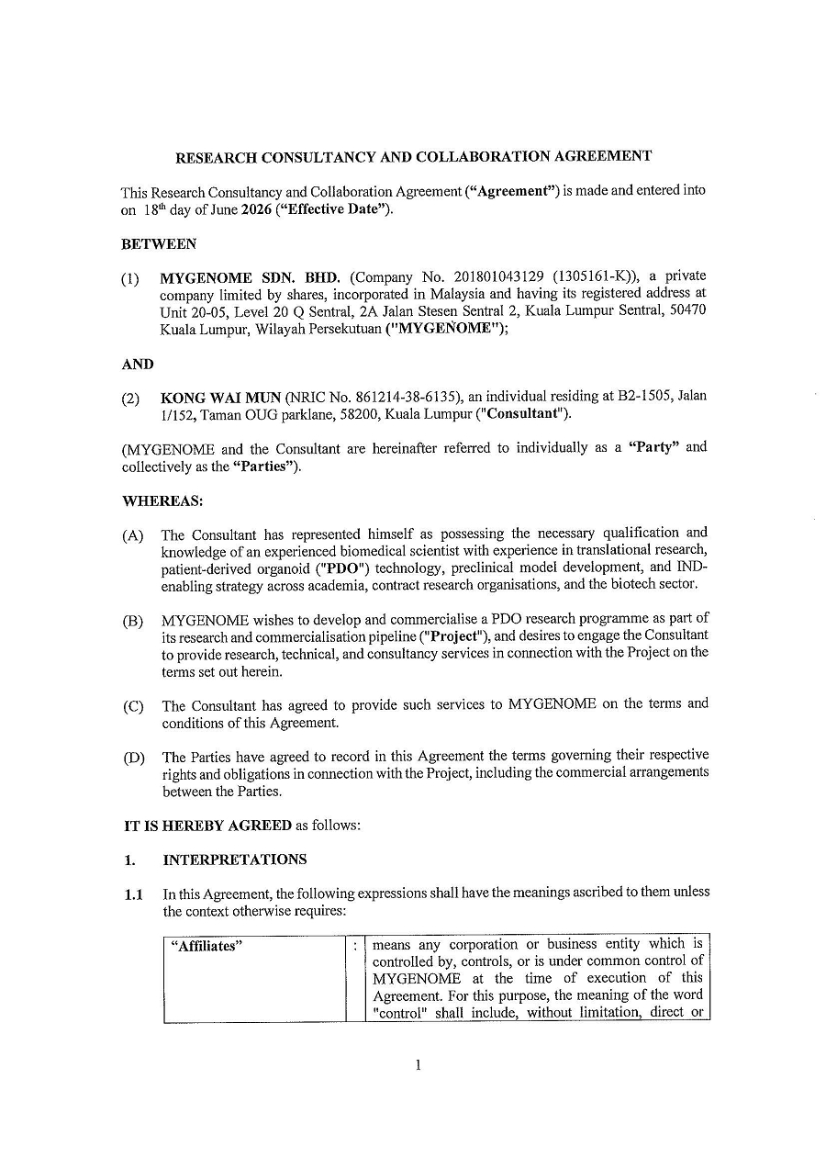

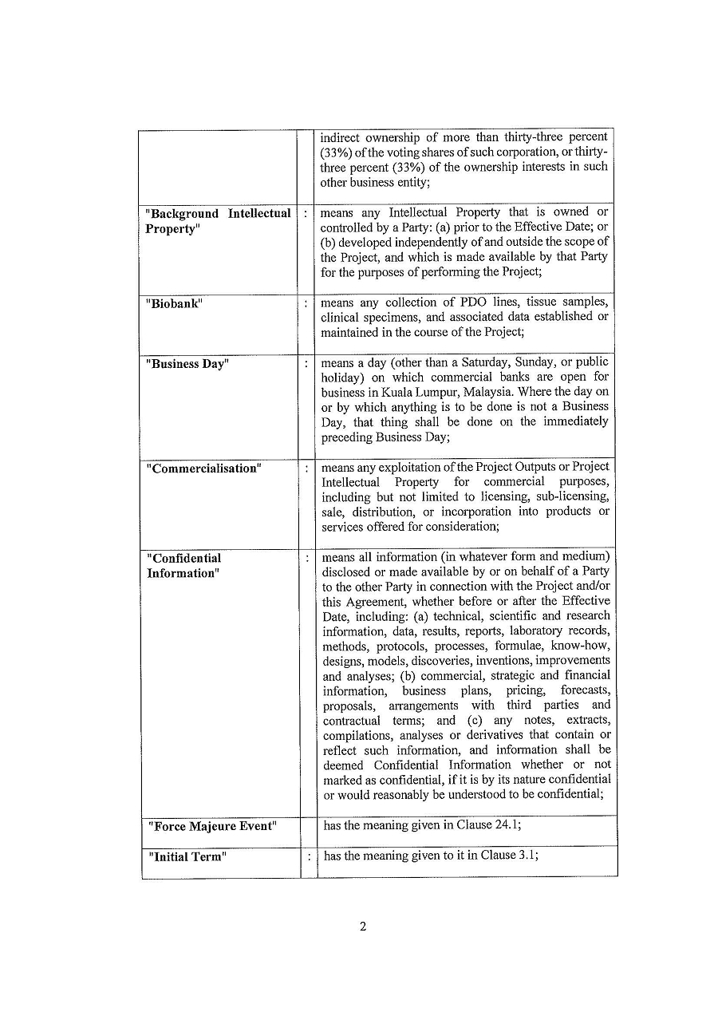

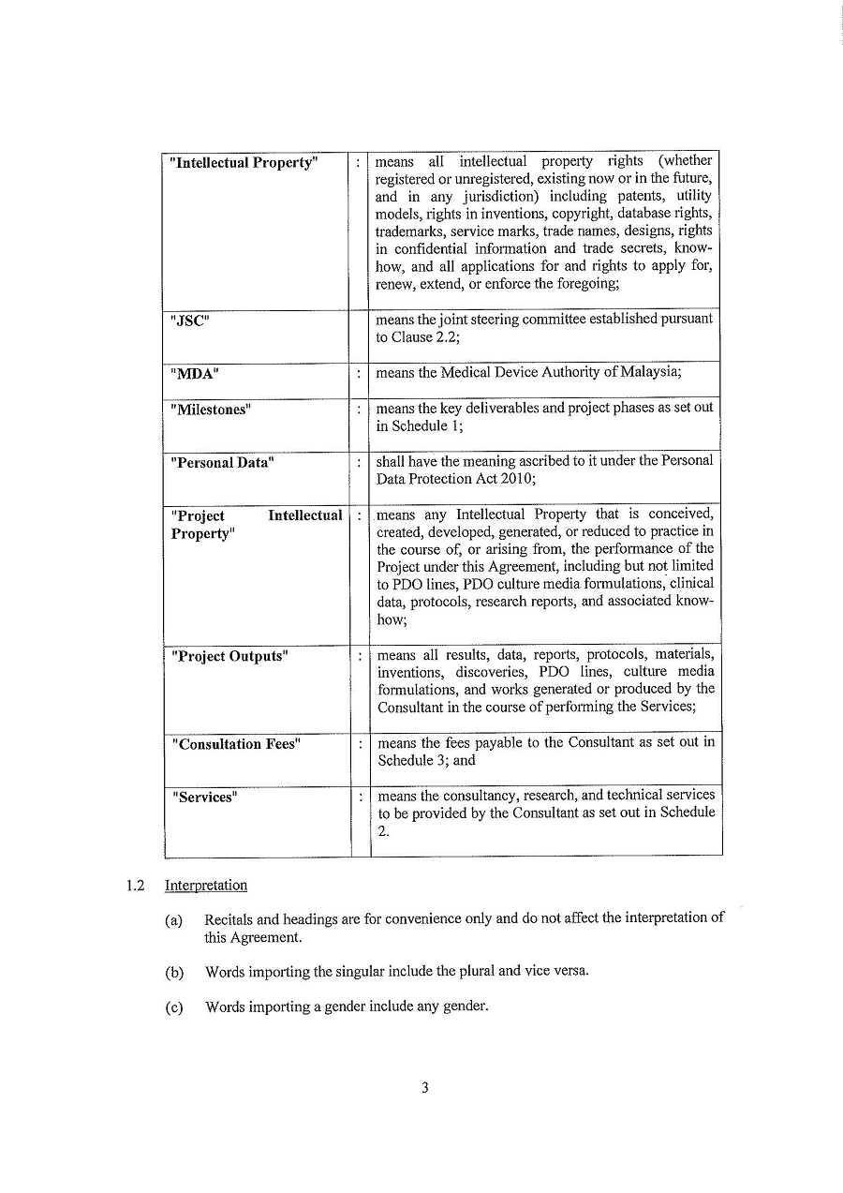



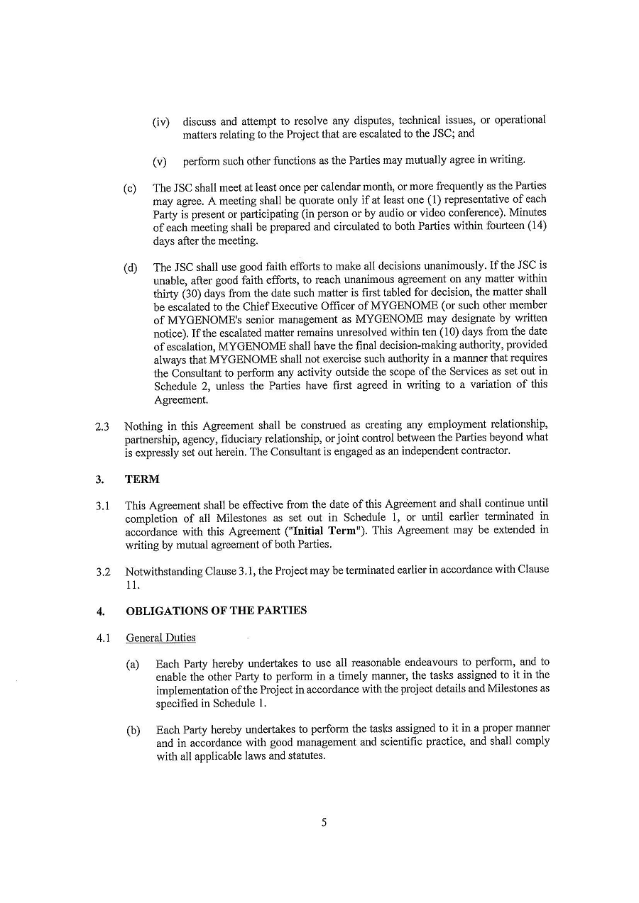

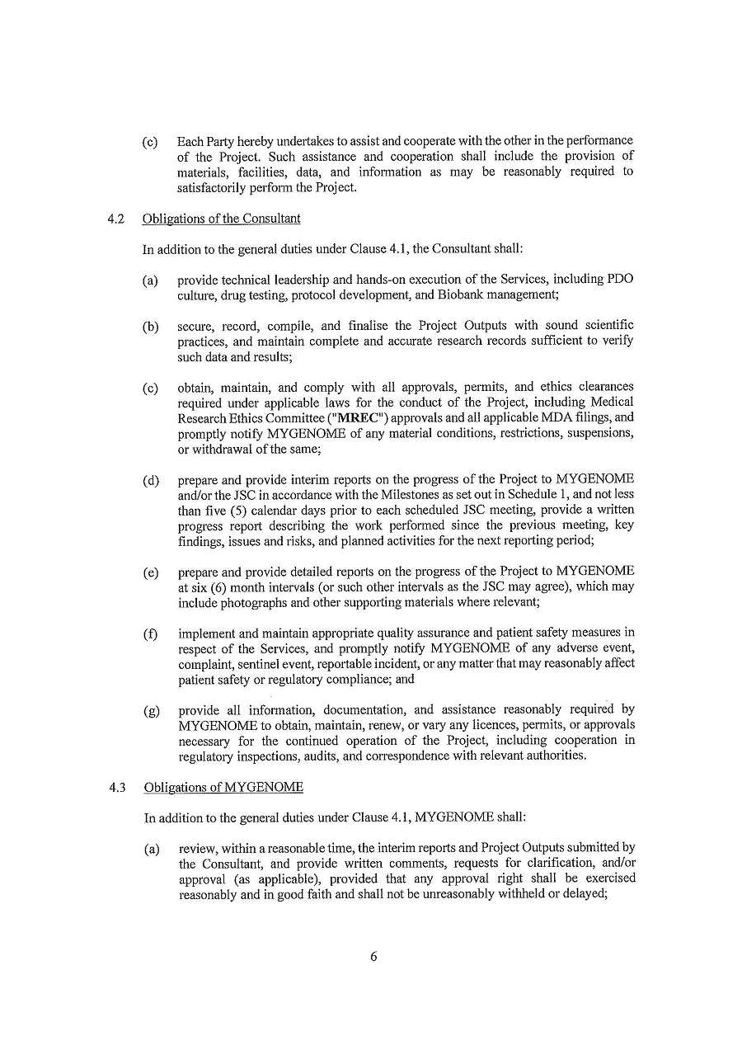



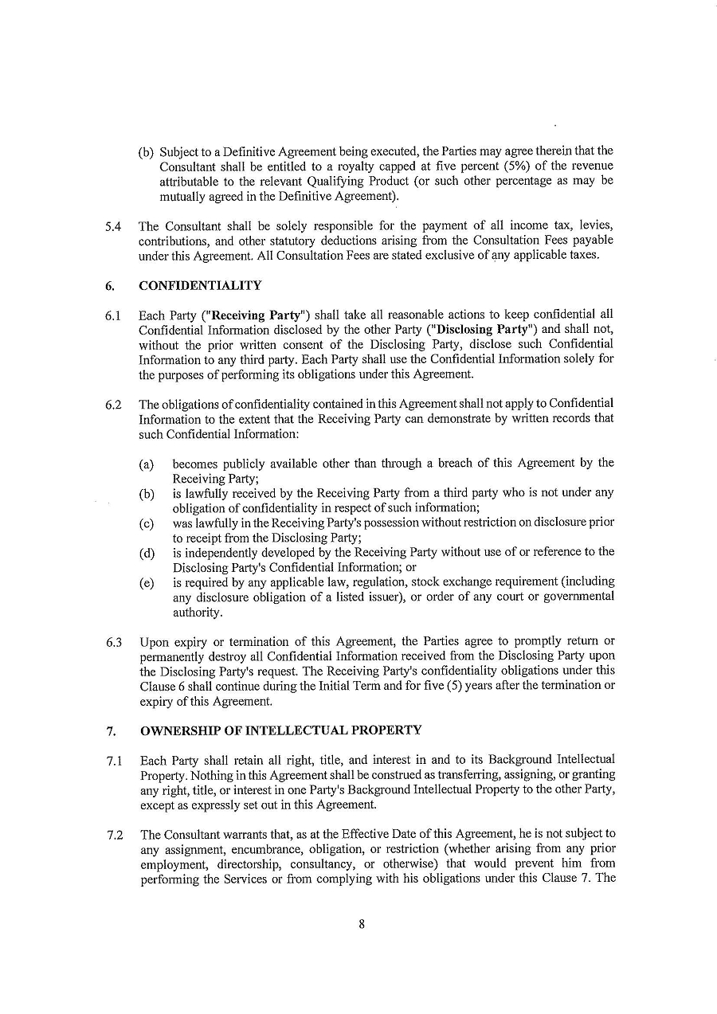

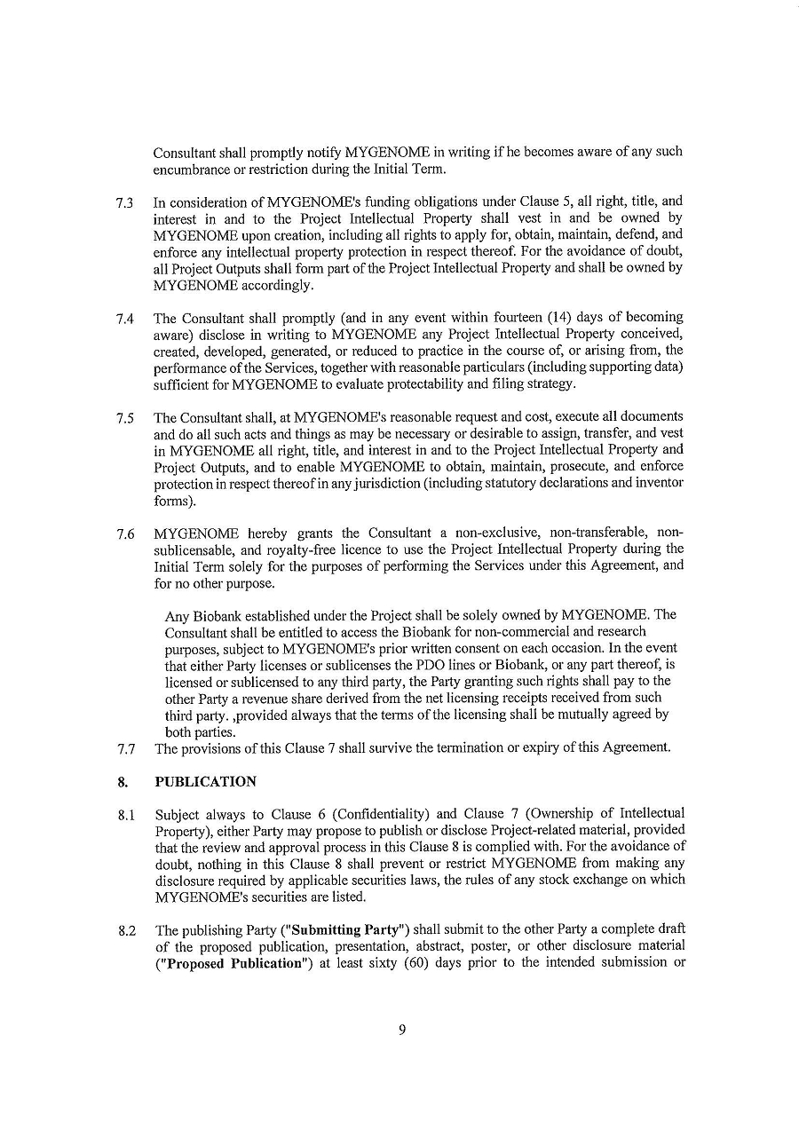



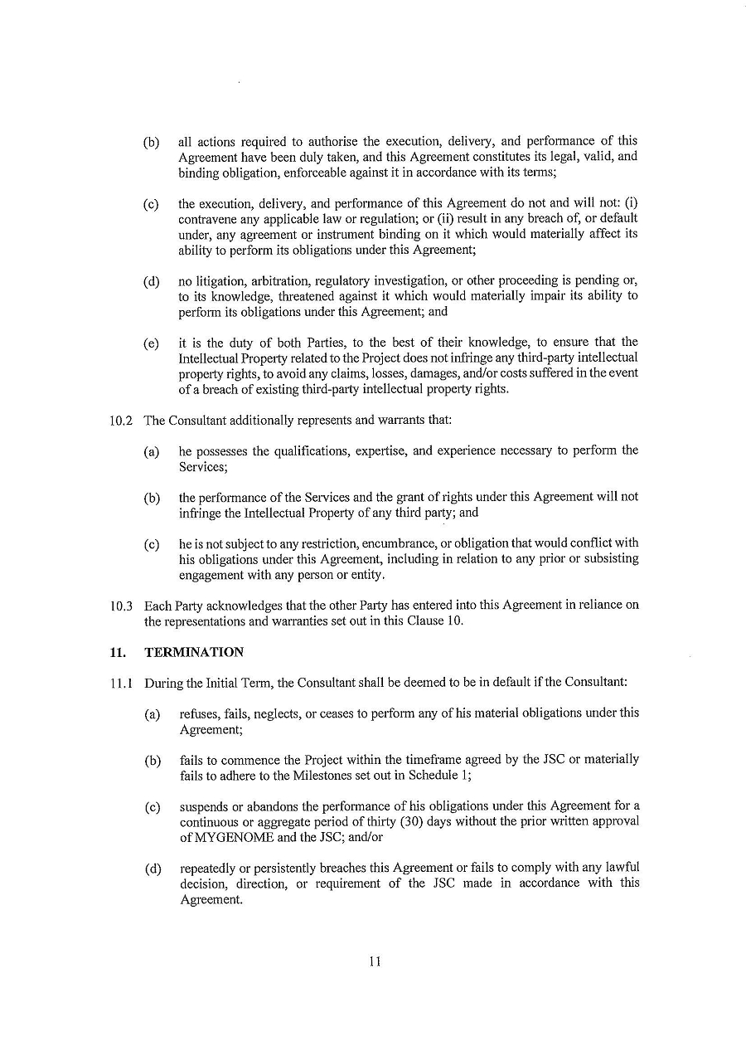



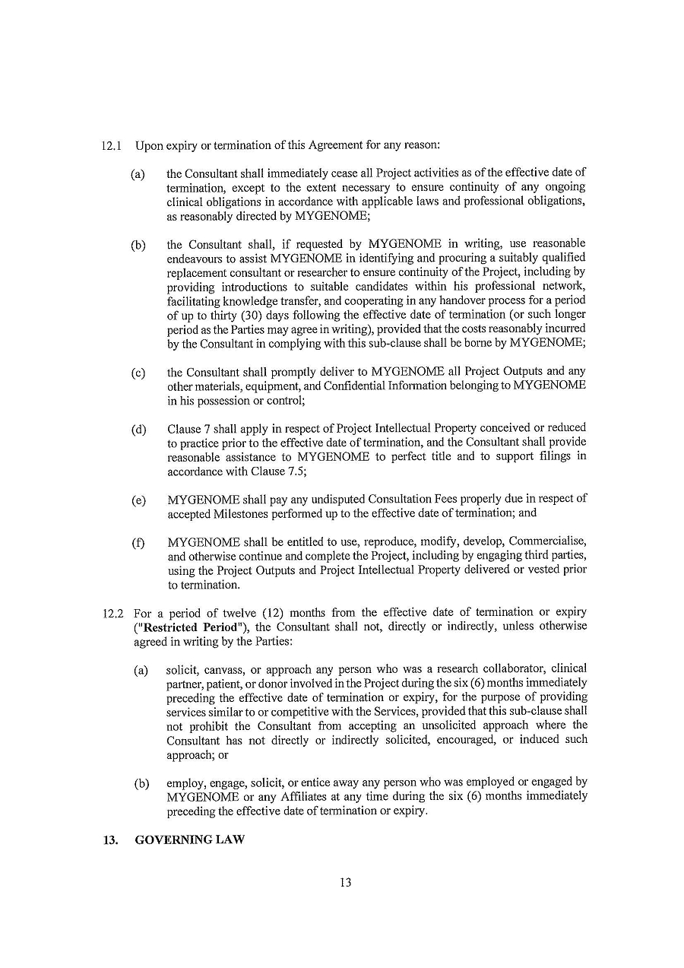

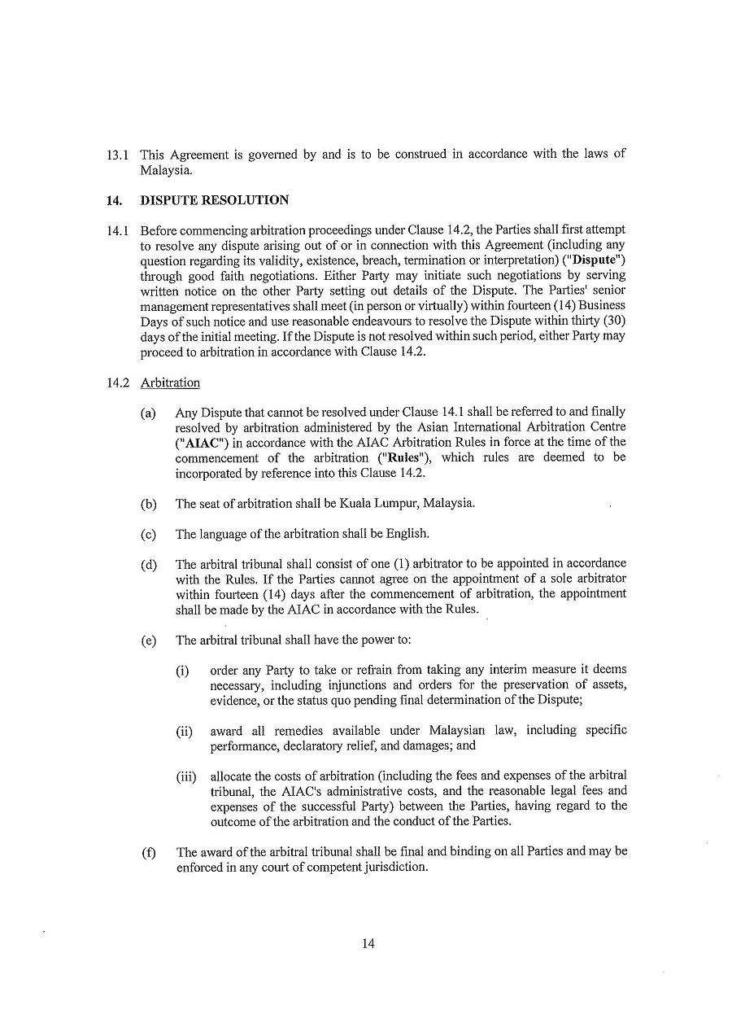

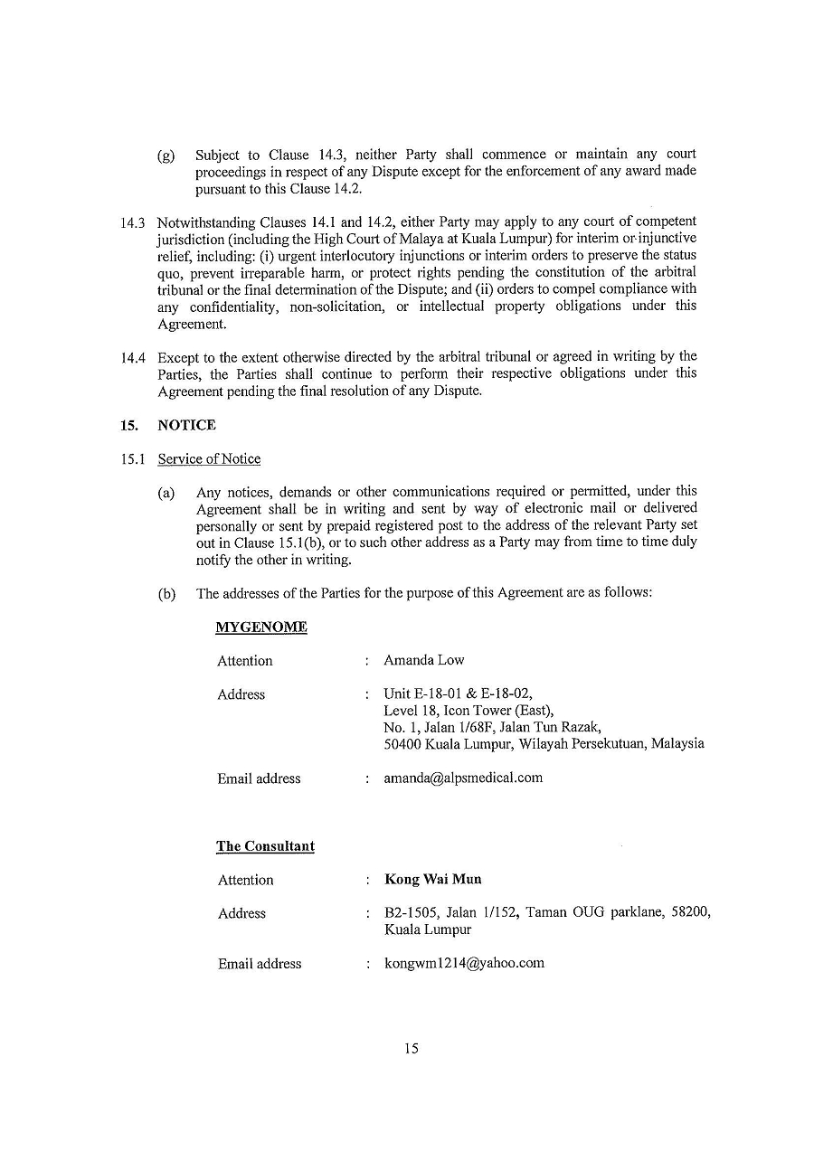

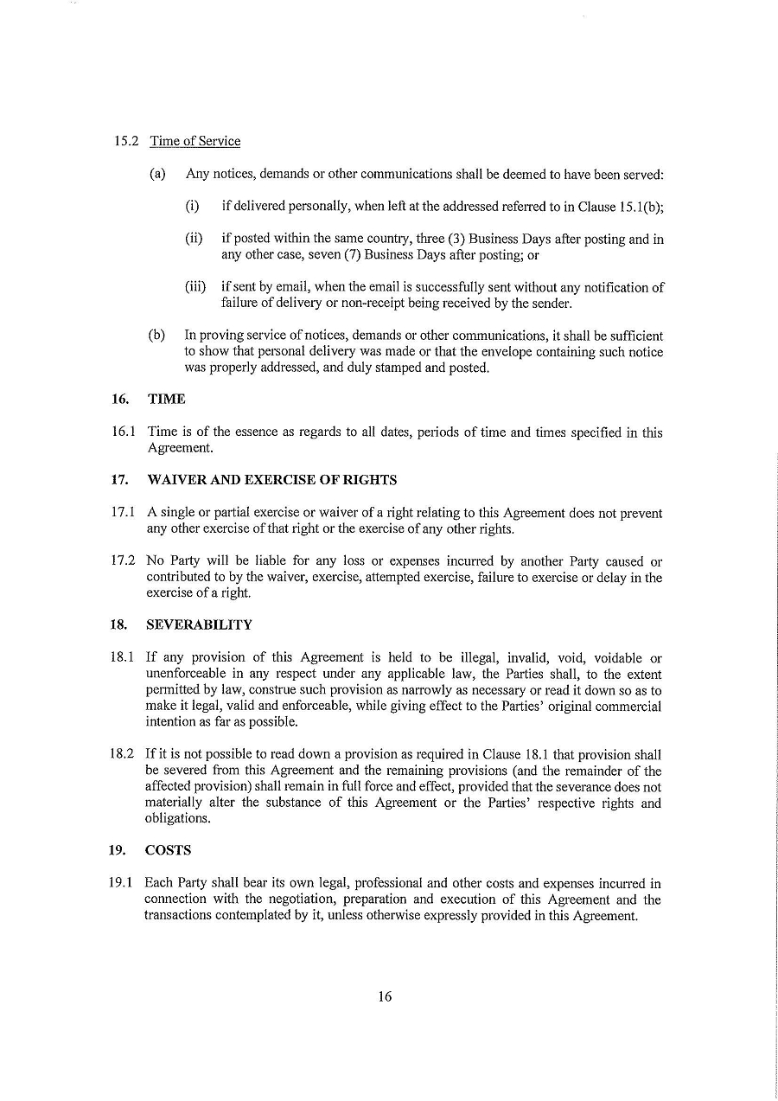

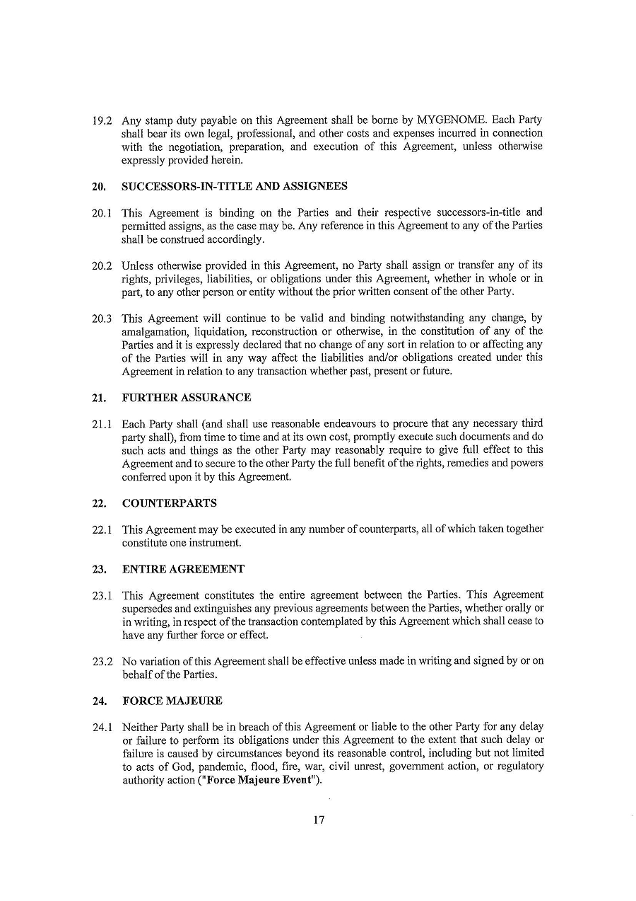

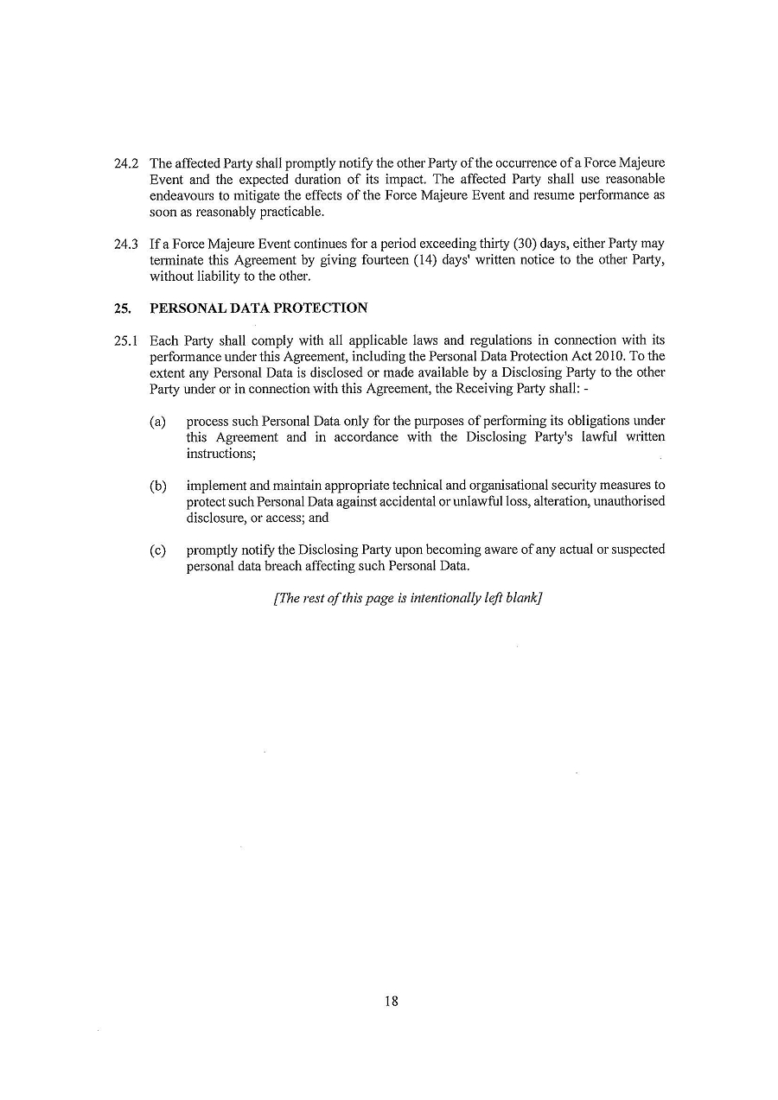

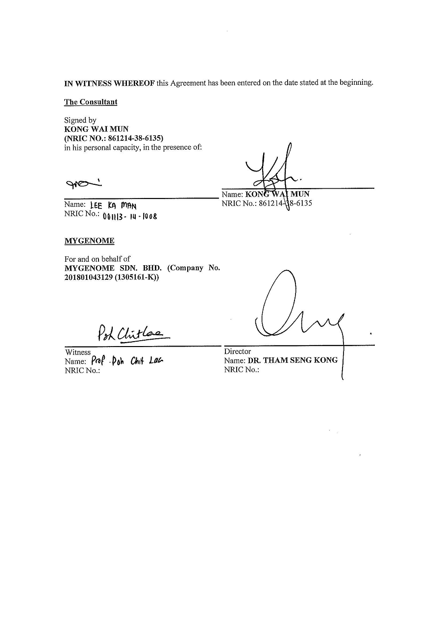

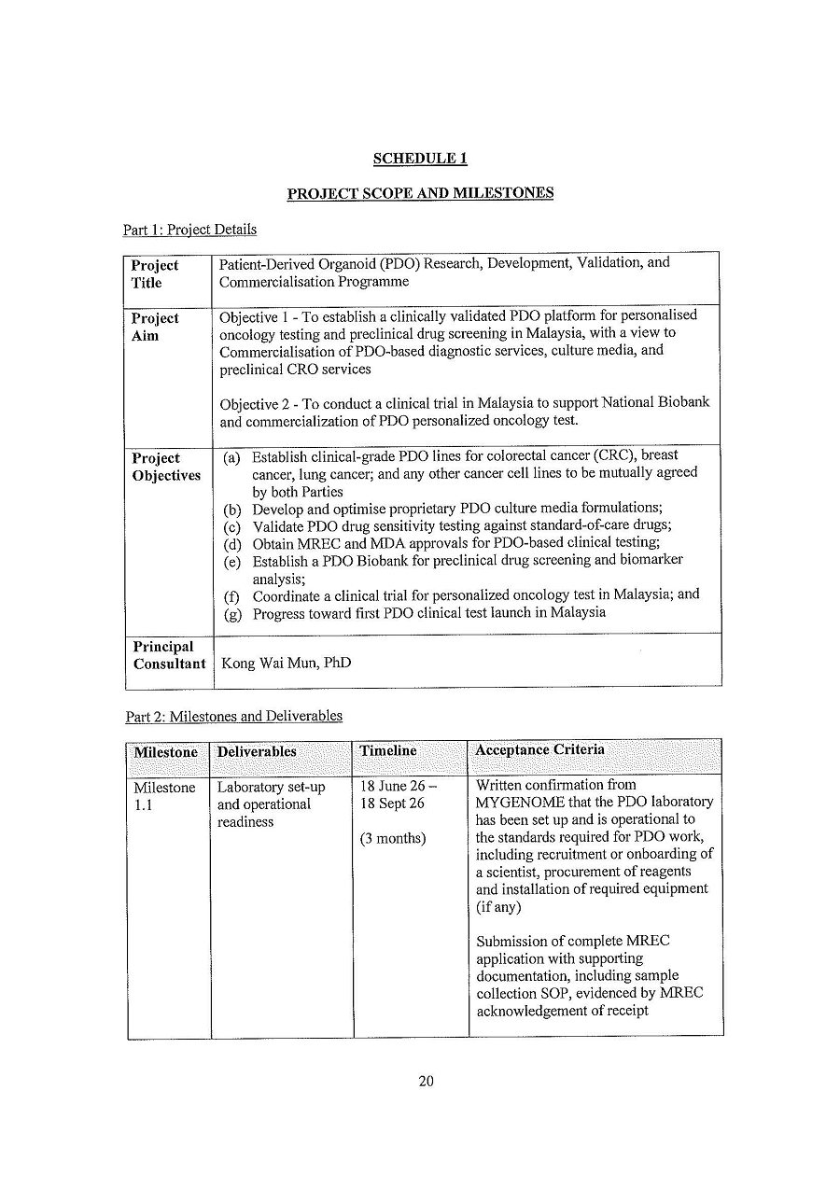

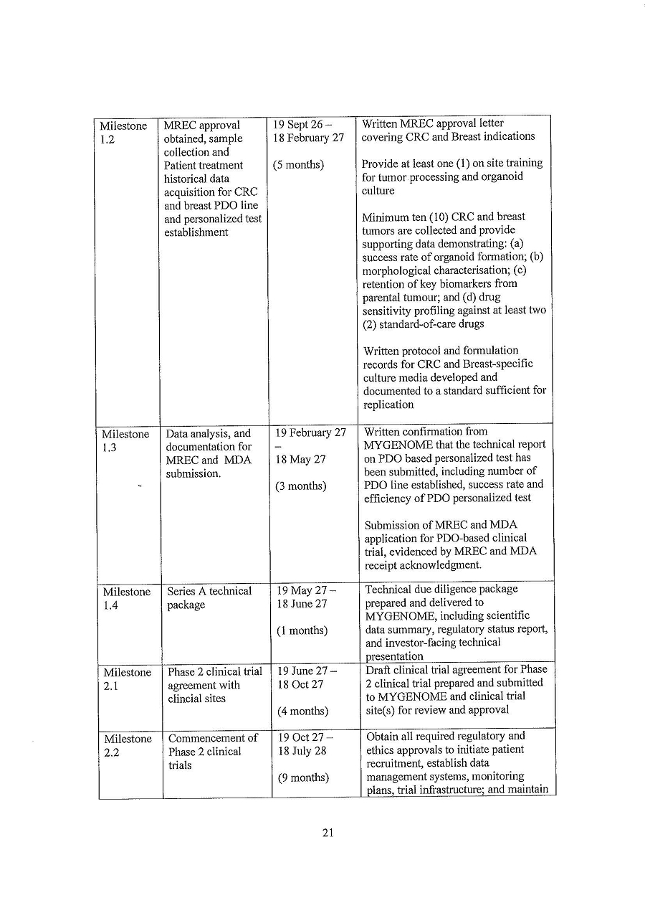

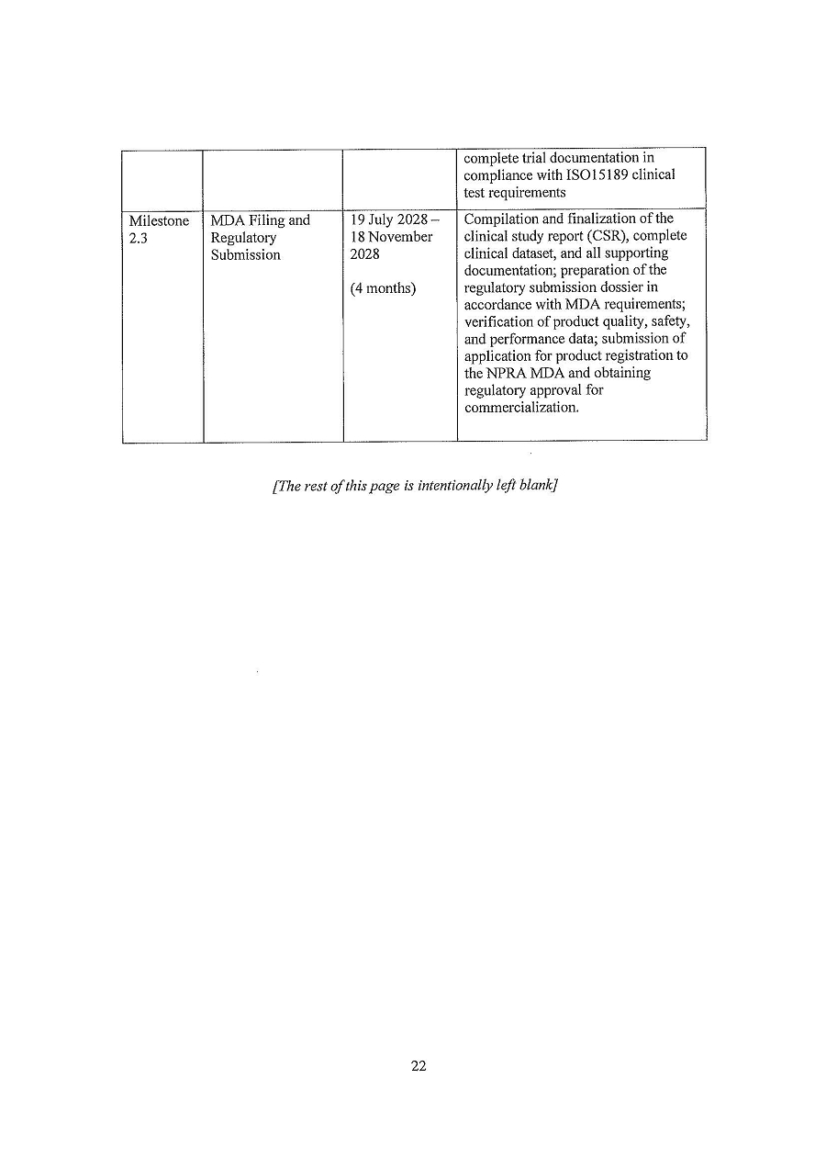

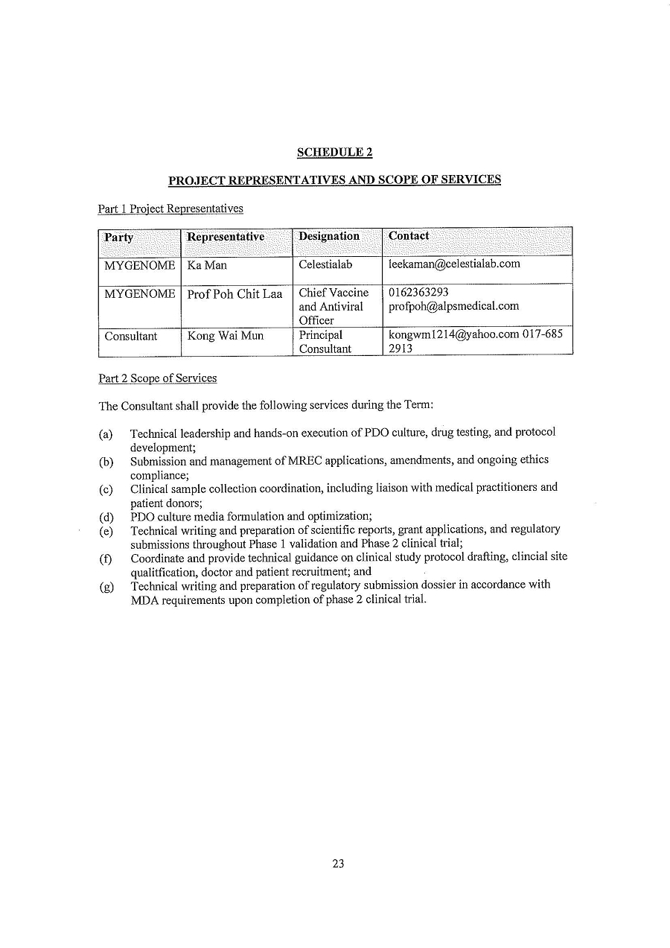

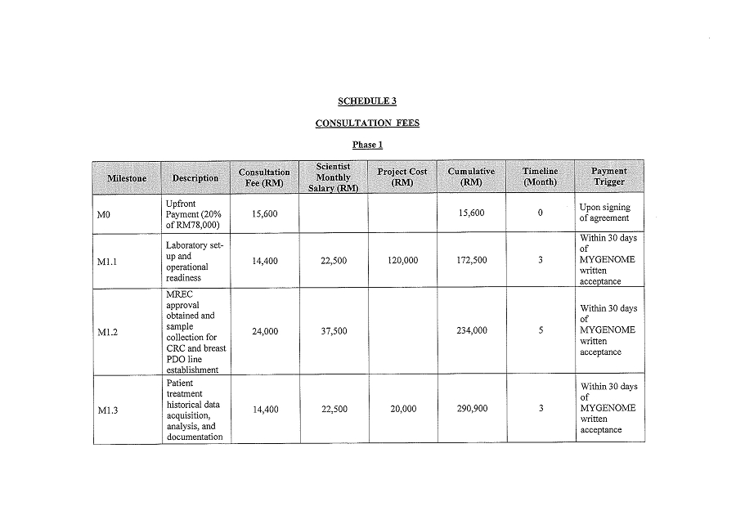

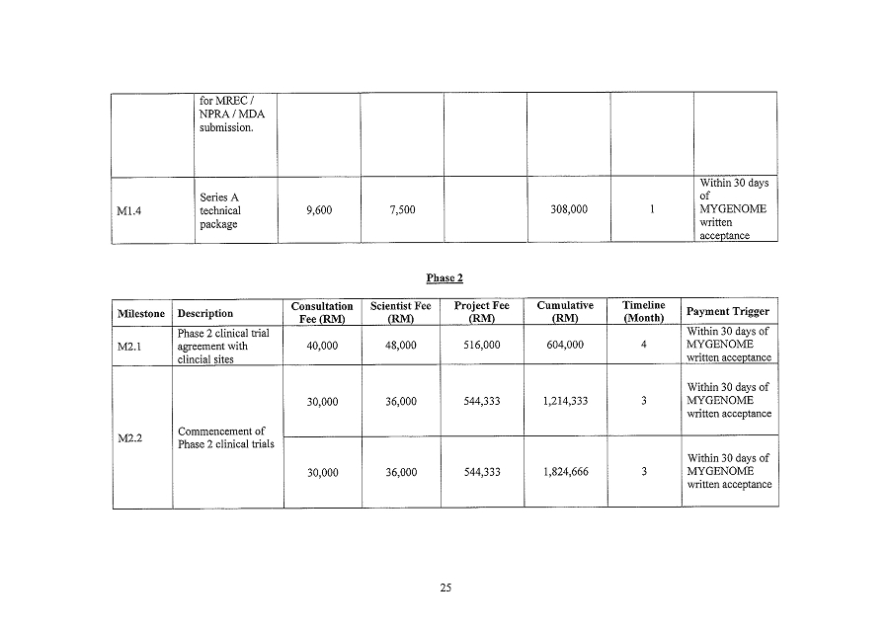

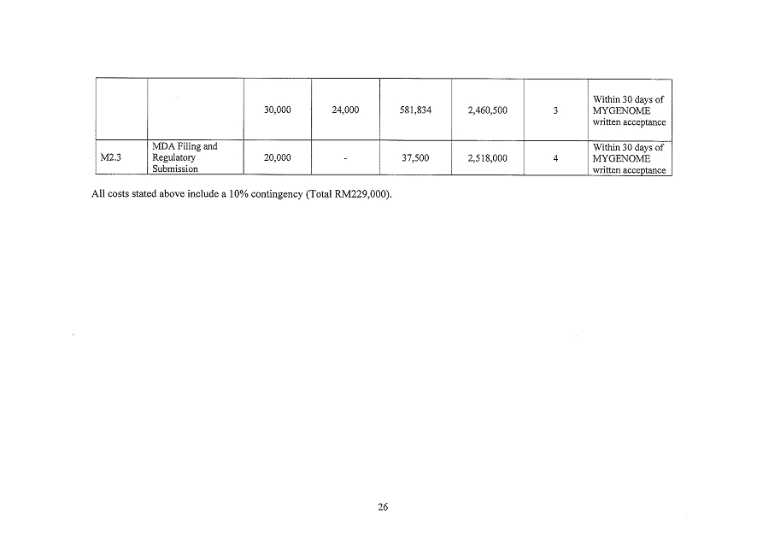

Exhibit 10.27

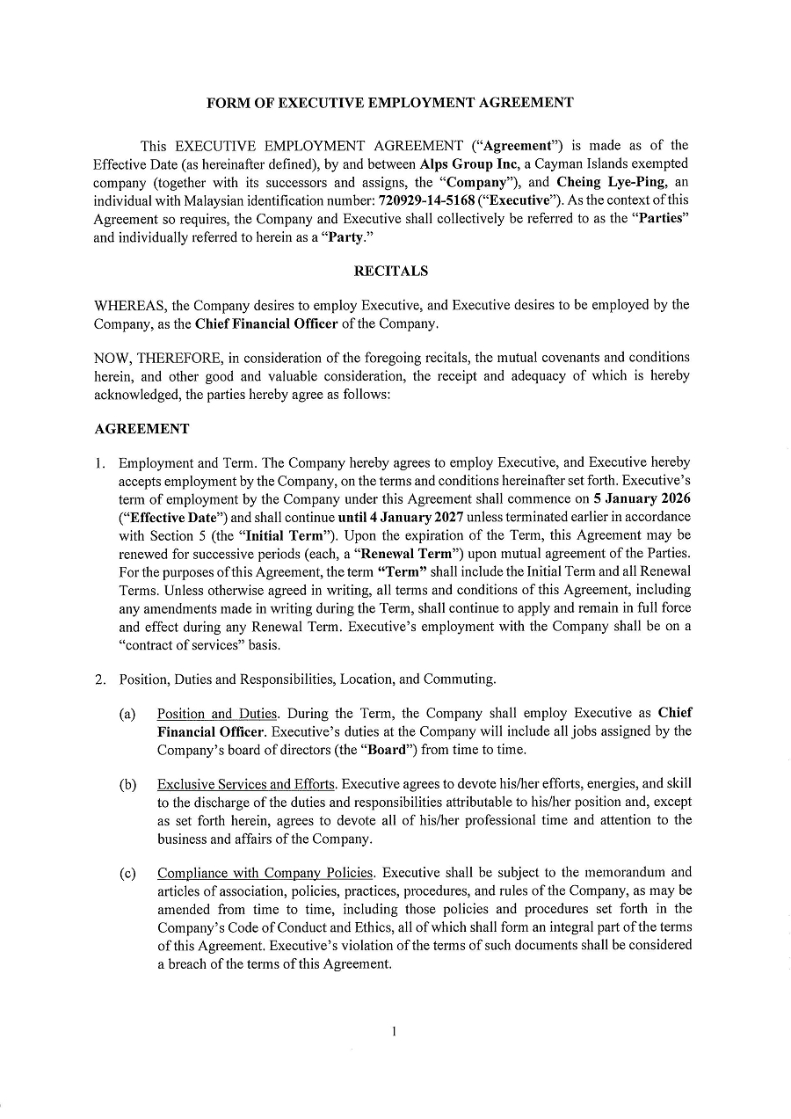

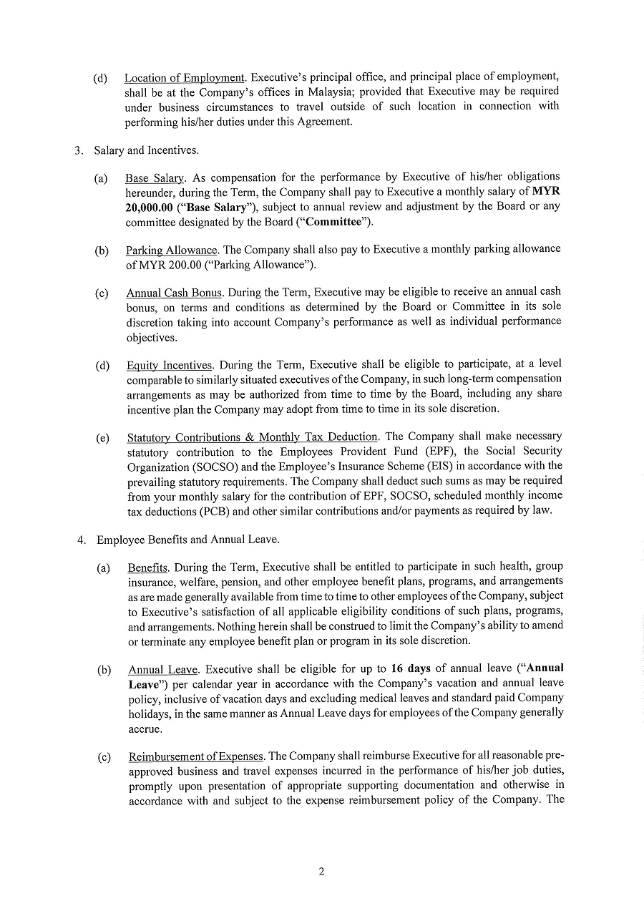

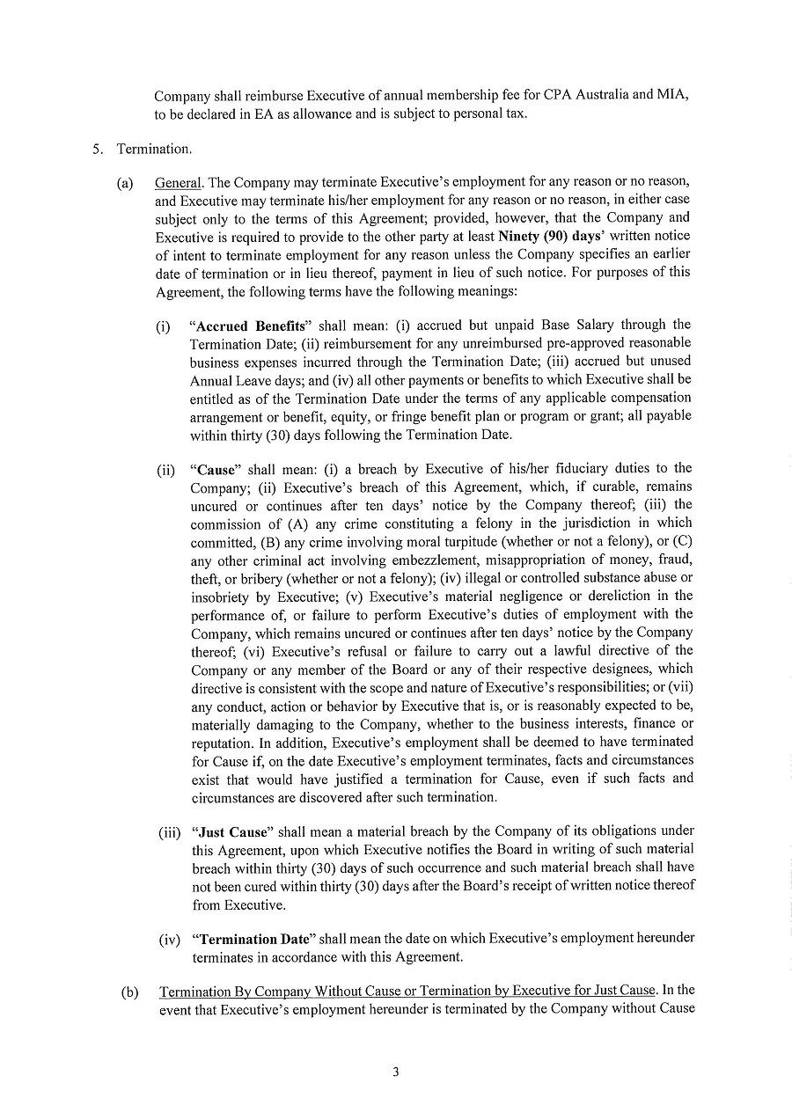

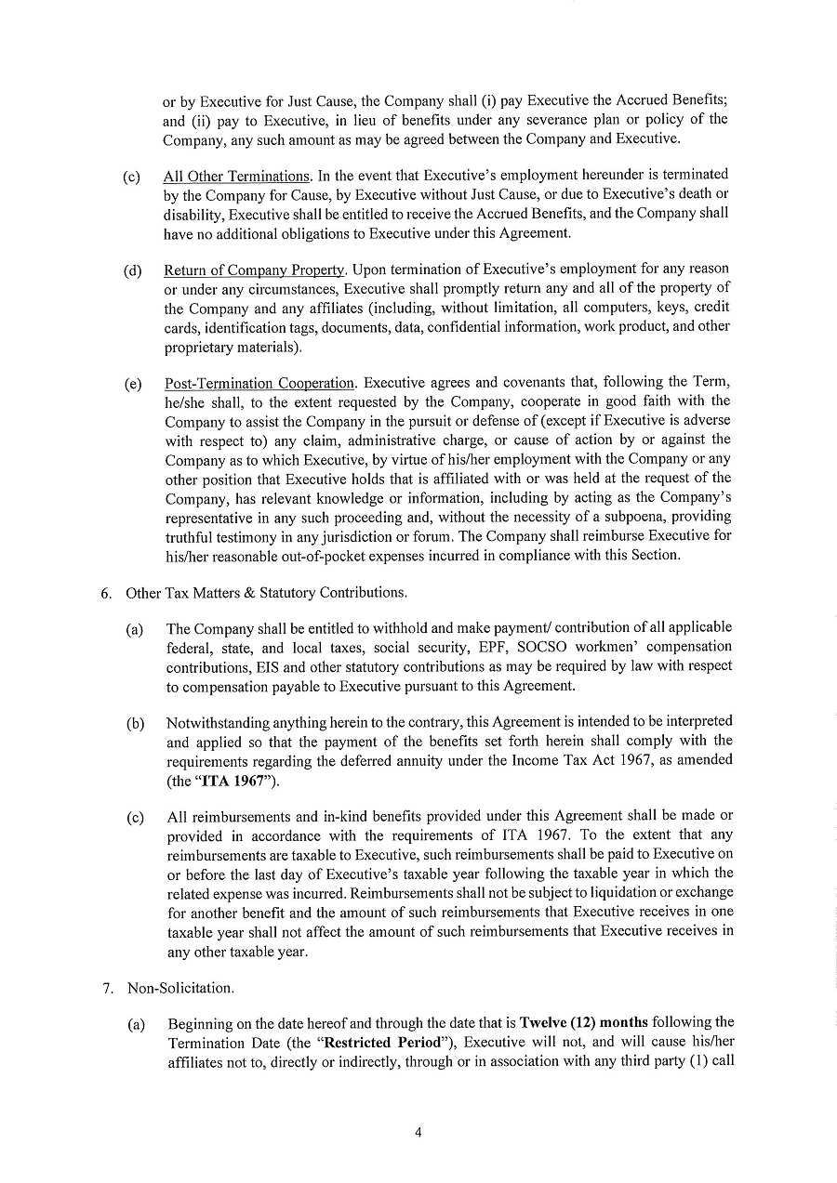

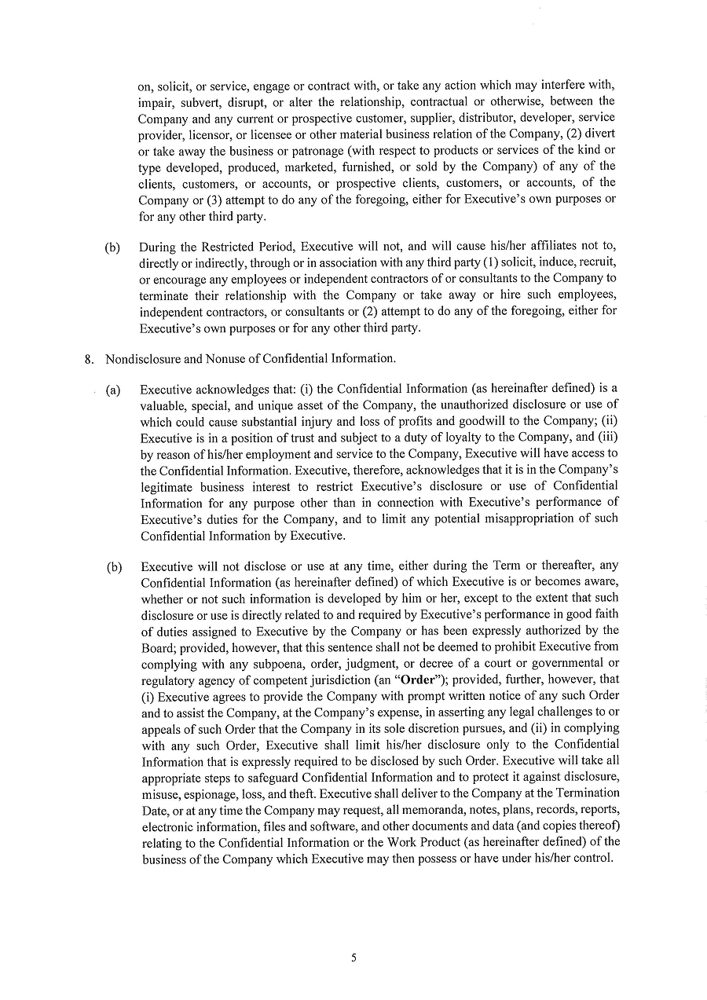

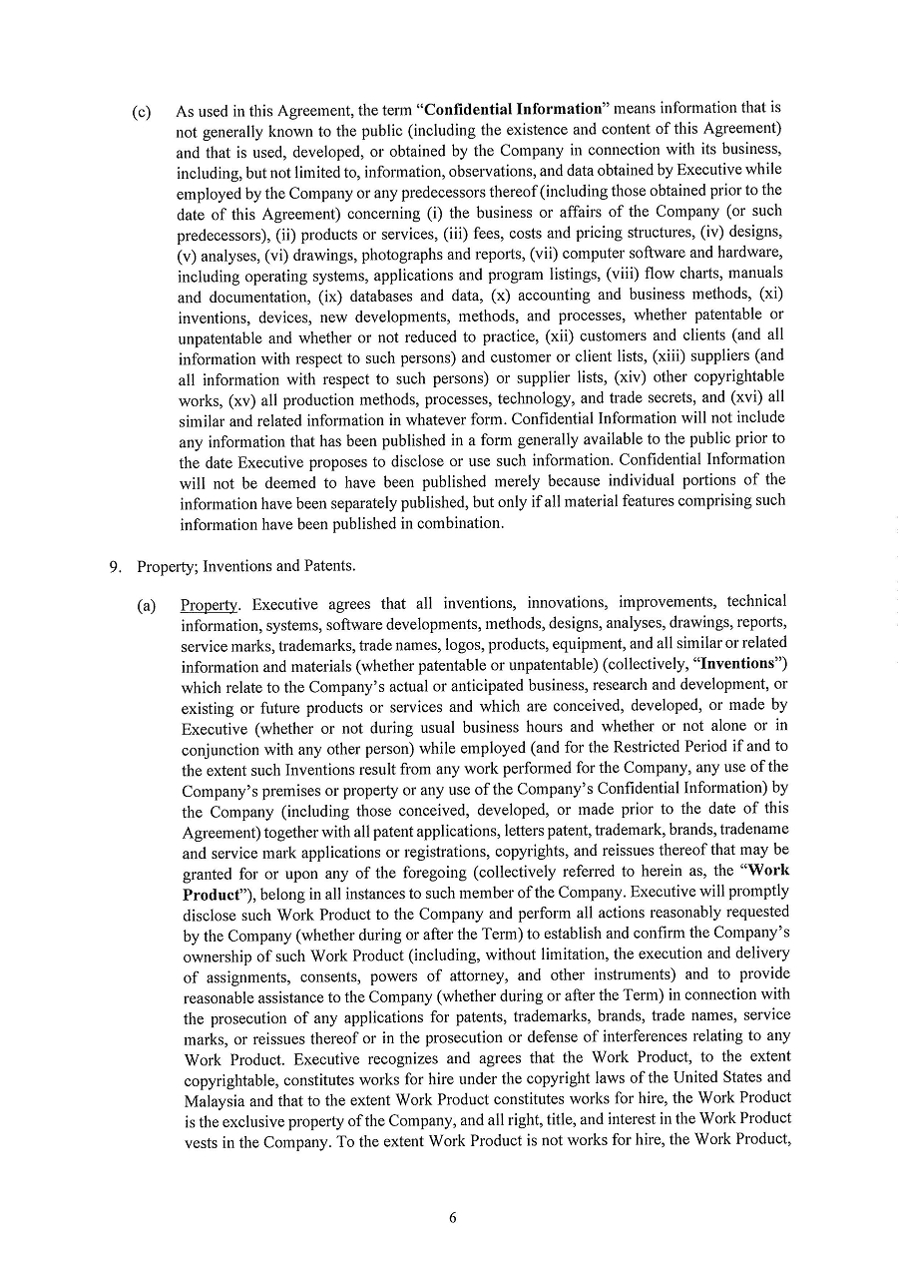

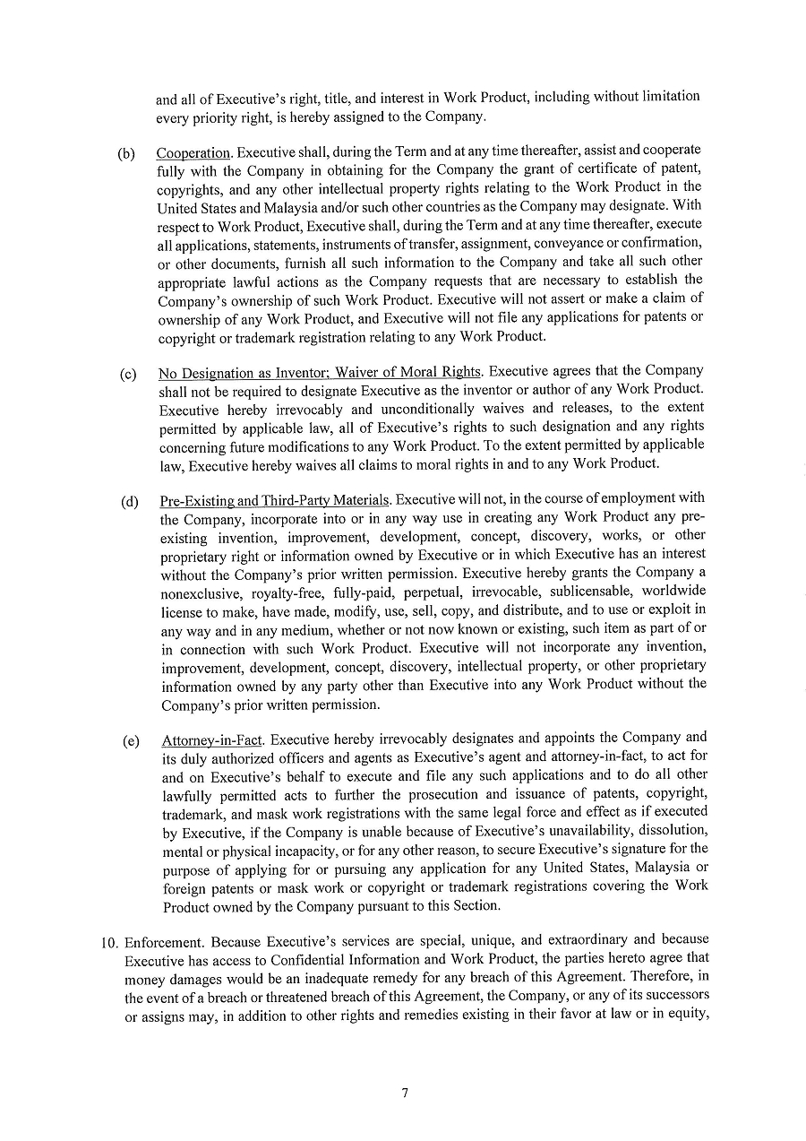

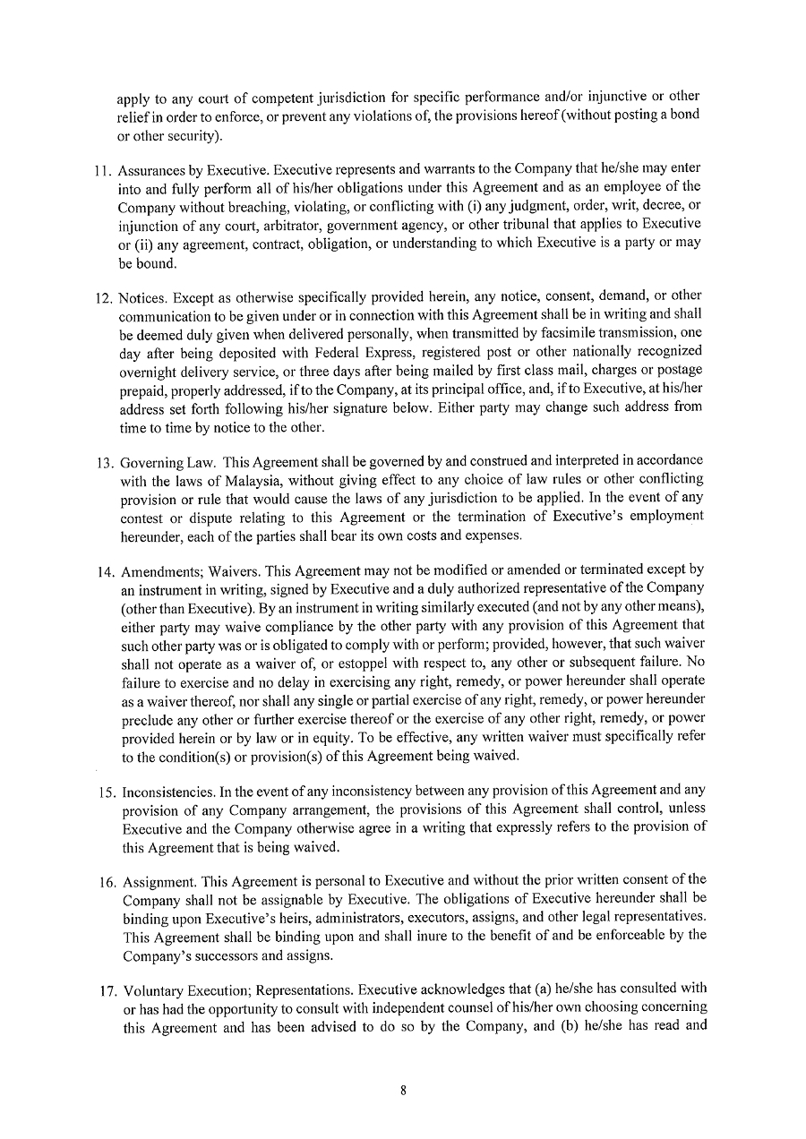

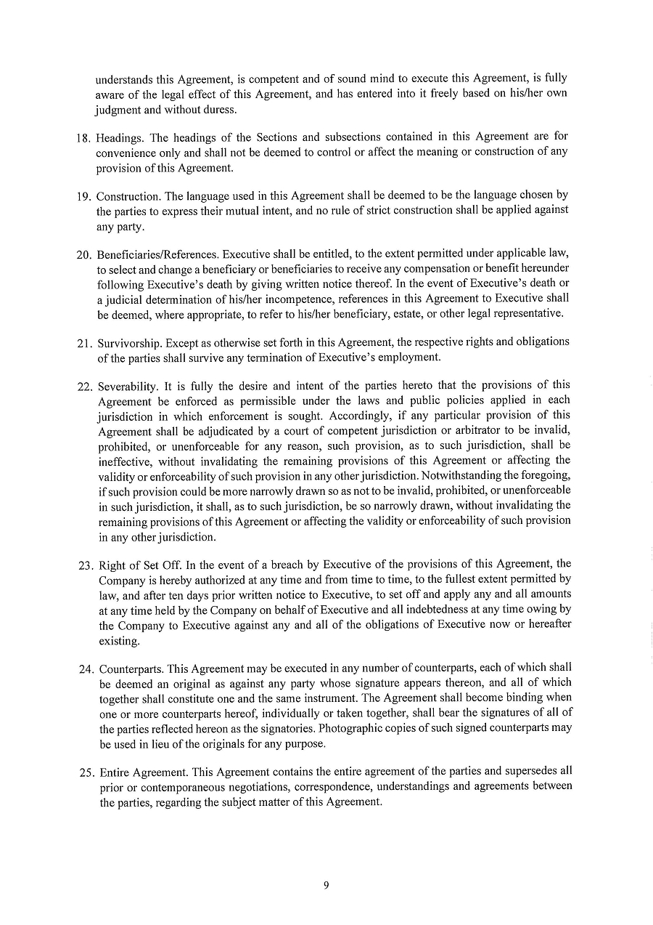



Exhibit 11.2

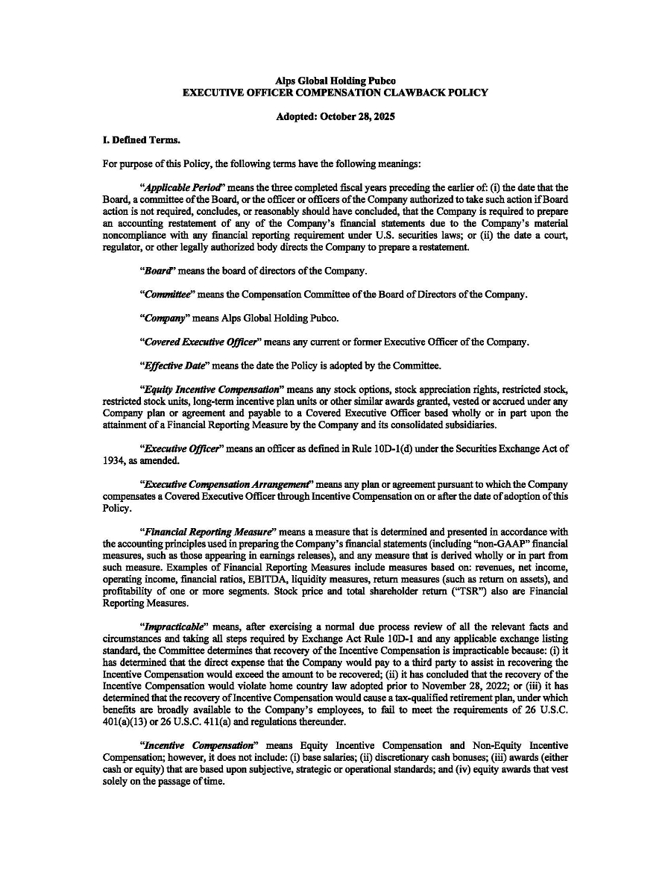

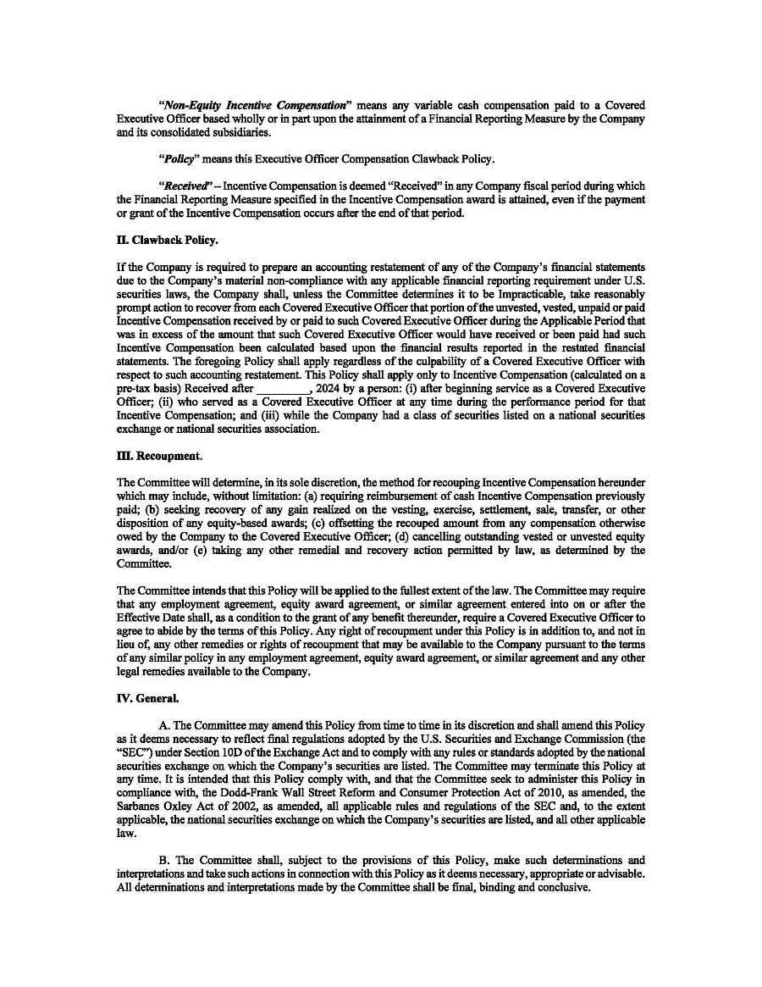



Exhibit 12.1

Certification by the Chief Executive Officer
Pursuant to Section 302 of the Sarbanes-Oxley Act of 2002

I, Dr. Tham Seng Kong, certify that:

 | 1. | I have reviewed this annual report on Form 20-F of Alps Group Inc (the “Company”);

 | 2. | Based on my knowledge, this report does not contain any untrue statement of a material fact or omit to state a material fact necessary to make the statements made, in light of the circumstances under which such statements were made, not misleading with respect to the period covered by this report;

 | 3. | Based on my knowledge, the financial statements, and other financial information included in this report, fairly present in all material respects the financial condition, results of operations and cash flows of the Company as of, and for, the periods presented in this report;

 | 4. | The Company’s other certifying officer and I are responsible for establishing and maintaining disclosure controls and procedures (as defined in Exchange Act Rules 13a-15(e) and 15d-15(e)) for the Company and have:

 | (a) | Designed such disclosure controls and procedures, or caused such disclosure controls and procedures to be designed under our supervision, to ensure that material information relating to the Company, including its consolidated subsidiaries, is made known to us by others within those entities, particularly during the period in which this report is being prepared;

 | (b) | [intentionally omitted];

 | (c) | Evaluated the effectiveness of the Company’s disclosure controls and procedures and presented in this report our conclusions about the effectiveness of the disclosure controls and procedures, as of the end of the period covered by this report based on such evaluation; and

 | (d) | Disclosed in this report any change in the Company’s internal control over financial reporting that occurred during the period covered by the annual report that has materially affected, or is reasonably likely to materially affect, the Company’s internal control over financial reporting; and

 | 5. | The Company’s other certifying officer and I have disclosed, based on our most recent evaluation of internal control over financial reporting, to the Company’s auditors and the audit committee of the Company’s board of directors (or persons performing the equivalent functions):

 | (a) | All significant deficiencies and material weaknesses in the design or operation of internal control over financial reporting which are reasonably likely to adversely affect the Company’s ability to record, process, summarize and report financial information; and

 | (b) | Any fraud, whether or not material, that involves management or other employees who have a significant role in the Company’s internal control over financial reporting.

Date: August 6, 2026

/s/ Dr. Tham Seng Kong
Dr. Tham Seng Kong
Chief Executive Officer

Exhibit 12.2

Certification by the Principal Financial Officer
Pursuant to Section 302 of the Sarbanes-Oxley Act of 2002

I, CHEING Lye-Ping, certify that:

 | 1. | I have reviewed this annual report on Form 20-F of Alps Group Inc (the “Company”);

 | 2. | Based on my knowledge, this report does not contain any untrue statement of a material fact or omit to state a material fact necessary to make the statements made, in light of the circumstances under which such statements were made, not misleading with respect to the period covered by this report;

 | 3. | Based on my knowledge, the financial statements, and other financial information included in this report, fairly present in all material respects the financial condition, results of operations and cash flows of the Company as of, and for, the periods presented in this report;

 | 4. | The Company’s other certifying officer and I are responsible for establishing and maintaining disclosure controls and procedures (as defined in Exchange Act Rules 13a-15(e) and 15d-15(e)) for the Company and have:

 | (a) | Designed such disclosure controls and procedures, or caused such disclosure controls and procedures to be designed under our supervision, to ensure that material information relating to the Company, including its consolidated subsidiaries, is made known to us by others within those entities, particularly during the period in which this report is being prepared;

 | (b) | [intentionally omitted];

 | (c) | Evaluated the effectiveness of the Company’s disclosure controls and procedures and presented in this report our conclusions about the effectiveness of the disclosure controls and procedures, as of the end of the period covered by this report based on such evaluation; and

 | (d) | Disclosed in this report any change in the Company’s internal control over financial reporting that occurred during the period covered by the annual report that has materially affected, or is reasonably likely to materially affect, the Company’s internal control over financial reporting; and

 | 5. | The Company’s other certifying officer and I have disclosed, based on our most recent evaluation of internal control over financial reporting, to the Company’s auditors and the audit committee of the Company’s board of directors (or persons performing the equivalent functions):

 | (a) | All significant deficiencies and material weaknesses in the design or operation of internal control over financial reporting which are reasonably likely to adversely affect the Company’s ability to record, process, summarize and report financial information; and

 | (b) | Any fraud, whether or not material, that involves management or other employees who have a significant role in the Company’s internal control over financial reporting.

Date: August 6, 2026

/s/ CHEING Lye-Ping
CHEING Lye-Ping
Chief Financial Officer

EXHIBIT 13.1

CERTIFICATION PURSUANT TO
18 U.S.C. SECTION 1350,
AS ADOPTED PURSUANT TO
SECTION 906 OF THE SARBANES-OXLEY ACT OF 2002

In connection with the Annual Report of Alps Group Inc (the “Company”) on Form 20-F for the year ended March 31, 2026, as filed with the Securities and Exchange Commission on the date hereof (the “Annual Report”), each of the undersigned officers of the Company, does hereby certify, pursuant to 18 U.S.C. Section 1350, as adopted pursuant to Section 906 of the Sarbanes-Oxley Act of 2002, that:

(1) The Annual Report fully complies with the requirements of Section 13(a) or 15(d) of the Securities Exchange Act of 1934; and

(2) The information contained in the Annual Report fairly presents, in all material respects, the financial condition and result of operations of the Company.

Dated: August 6, 2026 | By: | /s/ Dr. Tham Seng Kong
 | Name: | Dr. Tham Seng Kong
 | Title: | Chief Executive Officer (Principal Executive Officer)

Dated: August 6, 2026 | By: | /s/ CHEING Lye-Ping
 | Name: | CHEING Lye-Ping
 | Title: | Chief Financial Officer (Principal Financial and Accounting Officer)

